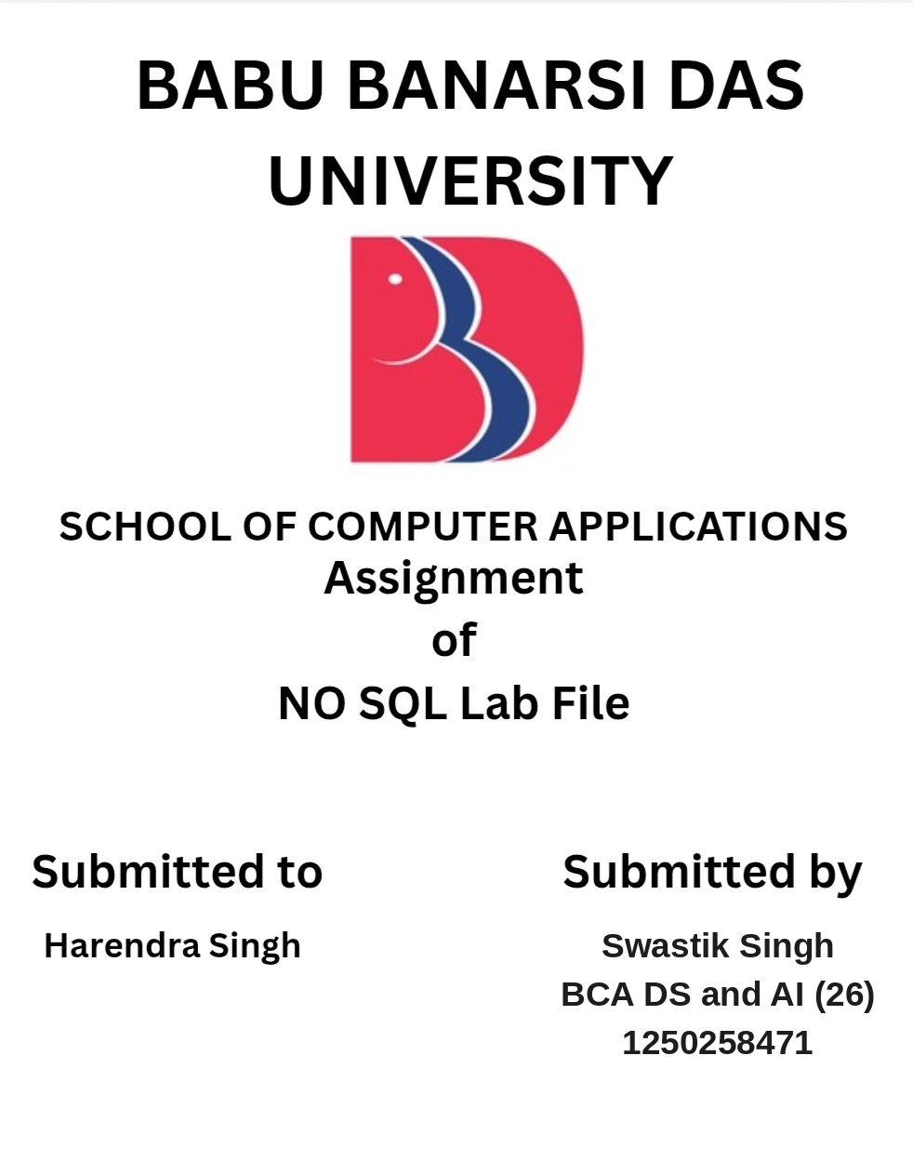

ACKNOWLEDGEMENT
I sincerely express my gratitude to my teacher for giving me the opportunity to prepare this NoSQL project using MongoDB. Working on this project helped me connect the theoretical concepts of NoSQL databases with practical commands used in a MongoDB Shell.
I am thankful for the guidance, suggestions and encouragement received during the preparation of this project. I also appreciate the support of my classmates, friends and family, which helped me complete the work carefully and understand the different database operations.
Through this project, I learned how student records can be created, inserted, searched, filtered, updated, deleted and sorted in a document-oriented database. I am grateful for this learning experience.

INTRODUCTION
NoSQL stands for 'Not Only SQL'. NoSQL databases are designed to handle data in flexible, non-tabular formats. MongoDB is a popular document-oriented NoSQL database in which data is stored as BSON documents inside collections.
In this project, a database named StudentDB and a collection named students are used. The collection contains 50 student records with fields such as roll number, name, age, gender, course, semester, marks and city. The project demonstrates basic CRUD operations and comparison operators such as $eq, $gt and $lt.

OBJECTIVES
- Create a MongoDB database and collection.
- Insert 50 student records using insertMany().
- Read and search records using find() and findOne().
- Filter records using equal-to, greater-than and less-than operators.
- Update and delete records.
- Use sorting, counting, projection and limit operations.

1. CREATE DATABASE AND COLLECTION
MongoDB Command
use StudentDB
db.createCollection("students")
Explanation
The use command selects (or switches to) the StudentDB database. createCollection() creates a collection named students. A collection is where MongoDB stores related documents. This is the first step before inserting student records.
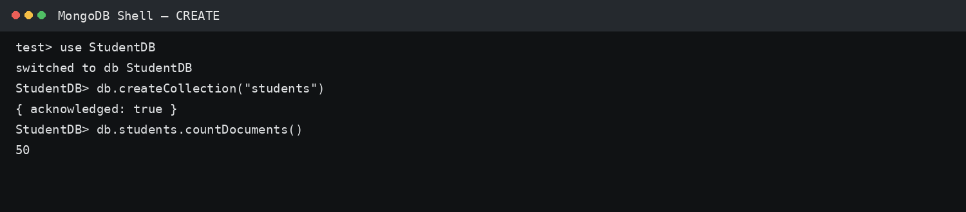
MongoDB Shell output screenshot

2. INSERT 50 STUDENTS — insertMany()
MongoDB Command
db.students.insertMany([
{rollNo:1, name:"Aarav Sharma", age:19, gender:"Male", course:"BCA", semester:1, marks:82, city:"Lucknow"},
{rollNo:2, name:"Ananya Singh", age:18, gender:"Female", course:"BCA", semester:1, marks:91, city:"Kanpur"},
...
{rollNo:50, name:"Rohit Sharma", age:19, gender:"Male", course:"BCA", semester:1, marks:83, city:"Lucknow"}
])
Explanation
insertMany() is used when we want to add many documents at the same time. In this project, 50 student documents are inserted into the students collection. Each document contains roll number, name, age, gender, course, semester, marks and city.
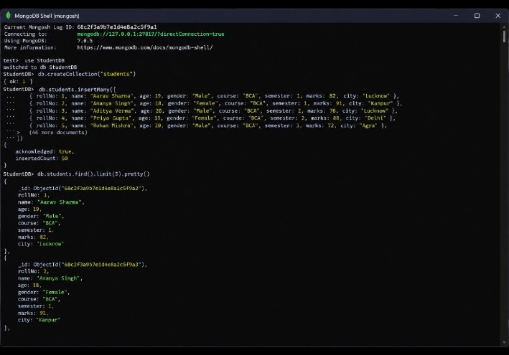
MongoDB Shell output screenshot

3. READ / DISPLAY DATA — find()
MongoDB Command
db.students.find().pretty()
db.students.findOne({rollNo:10})
Explanation
find() reads and displays documents from the collection. pretty() formats the output so that it is easier to read. findOne() returns a single matching document. These are basic read operations in MongoDB.
MongoDB Shell output screenshot

4. EQUAL TO — $eq
MongoDB Command
db.students.find(
{marks: {$eq: 90}},
{_id:0, rollNo:1, name:1, marks:1}
)
Explanation
$eq means 'equal to'. It returns documents where the selected field exactly matches the given value. For example, the query above finds students whose marks are exactly 90. Comparison operators are useful for filtering records according to conditions.
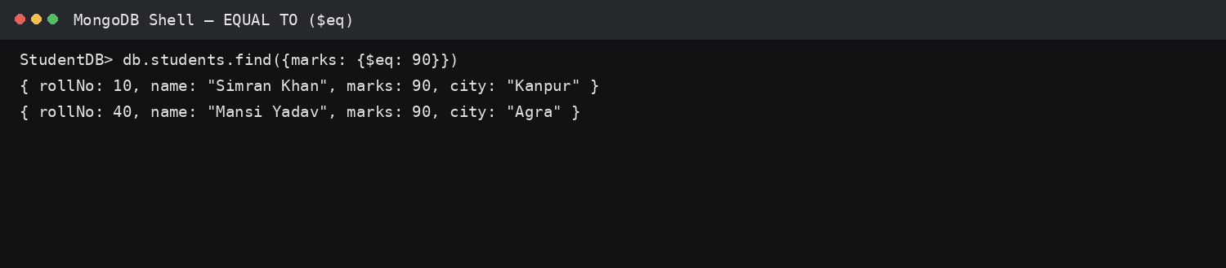
MongoDB Shell output screenshot

5. GREATER THAN — $gt
MongoDB Command
db.students.find(
{marks: {$gt: 90}},
{_id:0, rollNo:1, name:1, marks:1}
)
Explanation
$gt means 'greater than'. It returns documents where marks are greater than 90. The query can be changed to another field or value as required.
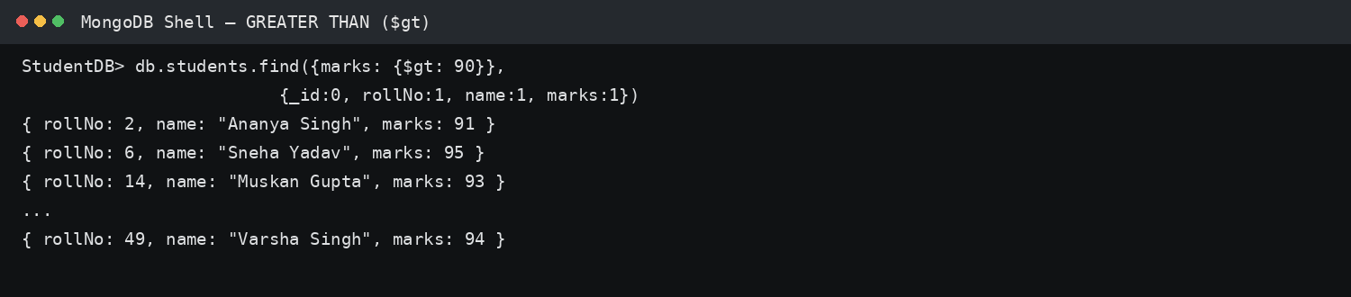
MongoDB Shell output screenshot

6. LESS THAN — $lt
MongoDB Command
db.students.find(
{marks: {$lt: 75}},
{_id:0, rollNo:1, name:1, marks:1}
)
Explanation
$lt means 'less than'. It returns students whose marks are below 75. This type of condition is useful for finding records below a particular performance level.
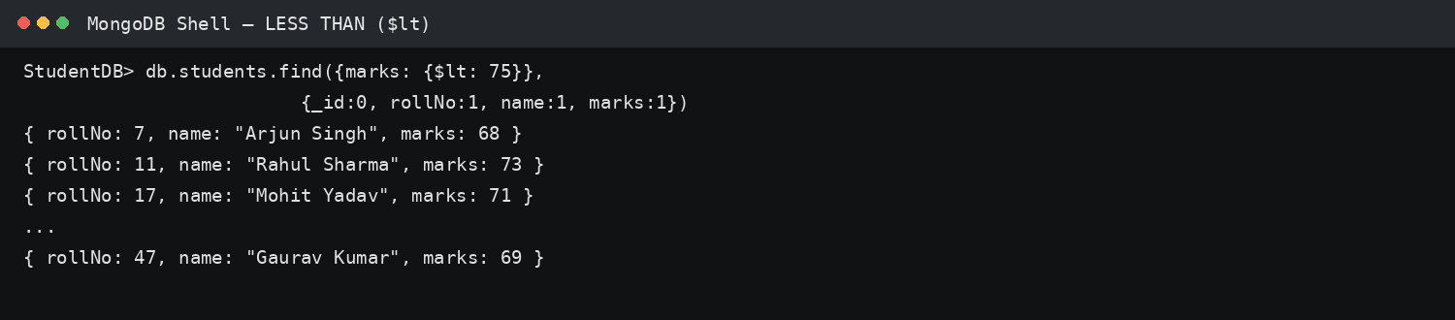
MongoDB Shell output screenshot

7. UPDATE ONE — updateOne()
MongoDB Command
db.students.updateOne(
{rollNo:1},
{$set:{marks:90}}
)
Explanation
updateOne() changes the first document that matches the filter. $set changes the value of the specified field without replacing the complete document. Here the marks of roll number 1 are changed to 90.
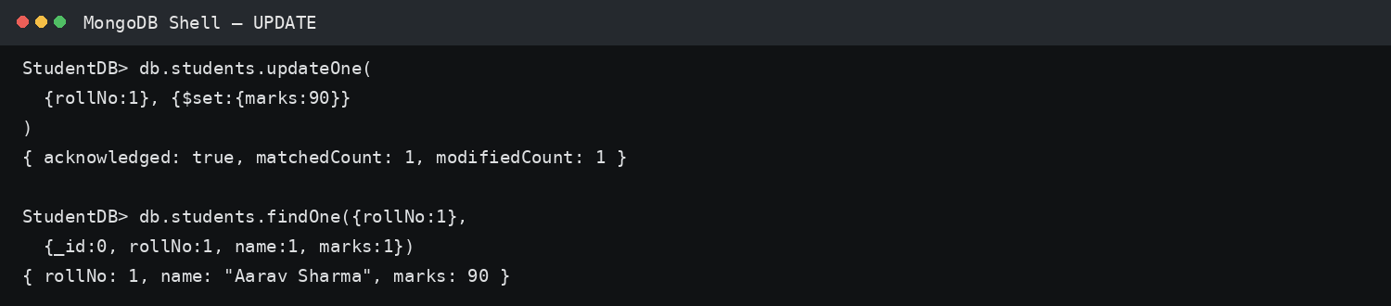
MongoDB Shell output screenshot

8. UPDATE MANY — updateMany()
MongoDB Command
db.students.updateMany(
{marks: {$lt: 75}},
{$inc:{marks:5}}
)
Explanation
updateMany() modifies every document that matches the condition. $inc increases a numeric field. Here, 5 marks are added to every student whose marks are below 75.
MongoDB Shell output screenshot

9. DELETE ONE — deleteOne()
MongoDB Command
db.students.deleteOne({rollNo:50})
Explanation
deleteOne() removes the first document matching the given condition. In this example, the student with roll number 50 is deleted. The result normally shows acknowledged: true and deletedCount: 1 when a matching document is found.
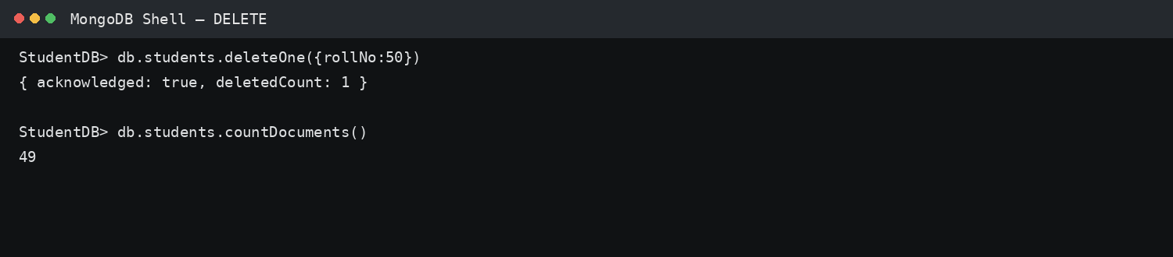
MongoDB Shell output screenshot

10. DELETE MANY — deleteMany()
MongoDB Command
db.students.deleteMany({marks: {$lt: 40}})
Explanation
deleteMany() removes all documents that satisfy the condition. The example removes every student whose marks are below 40. It is different from deleteOne() because multiple matching documents can be removed.
MongoDB Shell output screenshot

11. SORT — sort()
MongoDB Command
db.students.find(
{},
{_id:0,name:1,marks:1}
).sort({marks:-1})
Explanation
sort() arranges query results. The value 1 means ascending order and -1 means descending order. Here, students are arranged from highest marks to lowest marks.
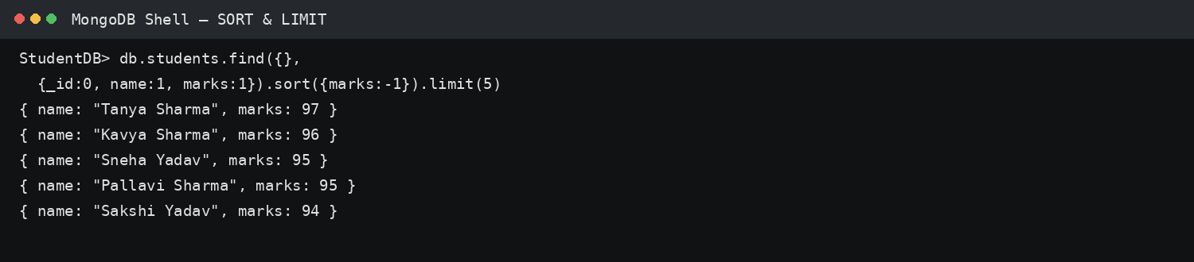
MongoDB Shell output screenshot

12. COUNT — countDocuments()
MongoDB Command
db.students.countDocuments()
db.students.countDocuments({city:"Lucknow"})
Explanation
countDocuments() returns the number of documents matching a query. The first command counts all students. The second counts only students whose city is Lucknow.
MongoDB Shell output screenshot

13. PROJECTION
MongoDB Command
db.students.find(
{},
{_id:0, name:1, marks:1}
)
Explanation
Projection controls which fields are displayed in the result. A value of 1 includes a field and a value of 0 excludes it. This example displays only name and marks and hides the automatically generated _id field.
MongoDB Shell output screenshot

14. LIMIT — limit()
MongoDB Command
db.students.find().limit(10)
Explanation
limit() restricts the number of documents returned by a query. The command above displays only the first 10 documents. It is useful when a collection contains many records and only a small sample is required.
MongoDB Shell output screenshot

IMPORTANT COMPARISON OPERATORS
Operator | Meaning | Example
$eq | Equal to | marks: {$eq: 90}
$gt | Greater than | marks: {$gt: 90}
$gte | Greater than or equal to | marks: {$gte: 90}
$lt | Less than | marks: {$lt: 75}
$lte | Less than or equal to | marks: {$lte: 75}
$ne | Not equal to | city: {$ne: "Lucknow"}

CONCLUSION
This project gave practical experience with MongoDB and the basic working of a NoSQL database. A StudentDB database and students collection were created, and 50 student records were inserted. Different operations were then performed to understand how data can be read, filtered, modified, removed and organized.
The use of comparison operators such as $eq, $gt and $lt showed how MongoDB can retrieve records according to specific conditions. updateOne(), updateMany(), deleteOne() and deleteMany() demonstrated how existing data can be changed or removed. Sorting, counting, projection and limit operations further showed how query results can be controlled.
Overall, this project improved my understanding of CRUD operations and MongoDB query syntax. It also demonstrated how a student database can be managed efficiently using a NoSQL document database.

