Module-8, :- Theory

Python – Advance Python Programming

**Q1. Introduction to the print() function in Python**

* print() is used to display output on the screen.



**Q2. Formatting outputs using f-strings and format()**

* 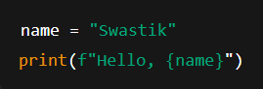**f-strings** (fast & easy):
* **format() method**:

**Q3. Using the input() function**

* 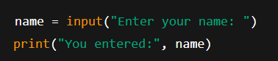Reads data from the keyboard as a **string**.

**Q4. Converting user input into different data types**

* 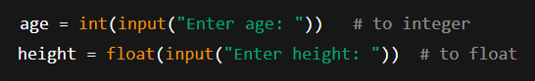Since input() gives a string, we convert it.

**Q5. Opening files in different modes**

* 'r' → read
* 'w' → write (overwrite)
* 'a' → append
* 'r+' → read & write
* 'w+' → write & read (overwrites)

**Q6. Using the open() function**



**Q7. Closing files using close()**

**Q8. Reading from a file**

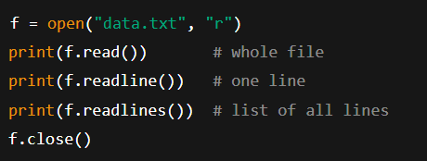

**Q9. Writing to a file**

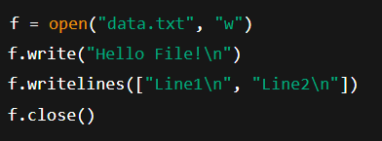

**Q10. Introduction to Exceptions (try, except, finally)**

* Exception = error during runtime.

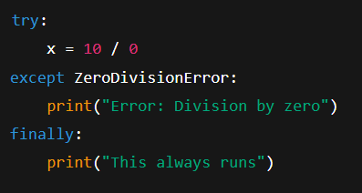

**Q11. Multiple and Custom Exceptions**

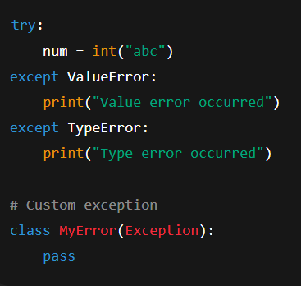

**Q12. Classes, Objects, Attributes, Methods**

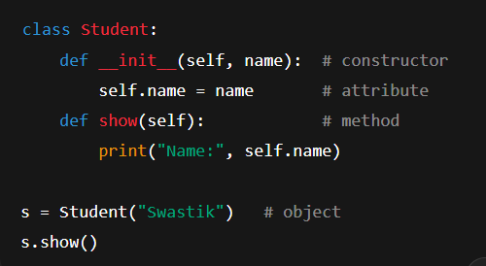

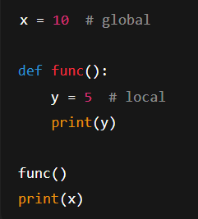**Q13. Local vs Global Variables**

**Q14. Types of Inheritance**

* **Single** → one parent → one child
* **Multilevel** → grandparent → parent → child
* **Multiple** → child inherits from multiple parents
* **Hierarchical** → one parent → many children
* **Hybrid** → combination

**Q15. Using super() function**

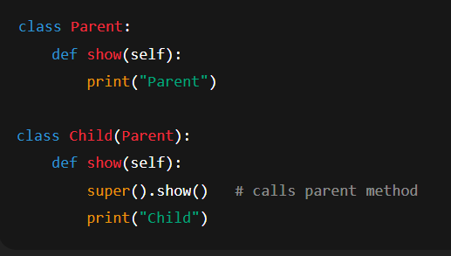

**Q16. Method Overloading *(Not direct in Python, done using default args)***

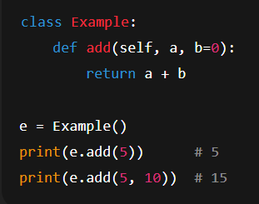

**Q17. Method Overriding**

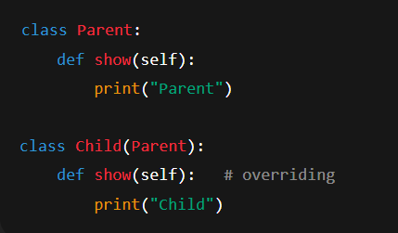

**Q18. SQLite3 and PyMySQL**

* **SQLite3** → built-in lightweight DB.
* **PyMySQL** → external library to connect Python with MySQL DB.

**Q19. Executing SQL Queries**

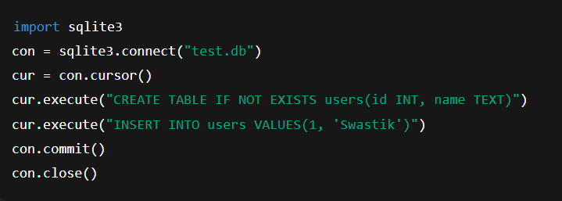

**Q20. re.search() and re.match()**

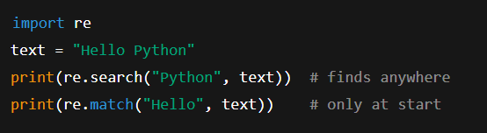

**Q21. Difference between search and match**

* **match()** → checks only at **beginning** of string.
* **search()** → scans **entire string** for pattern.