**Swastik infixtopostfix**

#include<stdio.h>

#include<string.h>

int ind=0,pos=0,top=-1,length;

char symbol,temp,infix[20],postfix[20],stack[20];

void infixtopostfix();

void push(char);

char pop();

int pred(char symbol);

int main()

{

printf("Enter infix expression\n");

scanf("%s",infix);

infixtopostfix();

printf("\ninfix expression %s",infix);

printf("\npostfix expression %s",postfix);

}

void infixtopostfix()

{

length=strlen(infix);

push('#');

while(ind<length)

{

symbol=infix[ind];

switch(symbol)

{

case '(': push(symbol);

break;

case ')': temp=pop();

while(temp!='(')

{

postfix[pos]=temp;

pos++;

temp=pop();

}

break;

case'+':

case'-':

case'*':

case'/':

case'^': while(pred(stack[top])>=pred(symbol))

{

temp=pop();

postfix[pos++]=temp;

}

push(symbol);

break;

default: postfix[pos++]=symbol;

}

ind++;

}

while(top>0)

{

temp=pop();

postfix[pos++]=temp;

}

}

void push(char symbol)

{

top=top+1;

stack[top]=symbol;

}

char pop()

{

char symb ;

symb=stack[top];

top=top-1;

return(symb);

}

int pred(char symbol)

{

int p;

switch(symbol)

{

case'^':p=3;

break;

case'*':

case'/':p=2;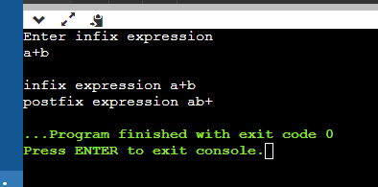

break;

case'+':

case'-':p=1;

break;

case'(':p=0;

break;

case'#':p=-1;

break;

}

return(p);

}