

NCAssure USER MANUAL
AI-Powered QA Intelligence Platform
NCAssure QA Portal — End User Guide
Document Version: 1.0
Issue Date: August 28, 2026
Application URL: https://ncqaportal.azurewebsites.net/
Classification: Internal Use Only — Nathcorp Confidential

Document Control

Version History
Version | Date | Author | Description
1.0 | 28-Aug-2026 | QA Documentation Team | NCAssure User Manual covering Dashboard, Release Build, Release Notes, AI Orchestration, Build History and Sign-off History. Approving Builds (DevManager/Admin), Requesting a QA Sign-off (QAEngineer), Approving Sign-offs (QAManager/Admin), Knowledge Base, and Tester Assignment (QAManager/Admin) sections.

Distribution
This document is intended for internal circulation to all NCAssure users within Nathcorp Inc., including Development Engineers, Development Managers, QA Engineers, QA Managers, Administrators, and general portal users.

Related Application
Item | Details
Application Name | NCAssure — QA Portal
Owner | Nathcorp Inc.
Portal URL | https://ncqaportal.azurewebsites.net/
Authentication | Sign-in via Microsoft (Enterprise SSO)

Table of Contents
1. Introduction 5
1.1 About NCAssure 5
1.2 Purpose of This Manual 5
1.3 Intended Audience 5
2. Getting Started 5
2.1 Accessing the Portal 5
2.2 Signing In 6
3. User Roles and Permissions 7
4. Dashboard 8
4.1 Left Navigation Sidebar 8
4.2 Top Navigation Bar 8
4.3 Recent QA Releases and Build Details 9
4.4 Overall Project Progress 9
4.5 Status Distribution 9
4.6 Project's Bugs Activity 10
4.7 Build Confidence Score 10
4.8 Daily Bug Status 10
4.9 Central Repository 10
5. Release Build 11
5.1 Completing the Release Build Form 11
5.2 Generating a Release Note 12
5.3 Submitting for Approval 12
5.4 Dev–QA Release Workflow 12
6. Creating a Release Note 13
6.1 Current Build Details 13
6.2 Build Overview 13
6.3 QA Scope 13
6.4 Testing Types (In / Out of Scope) 14
6.5 Work Items Summary (Resolved Bugs + Active Issues) 14
6.6 Impact Summary 14
6.7 Dependencies and Configuration Notes / Steps for Testing 14
6.8 Risks and Mitigation 14
6.9 Generating the Document 15
7. Approving Builds (DevManager / Admin) 16
7.1 Reviewing a Pending Build 16
7.2 Approve or Reject 17
8. AI Orchestration 18
8.1 Filters 18
8.2 Summary Cards 18
8.3 Bugs by Feature (AI) 18
8.4 AI Insights 18
9. Requesting a QA Sign-off (QAEngineer) 19
9.1 Status Banners 19
9.2 Sign Off Document Details 19
9.3 Build Details 20
10. Approving Sign-offs (QAManager / Admin) 21
11. Knowledge Base 22
11.1 Adding a Reference 22
11.2 Finding a Reference 22
12. Build History and Sign-off History 23
12.1 Build History 23
12.2 Sign-off History 24
12.3 Assigning a Tester (QAManager / Admin) 25
13. Profile and Notifications 28
13.1 Viewing Your Profile 28
13.2 Notifications 28
14. Signing Out 29
15. Appendix: Areas Not Yet Covered 30
16. Support and Assistance 31

1. Introduction

1.1 About NCAssure
NCAssure is Nathcorp's AI-powered Quality Assurance (QA) intelligence platform, also referred to internally as the “QA Portal.” It centralizes the software release lifecycle — from build submission and approval, through QA testing and formal sign-off — while layering AI-driven analytics on top of bug and release data to help teams identify risk and quality trends earlier.
The platform's key capabilities include:
- QA Analytics Dashboard — a real-time view of releases, bugs, tasks, and project health.
- Build Confidence Score — an at-a-glance quality/readiness indicator for a release.
- AI-Driven Insights — automated, narrative analysis of defect trends and high-risk features.
- Smart Build Releases — a structured workflow for submitting and approving builds.
- Automated Sign-offs — a formal QA sign-off workflow with full audit history.
- ADO Integration — connectivity with Azure DevOps for work item and build tracking.
- Teams Notifications — release and workflow alerts delivered to Microsoft Teams.

1.2 Purpose of This Manual
This manual explains how to access NCAssure and how to use each area of the portal: the Dashboard, Release Build, Release Note generation, AI Orchestration, Build History, Sign-off History, and account features such as Profile and Notifications. It is intended to help new and existing users navigate the application confidently and consistently.

1.3 Intended Audience
This manual is written for all internal NCAssure users at Nathcorp Inc., including Development Engineers, Development Managers, QA Engineers, QA Managers, Administrators, and general/default users. Screens and actions that are restricted to a specific role are labelled accordingly throughout this document.

2. Getting Started

2.1 Accessing the Portal
NCAssure is accessed through a standard web browser at the following internal URL:
https://ncqaportal.azurewebsites.net/
Note: No separate NCAssure account or password is required. Access is managed centrally through your organizational Microsoft account.

2.2 Signing In
NCAssure uses Microsoft Single Sign-On (SSO) for authentication, so users sign in with their existing Nathcorp organizational credentials.
To sign in:
- Navigate to https://ncqaportal.azurewebsites.net/ in your browser.
- On the welcome screen, select Sign in.
- Enter your organizational Microsoft email address and password when prompted, and complete multi-factor authentication (MFA) if requested.
- You will be redirected to the NCAssure Dashboard once authentication succeeds.
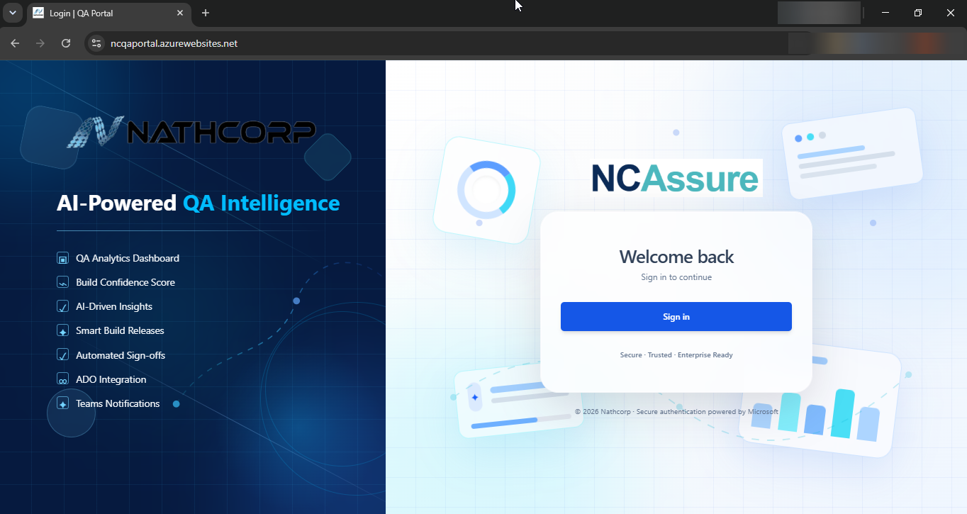
Figure 1: NCAssure sign-in page (Microsoft SSO).

3. User Roles and Permissions
NCAssure supports six user roles. Your assigned role determines which sidebar sections and actions are visible to you. Your current role is always shown on your Profile card (see Section 13.1).
Role | Typical Responsibility in NCAssure
DEVENGINEER | Submits new builds for release via the Release Build form and generates release notes (Sections 5–6).
DEVMANAGER | Reviews build requests submitted by Development Engineers and approves or rejects them via the Approve Builds screen (Section 7), before release to QA. See also the Dev–QA Release Workflow (Section 5.4).
QAENGINEER | Receives approved builds for testing, performs QA validation, and submits a formal sign-off request via the Sign Offs screen (Section 9). Can also reference the Knowledge Base (Section 11).
QAMANAGER | Reviews and approves or rejects sign-off requests via the Approve Sign Offs screen (Section 10). Can also assign testers to a build and edit build/testing details from Build History (Section 12.3).
ADMIN | Shares the Approve Builds (Section 7) and Approve Sign Offs (Section 10) screens with Development Managers and QA Managers respectively, and is expected to hold broader administrative privileges such as user and role management (not yet documented — see Appendix).
DEFAULTUSER | General/baseline access to the portal, primarily for viewing dashboards and reports (not yet documented — see Appendix).
Scope Note: This edition of the manual covers the DevEngineer, DevManager, QAEngineer, and QAManager perspectives — including build submission, build approval, QA sign-off request and review, tester assignment, and the shared Knowledge Base.

4. Dashboard
The Dashboard is the landing page after sign-in and gives a consolidated view of recent releases, project health, bug trends, and quality metrics.
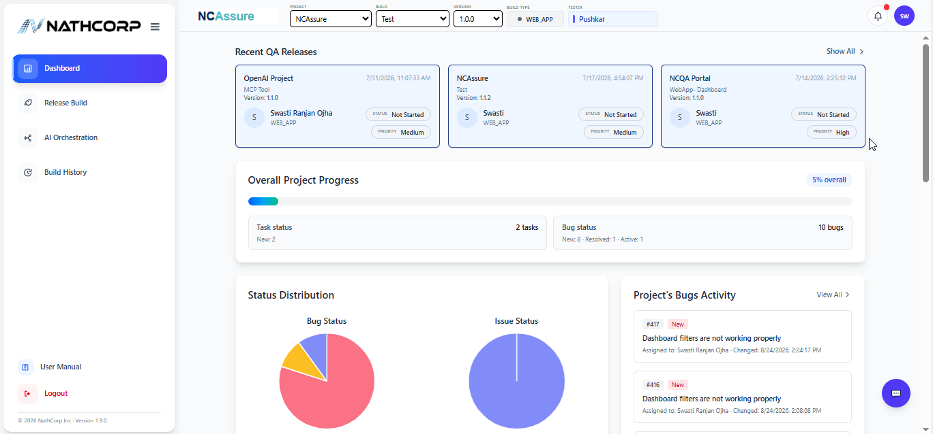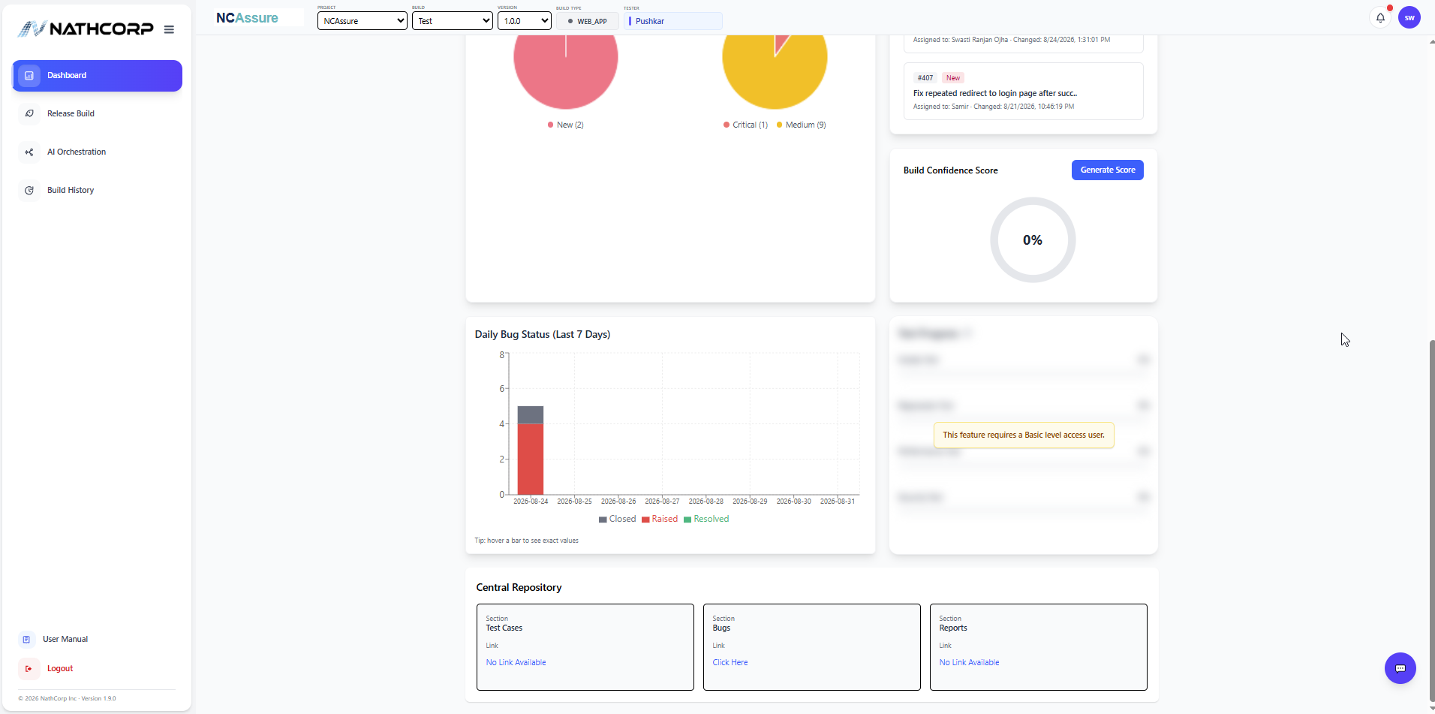
Figure 2: NCAssure Dashboard.

4.1 Left Navigation Sidebar
The sidebar on the left is present on every screen and provides access to the main modules. Its contents adjust based on your assigned role (see Section 3):
- Dashboard — the home/overview screen described in this section. (All roles.)
- Release Build — submit a new build for approval (Section 5). DevEngineer only.
- Approve Builds — review and approve/reject pending build requests (Section 7). DevManager and Admin only.
- AI Orchestration — AI-driven bug trend analysis (Section 8). All roles.
- Sign Offs — submit a formal QA sign-off request (Section 9). QAEngineer only.
- Approve Sign Offs — review and approve/reject pending sign-off requests (Section 10). QAManager and Admin only.
- Knowledge Base — shared reference library (Section 11). QAEngineer, QAManager, and Admin.
- Build History — build and sign-off history and audit trail (Section 12). All roles.
- User Manual — opens the in-app reference guide. (All roles.)
- Logout — signs you out of NCAssure (Section 14). (All roles.)

4.2 Top Navigation Bar
At the top of every screen you can filter the data shown by Project, Build, Version using the drop-down selectors. The bell icon opens Notifications and the circular avatar opens your Profile card (see Section 13).

4.3 Recent QA Releases and Build Details
The Recent QA Releases panel lists the latest builds as cards, each showing the project name, build name, version, release date/time, and the release status. Select Show All to view the complete list.
Selecting any release card opens a Build Details window with the full record for that release:
- Project, Build Name, Version
- Released By and Date
- Build Type
- Description
- Build URL — link to the build artifact/pipeline
- Release Notes URL — link to the generated release note
Select Close to return to the Dashboard.
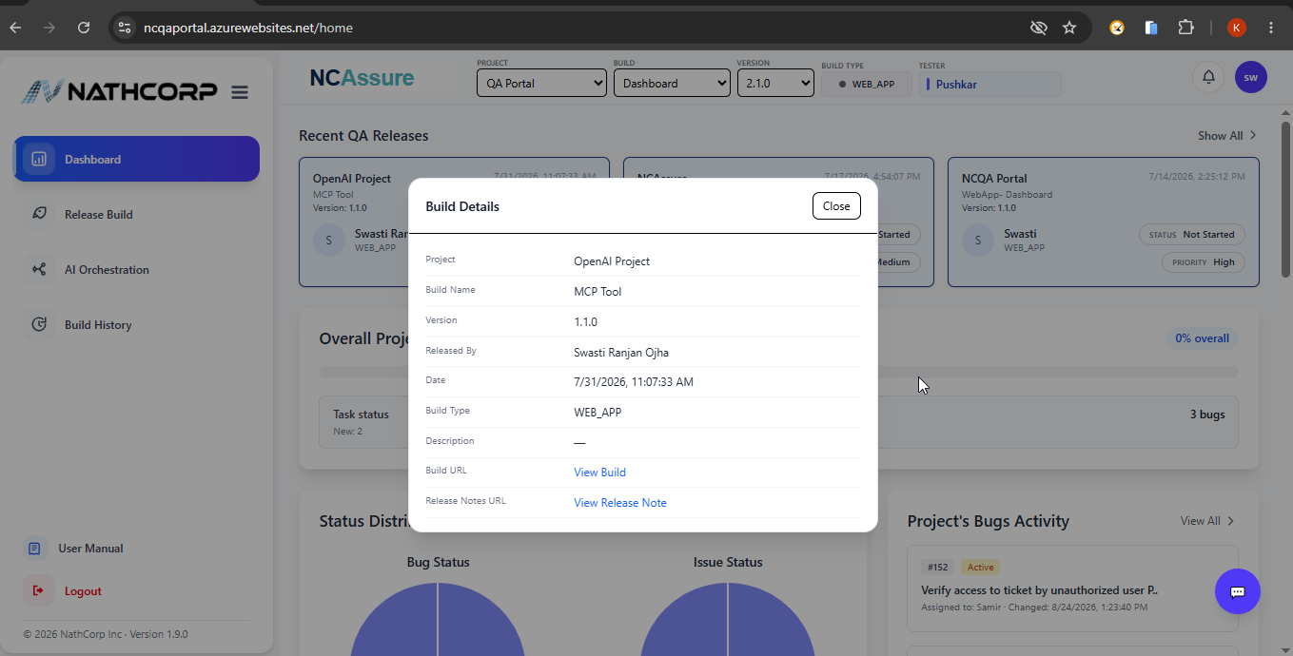
Figure 3: Build Details window, opened from a Recent QA Releases card.

4.4 Overall Project Progress
This panel summarizes task status and bug counts for the selected project, giving a quick read on how much work remains open.

4.5 Status Distribution
Four donut charts break down the current data set by Bug Status, Issue Status, Task Status, and Bug Severity Status, so you can see at a glance how work is distributed across categories and severities.

4.6 Project's Bugs Activity
A live feed of the most recent bug activity for the project, including the bug ID, current status, title, assignee, and last-changed timestamp. Select View All to see the full DevOps activity.

4.7 Build Confidence Score
A calculated score (0–100%) that reflects the overall quality/readiness of the current build based on testing coverage and open defects. Select Recalculate Score to refresh the value after new data (bugs, test results) becomes available.

4.8 Daily Bug Status
A rolling 7-day view of bug activity, useful for spotting spikes in new defects or tracking closure trends leading up to a release.

4.9 Central Repository
Quick-access cards linking to the project's Test Cases, Bugs, and Reports repositories.

5. Release Build
Role-Restricted: The Release Build section is visible only to users with the DEVENGINEER role.
Use the Release Build screen to submit a completed build for formal approval and to generate its accompanying release note.
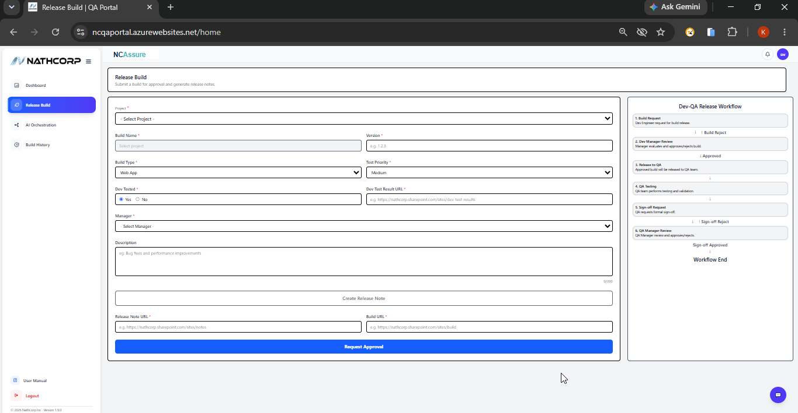
Figure 4: Release Build form.

5.1 Completing the Release Build Form
Field | Description
Project * | Select the project this build belongs to.
Build Name * | The name of the build/component being released.
Version * | Version number of the build, e.g. 1.2.3.
Build Type * | The type of build, e.g. Web App.
Test Priority * | Priority assigned to QA testing for this build (e.g. Medium).
Dev Tested * | Indicates whether the developer has already tested the build (Yes/No).
Dev Test Result URL * | Link to the developer's test evidence (e.g. a SharePoint page).
Manager * | The Development Manager who will review and approve the build.
Description | Optional free-text notes, e.g. summary of bug fixes or improvements (0/200 characters).
Release Note URL * | Link to the release note for this build (generated in Section 6, or pasted manually).
Build URL * | Link to the build artifact or pipeline.
Fields marked with an asterisk (*) are mandatory.

5.2 Generating a Release Note
Select Create Release Note to open the Release Note builder described in Section 6. Once the release note is generated, its link can be pasted into the Release Note URL field above.

5.3 Submitting for Approval
After all required fields are completed, select Request Approval to submit the build into the Dev–QA Release Workflow.

5.4 Dev–QA Release Workflow
Every build submitted through Release Build progresses through the following six-stage workflow, shown alongside the form:
Stage | Description
1. Build Request | The Development Engineer requests a build release.
2. Dev Manager Review | The Development Manager evaluates the request and approves or rejects it. A rejection returns the build to stage 1 (Build Reject).
3. Release to QA | An approved build is released to the QA team.
4. QA Testing | The QA team performs testing and validation on the released build.
5. Sign-off Request | QA requests a formal sign-off once testing is complete.
6. QA Manager Review | The QA Manager reviews and approves or rejects the sign-off. A rejection returns the build to stage 5 (Sign-off Reject); an approval ends the workflow (Workflow End).

6. Creating a Release Note
The release note builder is opened from the Release Build screen via Create Release Note. It formally hands the build from Development to QA for validation, testing, and sign-off, and captures scope, risk, and impact details in one document.
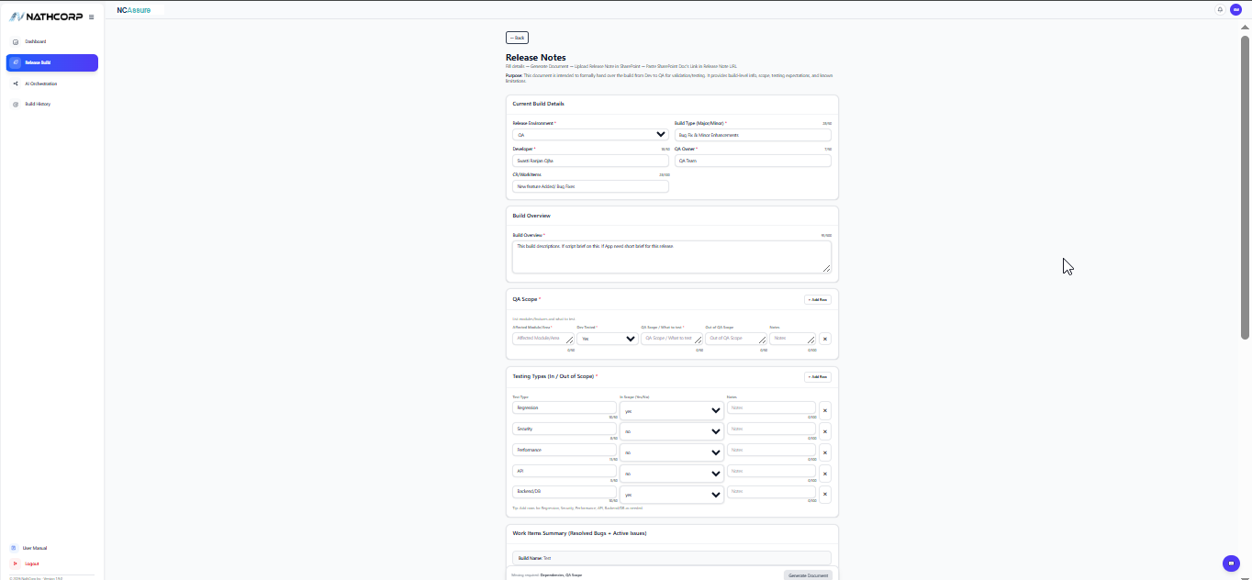
Figure 5: Release Note builder — Current Build Details, Build Overview, QA Scope, and Testing Types.

6.1 Current Build Details
Field | Description
Release Environment * | Target environment for the release, e.g. QA.
Build Type (Major/Minor) * | Classification of the release, e.g. Bug Fix & Minor Enhancements.
Developer * | Name of the developer who produced the build.
QA Owner * | QA team or individual responsible for validating the build.
CR / Work Items | Related change request or work item reference, e.g. “New Feature Addition / Bug Fixes.”

6.2 Build Overview
A free-text summary describing the build — a short, plain-language overview of what this release contains.

6.3 QA Scope
A row-based table (use + Add Row to add entries) capturing, for each affected module/area: whether it was dev-tested, what is in scope for QA to test, what is explicitly out of scope, and any additional notes.

6.4 Testing Types (In / Out of Scope)
Indicates which categories of testing apply to this release. The form is pre-populated with common test types — Regression, Security, Performance, API, and Backend/DB — each marked In Scope (Yes/No) with an optional note. Additional rows can be added as needed.
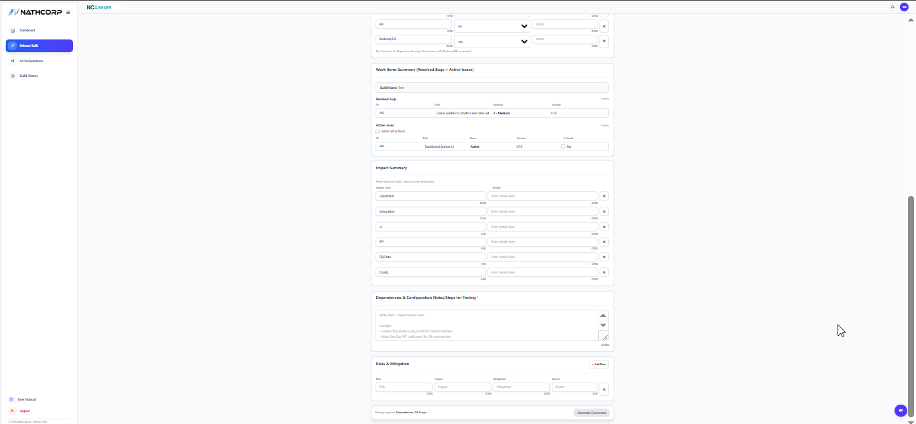
Figure 6: Release Note builder (continued) — Work Items Summary, Impact Summary, Dependencies, and Risks & Mitigation.

6.5 Work Items Summary (Resolved Bugs + Active Issues)
Automatically lists the Resolved Bugs (ID, Title, Severity, Version) and Active Issues (ID, Title, Status, Version) associated with the build name entered. Each active issue can be individually marked Is Fixed, or all issues can be marked at once using Select all as fixed.

6.6 Impact Summary
A row-based table for documenting the impact of the release across pre-listed areas — Functional, Integration, UI, API, DB/Data, and Config — with a details field for each.

6.7 Dependencies and Configuration Notes / Steps for Testing
A free-text area for listing any dependencies, feature flags, or configuration steps a tester needs to know before testing — for example, enabling a feature flag or configuring an Azure DevOps (ADO) connection.

6.8 Risks and Mitigation
A row-based table for logging known risks associated with the release, their impact, the mitigation plan, and the owner responsible.

6.9 Generating the Document
Once the required sections (at minimum, Dependencies and QA Scope) are completed, select Generate Document to produce the release note. Select Back at any time to return to the Release Build form without generating a document.

7. Approving Builds (DevManager / Admin)
Role-Restricted: The Approve Builds section is visible only to users with the DEVMANAGER or ADMIN role. Both roles see an identical screen.
Approve Builds lists every build that a Development Engineer has submitted through Release Build (Section 5) and is awaiting a decision.
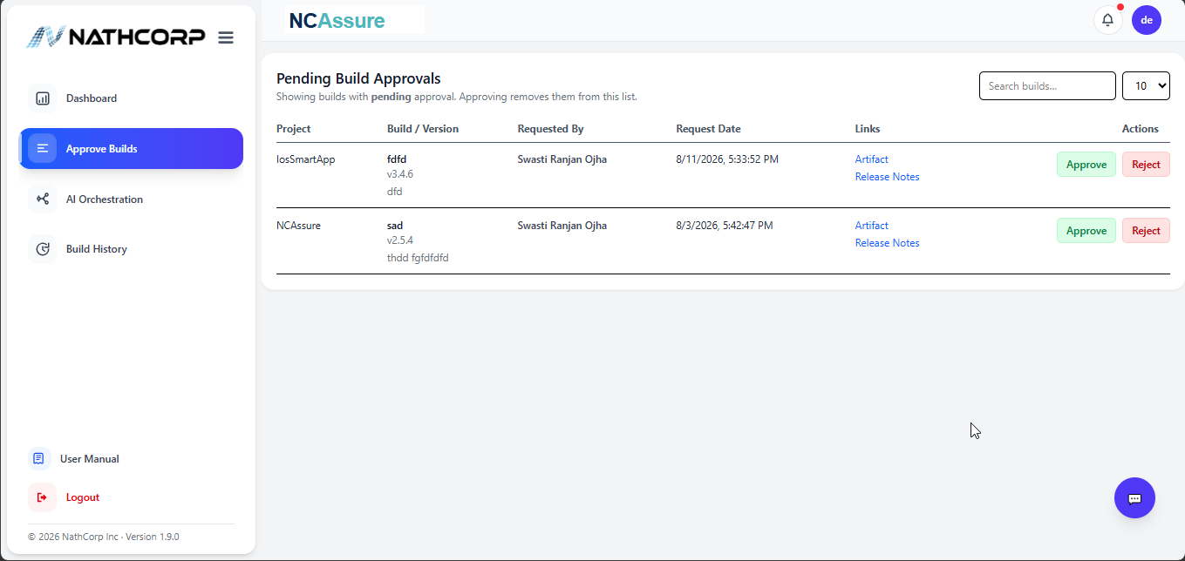
Figure 7: Pending Build Approvals screen.

7.1 Reviewing a Pending Build
The Pending Build Approvals table shows builds with a pending decision. Approving a build removes it from this list.
Column | Description
Project | The project the build belongs to.
Build / Version | Build name and version number.
Requested By | The Development Engineer who submitted the build.
Request Date | Date and time the approval request was submitted.
Links | Artifact and Release Notes links for review before deciding.
Actions | Approve or Reject buttons.
Use the Search builds field to locate a specific request, and the page-size selector (e.g. 10) to control how many rows are shown at once.

7.2 Approve or Reject
- Approve — the build is approved and immediately becomes visible to all users in Recent QA Releases on the Dashboard (Section 4.3), and its status is recorded as Approved in Build History (Section 12.1).
- Reject — the build is not shown in Recent QA Releases, but is still recorded in Build History with a status of Rejected, preserving a full audit trail.

8. AI Orchestration
AI Orchestration analyzes bugs for a selected project, build, and version to identify defect trends, highlight the most error-prone features, and surface AI-generated quality insights.
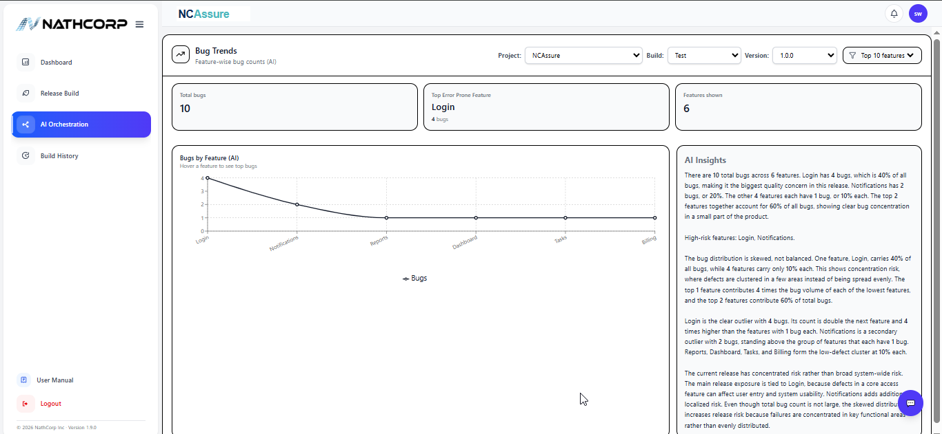
Figure 8: AI Orchestration — Bug Trends and AI Insights.

8.1 Filters
Use the Project, Build, and Version selectors at the top of the screen to choose the data set to analyze, and use the Top N Features filter to control how many features are included in the analysis (e.g. Top 10 Features).

8.2 Summary Cards
- Total Bugs — total defect count across the selected data set.
- Top Error-Prone Feature — the feature with the highest concentration of bugs.
- Features Shown — the number of features included in the current analysis.

8.3 Bugs by Feature (AI)
A trend chart plotting bug counts against application features. Hover over a point on the chart to see the top bugs for that feature.

8.4 AI Insights
A narrative panel that automatically interprets the chart data — for example, identifying which features carry a disproportionate share of defects, flagging concentration risk, and calling out high-risk features that may need additional attention before release.

9. Requesting a QA Sign-off (QAEngineer)
Role-Restricted: The Sign Offs section is visible only to users with the QAENGINEER role. Note that the sidebar for this role does not include Release Build or Approve Builds, but does include Knowledge Base (Section 11), which is shared with QAManager and Admin.
Once testing on an assigned build is complete, a QA Engineer uses Sign Offs to formally request sign-off from a QA Manager or Admin. The screen displays the process at the top: Fill details → Generate PDF → Upload to SharePoint → Paste link → Send Approval Request.
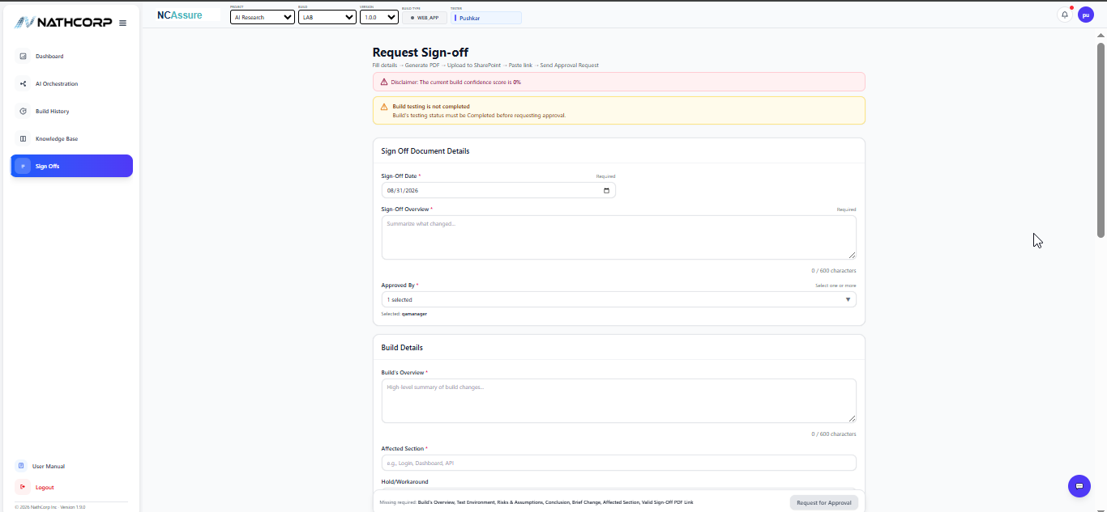
Figure 9: Request Sign-off form (top section).

9.1 Status Banners
Before filling in the form, NCAssure surfaces any blocking conditions at the top of the screen — for example, a low Build Confidence Score, or a warning that build testing is not yet marked Completed. These should be resolved (or acknowledged) before requesting approval.

9.2 Sign Off Document Details
Field | Description
Sign-Off Date * | Date of the sign-off request (defaults to today).
Sign-Off Overview * | Free-text summary of what changed in this build (600-character limit).
Approved By * | One or more approvers to route the request to, selected from a list (e.g. a QA Manager).

9.3 Build Details
Field | Description
Build's Overview * | High-level summary of what changed in the build (600-character limit).
Affected Section * | The area(s) of the application impacted, e.g. Login, Dashboard, API.
Hold / Workaround | Any known holds or workarounds testers should be aware of.
Note: The remaining fields further down this form — Test Environment, Risks & Assumptions, Conclusion, Brief Change, and the Sign-off PDF Link — along with the Request for Approval button, are referenced in the form's own validation message but have not been captured in this manual.

10. Approving Sign-offs (QAManager / Admin)
Role-Restricted: The Approve Sign Offs section is visible only to users with the QAMANAGER or ADMIN role. Both roles see an identical screen.
Approve Sign Offs lists sign-off requests submitted by QA Engineers through the Sign Offs screen (Section 9) that are awaiting a decision.
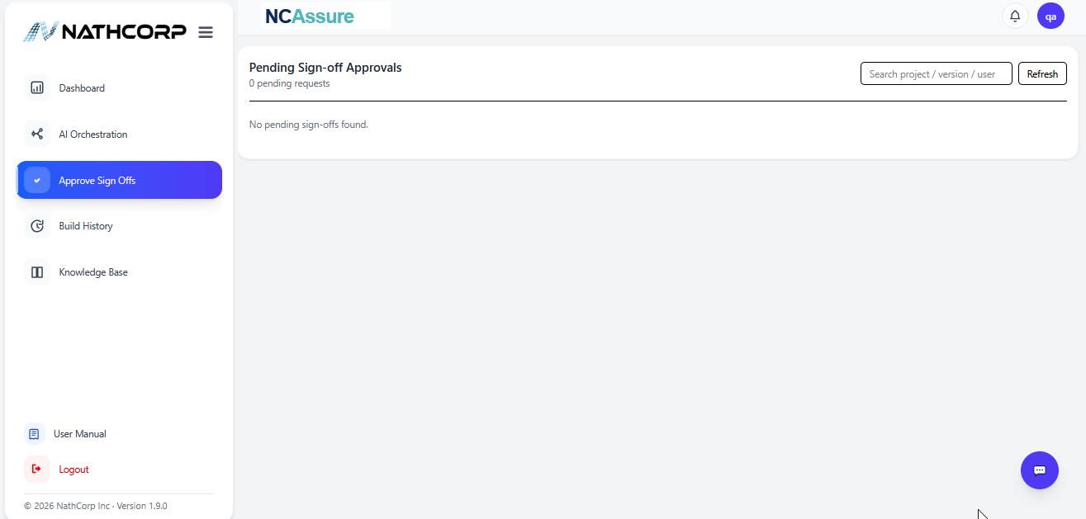
Figure 10: Pending Sign-off Approvals screen (empty state).
The Pending Sign-off Approvals table can be searched by project, version, or user, and refreshed using the Refresh button. When there is nothing awaiting review, the table displays “No pending sign-offs found.”
- Approve — the sign-off is approved and recorded with an Approved status in the Sign-off History tab of Build History (Section 12.2), visible to all users.
- Reject — the sign-off is recorded with a Rejected status in the same Sign-off History tab, preserving a full audit trail.
Note: This screen was captured with no pending requests, so the populated table with its Approve/Reject buttons has not been documented.

11. Knowledge Base
Role-Restricted: The Knowledge Base section is visible to users with the QAENGINEER, QAMANAGER, or ADMIN role.
Knowledge Base is a shared library of reference links — for example, test plans, environment guides, or process documents — that QA and management roles can build up over time.
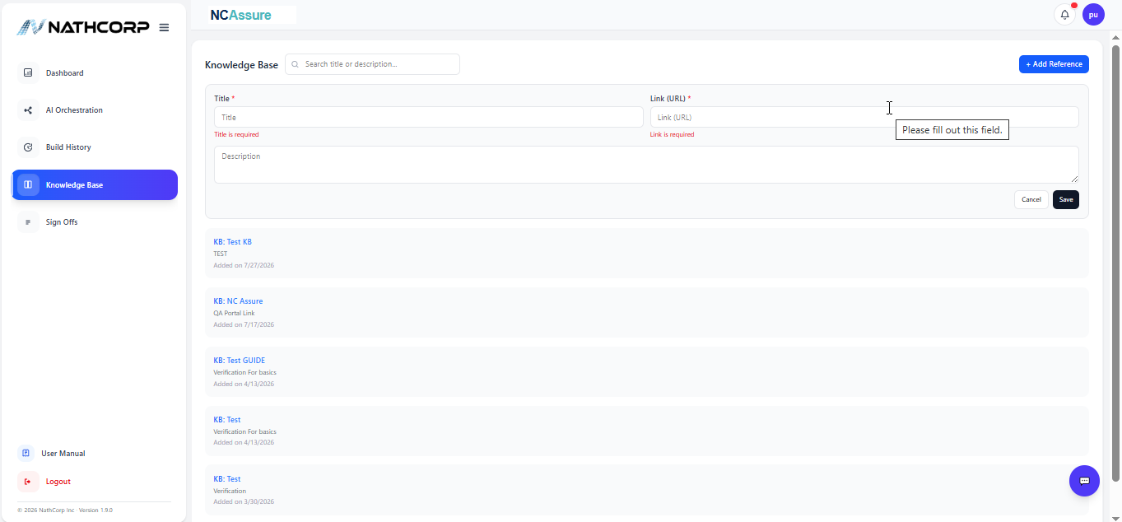
Figure 11: Knowledge Base.

11.1 Adding a Reference
Select + Add Reference to open an inline form:
Field | Description
Title * | Short name for the reference.
Link (URL) * | The web address the reference points to.
Description | Optional free-text notes about the reference.
Select Save to add the entry to the list below, or Cancel to discard it.

11.2 Finding a Reference
Use the Search title or description field at the top of the screen to filter the list. Each entry in the list shows its title (as a clickable link), description, and the date it was added.

12. Build History and Sign-off History
The History screen provides a full audit trail of releases, split across two tabs: Build History and Sign off History.

12.1 Build History
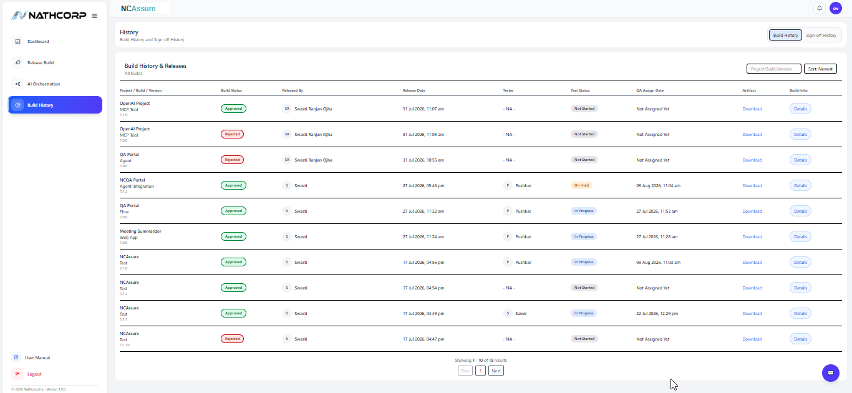
Figure 12: Build History tab.
The Build History table lists every submitted build with the following columns:
Column | Description
Project / Build / Version | Identifies the release.
Build Status | Approved or Rejected.
Released By | The Development Engineer who submitted the build.
Release Date | Date and time the build was released.
Tester | The QA tester assigned to the build, if any.
Test Status | Not Started, In Progress, or On Hold.
QA Assign Date | Date the build was assigned to QA, or “Not Assigned Yet.”
Artifact | Download link for the build artifact.
Build-Info | Select Details to expand additional information (see below), or Hide to collapse it again.
You can search by Project/Build/Version and sort the list (e.g. Sort Newest) using the controls above the table.
Selecting Details on a row expands it in place to reveal:
- Description and Reason
- Test Priority and Build Type
- Tester History
- Test Completion Date and Dev Test Result URL
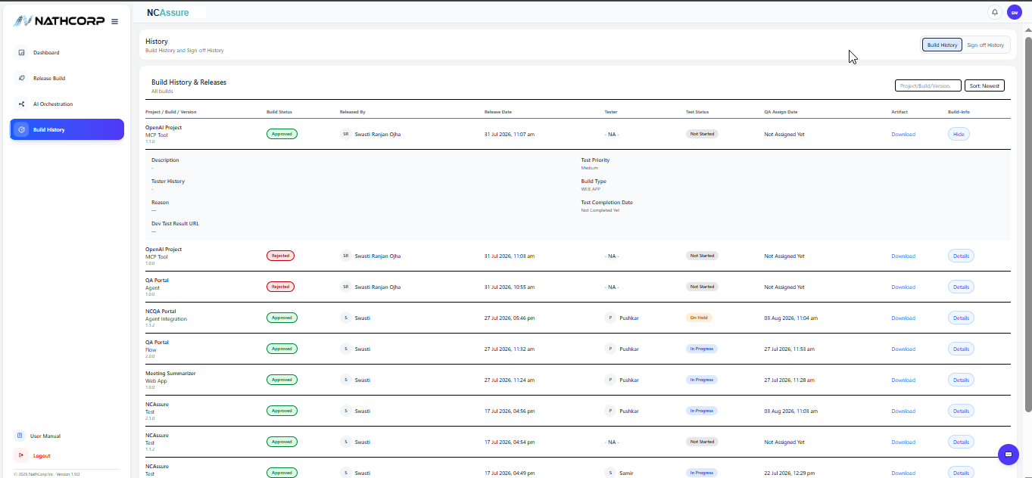
Figure 13: Build History — expanded row detail.

12.2 Sign-off History
Select the Sign off History tab to view the formal QA sign-off audit trail.
Column | Description
Project / Build / Version | Identifies the release.
Signoff Status | Approved or Rejected.
Tested By | The QA Engineer who performed testing.
Approved By | The QA Manager (or administrator) who approved or rejected the sign-off.
Approved Date | Date and time of the sign-off decision.
Signoff URL | Select Open to view the sign-off record.
Signoff-Info | Select Details to expand additional information (see below), or Hide to collapse it again.
Expanding Details on a sign-off row reveals linked reference documents:
- Description
- Risks & Assumptions
- Test Environment
- Conclusion
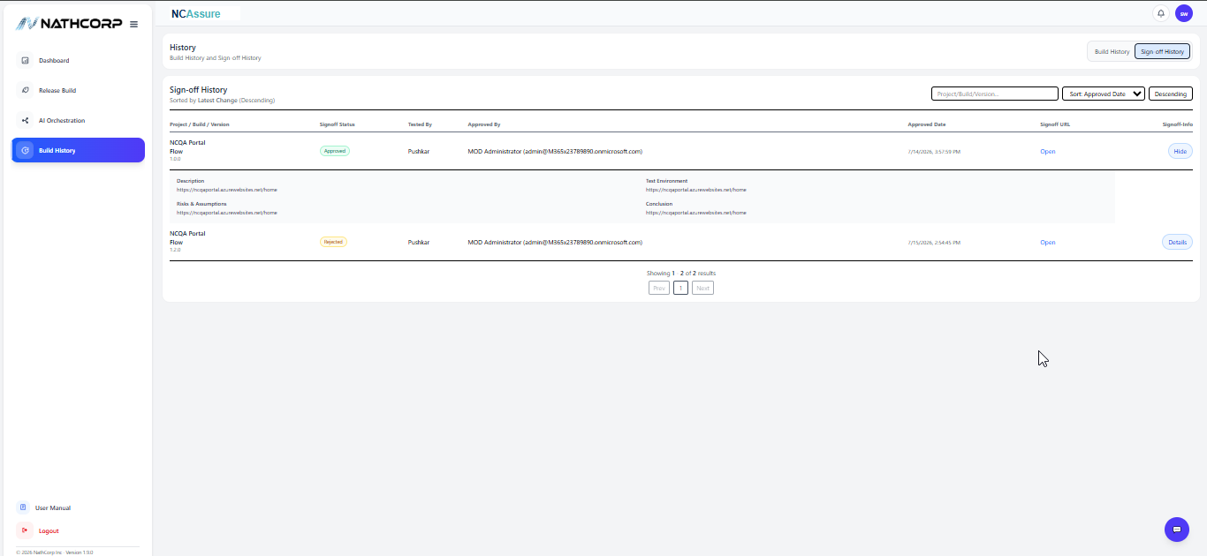
Figure 14: Sign-off History — expanded row detail.
Like Build History, results can be searched by Project/Build/Version and sorted (e.g. by Approved Date, Descending).

12.3 Assigning a Tester (QAManager / Admin)
Role-Restricted: Tester assignment and the Edit capability described below are available to users with the QAMANAGER or ADMIN role.
A QAManager (or Admin) can assign a tester to an approved build in two ways.

Method 1: From the Build Details Window
Open a build's card from Recent QA Releases on the Dashboard (Section 4.3). For these roles, the Build Details window includes an additional Tester field with a dropdown of available testers and a Save button.
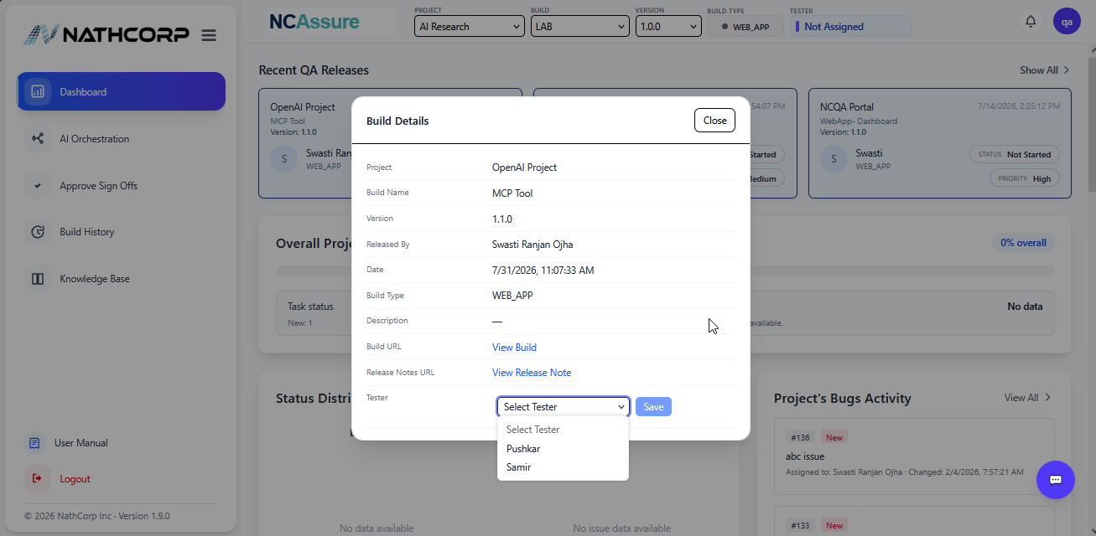
Figure 15: Build Details window — assigning a Tester.

Method 2: From Build History
For QAManager and Admin, the Build History table (Section 12.1) includes an additional Edit column not shown to other roles. Selecting Edit opens an Edit Build window:
Field | Description
Project / Version | Read-only identification of the build.
Build Name / Build Type | Read-only build details.
QA Assignee | Dropdown to assign or reassign the tester, shown with their name and email.
Testing Status | Dropdown to update testing progress, e.g. Not Started, In Progress, Completed.
Build URL / Release Note URL | Links associated with the build.
Description | Free-text notes (500-character limit).
Select Save Changes to apply the update, or Cancel to discard it.
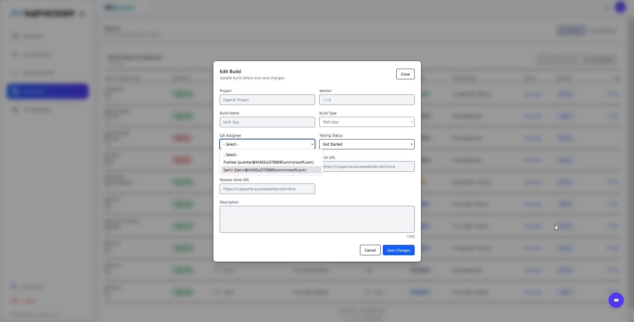
Figure 16: Edit Build window.
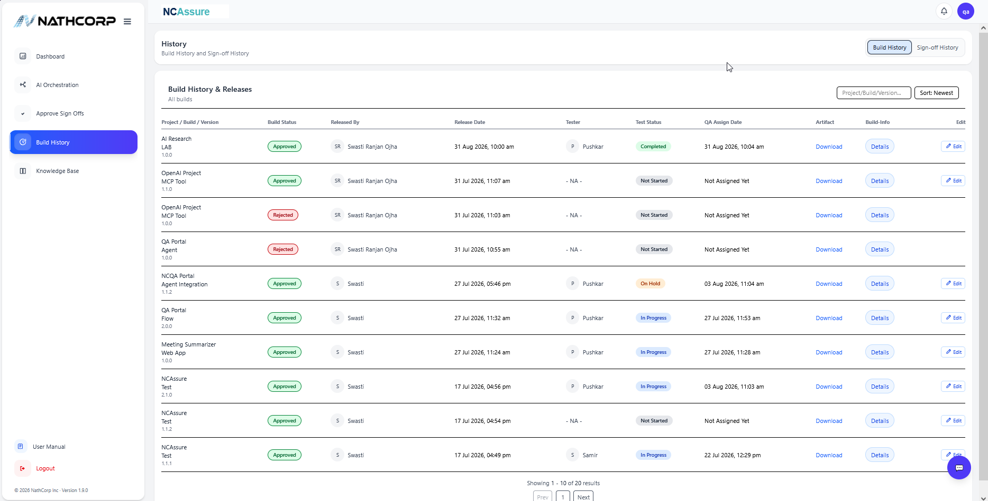
Figure 17: Build History with the Edit column, as seen by QAManager/Admin.

13. Profile and Notifications

13.1 Viewing Your Profile
Select the circular avatar in the top-right corner of any screen to open your Profile card. It displays your avatar initials, full name, assigned role (e.g. DEVENGINEER), and organizational email address. This is the quickest way to confirm which role you are currently signed in as.
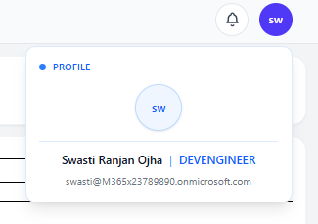
Figure 18: Profile card.

13.2 Notifications
Select the bell icon in the top-right corner to open the Notifications panel. New notifications (e.g. build approvals, sign-off requests) will appear here; if there is nothing to review, the panel displays “No notifications.” Select Close to dismiss the panel.
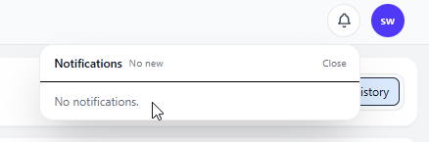
Figure 19: Notifications panel.

14. Signing Out
To end your session, select Logout at the bottom of the left sidebar. You will be returned to the NCAssure sign-in page.
Security Tip: Always sign out when using a shared or public computer to protect your organizational account.

15. Appendix: Areas Not Yet Covered
The following areas exist within the NCAssure workflow but are not yet fully captured in this edition of the manual. They are listed here so this document can be extended in a future revision:
Area | Applicable Role(s) | Status
User and role administration | ADMIN | Not documented

16. Support and Assistance
If you encounter an issue that is not covered in this manual, or if you notice unexpected behavior in NCAssure, contact your internal QA support channel or your Nathcorp system administrator.
An in-app reference is also available at any time via the User Manual link in the left sidebar.

Document Feedback
This manual is maintained by the QA Documentation Team. Suggestions, corrections, and additions (including screens from the DevManager, QA Engineer, QA Manager, and Admin roles) are welcome and will be incorporated in future revisions.

