**Experiment 5 : Terraform**

**Name : Swasti Jain**

**Roll No: 24**

**Aim**: To understand terraform lifecycle, core concepts/terminologies and install it on any

Machine. After that create a folder and a file with extension .tf. Mention the provider and resource in the .tf file as shown below .Before writing the provider get the access key and secret key from aws .Also you will have to get ami from aws

**Procedure:**

1) Install Terraform package and install it on your machine Link for terraform installation: :https://releases.hashicorp.com/terraform/1.2.7/terraform_1.2.7_wi ndows_amd64.zip 2)Make a folder named terraform and extract all the downloaded packages over there.

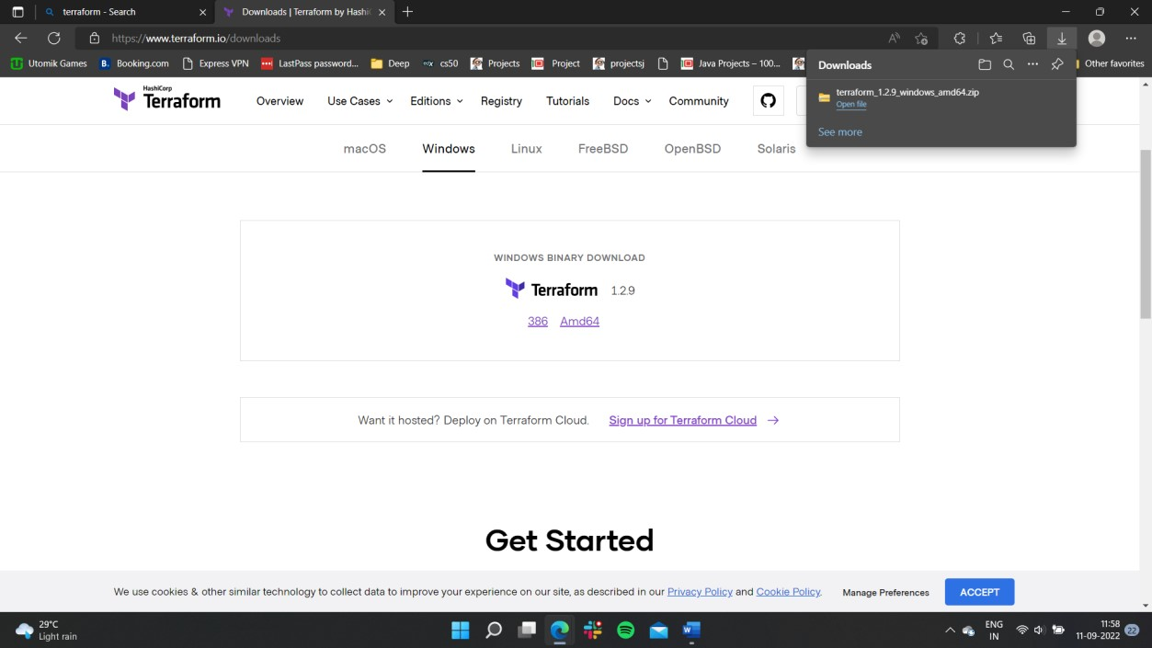

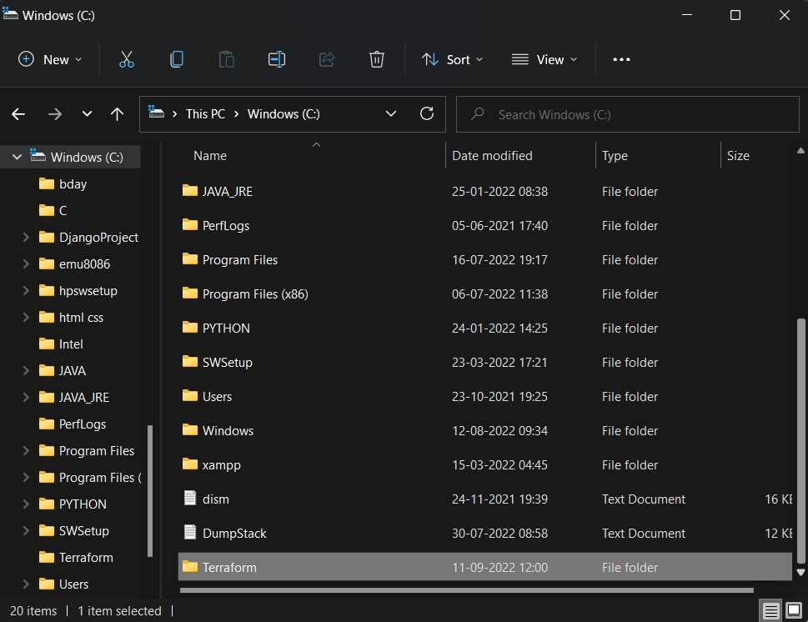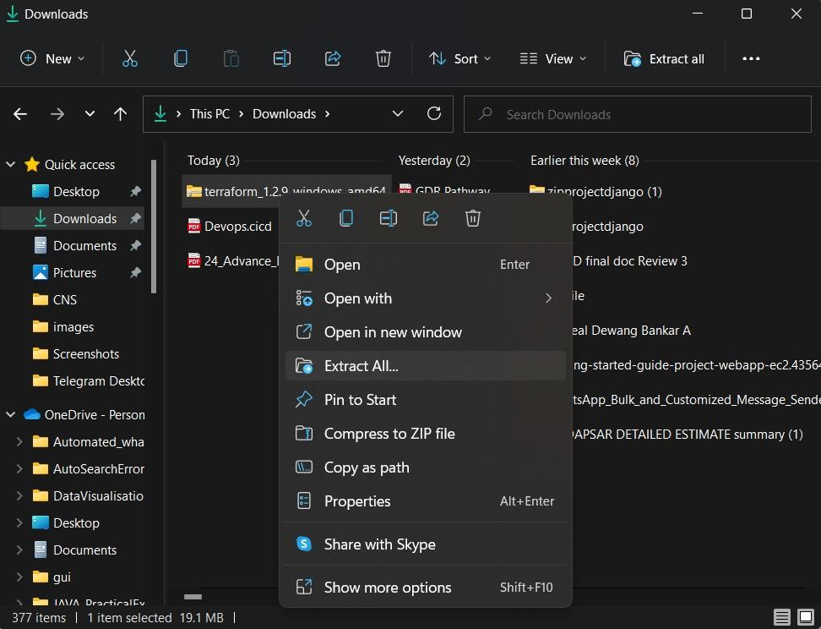

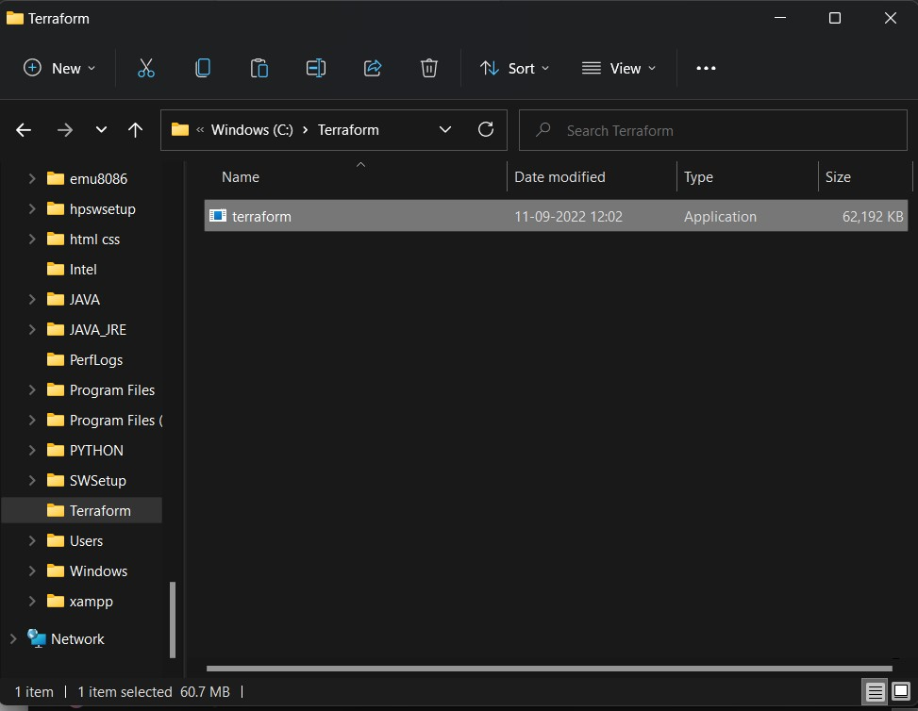

3)Now go to the environment variables and add path of the terraform folder

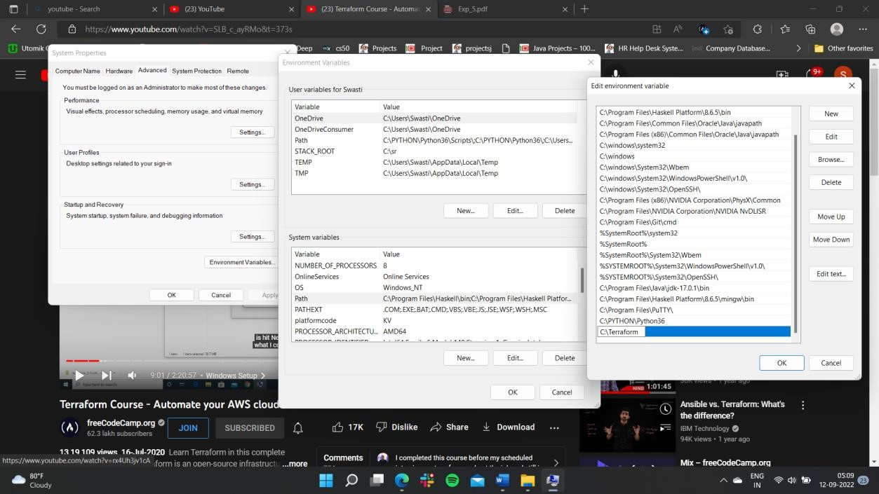

We have successfully configured terraform on our system.

1. Install the terraform extension in VScode

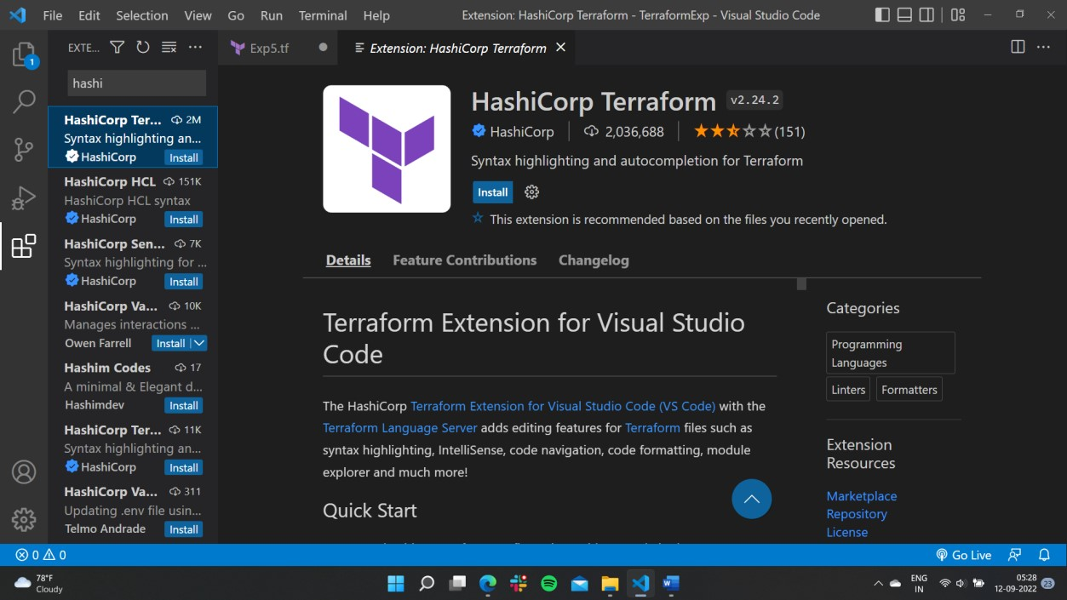

1. Open aws account, Go to Your account and click on security credentials

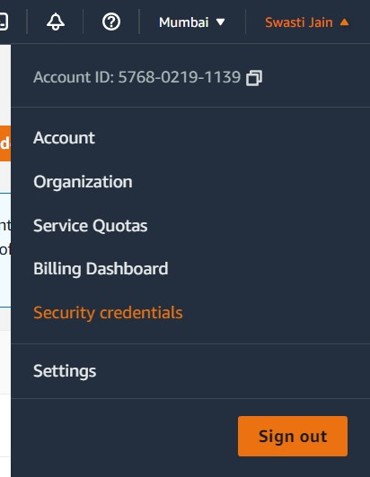

1. Click on Access key if you have a key you can use that only if you don’t have a key you have to create a new access key:

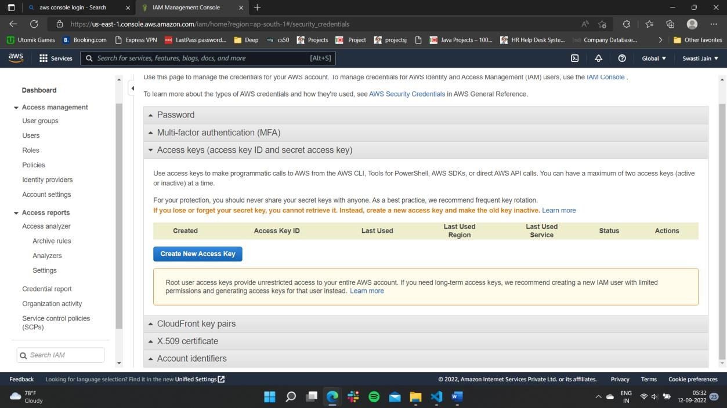

7)Create new access key and also download the root key folder

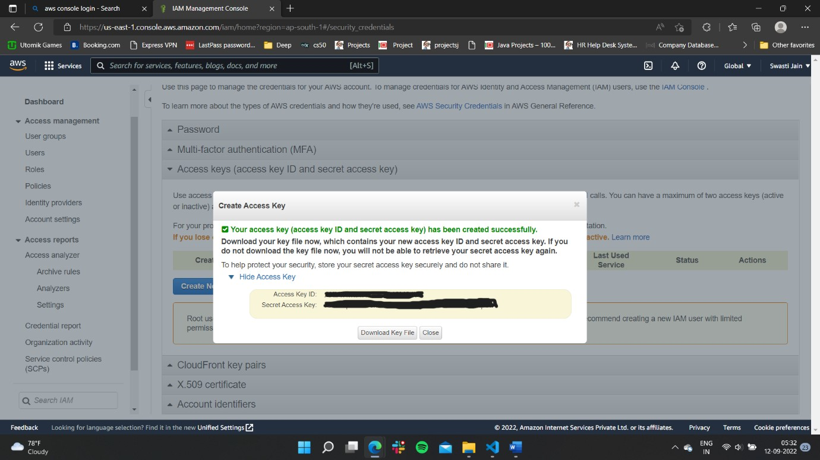

8)Create new folder named terraform and also create .tf file, Now add the code with the access key and secret key

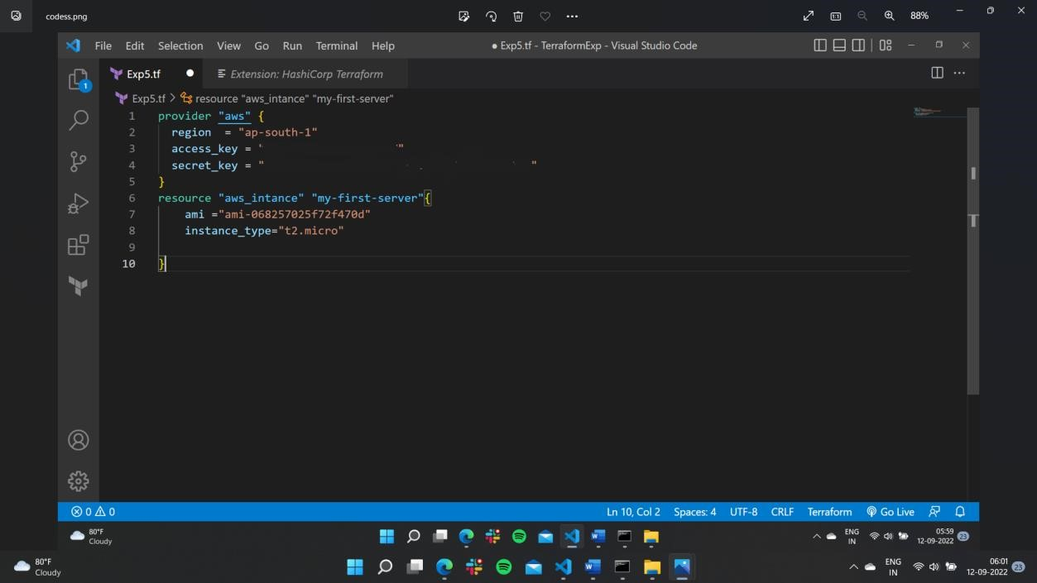

1. Add the key pair name

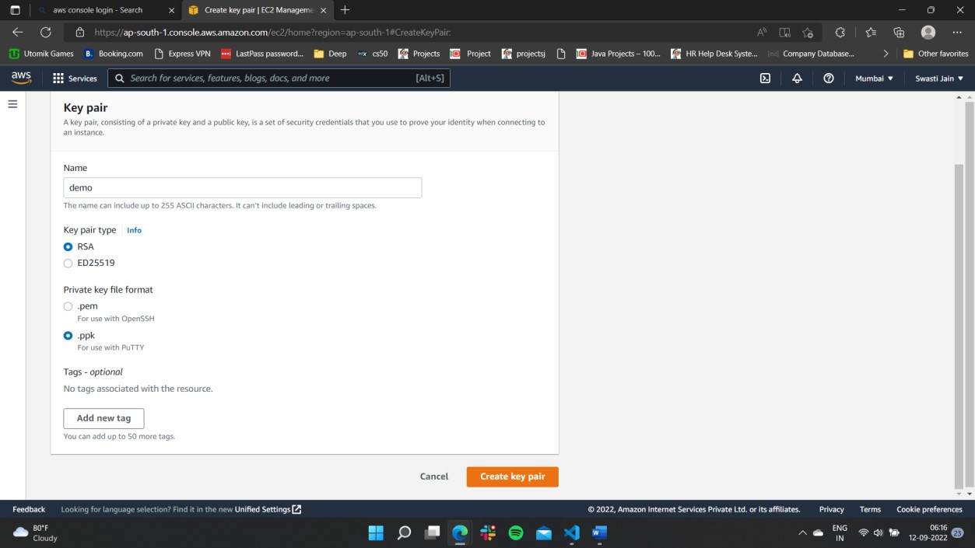

1. Now we have to initalize terraform

