Organization within a Document

Table of contents

Understanding headers and the navigation pane 1

Heading structure 2

Example heading use cases 2

Skills 3

Enable the navigation pane 3

Use the mouse/trackpad to create headings 3

Use the keyboard to create headings 3

Change format of all headers 4

Create a table of contents 5

Practice 7

Author: Ella Foster-Molina

This is a guide for organizing a document using headers and the navigation pane. This downloaded version lets you work with the skills in real time, but you can also see it [online](https://swat-ssql.github.io/organization-within-document/).

# Understanding headers and the navigation pane

A heading in writing is a title or subtitle used to introduce and organize sections of text. Headings:

* make the text easier to understand by acting as a signpost for the author and reader to guide them through the narrative,
* allow screen readers to guide a user through a document in an organized and efficient manner, and
* can be used to create a table of contents with a few clicks of the mouse.

You can readily make headings with a few keystrokes in Google Docs or Microsoft Word. All you need to do is press Ctrl+Alt+(number) on a PC or Cmd+Option+(number) on a Mac to designate a heading level to that particular text. More details are in the “Use the keyboard to create headers” section.

The navigation pane is an interactive panel automatically generated by headings. If enabled, it appears on the left side of a Google Doc or Word document. It improves:

* idea organization,
* document navigation, and
* teamwork and delegation by telling collaborates to use the navigation pane to work on a specified section..

## Heading structure

A first order topical heading like “Understanding headers and the navigation pane” above a level 1 heading. A second order heading like “Heading structure” above is a level 2 heading. Somewhat counter intuitively, title headers are discouraged due to the way they are handled in screen readers and web searches. Heading level 1 should generally appear only once in your document.

## Example heading use cases

These are some examples of how headers can help.

1. When writing a paper, you can jump from your introduction to your conclusion with a click. This can help you ensure that your introduction and conclusion are argumentatively aligned.
2. You can tell a collaborator to look at section “XXX” and use the navigation pane to get there.
3. You can “zoom out” of a long document with headings by looking at the navigation pane. With this view, you can assess questions like “Is everything there that should be?” and “Does this order make sense?”
4. In Microsoft Word, you can collapse all sections of your document to focus on the one or two that you are currently working on.



Microsoft Word

# Skills

Practice the skills described while reading this guide, during everyday computing work, and in the practice tasks at the end of this section.

## Enable the navigation pane

The navigation pane displays all headings in your document in a easy-to-use and ordered way. To see the navigation pane in Microsoft Word, go to the View ribbon. In the “Show” section, click “Navigation Pane.” Google Docs opens the navigation pane by default. You may need to click the list icon at the top left of your screen.

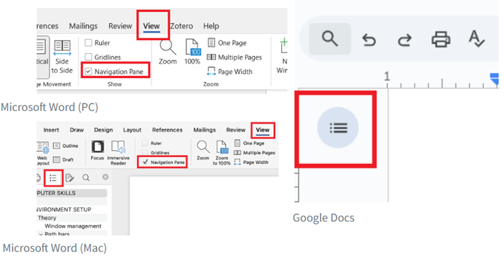

## Use the mouse/trackpad to create headings

You can select a heading from the “Styles” section of the “Home” ribbon using a mouse/trackpad. This is straightforward but takes more time than using keyboard shortcuts.

## Use the keyboard to create headings

Headings are especially practical if you memorize the keystrokes to generate them.

|  |  |  |  |  |
| --- | --- | --- | --- | --- |
| **Type** | **Microsoft Word**  **(PC)** | **Google Docs**  **(PC)** | **Microsoft Word**  **(Mac)** | **Google Docs**  **(Mac)** |
| Heading level 1 | Ctrl+alt+1 | Ctrl+alt+1 | Cmd+option+1 | Cmd+option+1 |
| Heading level 2 | Ctrl+alt+2 | Ctrl+alt+2 | Cmd+option+2 | Cmd+option+2 |
| Heading level 3 | Ctrl+alt+3 | Ctrl+alt+3 | Cmd+option+3 | Cmd+option+3 |
| Normal | Ctrl+shift+n | Ctrl+alt+0 | Cmd+shift+n | Cmd+option+0 |
| Heading dialogue box | Ctrl+shift+s |  | (see below) |  |

Note that Google Docs can create additional heading levels beyond level 3 using the same keyboard shortcut pattern. Microsoft Word stops keyboard shortcuts after heading level 3, although Ctrl+shift+s (PC) provides a handy alternative for lower-level headings. A more complex solution for a Mac can be found by Googling [“mac apply styles shortcut word.”](https://www.google.com/search?q=mac+apply+styles+shortcut+word)

Sometimes you might need to change multiple headers from UPPER CASE to Title Case or lower case. A handy trick in Microsoft Word is to change the case pattern of text using shift+f3 (PC) and Cmd+shift+a (Mac). Put your cursor in the middle of the word you want to change, then press the keyboard combination above.

## Change format of all headers

On either platform, you can adjust heading formats with the following steps. There are multiple other methods to change header formats. This one is reasonably efficient and minimizes mouse/trackpad use.

1. Move to one of the existing headers a document. Change the format. For example, you can bold it. Keep your cursor blinking on that header.
2. Make all headers with that level match your new format. Right click (secondary click) the header you changed.
   1. Microsoft Word: Click "Styles" in the dialogue box that pops up. Right click (secondary click) the appropriate heading. Click “Update Heading __ to Match Selection."

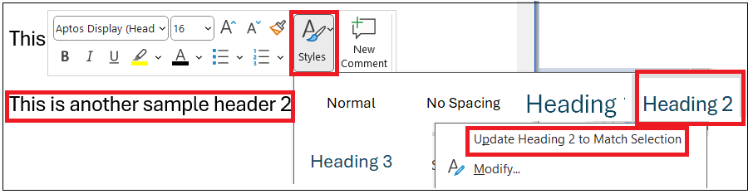

* 1. Google Docs: Click "Format options" in the dialogue box that pops up. Click "Update Heading __ to match."

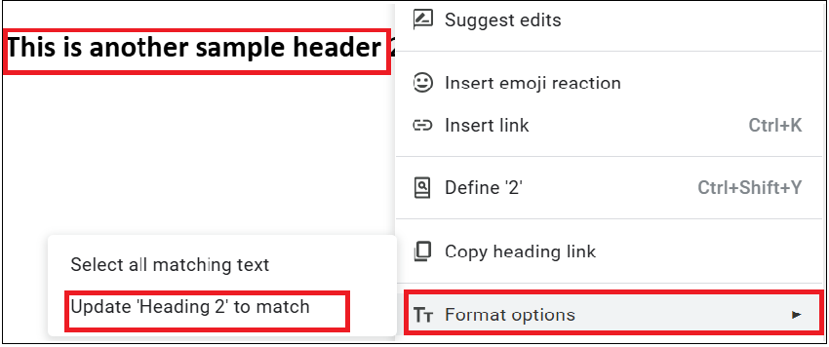

1. All headings of that level should now match the format of the heading your cursor started on.

## Create a table of contents

Headers can be used to create a table of contents that is easy to update.

1. Place your cursor blinking in the location you would like your table of contents to appear.
2. Insert the table.
   1. (Word) Select the “Reference” tab of the ribbon. Select “Table of Contents,” then one of the table styles.

* 1. (Google Docs) Type “@table” and select “Table of contents” from the dialogue box that pops up. There are multiple other methods to create a table of contents in Google Docs, but this is the quickest method, reasonably intuitive, and unlikely to change as Google Docs updates its user interface.

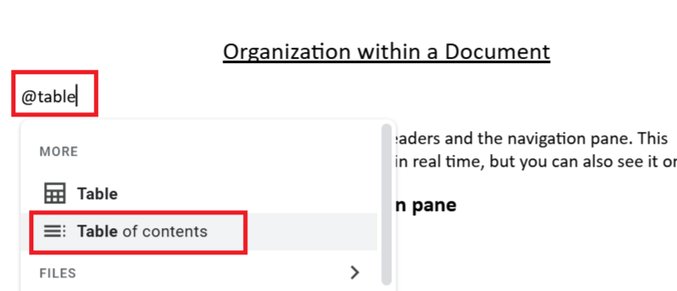

1. Adjust the format.
   1. (Word) Click “Custom Table of Contents” from the “Table of Contents” drop down menu shown above (item 2). In the “Table of Contents” tab, adjust “Show levels.”

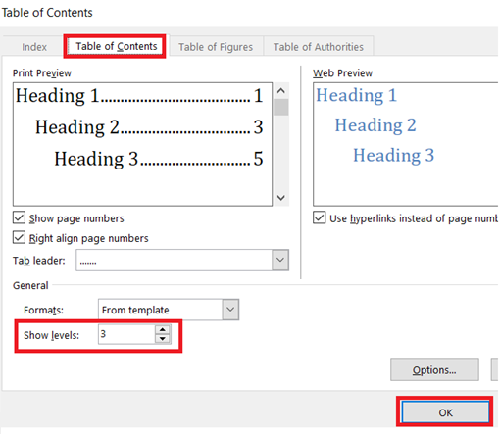

* 1. (Google Docs) Click the three vertical dots that appear to the left of the table of contents while your cursor or mouse is in the table of contents. Click “More options.” Then adjust the heading levels in the dialogue box that opens to the right of the Google Docs window. 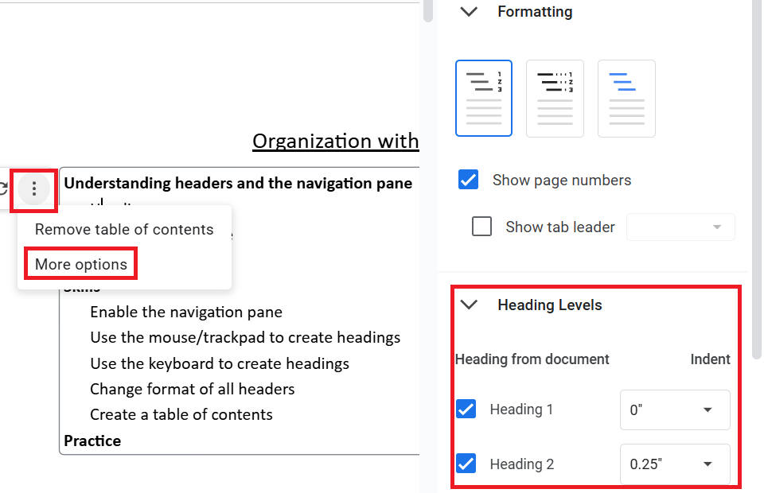

# Practice

Copy and paste tasks 1-4 into Google Docs or Microsoft Word. Alternately, [download a Word version of this document](https://github.com/swat-ssql/organization-within-document-docx/raw/refs/heads/main/Organization-within-a-Document.docx) to your computer. Instead of copy-pasting the text in this section to a word processor, you can work within that downloaded document.

Tasks:

1. Make the “Tasks” line above into heading level 3 with just your keyboard.
2. Create a table of contents for your document.
3. Change the format of the “Tasks” line.
4. Apply that format to all level 3 headings in the document.
5. Undo your changes with Cmd+z (Mac) or Ctrl+z (PC).