A PROJECT REPORT
ON
PREDICTIVE ANALYTICS ON STUDENT ACADEMIC PERFORMANCE PREDICTION
Using IBM SPSS Modeler and Decision Tree Classification

Submitted in partial fulfilment of the requirements for the award of the degree of

MASTER OF BUSINESS ADMINISTRATION

Submitted by
SWATANTRA RAI
Roll No.: 25050020023

Under the Guidance of
Mr. FERHAN AHMED

UNITED UNIVERSITY
Rawatpur, Prayagraj, Uttar Pradesh 211012
Academic Session 2026–27

DECLARATION

I hereby declare that the project report entitled “Predictive Analytics on Student Academic Performance Prediction” has been prepared for academic purposes as part of the Master of Business Administration programme. The dataset and numerical results used in this report are synthetic and have been generated for learning and demonstration. The analysis and interpretations are based on the simulated data described in this report.
I understand that the findings should not be represented as actual results of any real organization.

SWATANTRA RAI
Roll No.:25050020023

ACKNOWLEDGEMENT

I express my sincere gratitude to United University for providing the opportunity to undertake this academic project. I am thankful to my faculty guide, Mr. FERHAN AHMED
for guidance and support throughout the preparation of this report.
I also acknowledge the learning resources and software documentation that helped me understand data preparation, analytics methods and business reporting. Finally, I thank everyone who encouraged and supported me during this project.

ABSTRACT
This project demonstrates a predictive analytics workflow for identifying students who may be at academic risk using a synthetic dataset of 650 student records. The dataset contains attendance, daily study hours, internal marks, assignment scores, previous semester scores, class participation and academic programme. A decision-tree classification approach is used to classify the outcome as Pass or At Risk. The report explains data preparation, partitioning, model building, scoring and evaluation, and presents test-set metrics, a confusion matrix and feature-importance output. All data and results are simulated for academic demonstration; they are not actual student records or a live institutional model.
Project detail | Description
Project title | Predictive Analytics on Student Academic Performance Prediction
Dataset size | 650 synthetic student records
Target variable | Pass / At Risk
Software workflow | IBM SPSS Modeler-style decision tree workflow
Model type | Decision Tree classification
Evaluation | 75% training / 25% testing; test-set metrics
Purpose | Identify students who may benefit from timely academic support

TABLE OF CONTENTS
Section | Page (approx.)
Declaration | i
Acknowledgement | ii
Abstract | iii
1. Introduction | 1
2. Problem Statement, Scope and Objectives | 2
3. Data Discussion | 3
4. Methods, Tools and Technologies | 4
5. Workflow | 5
6. Procedure | 6
7. Results / Analytical Model | 7
8. Insights and Observations | 9
9. Recommendations / Suggestions | 10
10. Conclusion | 11
References and Appendix | 12

1. INTRODUCTION
Educational institutions collect information about attendance, assessment marks, assignments, study habits and classroom participation. These factors can provide useful context about a student's academic progress. When such information is examined systematically, institutions may identify students who could benefit from additional academic support.
Predictive analytics uses historical data and statistical or machine-learning methods to estimate likely future outcomes. In this project, a decision-tree classification model is used to estimate whether a student belongs to the Pass or At Risk category. The model output can support early review and academic guidance, but it should not replace teacher judgement or be treated as a final decision about a student.

1.1 Objectives
- Understand how predictive analytics can be applied to academic performance.
- Prepare student-related input variables and a target outcome.
- Use a decision-tree classification workflow in IBM SPSS Modeler.
- Partition data into training and testing subsets.
- Review model predictions and evaluation metrics.
- Suggest responsible academic support actions based on risk categories.

2. PROBLEM STATEMENT, SCOPE AND RESEARCH QUESTIONS

2.1 Problem Statement
Institutions may find it difficult to identify students who need academic support early, particularly when they have many students and multiple performance indicators. This project addresses the question: can student attendance, study habits and assessment information be used to classify students into Pass and At Risk groups so that support can be offered in a timely manner?

2.2 Scope
- The project uses 650 synthetic student records.
- Input variables include attendance, study hours, internal marks, assignment score, previous semester score, class participation and programme.
- The target field is Result, with two classes: Pass and At Risk.
- A decision-tree classification method is demonstrated.
- The dataset and model outputs are simulated and must not be used to make real student decisions.

2.3 Research Questions
- Can the selected academic indicators help classify student outcomes?
- How is a decision-tree model prepared and trained?
- How does the model perform on a held-out test dataset?
- Which input variables receive higher importance in the fitted tree?
- How can predicted risk be used responsibly to support students?

3. DATA DISCUSSION
Each row represents one student record. The dataset contains a unique student ID, attendance percentage, daily study hours, internal marks, assignment score, previous semester score, class participation, academic programme and result category.

3.1 Dataset Profile
Attribute | Description
Records | 650
Input variables | 7 academic and profile fields
Target variable | Result: Pass or At Risk
Programmes | Marketing, Finance, HR and Operations
Data source | Synthetic academic dataset
Class distribution | Pass: 579; At Risk: 71

3.2 Data Dictionary
Field | Meaning / use | Role
Student_ID | Unique student record ID | Identifier
Attendance_Percent | Percentage of classes attended | Input
Study_Hours_Daily | Average daily study hours | Input
Internal_Marks | Internal assessment score | Input
Assignment_Score | Assignment performance score | Input
Previous_Semester_Score | Previous semester marks | Input
Class_Participation | Low, Medium or High participation | Input
Program | Academic programme | Input
Result | Pass or At Risk category | Target

3.3 Data Preparation Considerations
- Check missing values and duplicate student identifiers.
- Confirm attendance is between 0 and 100 percent.
- Ensure marks and study hours are stored as numeric values.
- Treat programme and participation as categorical fields.
- Define Result as the target field and prevent identifiers from being used as predictors.
- Protect student information and use only approved data for real deployments.

4. METHODS, TOOLS AND TECHNOLOGIES

4.1 Predictive Analytics
Predictive analytics estimates the likelihood of an outcome using patterns learned from historical examples. In this project, the outcome is a two-class result: Pass or At Risk. The model learns from academic indicators in the training records and then produces predictions for records not used during training.

4.2 Decision Tree Classification
A decision tree is a supervised learning method that divides records into smaller groups using conditions on input variables. Each split is selected to help separate the target classes. The final branches lead to predicted classes. Decision trees are useful for demonstration because their decision rules can be easier to explain than some more complex models.

4.3 Tools and Workflow Nodes
Tool / component | Purpose
IBM SPSS Modeler | Visual data-mining workflow and model development
Source node | Imports the student dataset
Type node | Defines field types and input/target roles
Partition node | Separates training and testing records
C&R Tree / Decision Tree node | Builds a classification tree
Model Nugget | Stores the trained model for scoring
Analysis / Evaluation node | Reviews predictions and model performance
Table node | Displays student-level predicted results
Microsoft Word | Prepares the report
This report provides a reproducible decision-tree demonstration using synthetic data. The procedure is written in terms of the corresponding SPSS Modeler workflow; exact node labels and menu positions may vary by software version.

5. WORKFLOW
- Import Student_Academic_Data.csv into IBM SPSS Modeler.
- Use the Type node to define field types and mark Result as the target.
- Exclude Student_ID from model inputs.
- Use the Partition node to create training and testing subsets.
- Connect a C&R Tree or equivalent decision-tree classification node.
- Train the model using the training partition.
- Apply the Model Nugget to the testing records.
- Review predicted classes and probability scores.
- Evaluate results using a confusion matrix, accuracy, precision, recall and F1-score.
- Review variable importance and prepare responsible recommendations.
Student data → Type → Partition → C&R Tree → Model Nugget → Evaluation → Table

6. PROCEDURE IN IBM SPSS MODELER
- Open IBM SPSS Modeler and create a new stream.
- Add a file source node and select Student_Academic_Data.csv.
- Preview the fields and confirm the data is read correctly.
- Add a Type node and set Result as the target field; set the academic indicators as inputs and Student_ID as a record identifier.
- Add a Partition node and select a training/testing split, such as 75% training and 25% testing.
- Add a C&R Tree node and connect it to the partitioned data.
- Set the target field to Result and review tree settings such as maximum depth and minimum records per node.
- Run the tree node to generate the model nugget.
- Connect the model nugget to the testing data or score the partitioned stream.
- Use an Evaluation or Analysis node to inspect the confusion matrix and classification metrics.
- Use a Table node to view actual result, predicted result and class probabilities.
- Save the stream and document the model settings and results.

6.1 Model Validation
- Evaluate on records not used to train the model.
- Review precision and recall for the At Risk class, not only overall accuracy.
- Check whether the model misses students who are actually At Risk.
- Review the confusion matrix and possible class imbalance.
- Repeat validation with another split or cross-validation before real use.

7. RESULTS / PREDICTIVE MODEL
The synthetic dataset contains 650 student records. The records were split into 75% training and 25% testing subsets using stratified sampling. A decision-tree classifier with a maximum depth of four was fitted on the training data and evaluated on the held-out test set. The following metrics are generated from this simulated exercise.
Evaluation measure | Test result
Accuracy | 65.03%
Precision (Pass class) | 93.14%
Recall (Pass class) | 65.52%
F1-score (Pass class) | 76.92%
Training records | 487
Testing records | 163

7.1 Student Outcome Distribution
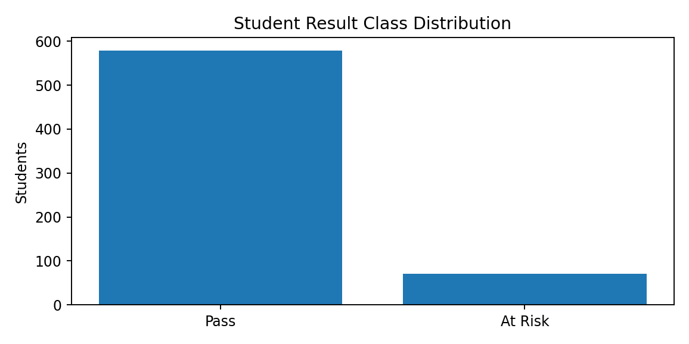
Figure 1. Distribution of Pass and At Risk records
The chart shows the number of records in each target category. The class distribution should be checked before model training because a strongly imbalanced target can make accuracy alone misleading.

7.2 Confusion Matrix
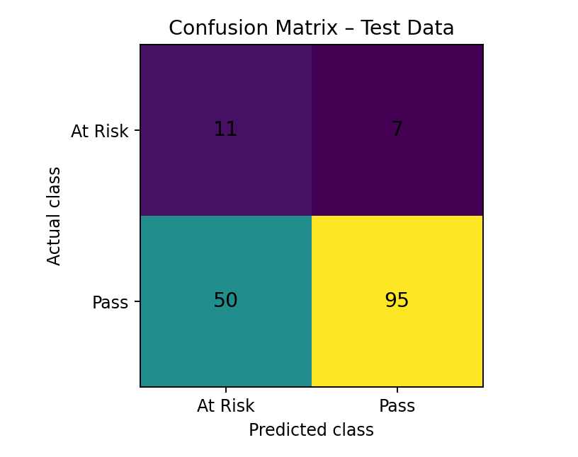
Figure 2. Confusion matrix for held-out test records
Actual class | Predicted At Risk | Predicted Pass
At Risk | 11 | 7
Pass | 50 | 95
The confusion matrix compares the actual test-set class with the model's predicted class. Correct predictions appear on the diagonal; off-diagonal values represent classification errors.

7.3 Feature Importance
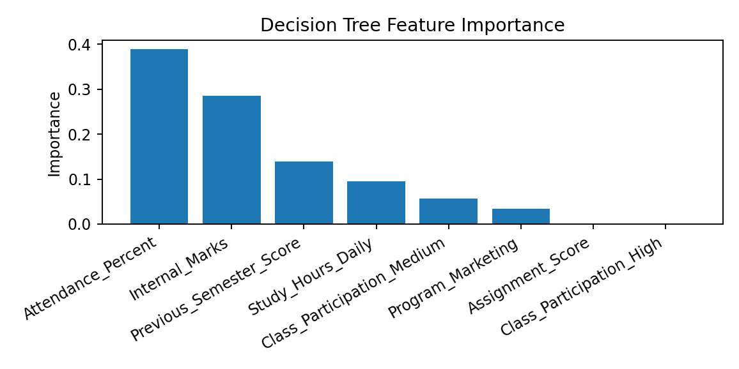
Figure 3. Relative feature importance from the fitted decision tree
Feature | Importance
Attendance_Percent | 0.389
Internal_Marks | 0.286
Previous_Semester_Score | 0.139
Study_Hours_Daily | 0.095
Class_Participation_Medium | 0.057
Program_Marketing | 0.034
Assignment_Score | 0.000
Class_Participation_High | 0.000
Feature importance indicates how much each field contributed to the fitted tree's splits. It does not prove that a field causes academic success or failure.

7.4 Sample Prediction Output
Record | Attendance % | Study hrs/day | Internal marks | Actual | Predicted | Pass probability
72 | 79.0 | 2.2 | 56.3 | Pass | At Risk | 19.6%
38 | 83.3 | 3.3 | 64.4 | Pass | Pass | 100.0%
383 | 76.3 | 2.4 | 34.7 | Pass | At Risk | 19.6%
591 | 82.5 | 2.5 | 74.6 | Pass | Pass | 72.4%
33 | 71.2 | 2.6 | 75.7 | Pass | Pass | 100.0%
468 | 72.1 | 4.0 | 54.1 | Pass | Pass | 100.0%
620 | 81.5 | 3.6 | 24.4 | At Risk | At Risk | 19.6%
312 | 100.0 | 1.7 | 80.4 | Pass | Pass | 72.4%
The sample rows are selected from the held-out synthetic test records. A predicted probability is a model estimate, not a guarantee of the student's final result.

8. INSIGHTS AND OBSERVATIONS

8.1 Academic Indicators Provide Classification Information
The decision-tree model uses attendance, study hours and assessment-related information to classify student outcomes in the synthetic dataset.

8.2 Predictions Are Not Certain
Some records may be classified incorrectly. Predictions should therefore be treated as a prompt for review and support rather than as a final judgement.

8.3 Model Performance Must Be Evaluated
Accuracy, precision, recall and F1-score provide different views of performance. The confusion matrix helps identify the types of mistakes made by the classifier.

8.4 Feature Importance Helps Explain the Model
The highest-ranked fields in this fitted model include Attendance_Percent, Internal_Marks, Previous_Semester_Score. Their importance is specific to this simulated dataset and this particular model.

8.5 Student Context Matters
A model cannot fully represent personal circumstances, learning needs, teaching quality or other factors that may influence academic performance.

9. RECOMMENDATIONS / SUGGESTIONS
- Use predicted At Risk labels to offer supportive academic check-ins, not punishment.
- Review attendance and assessment information with teachers before taking action.
- Provide remedial classes, mentoring, study-planning support and assignment guidance where appropriate.
- Avoid using a single prediction as the basis for academic decisions.
- Check model performance regularly and evaluate errors across programmes and student groups.
- Protect student data and restrict access to identifiable records.
- Use real institutional data only with appropriate permission, privacy safeguards and validation.
- Retrain and re-evaluate the model when academic patterns or assessment practices change.

10. CONCLUSION
This project demonstrates a predictive analytics workflow for classifying student academic outcomes using a decision-tree approach. A synthetic dataset of 650 student records was prepared with attendance, study hours, internal marks, assignment scores, previous semester scores, participation and programme information.
The workflow follows the stages of data import, field-role definition, partitioning, decision-tree training, model scoring and evaluation. The report presents test-set metrics, a confusion matrix, feature-importance information and sample predictions.
The results are generated from simulated data and do not represent actual student performance or a validated institutional model. In real educational settings, predictions should be carefully validated, interpreted by qualified staff and used only to provide fair and supportive interventions.

11. REFERENCES
- IBM Documentation – SPSS Modeler: data preparation, Type node, Partition node, C&R Tree modelling and model evaluation.
- IBM SPSS Modeler product learning resources and institution-provided software guidance.
- Scikit-learn documentation – DecisionTreeClassifier and classification metrics (used to calculate the illustrative synthetic model results).
- Synthetic student academic dataset generated for this academic project (650 records).

APPENDIX: KEY RESULTS
Item | Summary
Project topic | Predictive Analytics on Student Academic Performance Prediction
Software workflow | IBM SPSS Modeler-style decision tree
Input dataset | Student_Academic_Data.csv (synthetic)
Records | 650
Target | Pass / At Risk
Test accuracy | 65.03%
Model output | Predicted class and probability
Important limitation | Synthetic data; not a validated real-world student model

