**EMBEDDED SYSTEMS-EE 3401**



Automatic switch control of out roof-top water tank

Submitted by: Submitted to:

* Kratik Dwivedi (117EE0355) Dr. Supratim Gupta
* Anuj Gaur (117EE0356)
* Swatantra kumar gupta (117EE0759)

Table of content

* Objective of the Experiment
* Equipment Required
* Software Used
* Bill of Materials
* Theory and Pin Configurations
* Introduction & Procedure
* Code with Comments
* Results
* Problems faced during experimental design
* Conclusion

Objective Of The Experiment:

To develop automatic switch control of out roof-top water tank.

Components Required For Automatic Switch Control

* AT89C51 Microcontroller
* 8051 Programming/Development board
* 7 segment display common anode (x3)
* Water tanker prototype
* LEDs
* Relay (5V switching)
* Battery (9V)
* 2N2222 npn BJT (x8)
* 5x 1KΩ Resistor (1/4 Watt)
* Connecting wires
* Breadboard

Software Used :

* Keil µVision Software
* Proteus

Bill Of Materials:

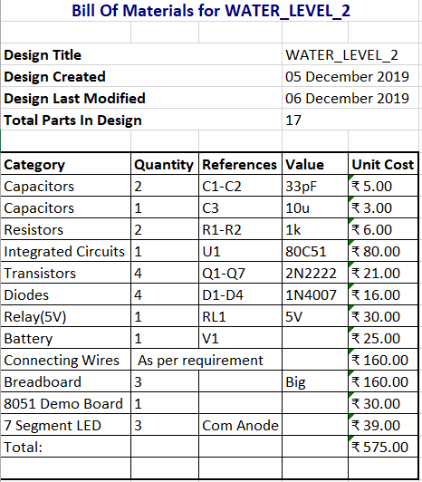

Theory And Pin Configurations:

AT89C51 microcontroller

Operational Temperature: -50° to 125° C

Operational voltage: 5V~20%

Operational current: max 1mA

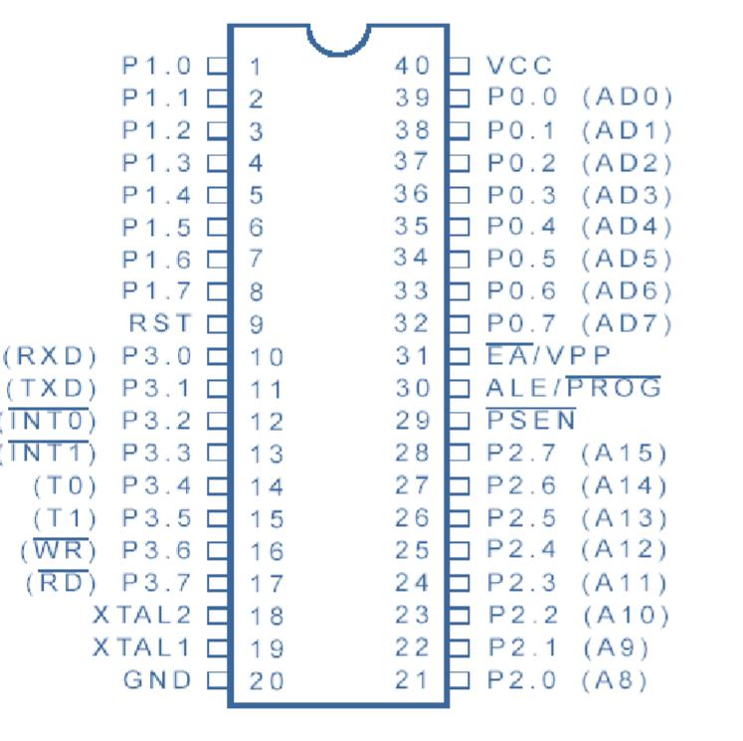

Fig1: AT89C51 Pin-out

Timer T0

In order to visualise each segment individually, we have to persist each of segment for a while to do so we have to use a delay of 0.5msec. So that we can easily visualised the display

### 5V Relay Module 10A

5V Relay Module is a relay interface board, it can be controlled directly by a wide range of microcontrollers such as Arduino, AVR, PIC, ARM and so on. It uses a low level triggered control signal (3.3-5VDC) to control the relay. Triggering the relay operates the normally open or normally closed contacts. It is frequently used in an automatic control circuit. To put it simply, it is an automatic switch to control a high-current circuit with a low-current signal.5V relay signal input voltage range, 0-5V. VCC power to the system. JD-VCC relay in the power supply. JD-VCC and VCC can be a shorted.

**Features :**

* Supports any microcontroller or TTL signal. 3.3V and 5V supported.
* Relay current consumption at 5V is 75mA
* Red LED On Indicator
* On-board switching transistor.
* On-board back EMF protection.
* Easy 1 wire drive. High for on, low for off.

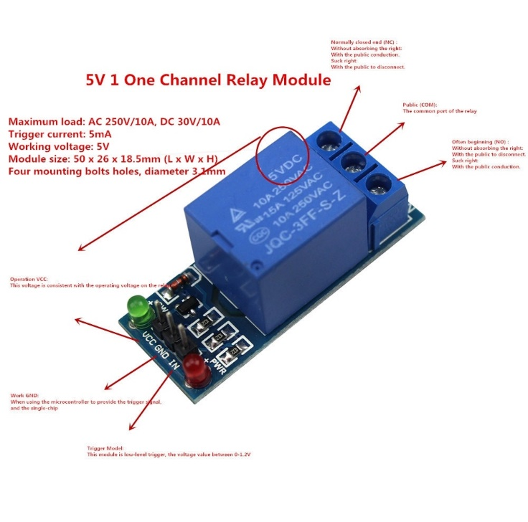

Common Anode 7-segment Display

Each one of the seven LEDs in the display is given a positional segment with one of its connection pins being brought straight out of the rectangular plastic package. These individually LED pins are labelled from a through to g representing each individual LED. The other LED pins are connected together and wired to form a common pin.

In the common cathode display, all the cathode connections of the LED segments are joined together to logic “0” or ground. The individual segments are illuminated by applicat ion of a “HIGH”, or logic “1” signal via a current limiting resistor to forward bias the individual Anode terminals (a-g).

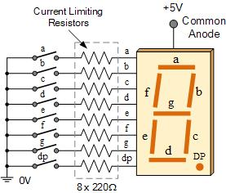

Introduction & Procedure:

* Introduction

Water Level Controller using 8051 Microcontroller project will help in automatically controlling the water motor by sensing the water level in a tank. This system monitors the water level of the tank and automatically switches ON the motor whenever tank is empty. The motor is switched OFF when the overhead tank or container is FULL. Here, the water level of the tank is indicated on Common Anode 7-segment Display. Using this system, we can avoid the overflow of the water.

This system mainly works on a principle that “water conducts electricity”. The four wires which are dipped into the tank will indicate the different water levels. Based on the outputs of these wires, microcontroller displays water level on Common Anode 7-segment Display as well as controls the motor.

Initially when the tank is empty, Common Anode 7-segment Display will display the “000” and motor runs automatically. When water level reaches to half level, now Common Anode 7-segment Display displays “050” and still motor runs.

When the tank is full, Common Anode 7-segment Display “100” and motor automatically stops. Again, the motor runs when water level in the tank becomes low i.e. 000.

Procedure

* A firmware project was created on Proteus using AT89C51 as the microcontroller model. The necessary circuit diagram was made as adjoint in Figure.
* The code was written and tested as a simulation in the Proteus environment. The hex file of the code was generated and burnt into the microcontroller using the USB programmer
* module.
* The 7 segment display segments were powered from port 3 itself and was controlled from a npn transistor.
* The hardware circuit was then designed by interfacing all the components with 8051.
* And prototype water tank was develop for giving input to the controller and relay is connected to the P1.3 for switching of water pump.
* Then the circuit was run and tested for errors which were rectified to obtain the final product.

Code with Comments:

;====================================================================

* MAIN.ASM FILE GENERATED BY NEW PROJECT WIZARD
* CREATED: Thursday Dec 5 2019
* OBJECTIVE: To develop automatic switch control of out roof-top water tank.
* CREATED BY: Swatantra , Anuj & Kratik
* PROCESSOR: AT89C51
* COMPILER: ASEM-51 (PROTEUS)

;===============================================================$NOMOD51

$INCLUDE (8051.MCU)

ORG 0000H

START:

MOV P2,#0FFH ; initialization of port 2 as input

MOV P1,#00H ; initialization of port 1 as output

MAIN1: ; loop for checking water level and jumps for display water level

JB P2.3,D1

JB P2.2,D2

JB P2.1,D3

JB P2.0,D4

JNB P2.0,D10

LJMP MAIN1

D10: LJMP D5

D1: ;*to display 100%*

SETB P1.4

MOV P3,#0f9H

ACALL DELAY

CLR P1.4

SETB P1.1

MOV P3,#0C0H

ACALL DELAY

CLR P1.1

SETB P1.2

MOV P3,#0C0H

ACALL DELAY

CLR P1.2

CLR P1.3

JNB P2.3 ,D9

JMP D1

D9: LJMP MAIN2

D2: ;to display 75%

SETB P1.4

MOV P3,#0C0H

ACALL DELAY

CLR P1.4

SETB P1.1

MOV P3,#0F8H

ACALL DELAY

CLR P1.1

SETB P1.2

MOV P3,#92H

ACALL DELAY

CLR P1.2

SETB P1.3

LJMP MAIN1

D3: ;to display 50%

SETB P1.4

MOV P3,#0C0H

ACALL DELAY

CLR P1.4

SETB P1.1

MOV P3,#92H ;

ACALL DELAY

CLR P1.1

SETB P1.2

MOV P3,#0C0H

ACALL DELAY

CLR P1.2

SETB P1.3

LJMP MAIN1

D4: ;to display 25%

SETB P1.4

MOV P3,#0C0H

ACALL DELAY

CLR P1.4

SETB P1.1

MOV P3,#0A4H ;

ACALL DELAY

CLR P1.1

SETB P1.2

MOV P3,#92H

ACALL DELAY

CLR P1.2

SETB P1.3

LJMP MAIN1

D5: ;to display 000%

SETB P1.4

MOV P3,#0C0H

ACALL DELAY

CLR P1.4

SETB P1.1

MOV P3,#0C0H

ACALL DELAY

CLR P1.1

SETB P1.2

MOV P3,#0C0H

ACALL DELAY

CLR P1.2

SETB P1.3

LJMP MAIN1

MAIN2: ;loop for display and triggering relay of water pump

JB P2.2,D6

JB P2.1,D7

JB P2.0,D8

JNB P2.0,D

LJMP MAIN2

D:

AJMP D5

D6: ;to display 75%

SETB P1.4

MOV P3,#0C0H

ACALL DELAY

CLR P1.4

SETB P1.1

MOV P3,#0F8H ;

ACALL DELAY

CLR P1.1

SETB P1.2

MOV P3,#92H

ACALL DELAY

CLR P1.2

LJMP MAIN2

D7: ;to display 50%

SETB P1.4

MOV P3,#0C0H

ACALL DELAY

CLR P1.4

SETB P1.1

MOV P3,#92H ;

ACALL DELAY

CLR P1.1

SETB P1.2

MOV P3,#0C0H

ACALL DELAY

CLR P1.2

LJMP MAIN2

D8: ;to display 25%

SETB P1.4

MOV P3,#0C0H

ACALL DELAY

CLR P1.4

SETB P1.1

MOV P3,#0A4H ;

ACALL DELAY

CLR P1.1

SETB P1.2

MOV P3,#92H

ACALL DELAY

CLR P1.2

LJMP MAIN2

DELAY: ;delay for LEDs

MOV TMOD,#01H

MOV TL0,#0CH

MOV TH0,#0FEH

MOV TCON,#10H

WAIT:JNB TF0,WAIT

CLR TR0

CLR TF0

RET

END

*****

Result

Proteus simulation:

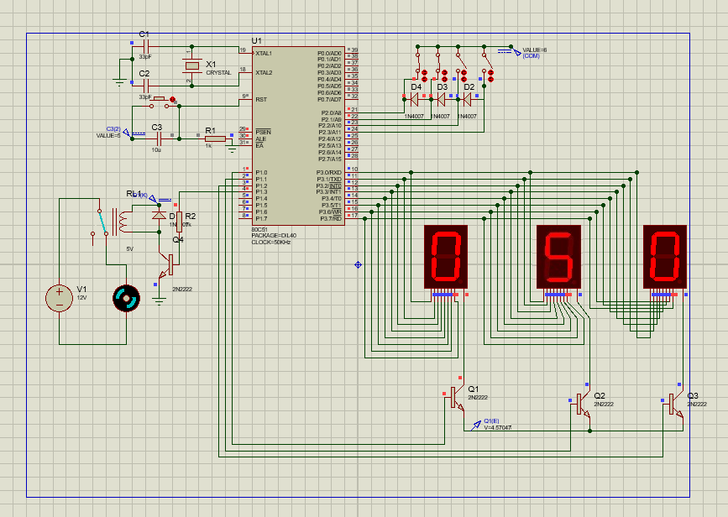

Hardware assembly along with output

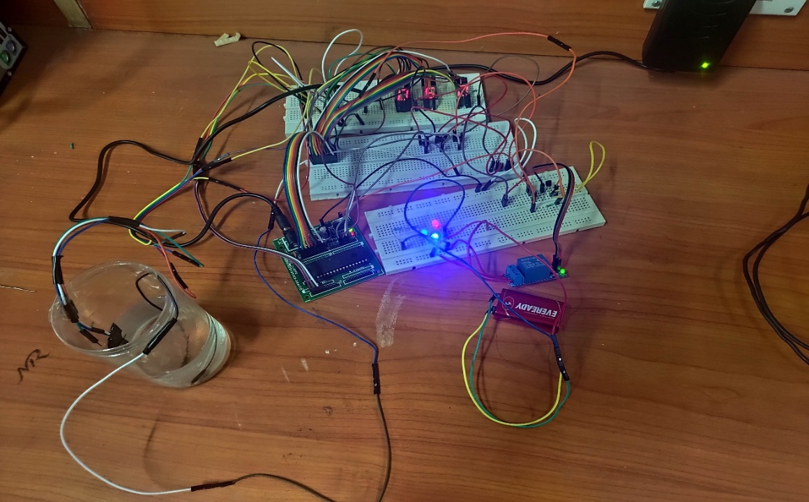

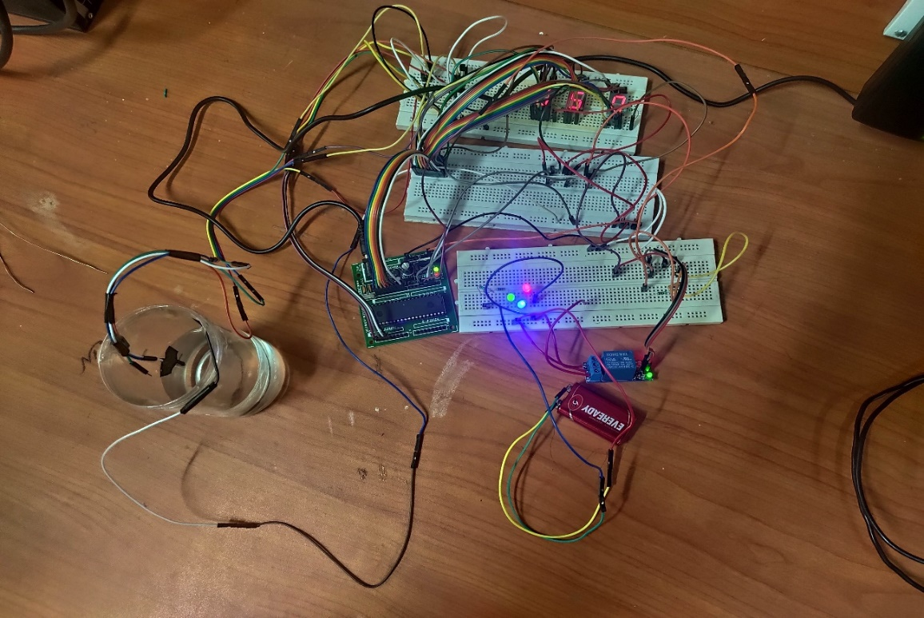

Problems Faced During Experimental Design:

The first problem we faced was assembling the 8051 chip on the Demo board. In the first run we broke our input port(P2) pin while trying to execute our program on the hardware.

In such cases we need to take care of hardware before burning our code on the chip so that such problem do not arise in the future occurences.

The next problem was faced in the Hardware assembling .If one of the three 7 segment display was not inserted properly the output was not coming. In this case we checked our code for errors and later was again confirmed on the hardware.

Also the water in the water tank was not able to give enough potential difference to be considered as high for input port of 8051.Therefore we used BJTs to set the input port high at much lower potential difference that the previous case.

Conclusion: -

After this project we conclude that it helps to reduce Human effort as the system controls the motor automatically based on the water level. This system consumes less power compared to motor attached to its relay, it is simple and more reliable.

Its can used in big buildings where the manual monitoring is difficult or used in industries to control the liquid level automatically.