clc;

clear all;

close all;

N=input('Number of Sample = ');

t1=-N:1:N;

x1=[zeros(1,N),1,zeros(1,N)];

subplot(2,3,1);

stem(t1,x1);

xlabel('Time');

ylabel('Amplitude');

title('Unit Impulse signal');

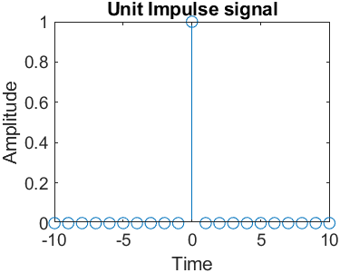

clc;

clear all;

close all;

N=input('Number of Sample');

t1=-N:1:N-1;

x1=[zeros(1,N),1,ones(1,N-1)];

stem(t1,x1);

xlabel('Time');

ylabel('Amplitude');

title('Unit Step signal');

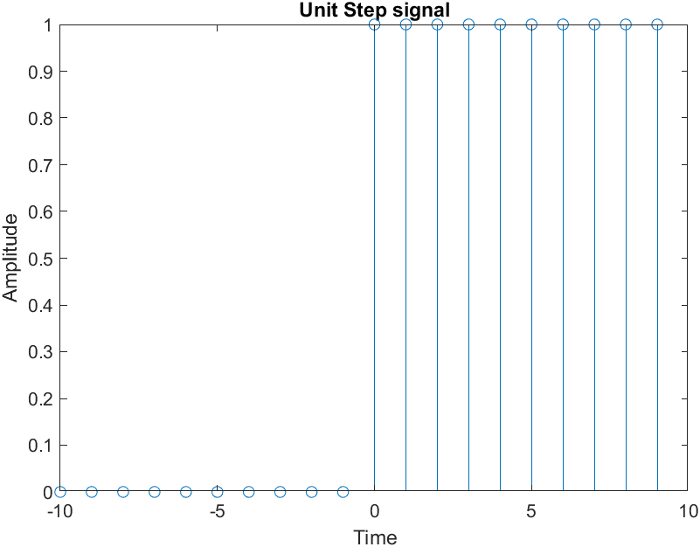

clc;

clear all;

close all;

N=input('Number of Sample');

t1=-N:1:N;

x1=[-N:-1,0,1:N];

stem(t1,x1);

xlabel('Time');

ylabel('Amplitude');

title('Ramp signal');

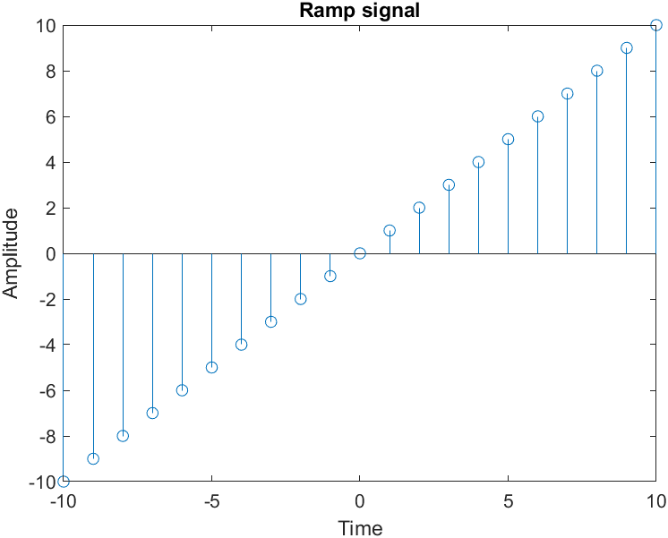

clc;

clear all;

N = input('Number of Samples');

a = 0.5

n = 0:0.1:N;

x = a.^n;

stem(n,x);

xlabel('time');

ylabel('Amplitude');

title('Exponential decaying Signal')

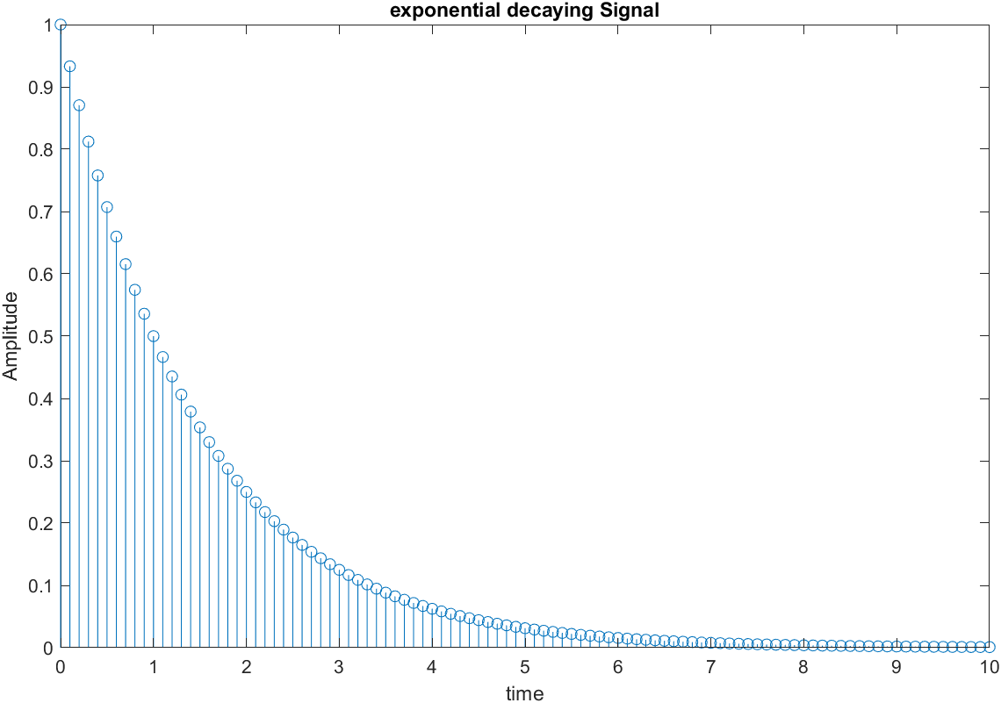

clc;

clear all;

N = input('Number of Samples');

a = 0.5

n = 0:0.1:N;

x = sin(a\*n)

stem(n,x);

xlabel('time');

ylabel('Amplitude');

title('Sine Signal')

