Jaikvin Export Management System
How the New System Will Work
A simple, step-by-step explanation
In one sentence:
Today we enter the same information into many Excel files. In the new system, we enter the buyer order only once. The system then uses the master data, calculates quantities, boxes, weights and values, keeps the FIFO balance, and creates all export documents, reports and bank documents automatically.

Why We Are Building This

The situation today
Right now, the team types the same information again and again into many different Excel files:
- Buyer Order
- Purchase Sheets
- Packing Lists
- Invoices
- Shipping Documents
- Reports
This takes a lot of time, and typing the same numbers in many places can create mistakes.

The goal of the new system
Enter data once → The system creates everything automatically.

The Complete Workflow at a Glance
The picture below shows the full journey from start to finish. The orange boxes are the only steps where a person enters information. The green boxes are done automatically by the system.
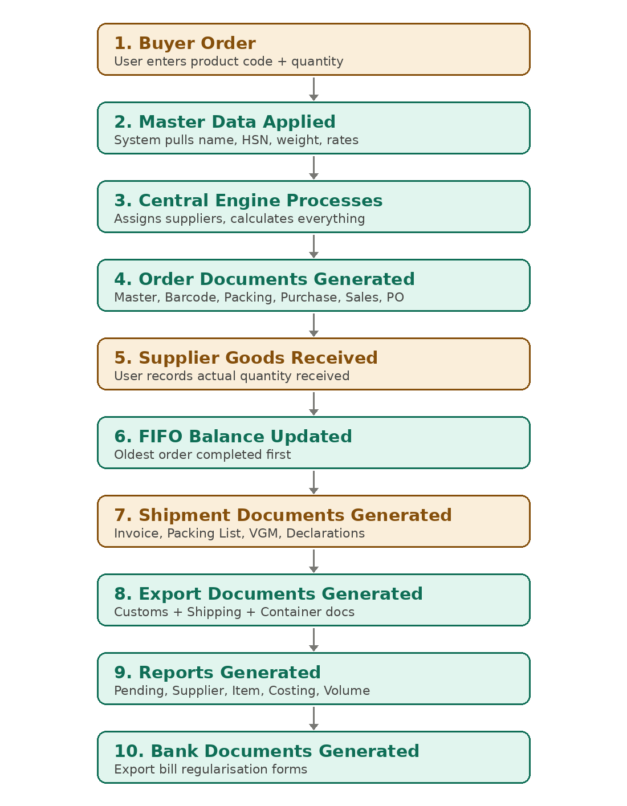

Each Step Explained Simply

Step 1 — Enter the Buyer Order
What the user does:
When a customer places an order, the user enters just three things — the product code, the quantity, and the selling price in USD.
Example:
Product Code | Quantity
GD001 | 1000 pcs
GD002 | 500 pcs

What the system does automatically:
The system already knows the product name, size, packing details, HSN code, barcode, weight, volume, purchase rate and GST rate. So the user does not need to type any of these again.

Step 2 — The System Reads the Master Data
Master Data is information that rarely changes. The system keeps it once and uses it every time.
Master | What it contains
Product Master | Name, HSN code, barcode, weight, packing, supplier details
Supplier Master | Supplier name, address, GST number
Buyer Master | Customer details, shipping address, currency

The system pulls this information automatically whenever a document needs it.

Step 3 — The Central Engine Does the Work
This is the brain of the system. As soon as an order is entered, the engine automatically:
- Assigns the suppliers
- Calculates the number of boxes
- Calculates the weights
- Calculates the volume
- Calculates the purchase value
- Calculates the sales value
- Keeps the FIFO balance up to date
- Generates the documents
No manual calculation is needed.

Step 4 — Order Documents Are Created Automatically
With one click on “Generate Order Documents”, the system creates the full order set:
- Master Sheet
- Barcode Sheet
- Packing Sheet
- Purchase Sheet
- Sales Sheet
- Supplier Purchase Orders
Instead of building many Excel files by hand, everything is ready instantly.

Step 5 — Supplier Sends the Goods
What the user does:
When suppliers send the packed goods, the user records the quantity that actually arrived and the actual packing details.
Example:
 | Quantity
Buyer ordered | 1000 pcs
Supplier delivered | 800 pcs
User records | 800 pcs received

Step 6 — FIFO Balance Is Updated
FIFO means First In, First Out. The oldest order is completed first.
Example:
What happens | Detail
Order 1 (March 1) | 10 boxes
Order 2 (March 10) | 20 boxes
Shipment (March 20) | 21 boxes go out

How the system calculates it:
- First, complete all 10 boxes from Order 1.
- 21 − 10 = 11 boxes still need to come from Order 2.
- Order 2 then has 20 − 11 = 9 boxes remaining.
Balance Report:
Order | Remaining
Order 1 | 0
Order 2 | 9

The user never calculates this by hand. The system always knows what is pending against each order.

Step 7 — Shipment Documents Are Created
When the goods are ready for export, the user enters the shipment details:
- Container Number
- Vessel Name
- Shipping Details
- BL Number
- Weight Details
The system then automatically creates all shipment documents, using the same data:
- Packing List
- Commercial Invoice
- Export Invoice
- Shipping Instructions
- VGM
- Declarations
- E-Way Bill documents
- CHA documents
There is no duplicate entry — every document uses the same figures, so they always match.

Step 8 — Final Export Documents Are Created
After the shipment is confirmed, the system generates the final documents.
Buyer documents:
- Commercial Invoice
- Packing List
- Declaration
Export documents:
- Container documents
- Shipping documents
- Customs documents

Step 9 — Reports Any Time
Management can generate reports whenever they want:
Report | What it shows
Pending Orders | What is pending and what is completed
Supplier Report | Which supplier supplied what quantity
Item Report | Product-wise balance
Costing Report | Purchase cost, selling value and profit
Volume Report | Boxes, weight and volume

Step 10 — Banking Documents
The system automatically prepares the export bank documents and the Export Bill Regularisation forms. There is no need to prepare them by hand.

Only a Few Things Stay Manual
The system automates almost everything. The user only needs to enter:
# | What the user enters | Why
1 | Buyer Order | The customer's order details
2 | Supplier Receipt | The actual quantity received from the supplier
3 | Shipment Details | Container number, vessel details, etc.
4 | External Numbers | BL number, e-way bill number, weighbridge slip — these come from outside agencies

Simple Explanation for the Client
“Today we enter the same information into many Excel files. In the new system, we only enter the buyer order once. The system automatically uses the master data, calculates quantities, boxes, weights and values, maintains the FIFO balance, and generates all export documents, reports and banking documents. This reduces manual work, saves time, and prevents errors.”

