**Task Spawning Run Code & Task Management View Customization**

Customer: Schurz Communications

Version: 6.0.6466

1. Go to the Entity Editor
2. Create a new lookup list with a caption of “Location Team” (without quotes) and a field name value of “LocationTeam” (without quotes) Under Incident Management > Incident Request > Model > Lookup Lists. **Save your changes**
3. Create a new association called “LocationTeamAssoication” (without the quotes) under Incident Management > Incident Request > Model > Associations. Give it the below properties and **save your changes.**

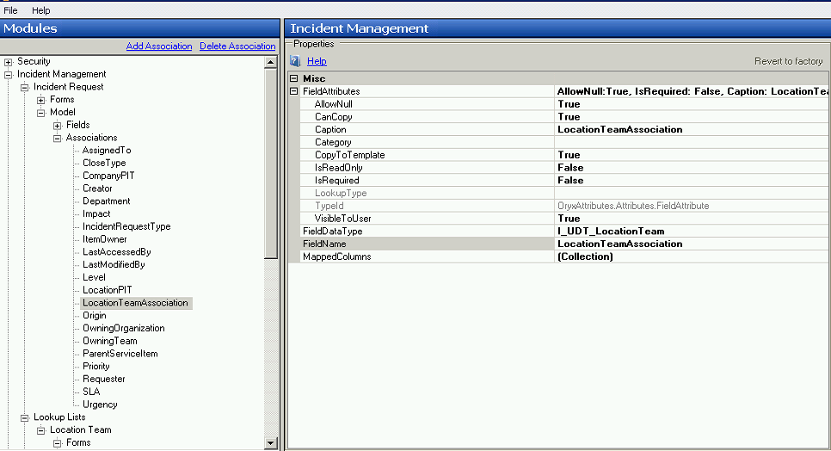

1. Add the new association to the active form for your incident module. This should go on the staff form and on the end user form (if end users need to utilize this field). The field should be called “UDF_LocationTeamAssociation” .  **Save your changes or save the form changes under a different name just to be on the safe side.**

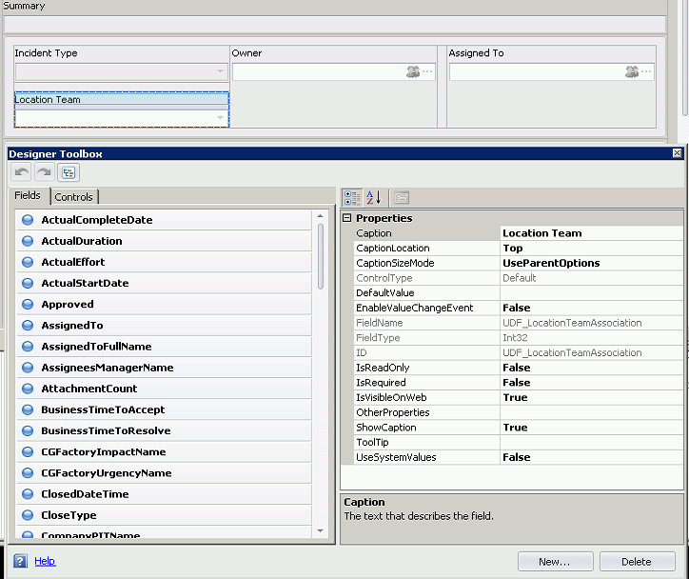

1. Closed out the Entity Editor and go to Incident Management > Location Team under the Administration tab and start adding items to the lookup list. Only the Name field needs to be filled out for each item.
2. Open up the **task_1.cs** file and scroll down to line 21 (should be the first switch statement in the code) . This switch statement maps out the relationship between the id values for the lookup list items that you just created and OID values of the users you want the task to be assigned to (the implementer) when the parent ticket is submitted. For example, the below statement:

case 1:

ht["AssignedTo"] = 61;

break;

Means set the AssignedTo field value to the user with an OID value of 61 if the item selected in the LocationTeamAssoication lookup list has a value of 1. Furthermore, these numbers should be updated in the code. You can find the OID values for the lookup list items and users under the Systems tab for the lookup list and user items in the Desktop Client.

1. Update the numbers for the switch statement on line 43.
2. Once the task_1.cs file has been updated, go to the active workflow for your Incident module, open it up, and add a new run code automation against the Submit action.
3. Add the contents of the **task_1.cs** file to the code field for the run code automation and give the automation a descriptive name and save your changes.
4. Add another run code automation against the submit action and add the contents of the **task_2.cs** file. **Note:**  There’s a hard coded value on line 13 for the AssignTo field in this code which can be updated to the user that should be assigned the task. Give the run code automation a description name and save your changes.
5. Go to the active workflow for the Incident Task Management module and add a new run code automation to the Close Task action for it.
6. Take the contents of the **task_closed.cs** file and add it to code field for this automation.
7. Add the My Completed Incident Tasks.xml and My Incident Tasks.xml files to the following path:

*..\Program Files (x86)\SunView Software\ChangeGear\Server\Views\System\IIncidentRequestTask*

**Note:** These files are found in the \Server\Views\System\IIncidentRequestTask directory for this package.

1. Restart the ChangeGear Service and Reset IIS.