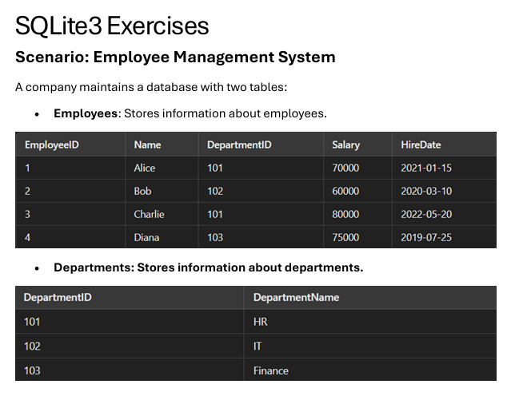

**QUESTIONS:**

**Q1. Write a query to list the names of employees hired after January 1, 2021.**

SELECT name

FROM Employees

WHERE hire_date > '2021-01-01';

**Q2. Write a query to calculate the average salary of employees in each department.**

SELECT d.department_name, AVG(e.salary) AS average_salary

FROM Employees e

JOIN Departments d ON e.department_id = d.department_id

GROUP BY d.department_name;

**Q3. Write a query to find the department name where the total salary is the highest.**

SELECT d.department_name

FROM Employees e

JOIN Departments d ON e.department_id = d.department_id

GROUP BY d.department_name

ORDER BY SUM(e.salary) DESC

LIMIT 1;

**Q4. Write a query to list all departments that currently have no employees assigned.**

SELECT department_name

FROM Departments d

LEFT JOIN Employees e ON d.department_id = e.department_id

WHERE e.department_id IS NULL;

**Q5. Write a query to fetch all employee details along with their department names.**

SELECT e.*, d.department_name

FROM Employees e

JOIN Departments d ON e.department_id = d.department_id;