1)VIRTUAL BASE CLASS:

#include<iostream>

using namespace std;

class A

{

public:

void display()

{

cout<<"i am virtual base class";

}

};

class B:virtual public A

{

};

class C:virtual public A{

};

class D:virtual public B,virtual public C

{

};

int main()

{

D D1;

D1.display();

return 0;

}

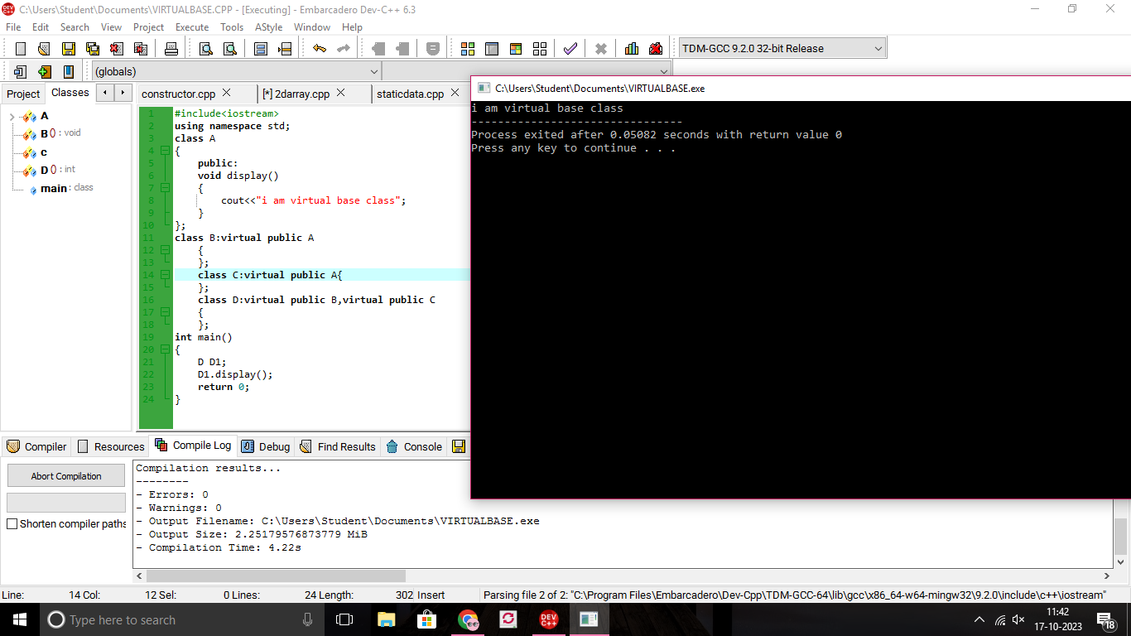

2)FUNCTION WITH DEFAULT ARGUMENT:

#include<iostream>

using namespace std;

class A

{

public:

int sum(int a,int b,int c=10,int d=20)

{

return (a+b+c+d);

}

};

int main()

{

A a1;

cout<<a1.sum(10,20,100,200)<<endl;

cout<<a1.sum(10,20,30)<<endl;

cout<<a1.sum(10,20)<<endl;

return 0;

}

