1)creating a class called car that has a private datamember company ,model,and year.implement memberfunction to get and set the data.

#include<iostream>

using namespace std;

class car

{

private:

string company,model;

int year;

public:

void set()

{

cout<<"enetr company name:";

cin>>company;

cout<<"enter model name:";

cin>>model;

cout<<"enter year:";

cin>>year;

}

void get()

{

cout<<company<<endl;

cout<<model<<endl;

cout<<year<<endl;

}

};

int main()

{

car c;

c.set();

c.get();

return 0;

}

2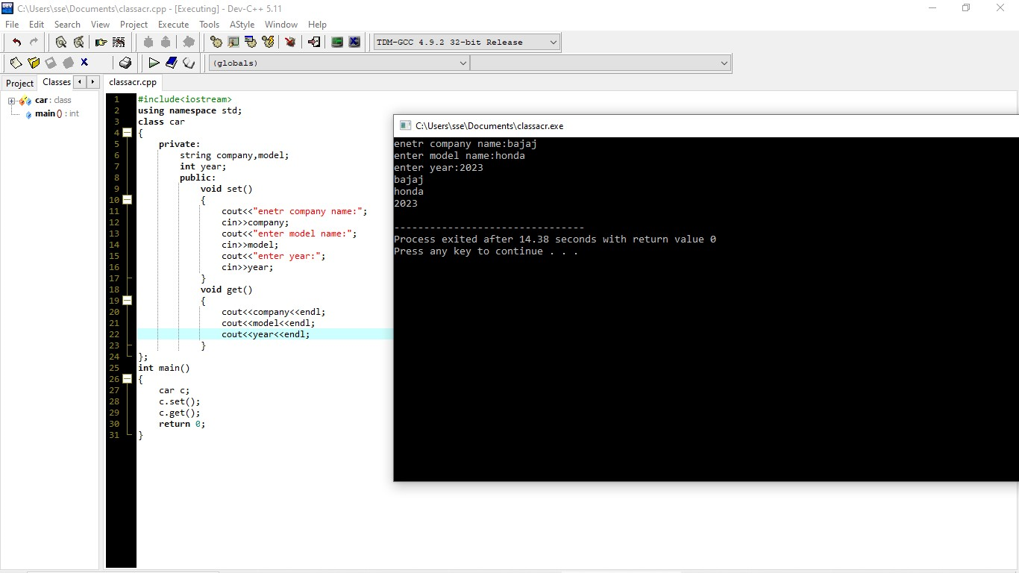

2)create a class named programming while creating an object of the class if nothing is passed to it then the message I like programming languages should be printed,if some string is passed to it,then print the string.

#include<iostream>

using namespace std;

class programming

{

public:

string name;

programming()

{

cout<<"i like programming languages";

}

programming(string x)

{

name==x;

cout<<"print string:"<<name;

}

};

int main()

{

programming \*pr;

pr = new programming();

cout << endl;

programming \*pr1;

pr1 =new programming("swathi");

return 0;

}

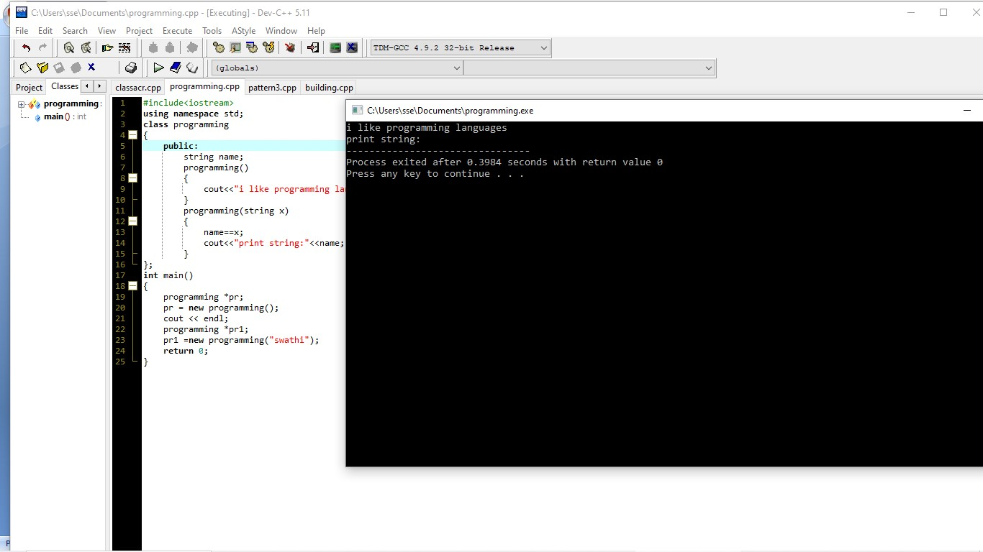

3)pattern program:

#include<iostream>

using namespace std;

int main()

{

int n,i,j;

cout<<"enter number";

cin>>n;

for(i=1;i<=n;i++)

{

for(j=1;j<i;j++)

cout<<j;

cout<<"\n";

}

return 0;

}

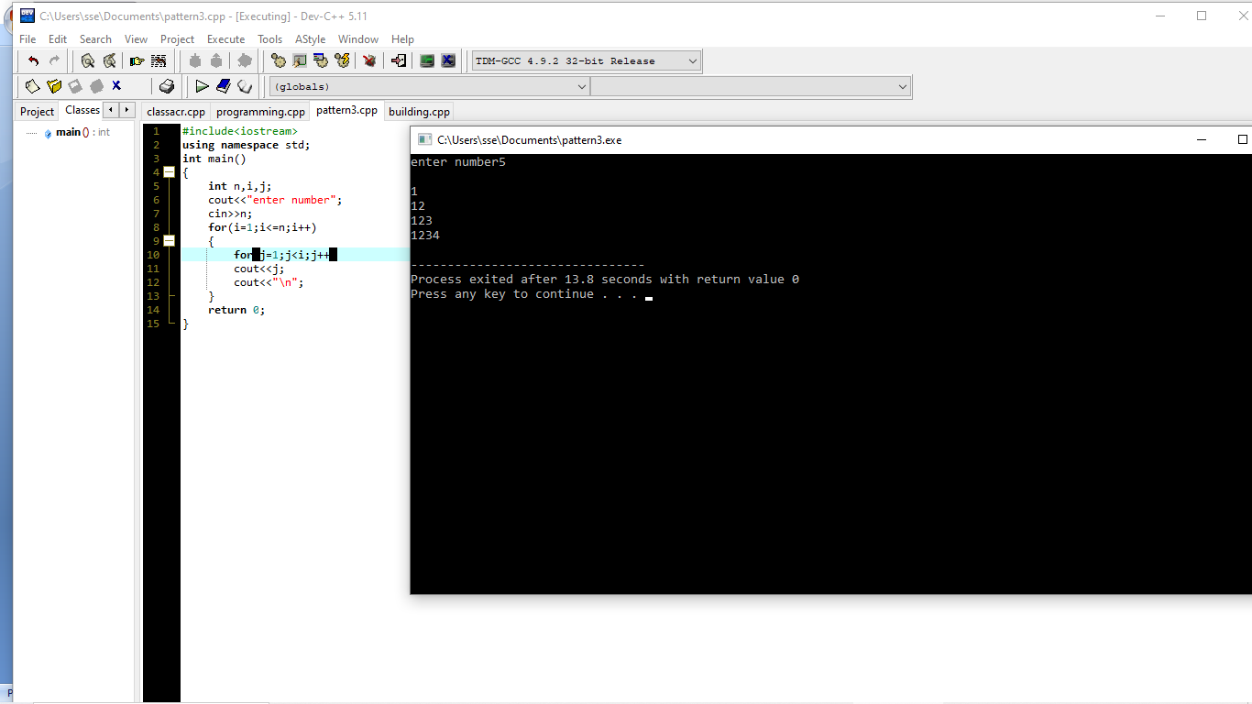

4)class for building and apartment:

#include<iostream>

using namespace std;

class building

{

public:

string name;

int units;

void set()

{

cout<<"enter units";

cin>>units;

cout<<"entr name";

cin>>name;

}

void display()

{

cout<<units<<endl<<name<<endl;

}

};

class apartment:public building

{

public:

int floor,block;

void set1()

{

cout<<"enter floor";

cin>>floor;

cout<<"enter block";

cin>>block;

}

void display1()

{

cout<<floor<<endl<<block<<endl;

}

void display2()

{

cout<<floor<<"\*"<<units;

}

};

int main()

{

building b;

b.set();

b.display();

apartment a;

a.set1();

a.display1();

a.display2();

return 0;

}

