Containers homework submission.

**Name: Swathi Manjunatha. Student ID: 1002162937**

You need to paste all the required screenshots in this one document and upload it. You have 3 attempts and must upload every time you submit. I will grade the last attempt. No partial credit. Ensure all fields in the screenshots are legible (make sure I can read them).

1. Paste the screenshot of the “Details” tab of the EC2 you created, similar to the below (7).

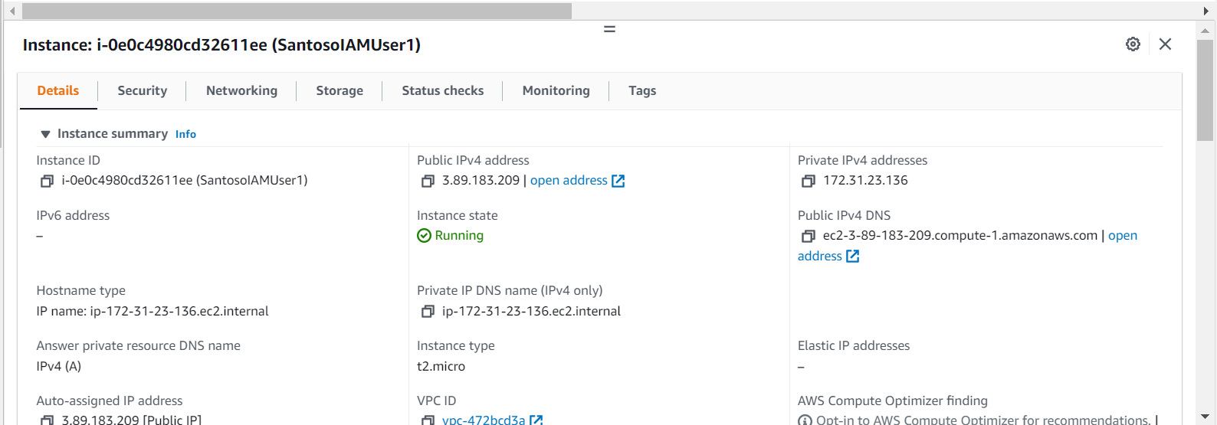

It must show clearly:

* + the public IPv4 address (must match the URL you call from a browser in a later question),
  + the private IPv4 address (must match what shown in the shell prompt in a later question).

Paste image here:

1. Paste the screenshot of the result when you do “docker ps -a” in the ssh shell, similar to the below. (7)



It must clearly show:

* + the internal IP address in the command prompt (must match with EC2 printout)
  + Image name (must have your name)
  + the PORTS must have 80->80

Paste the image here.

1. Paste the screenshot of the browser when you call the public IP address, similar to the below. (7)

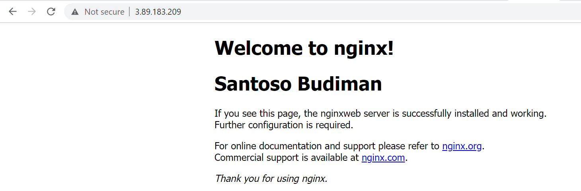

It must show:

* The public IP address (must match the EC2 public IP address)
* Must print your name

Paste image here:

