DynamoDB homework submission.

**Name: Swathi Manjunatha**

**Student ID: 1002162937**

You need to paste all the required screenshots in this one document and upload it. You have 3 attempts and must upload every time you submit. I will grade the last attempt. No partial credit. Ensure all fields in the screenshots are legible (make sure I can read them).

1. From the DynamoDB console show the screenshot of the table you created with the 6 items. It must show the table name (must have your name) and the 6 items (9).

Similar to the below:

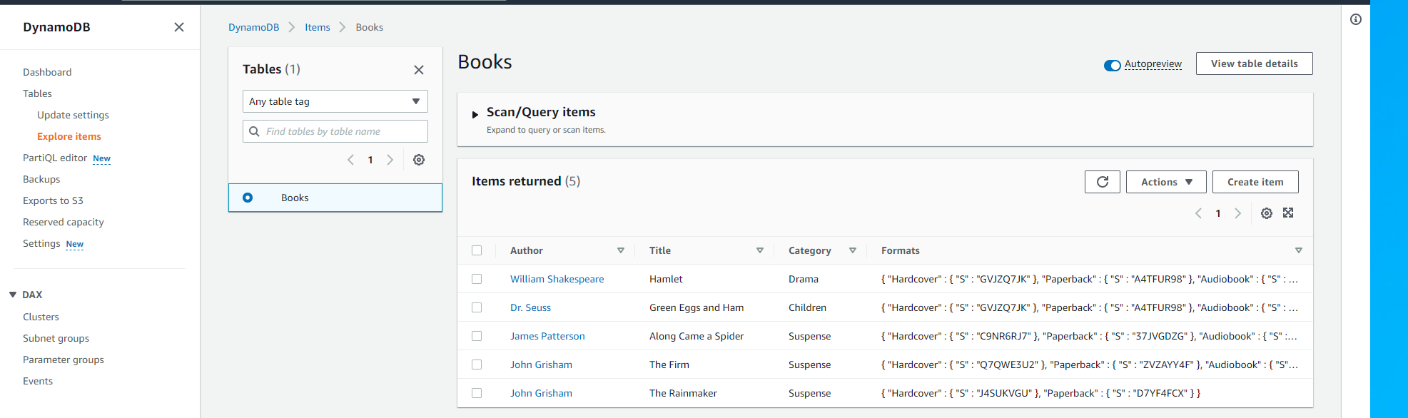

Paste the image here:

1. The screenshot of the query of the item ID = yourlastname103. Show the python script and the result (file editor and terminal), similar to the below. The ID must have your last name (8).

Paste the image here:

1. The Cloud9 screenshot of the query of all items in the Bicycle product category. It must show the python script and the result, similar to the below. The ID must have your last name (8).

Paste the image here.

