Kubernetes homework submission.

**Name: Swathi Manjunatha**

**Student ID: 1002162937**

You need to paste all the required screenshots in this one document and upload it. You have 3 attempts and must upload the document every time you submit. I will grade the one in the last attempt. No partial credit. Ensure all fields in the screenshots are legible (make sure I can read them).

1. Paste the screenshot of the EKS cluster, similar to the below.

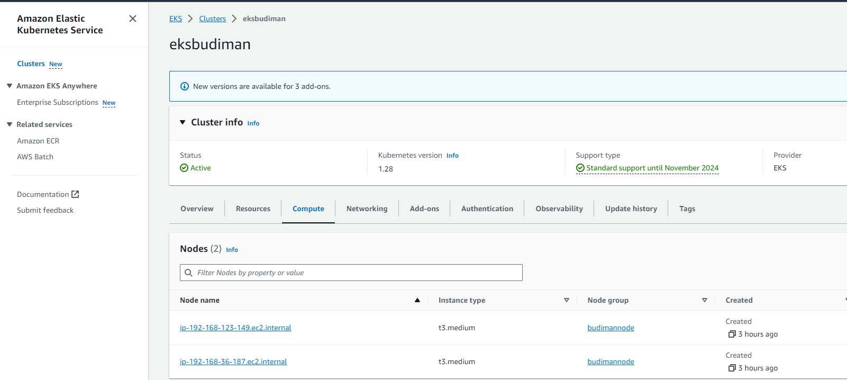

It must show the EKS cluster name (must contain your last name) and the 2 nodes created (10).

Paste the image here:

1. Paste the screenshot of the result of the command "kubectl get pods", similar to the below.

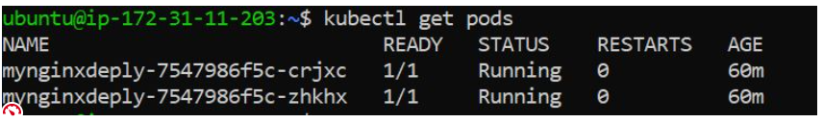

Must show the 3 pods with the deployment name (must contain your last name). (5)

Paste the image here:

1. Paste the screenshot of the result of kubectl get services, similar to the below.



The service name must contain your last name, the TYPE must be LoadBalancer, the EXTERNAL-IP must be complete and clearly shown. (5)

Paste the image here:

1. Paste the screenshot of the browser when you call the LoadBalancer DNS (similar to the below).

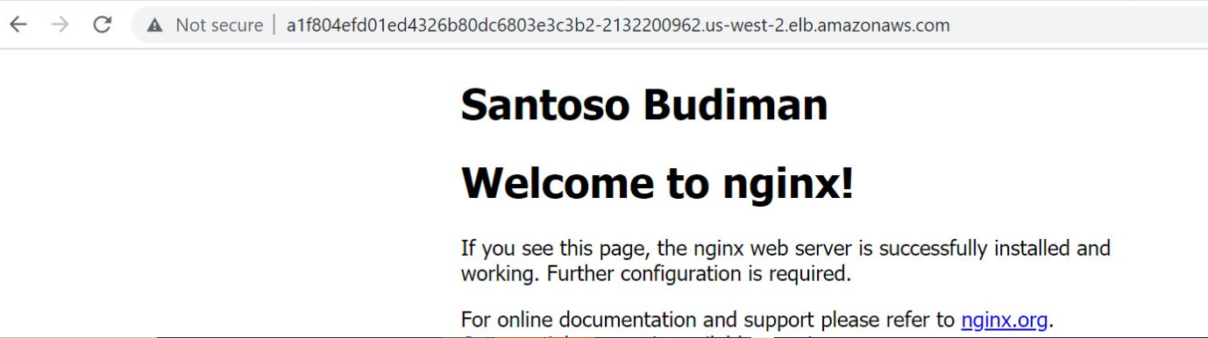

DNS name in the browser must match the DNS name in question 3. (5)

Paste the image here:

-----THE END----