Transit Gateway homework submission.

**Name:** Swathi Manjunatha , Student ID: 1002162937

You need to paste all the required screenshots in this one document and upload it. You have 3 attempts and must upload every time you submit. I will grade the last attempt. No partial credit. Ensure all fields in the screenshots are legible (make sure I can read them).

1. Show the 3 VPCs you created similar to the below. It must show the names (must have your last name) and IPv4CIDR blocks clearly. (7)

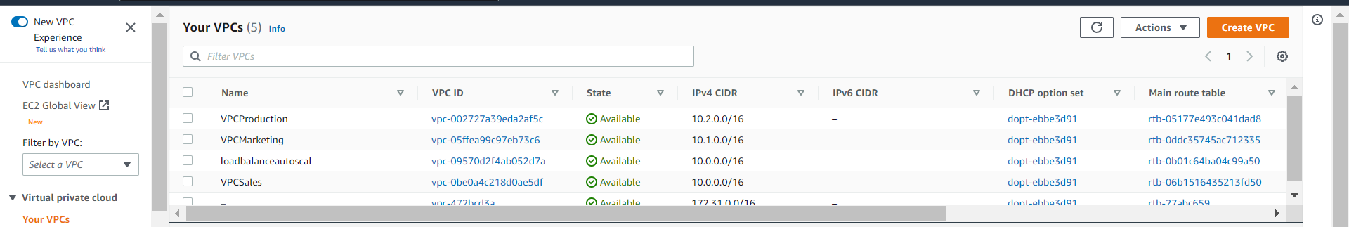

Paste the image here:

1. Show the 6 stacks you created (3 VPCs and 3 EC2s) from the CloudFormation console similar to the below. It must show the stack names (must have your last name) and status: Create_Complete. (8)

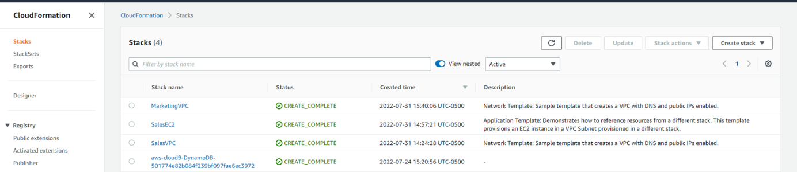

Paste the image here:

1. Show the routes you created for the route table in the RND VPC, similar to the below.

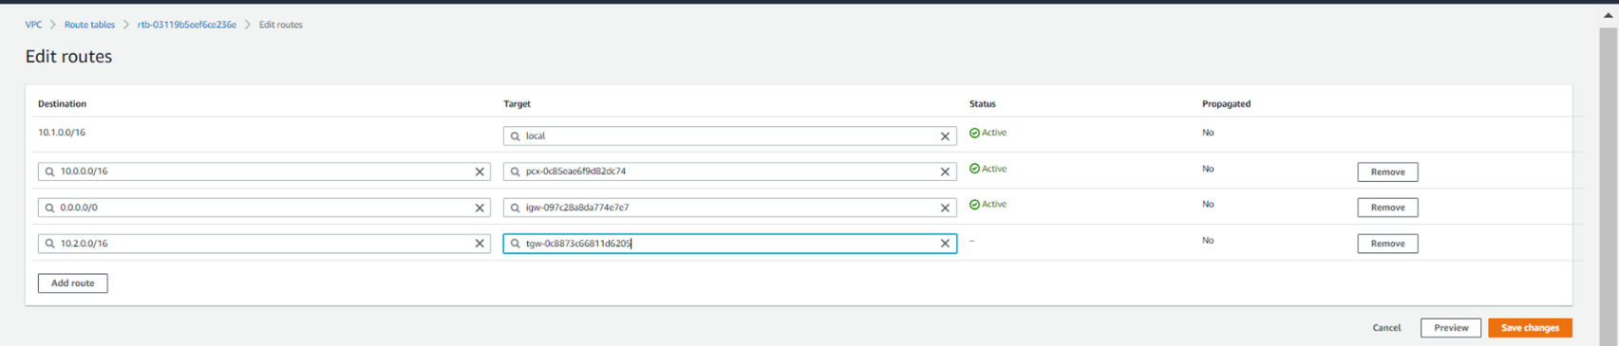

Paste the image here.

The End…