Create New project, select “SQL Server”, Name your project I have named it as DemoSql. Click on ok

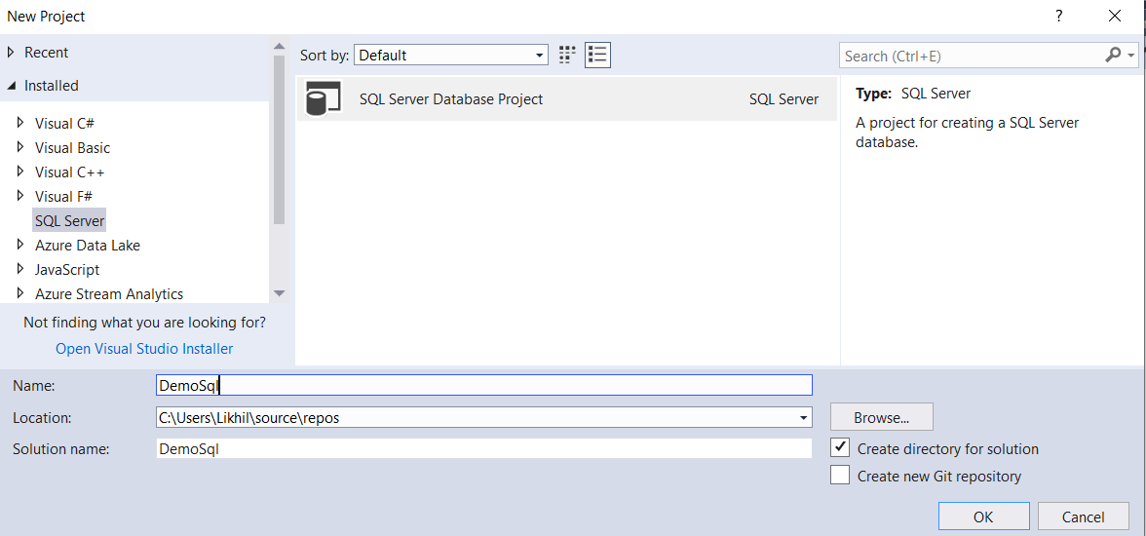

Add new item and select required component in the list. For now am selecting table as I want to build my schema.

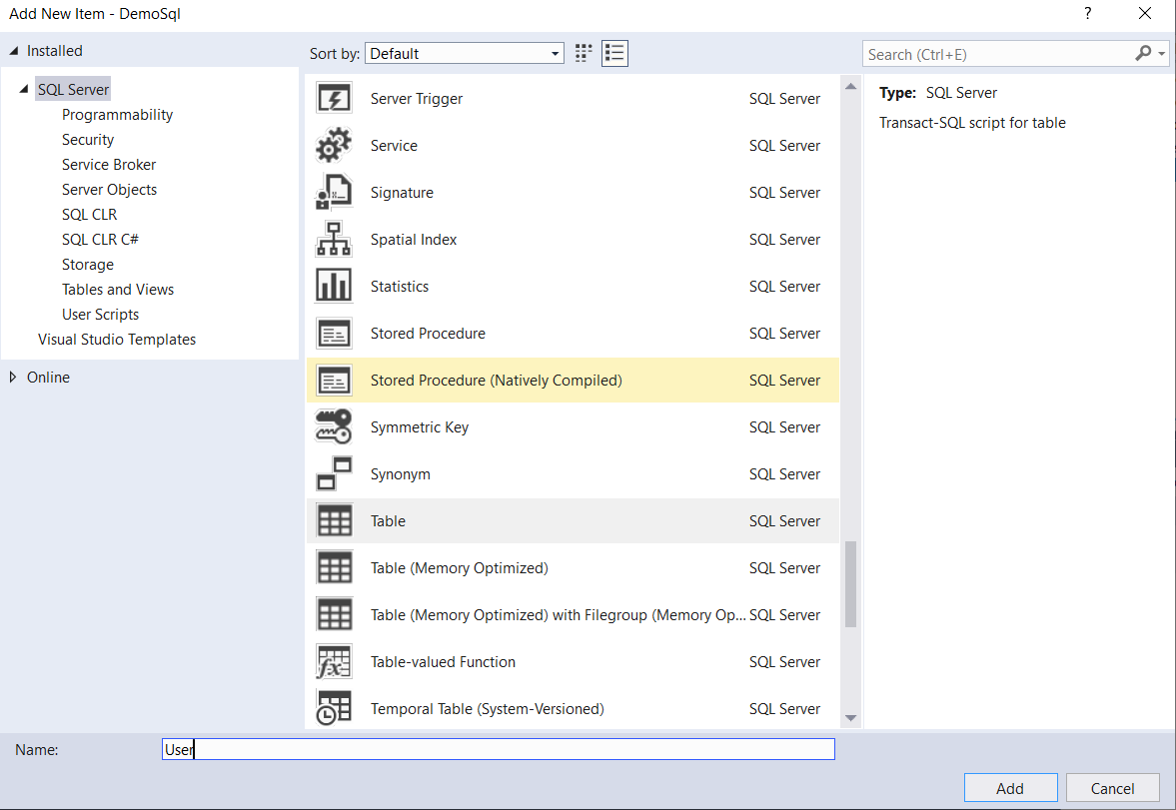

Demo purpose I have built the below table schema.

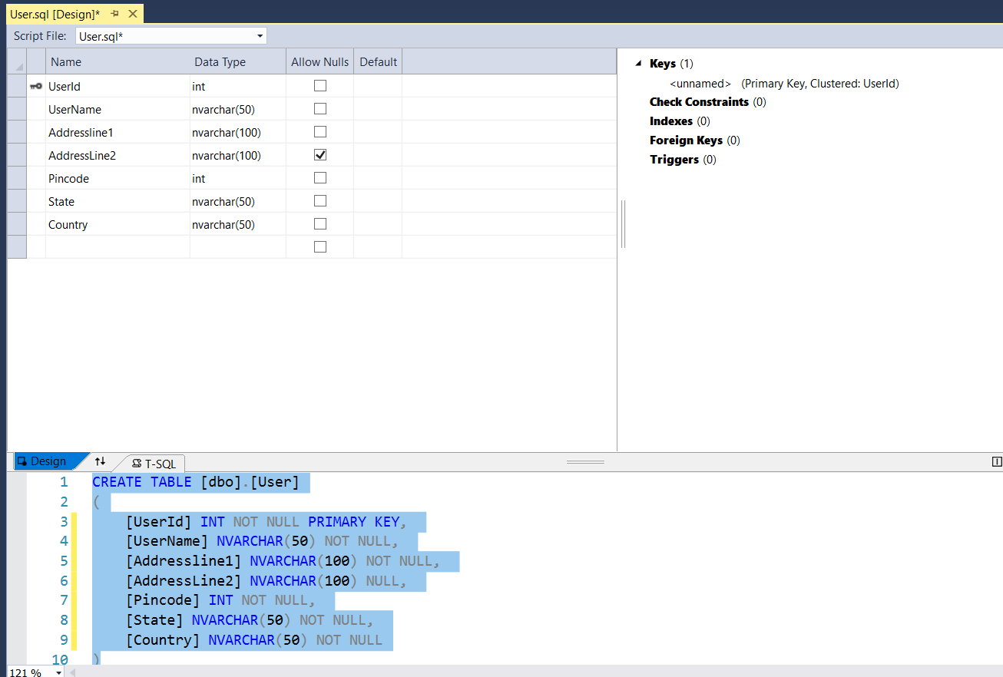

Likewise I have also added another table called Usertype so that we can see how to insert seed data.

CREATE TABLE [dbo].[UserType]

(

[UserTypeID] INT NOT NULL PRIMARY KEY,

[UserType] NCHAR(10) NOT NULL,

[CreatedDate] Datetime NOT NULL,

[CreatedBy] NVARCHAR(50) NOT NULL,

[ModifiedBy] NVARCHAR(50) NULL,

[ModifiedDate] Datetime NULL

)

So as to add seed data below is the script

IF NOT EXISTS (SELECT * FROM [dbo].[UserType] WHERE [UserTypeID] = 0)

INSERT [dbo].[UserType] ([UserTypeId], [UserType], [CreatedBy], [CreatedDate] )

VALUES (0, N'Admin', SUSER_SNAME(), GETUTCDATE())

GO

IF NOT EXISTS (SELECT * FROM [dbo].[UserType] WHERE [UserTypeID] = 1)

INSERT [dbo].[UserType] ([UserTypeId], [UserType], [CreatedBy], [CreatedDate] )

VALUES (1, N'Customer', SUSER_SNAME(), GETUTCDATE())

GO

You can add procedures, functions , views which ever database entity you would need .

Let’s see how do we build and publish it from visual studio .

Right click on project and build. As you see below in output window built completion information will be seen.

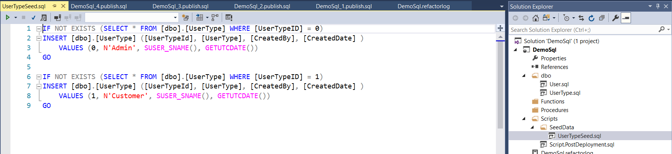

Now before we publish it just wanted to recall we have added seed data, these seed data script need to be executed. Hence, I will be adding PostdeployScript as below.

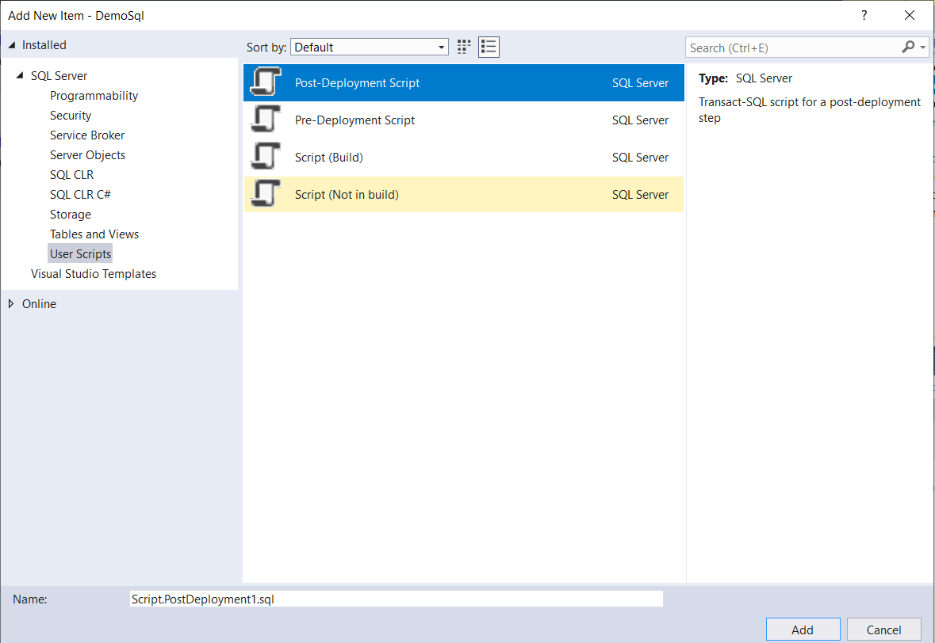

:r .\SeedData\UserType.sql

If you have multiple files then, keep on adding files for an instance say I have departmentType then, we would write as below.

:r .\SeedData\UserType.sql

:r .\SeedData\DepartmentType.sql

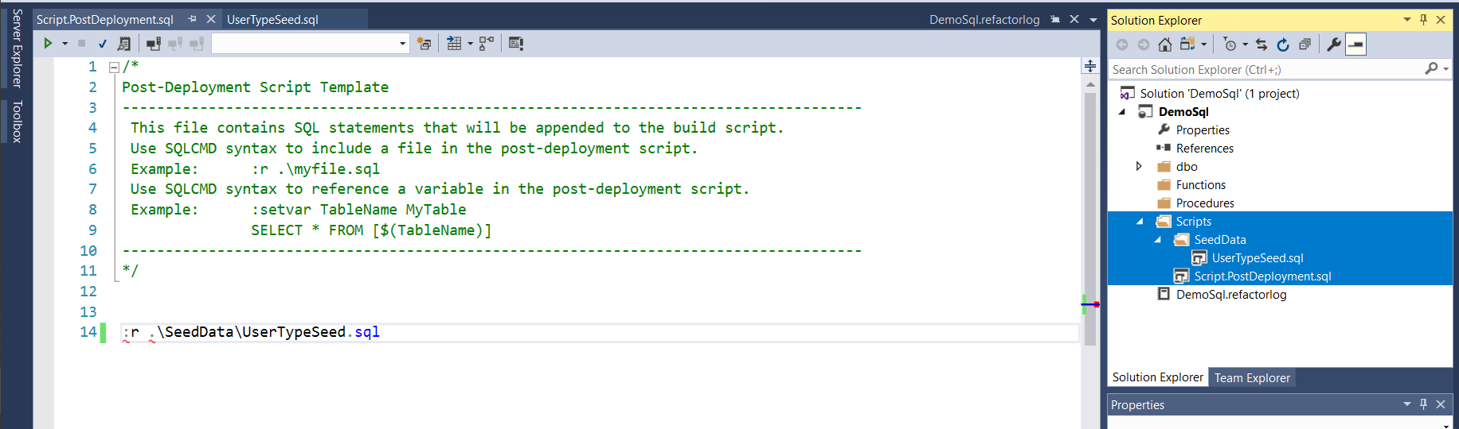

If you get error while you build then make sure you following right folder structure. As you see I have taken “PostDeploymentScript” under scripts folder Hence, While mentioning seed data in script its referred from “SeedData”. If I would have had Postdeployment script in the root folder then, I should have followed entire folder herirachy as .\Scripts\Seeddata\[TableName].

Now again build the solution. Right click and try to publish the project.

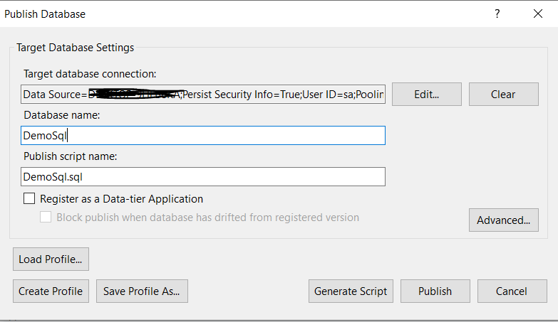

Incase publish fails the refer the view results and correct the same.

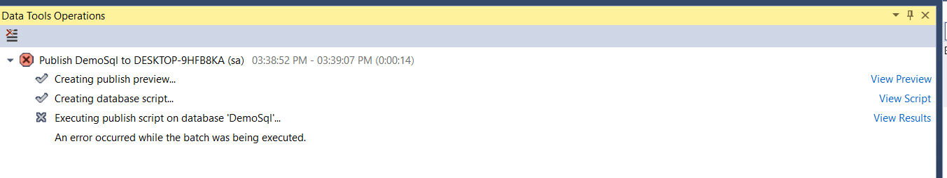

For me error is because of timestamp column. Now I have corrected the same. Am using Date time data type.

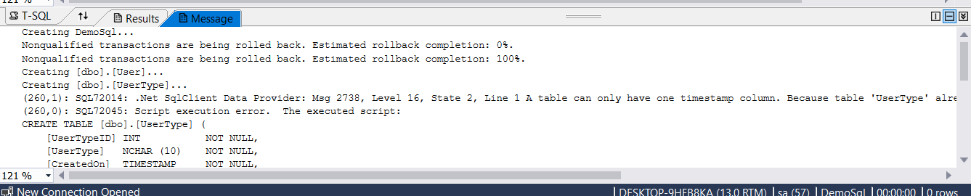

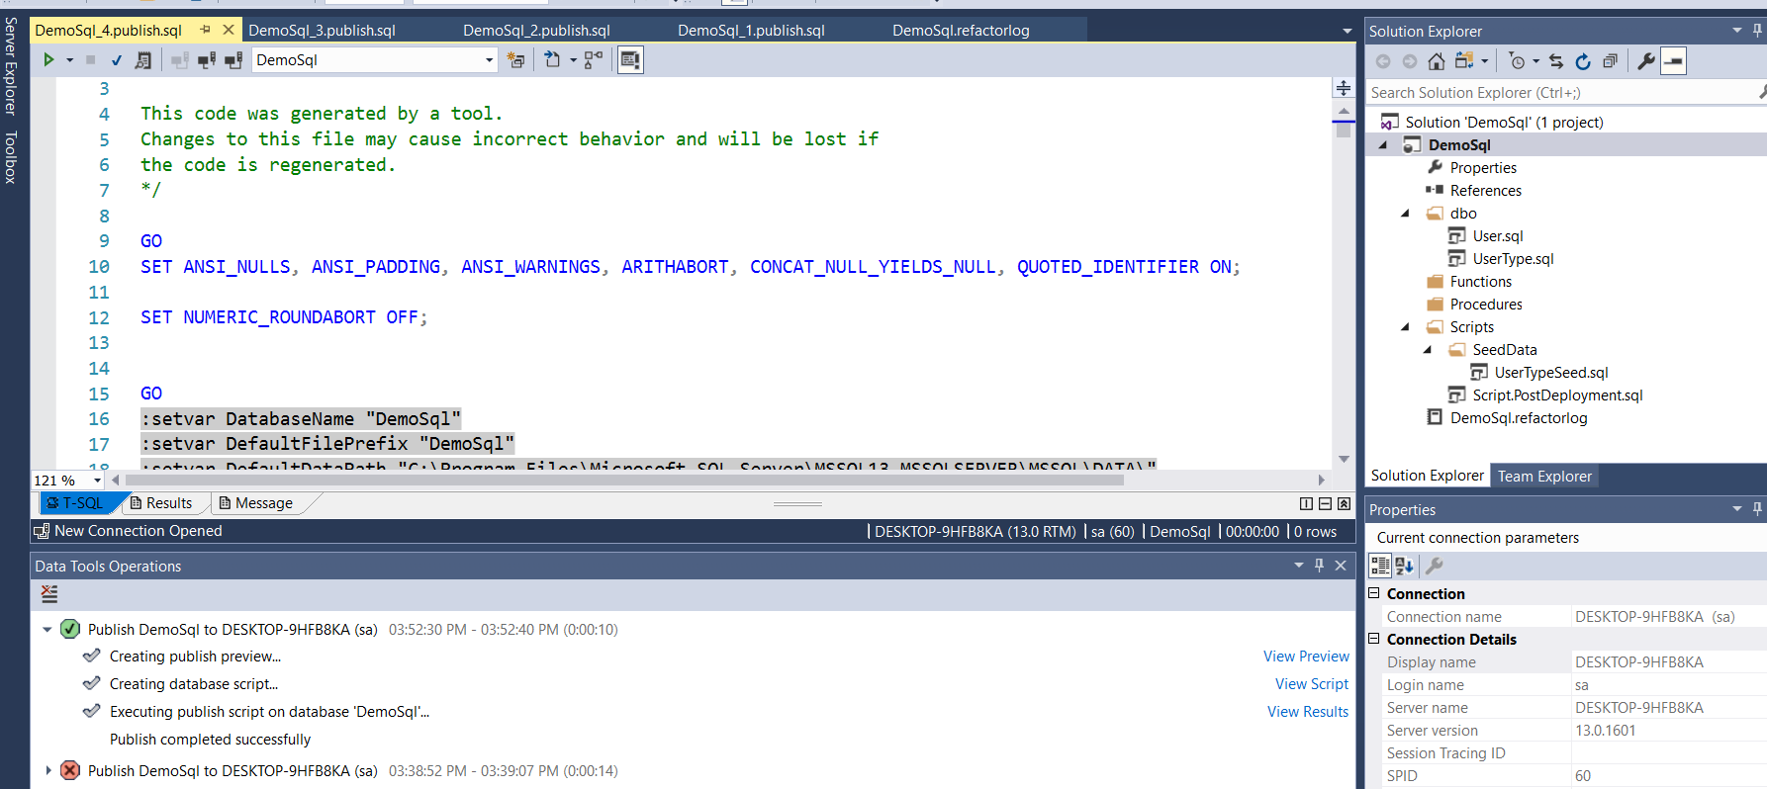

I had to do couple of changes to make this working changing data type. Once the publish succeed you should be able to see DB created in you SQL server.

As the publish succeeds you should be able to see seed data as well as table.

