***AN INDEX OF ECONOMIC***

***FREEDOM ANALYSIS***

***1.Introduction:***

* *Overview of economic freedom:*

The creation of the index is based around economist Adam Smith’s theories in ‘The Wealth of Nations’. One of them states that the “basic institutions that protect the liberty of individuals to pursue their own economic interests result in greater prosperity for the larger society”.

As per the index, the score of economic freedom has increased by 2.6 points in 2008, a significant jump since its creation in 1995. In 2011, however, the score did reduce to 59.7 from its 2008 score of 60.2. Overall the Economic Freedom Score showed improvement for about 117 cuties most of which were mainly developing and emerging market economies.

Economic Freedom Index 2021 has been published by the Heritage Foundation in March 2021.

Singapore topped the list while India ranked 26th in the Asia-Pacific region while ranking 121 overall.

The biggest news generated from the “2021 Index of Economic Freedom” was that the Heritage Foundation decided to exclude Hong Kong from its rankings for the first time ever. The Heritage Foundation said that the reason for leaving Hong Kong out is that the Special Administrative Region and its economic policies have now come under the direct control of Beijing.

* *Purpose of economic freedom:*

An index of economic freedom compares the jurisdictions against each other for various aspects, such as trade freedom, judicial effectiveness, and tax burden. These factors may be weighed for their influence on economic freedom and collated into a single score for ranking.

The cornerstones of economic freedom are (1) personal choice, (2) voluntary exchange coordinated by markets, (3) freedom to enter and compete in markets, and (4) protection of persons and their property from aggression by others.

***2.Problem definition and design thinking:***

* *EMPATHY Map:*

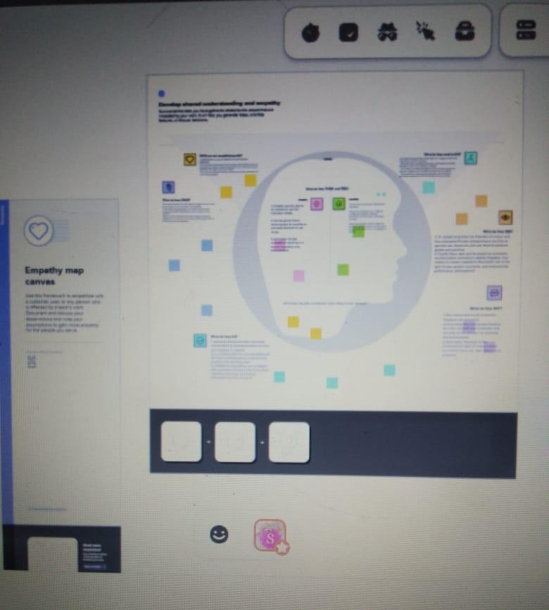

* *IDEATION AND BRAINSTORMING MAP:*

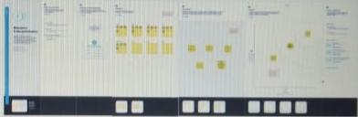

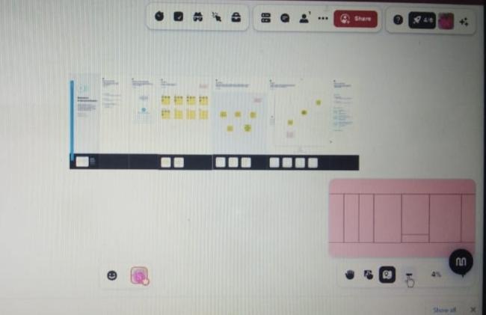

***3.Result:***

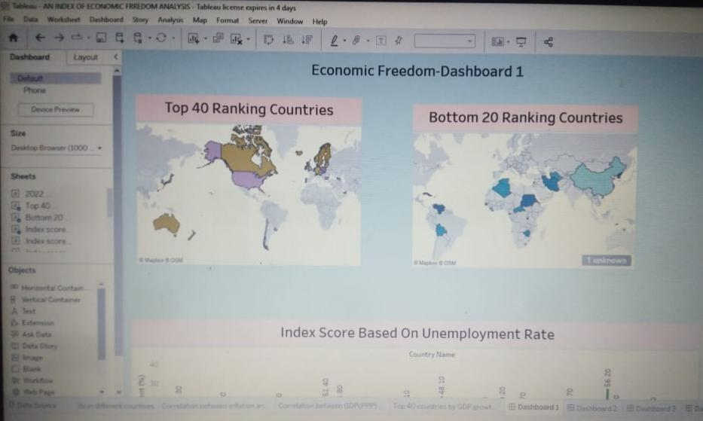

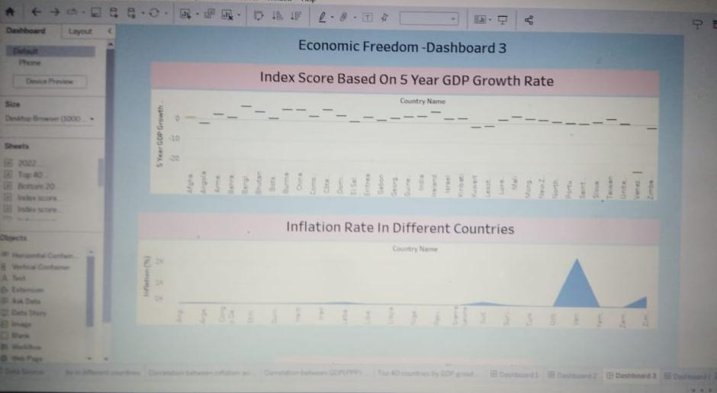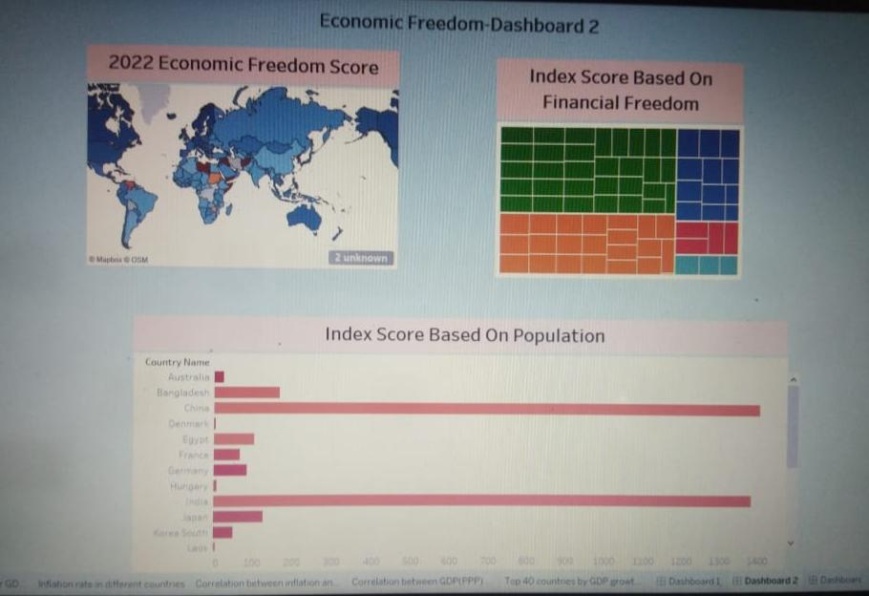

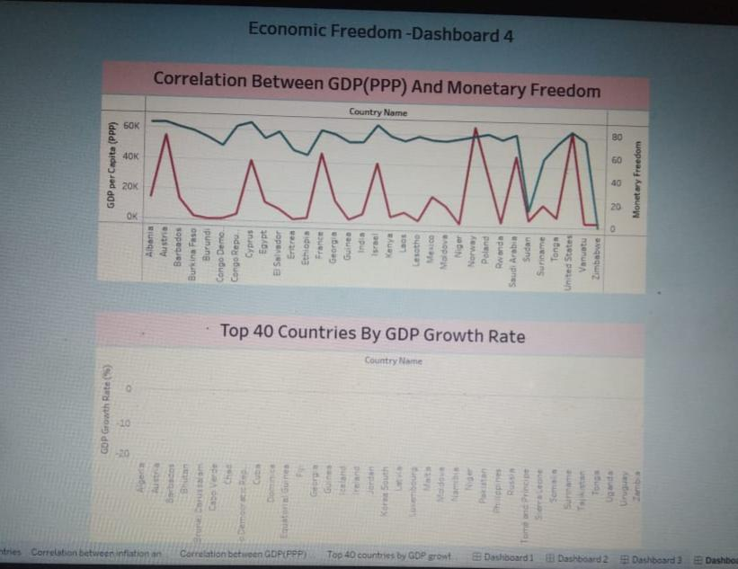

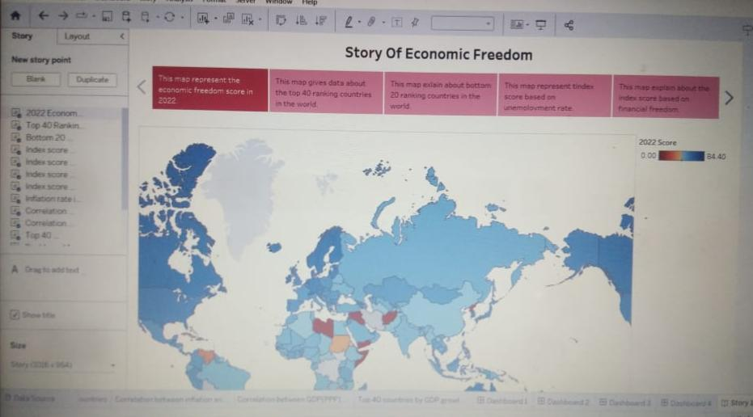

***4.Advantages and disadvantages:***

* *ADVANTAGES OF ECONOMIC FREEDOM:*

1. Resources are automatically allocated to be utilized in the most effective way.
2. Consumers have a wide variety of products to choose from.
3. Innovation is encouraged because of the profit motive and self-interest of the market participants.
4. Competition ensures better quality products, hard-working labour, and hence overall high efficiency.
5. The economy offers a high chance of wealth.
6. Products and services are produced based on customer demands and what they are willing to pay.

* *DISADVANTAGE OF ECONOMIC FREEDOM:*

1. No government intervention – can lead to manufacturers charging the customers whatever fee they want.
2. Inequality – It faces inequality problems among the citizens.
3. Profit as a motive – As the government is in no control of production, profit is the only motive for the production of goods.
4. Poor working conditions – There might be poor working conditions as there is no government regulation in place.
5. Unemployment – Unemployment may rise as there is no government check in the market.

***5.Application of economic freedom:***

Economic freedom is the fundamental right of every human to control his or her own labour and property. In an economically free society, individuals are free to work, produce, consume, and invest in any way.

***6.Conclusion:***

Scholars from the Fraser Institute and elsewhere, on the other hand, have marshalled enormous amounts of data to study the impacts from economic liberty.

Likewise, scholars found many positive associations between economic freedom and well-being.

More recently, and including this study, scholars have begun to find similar positive outcomes between where local governments rank in indices of economic liberty and important metrics such as income, employment and population growth.

***7.Future scope:***

The Index of Economic Freedom is a helpful tool for a variety of audiences, including academics, policymakers, journalists, students, teachers, and those in business and finance. The Index is an excellent objective tool for analysing 184 economies throughout the world and each country page is a resource for in-depth analysis of a country’s political and economic developments. The 12 economic freedoms and accompanying historical data also provide a comprehensive set of principles and facts for those who wish to understand the fundamentals of economic growth and prosperity.