A Project Report on
FOTOPHRASE
An AI-Based Image Caption Generator With Voice Assistance
Using Machine Learning
submitted in partial fulfillment for the award of
Bachelor of Technology
in
Computer Science & Engineering
By
K.Swathi (Y22ACS485) K.Surya Kumar (Y22ACS487)
M.Sailaja (Y22ACS493) K.Anvesh (L23ACS605)



Under the guidance of
N.Srikanth, M.Tech(Ph.D)
Assistant Professor
Department of Computer Science and Engineering
Bapatla Engineering College
(Autonomous)
(Affiliated to Acharya Nagarjuna University)
BAPATLA–522102, Andhra Pradesh, INDIA
2025-2026

Department of
Computer Science & Engineering



CERTIFICATE

This is to certify that the project report entitled FotoPhrase – An AI-Based Image Caption Generator With Voice Assistance Using Machine Learning that is being submitted by K Swathi (Y22ACS485), K Surya Kumar (Y22ACS487), M Sailaja (Y22ACS493), K Anvesh (L23ACS605) in partial fulfillment for the award of the Degree of Bachelor of Technology in Computer Science & Engineering to the Acharya Nagarjuna University is a record of bonafide work carried out by them under our guidance and supervision.

Date:

Signature of the Guide Signature of the HOD N. Srikanth Dr. M. Rajesh Babu Assistant Professor Assoc. Prof. & Head

DECLARATION

We declare that this project work is composed by ourselves, that the work contained herein is our own except where explicitly stated otherwise in the text, and that this work has not been submitted for any other degree or professional qualification except as specified.

K Swathi (Y22ACS485)
K Surya Kumar (Y22ACS487)
M Sailaja (Y22ACS493)
K Anvesh (L23ACS605)

Acknowledgement

We sincerely thank the following distinguished personalities who have offered their valuable advice and support for the successful completion of this work.
We are deeply indebted to our most respected guide, N. Srikanth, Assistant Professor, M.Tech (Ph.D), Department of Computer Science and Engineering, for his/her valuable guidance, constant encouragement, constructive suggestions, and inspiring support throughout the course of this project.
We extend our sincere thanks to Dr. M. Rajesh Babu, Associate Professor & Head of the Department, Department of Computer Science and Engineering, for his cooperation and for providing the necessary facilities and resources to carry out this work successfully.
We would also like to express our heartfelt gratitude to our beloved Principal, Dr. B. Srinivasarao, for providing the required infrastructure, online resources, and institutional support to complete this project.
We express our sincere thanks to our Project Coordinators, Dr. C. Prakasa Rao, Professor, Department of CSE, and Dr. P. Venkata Lakshmi, Associate Professor, Department of CSE, for their valuable suggestions and guidance in preparing and presenting this document.
We are always thankful to our parents and family members for their continuous support, encouragement, and motivation. Without their support, we would not have been able to complete this project work successfully.
Finally, we extend our sincere gratitude to all the teaching faculty and non-teaching staff of the Department of Computer Science and Engineering who helped us directly or indirectly with their cooperation and encouragement.

K Swathi (Y22ACS485)
K Surya Kumar (Y22ACS487)
M Sailaja (Y22ACS493)
K Anvesh (L23ACS605)

ABSTRACT

In today’s digital world, a large amount of visual content is generated every day, making it important to develop systems that can understand and describe images automatically. Image captioning is a technique that combines computer vision and natural language processing to generate meaningful descriptions for images. This project presents FotoPhrase, an AI-based image caption generation system with voice assistance, designed to improve accessibility and user interaction.
The system uses a deep learning-based encoder–decoder architecture, where a Convolutional Neural Network (CNN) extracts features from images and a Long Short-Term Memory (LSTM) network generates captions. An attention mechanism is used to improve the quality of captions by focusing on important parts of the image. The generated captions are further converted into speech using a text-to-speech module, making the system useful for visually impaired users.
The project also includes a user-friendly application that allows users to upload images or capture them using a camera, generate captions in real time, and listen to the output. Additionally, captions can be saved and viewed later through a history feature.
The performance of the system is evaluated using standard metrics such as BLEU and METEOR scores. The results show that the system is capable of generating relevant and understandable captions. This project demonstrates how artificial intelligence can be used to build practical and accessible solutions for real-world problems.
Keywords: Machine Learning, Image Captioning, Convolutional Neural Networks, Recurrent Neural Networks, LSTM, Attention Mechanism, Text-to-Speech, Accessibility.

Table of Contents
ABSTRACT ..................................................................................................................... v
1 INTRODUCTION................................................................................................1
1.1 Motivation............................................................................................7
1.2 Problem Statement ...............................................................................7
1.3 Objective Of The Project ......................................................................8
2 LITERATURE SURVEY ....................................................................................9
2.1 Existing System ..................................................................................10
2.2 Disadvantages of Existing System .....................................................10
2.3 Proposed System .................................................................................11
2.3.1 Data Collection .......................................................................12
2.3.2 Data Preprocessing .................................................................13
2.3.3 Model Architecture .................................................................14
2.3.4 Training ...................................................................................15
2.3.5 Model Integration ....................................................................16
2.2.6 Caption Generation .................................................................16
2.3.7 Text-to-Speech Conevrsion ....................................................16
2.3.8 Application Integration ...........................................................16
2.2.9 Evaluation ...............................................................................17
2.4 Advantages of Proposed System .........................................................17
3 ANALYSIS ..........................................................................................................19
3.1 Software Requirement Specification ....................................................20
3.1.1 User requirement ......................................................................20
3.1.2 Software requirements ..............................................................21
3.1.3 Hardware requirements ............................................................22
3.2 Content Diagram of Project ..................................................................22
4 DESIGN ...............................................................................................................24
4.1 Introduction ..........................................................................................24
4.2 UML diagrams .....................................................................................25
4.3 Data Dictionary ....................................................................................28
5 IMPLEMENTATION & RESULTS ....................................................................32
5.1 Method of Implementation ...................................................................33
5.1.1 Implementation of Algorithms .................................................37
5.1.2 Output Screens .........................................................................40
5.1.3 Result Analysis .........................................................................42
6 TESTING & VALIDATION ................................................................................44
6.1 Features to be Tested ............................................................................45
6.2 Features not to be Tested ......................................................................46
6.3 Testing Tools and Environment ...........................................................47
6.4 Design of test cases and scenarios .......................................................49
7 CONCLUSION & FUTURE ENHANCEMENT................................................50
8 BIBLIOGRAPHY ................................................................................................52

List of figures
Figure 1.1 Learning Phase .................................................................2
Figure 1.2 Inference from Model........................................................3
Figure 1.3 Architecture of Artificial neural network...........................5
Figure 3.1 Content Diagram...............................................................23
Figure 4.1 Data flow Diagram ...........................................................25
Figure 4.2 Use Case Diagram.............................................................26
Figure 4.3 Class Diagram...................................................................27
Figure 5.1 output before uploading image..........................................40
Figure 5.2 output after uploading image.............................................41
Figure 5.1 output of Captions_log.txt.................................................41
Figure 5.2 output of Evaluation Metrics.............................................42
List of Tables
Table 2.1 Features of data .....................................................13
Table 4.1 User data................................................................28
Table 4.2 Image data.............................................................28
Table 4.3 Preprocessing data.................................................29
Table 4.4 Feature extraction data ..........................................29
Table 4.5 Caption data...........................................................30
Table 4.6 Voice output data...................................................30
Table 4.5 History data............................................................31
Table 5.1 Evaluation Metrics.................................................43

1 INTRODUCTION

With the rapid growth of multimedia content, especially images, there is a significant need for intelligent systems that can automatically understand and describe visual data. Image captioning is a challenging task that integrates computer vision and natural language processing to generate meaningful textual descriptions from images.
This project, FotoPhrase — An AI-Based Image Caption Generator with Voice Assistance, aims to develop an end-to-end system capable of generating accurate captions for images using deep learning techniques. The system is designed with three major components: model training, caption generation, and performance evaluation.
The training module is implemented using a custom pipeline on the Flickr30k dataset , where an encoder–decoder architecture is used. The encoder is based on a pre-trained ResNet-50 model that extracts rich visual features from images, while the decoder is an LSTM network integrated with a Bahdanau Attention mechanism to generate context-aware captions. This attention mechanism enables the model to focus on important regions of the image during caption generation.
The trained model is then integrated into an interactive desktop application built using CustomTkinter. The application allows users to upload images from a gallery or capture images using a live camera. It generates captions in real time and also provides voice output using text-to-speech technology, enhancing usability and accessibility. Additional features such as caption saving and session history tracking improve user interaction.
To measure the effectiveness of the model, an evaluation module is implemented using standard metrics such as BLEU and METEOR scores. These metrics quantitatively assess the quality of generated captions by comparing them with ground truth captions.
Overall, this project demonstrates a complete pipeline for image caption generation, from training a deep learning model to deploying it in a real-world application with user interaction and performance evaluation. The system has potential applications in accessibility tools, content management systems, and intelligent human-computer interaction.

Machine Learning
Machine Learning is a system of computer algorithms that can learn from example through self-improvement without being explicitly coded by a programmer. Machine learning is a part of artificial Intelligence which combines data with statistical tools to predict an output which can be used to make actionable insights. The breakthrough comes with the idea that a machine can singularly learn from the data (i.e., example) to produce accurate results. Machine learning is closely related to data mining and Bayesian predictive modeling. The machine receives data as input and uses an algorithm to formulate answers.
How does Machine Learning work?
Machine learning is the brain where all the learning takes place. The way the machine learns is similar to the human being. Humans learn from experience. The more we know, the more easily we can predict. By analogy, when we face an unknown situation, the likelihood of success is lower than the known situation. Machines are trained the same. To make an accurate prediction, the machine sees an example. When we give the machine a similar example, it can figure out the outcome. However, like a human, if its feed a previously unseen example, the machine has difficulties to predict. The core objective of machine learning is the learning and inference. First of all, the machine learns through the discovery of patterns. This discovery is made thanks to the data. One crucial part of the data scientist is to choose carefully which data to provide to the machine. The list of attributes used to solve a problem is called a feature vector. You can think of a feature vector as a subset of data that is used to tackle a problem.The machine uses some fancy algorithms to simplify the reality and transform this discovery into a model.
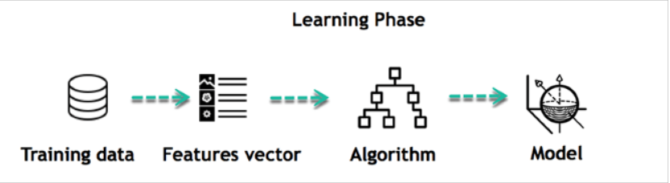

Figure 1.1 Learning Phase
For instance, the machine is trying to understand the relationship between the wage of an individual and the likelihood to go to a fancy restaurant. It turns out the machine finds a positive relationship between wage and going to a high-end restaurant: This is the model. When the model is built, it is possible to test how powerful it is on never-seen before data. The new data are transformed into a features vector, go through the model and give a prediction. This is all the beautiful part of machine learning. There is no need to update the rules or train again the model. You can use the model previously trained to make inference on new data.

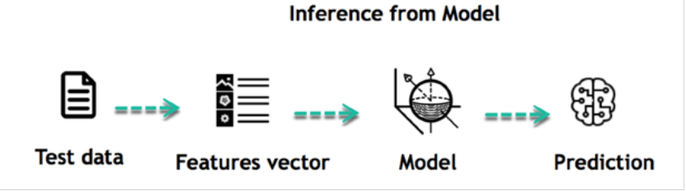

Figure 1.2 Inference from Model

The life of Machine Learning programs is straightforward and can be summarized in the following points:
- Define a question
- Collect data
- Visualize data
- Train algorithm
- Test the algorithm
- Collect Feedback
- Refine the algorithm
- Loop 4-7 until the results are satisfying
- Use the model to make a prediction
Once the algorithm gets good at drawing the right conclusions, it applies that knowledge to new sets of data.
Introduction to Neural Networks
Neural networks, inspired by the intricate workings of the human brain, have become central to the domain of artificial intelligence, particularly within the paradigm of deep learning. Comprised of interconnected nodes organized in layers, neural networks process data by receiving inputs, conducting computations through hidden layers, and producing outputs. Crucial components such as weights, biases, and activation functions shape the network's behavior, allowing it to learn patterns and make predictions. Deep learning, a subset of machine learning, extends this framework by employing neural networks with multiple hidden layers, enabling the extraction of complex features and representations from data. This approach has led to remarkable breakthroughs across diverse domains, including computer vision, natural language processing, and healthcare. However, challenges such as overfitting, computational demands, and data availability persist, requiring continual innovation and research. Despite these obstacles, the transformative potential of neural networks in addressing complex problems and advancing AI capabilities remains unparalleled, promising profound impacts on society and technology in the years to come.
Architecture of Neural Networks
Neural networks are inspired by the structure and function of the human brain. They consist of interconnected nodes called artificial neurons that process information. The architecture of a neural network refers to how these neurons are arranged and connected .Here are the key components of a neural network architecture:
Neurons : These are the basic processing units of a neural network. They receive input, perform calculations on it, and then output a signal.
Layers : Neurons are organized into layers. There are three main types of layers:
- Input layer : This layer receives the raw data that is fed into the network.
- Hidden layers : These layers perform the majority of the information processing in the network. There can be one or more hidden layers, and the number of neurons in these layers can vary depending on the complexity of the task.
- Output layer : This layer produces the final output of the network.
Weights : Weights are associated with the connections between neurons. They determine the strength of the signal that is passed between neurons. The weights are adjusted during the training process to improve the performance of the network.
The architecture of a neural network also determines how information flows through the network. There are two main types of network architectures:
Feed forward networks : In these networks, information flows in one direction, from the input layer to the output layer. Feedforward networks are the simplest type of neural network architecture.
Recurrent networks : In these networks, information can flow in loops, allowing the network to process sequential data or data with dependencies.

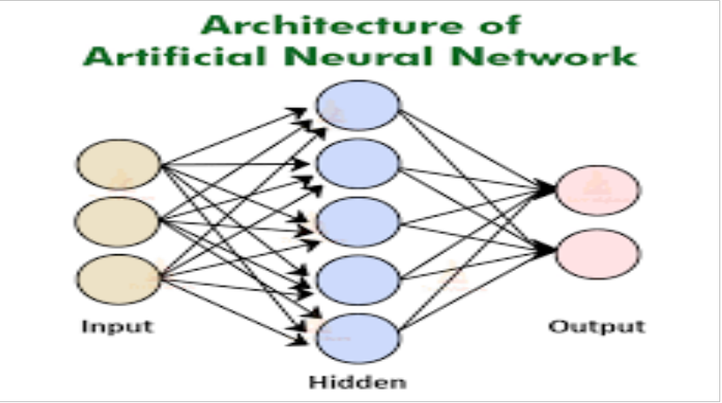

Figure 1.3 Architecture of Artificial neural network

Deep Learning Models
Deep learning models are a powerful type of artificial neural network architecture inspired by the structure and function of the human brain. They excel at uncovering complex patterns in data, achieving impressive results in various fields. Here's a breakdown of some popular deep learning models along with example datasets they can be trained on :
Convolutional Neural Networks (CNNs) : These models excel at capturing spatial relationships in data, making them ideal for analyzing grid-like structures like images. CNNs use filters to automatically learn features from the data, reducing the need for manual feature engineering.
Recurrent Neural Networks (RNNs) : RNNs are designed to handle sequential data where order matters. They process information one step at a time, maintaining an internal state that remembers past inputs. This allows them to analyze sequences like text or speech.
Long Short-Term Memory (LSTM) Networks : LSTMs are a specific type of RNN architecture that addresses the vanishing gradient problem. This limitation can hinder traditional RNNs in dealing with long sequences. LSTMs are particularly adept at learning long-term dependencies in data, making them suitable for tasks like machine translation or speech recognition.
Generative Adversarial Networks (GANs) : GANs take a unique approach where two neural networks compete. The generator tries to create new data that mimics the training data, while the discriminator attempts to identify real data from the generator's creations. This adversarial process pushes both networks to improve, ultimately leading to the generation of highly realistic data.
Transformers : Transformers are a recent advancement in deep learning that utilize an attention mechanism. This mechanism allows them to focus on specific parts of the input data and analyze relationships between them. Transformers are particularly powerful for natural language processing tasks where understanding context is crucial.

Understanding Deep Learning
Understanding deep learning entails grasping the intricate mechanisms through which neural networks learn complex representations from data. At its core, deep learning leverages neural networks with multiple layers to automatically extract hierarchical features, enabling the model to understand and generalize patterns inherent in the data. This process involves iterative training, where the network adjusts its parameters, such as weights and biases, to minimize the discrepancy between predicted and actual outputs. Key to this optimization is the use of backpropagation, a technique that computes the gradient of the loss function with respect to each parameter, facilitating efficient updates during training. Additionally, deep learning models often incorporate various architectural innovations, such as convolutional layers for spatial hierarchies in image data or recurrent layers for sequential dependencies in time-series data. Understanding deep learning also necessitates familiarity with optimization algorithms like stochastic gradient descent and advanced regularization techniques to mitigate overfitting. Through this holistic comprehension, practitioners can harness the power of deep learning to solve complex problems across diverse domains, driving innovation and progress in artificial intelligence.

  - MOTIVATION

In recent years, the rapid growth of digital content has led to an overwhelming number of images being shared across platforms such as social media, education systems, and online services. While these images provide valuable information for most users, they remain largely inaccessible to visually impaired individuals. This lack of accessibility highlights a critical gap in current technology, where visual content is not equally available to everyone.
The motivation behind this project is to address this challenge by developing an intelligent system that can automatically understand and describe images in a meaningful way. By converting visual information into both text and speech, the system aims to make digital content more inclusive and accessible. This is especially important in real-world scenarios where missing visual details can limit a person’s ability to learn, communicate, or interact with digital platforms.
Another key motivation is to explore how advanced Machine Learning techniques can be combined effectively to solve practical problems. Image captioning is not just about generating text, but about producing accurate, fluent, and context-aware descriptions. Integrating this with voice output further enhances usability, as it allows users to hear the description rather than read it.
Additionally, this project is driven by the goal of building a complete end-to-end system — from training a deep learning model to deploying it in a user-friendly application. This provides hands-on experience in multiple domains, including computer vision, natural language processing, and user interface design.
Overall, the motivation of this project is to create a smart, efficient, and accessible solution that demonstrates the real-world impact of artificial intelligence, particularly in improving the quality of life for visually impaired users and enhancing human-computer interaction.

  - PROBLEM STATEMENT

In the modern digital era, a vast amount of information is communicated through images across various platforms such as social media, educational resources, and web applications. However, this visual content is not easily accessible to visually impaired individuals, creating a significant barrier to information access and digital inclusion. Existing systems either lack the ability to generate meaningful descriptions of images or fail to provide outputs that are natural and useful in real-world scenarios.
Moreover, many traditional image captioning approaches focus only on generating text without considering how the output will be consumed, especially in the form of speech. Captions designed for reading may not be suitable for listening, leading to issues in clarity and user experience. Additionally, some systems do not effectively capture important details of an image, resulting in incomplete or less informative descriptions.
Therefore, there is a need to develop an intelligent system that can automatically generate accurate, context-aware, and fluent captions for images, while also converting them into natural-sounding speech. The system should be capable of understanding visual content, identifying key elements within an image, and presenting the information in a way that is both accessible and user-friendly.
This project aims to address these challenges by designing and implementing an AI-based image caption generation system integrated with voice assistance, ensuring improved accessibility, better user interaction, and practical real-world usability.

  - OBJECTIVE OF THE PROJECT

The main objective of this project is to develop an intelligent and user-friendly system that can automatically generate meaningful captions for images and convert them into speech, thereby improving accessibility and user interaction.
The specific objectives of the project are:
- To design and implement an image caption generation system using deep learning techniques.
- To extract meaningful visual features from images using Convolutional Neural Networks (CNN).
- To generate accurate and context-aware captions using Recurrent Neural Networks (RNN) with LSTM architecture.
- To incorporate an attention mechanism to improve the quality and relevance of generated captions.
- To enhance caption generation using beam search for better sentence formation.
- To convert generated text captions into speech using text-to-speech technology.
- To develop a user-friendly application that allows image upload and real-time caption generation.
- To enable image capture through a webcam for live caption generation.
- To store generated captions and maintain a session history for user reference.
- To evaluate the performance of the model using standard metrics such as BLEU and METEOR scores.
- To improve accessibility for visually impaired users by providing audio descriptions of images.

2 LITERATURE SURVEY
Image captioning has emerged as an important research area that combines computer vision and natural language processing to generate meaningful textual descriptions for images. It plays a vital role in applications such as accessibility, image indexing, content management, and human-computer interaction. Over the years, several approaches have been proposed to improve the accuracy and quality of generated captions.
Initially, image captioning systems were based on template-based and retrieval-based methods. Template-based approaches generated captions using predefined sentence structures, while retrieval-based methods selected captions from a dataset based on image similarity. Although these approaches were simple to implement, they lacked flexibility and were unable to generate diverse and context-aware descriptions.
With the advancement of deep learning, encoder–decoder architectures became the standard approach for image captioning. In these models, Convolutional Neural Networks (CNNs) are used as encoders to extract high-level visual features from images, while Recurrent Neural Networks (RNNs), particularly Long Short-Term Memory (LSTM) networks, are used as decoders to generate captions sequentially. This approach significantly improved the ability of models to produce fluent and grammatically correct sentences.
A significant improvement in caption generation was achieved through the introduction of attention mechanisms. Attention-based models allow the system to focus on specific regions of an image while generating each word, rather than relying on a single fixed representation. Techniques such as Bahdanau Attention enhance the model’s ability to capture important details, resulting in more accurate and descriptive captions.
In recent years, more advanced approaches such as Transformer-based architectures and pretrained vision-language models like BLIP have been developed. These models leverage large-scale datasets and achieve state-of-the-art performance in caption generation tasks. However, they often require high computational resources and may not be suitable for real-time or resource-constrained applications.
Furthermore, evaluation of image captioning models is commonly performed using metrics such as BLEU and METEOR, which compare generated captions with reference captions to measure accuracy and relevance. However, these metrics do not fully capture human-like understanding, especially in applications involving speech output.
Based on the review of existing methods, this project adopts a deep learning-based encoder–decoder model with an attention mechanism to generate captions. Unlike many traditional systems, this work integrates caption generation with text-to-speech functionality, forming a unified pipeline. This approach focuses not only on accuracy but also on usability, accessibility, and real-world application, particularly for visually impaired users.
2.1 EXISTING SYSTEM
Image captioning systems have evolved from simple rule-based and retrieval-based methods to advanced deep learning approaches. Early methods relied on predefined templates or matching similar images, but they lacked flexibility and often produced inaccurate captions.
Modern systems use encoder–decoder architectures, where CNNs extract image features and LSTMs generate captions. Attention mechanisms further improve performance by focusing on relevant image regions, producing more context-aware descriptions. However, challenges remain in handling complex scenes and ensuring consistent accuracy.
Recent advancements include Transformer-based and pretrained models, which achieve high accuracy but require significant computational resources, making them less suitable for real-time use. Additionally, most systems focus only on text output and lack integration with text-to-speech, limiting accessibility.
Many existing solutions also lack user-friendly interfaces and practical features like real-time input and caption storage. Therefore, there is a need for a system that combines accurate captioning, voice output, real-time performance, and an intuitive interface.

2.2 DISADVANTAGES OF EXISTING SYSTEM
Despite significant advancements in image captioning technologies, existing systems still face several limitations that affect their real-world usability and effectiveness:
- Lack of Accessibility Focus:
Most existing systems are designed primarily for generating text captions and do not adequately support visually impaired users, as they often lack integrated voice output.
- Separation of Captioning and Speech Modules:
Caption generation and text-to-speech functionalities are usually treated as separate components, leading to captions that are not optimized for natural and clear audio delivery.
- High Computational Requirements:
Advanced models such as Transformer-based and large pretrained models require powerful hardware (GPUs) and large datasets, making them less suitable for real-time or low-resource environments.
- Limited Context Understanding:
Many systems struggle to fully understand complex scenes, relationships between objects, and subtle details, resulting in incomplete or less accurate captions.
- Dependence on Predefined or Training Data:
Models often rely heavily on the dataset they are trained on, which limits their ability to generalize to unseen or diverse real-world images.
- Lack of Real-Time Performance:
Some existing systems are not optimized for real-time caption generation, especially when integrated into applications.
- Absence of User-Friendly Interfaces:
Many solutions are research-based and lack interactive features such as image upload, camera capture, caption history, and easy user interaction.
- Limited Evaluation Scope:
Most systems focus only on accuracy metrics like BLEU and METEOR, ignoring factors such as fluency, readability, and user experience.
- Repetitive or Generic Captions:
Some models generate repetitive or overly general captions that do not provide meaningful or detailed descriptions of the image.
- Not Optimized for Practical Applications:
Existing systems are often not designed for real-world deployment and lack integration with applications that users can easily access and use.
2.3 PROPOSED SYSTEM
To overcome the limitations of existing systems, this project proposes an advanced and integrated AI-based Image Caption Generator with Voice Assistance, named FotoPhrase. The system is designed as a complete end-to-end solution that combines image understanding, caption generation, and speech output into a single, unified pipeline, ensuring better accessibility and user experience.
The proposed system is based on a deep learning encoder–decoder architecture. In this approach, a Convolutional Neural Network (CNN), specifically ResNet-50, is used as an encoder to extract high-level visual features from the input image. These features capture important information such as objects, scenes, and spatial details. The extracted features are then passed to a decoder, which is implemented using a Long Short-Term Memory (LSTM) network. The decoder generates captions sequentially, producing one word at a time based on the visual features and previously generated words.
To enhance the quality and accuracy of captions, the system incorporates a Bahdanau Attention mechanism. This allows the model to focus on specific regions of the image while generating each word, resulting in more context-aware and descriptive captions. Additionally, a beam search algorithm is used during caption generation to improve sentence coherence and select the most probable caption from multiple possible sequences.
A key feature of the proposed system is the integration of text-to-speech (TTS) functionality. Unlike traditional systems where caption generation and speech output are handled separately, this system combines both processes to produce captions that are suitable for both reading and listening. This makes the system particularly useful for visually impaired users by providing audio descriptions of images.
The system is implemented as a user-friendly desktop application that allows users to interact easily with the model. Users can upload images from their device or capture images in real time using a webcam. The application processes the image, generates a caption instantly, and converts it into speech. Additional features such as caption saving and session history tracking further enhance usability and convenience.
The proposed system also includes a model training module using a standard dataset, where the model learns to generate captions, and an evaluation module that measures performance using metrics such as BLEU and METEOR scores. This ensures that the system produces reliable and high-quality results.
Overall, the proposed system provides a practical, efficient, and accessible solution by integrating deep learning techniques with real-time application features. It not only improves caption accuracy but also enhances usability, making it suitable for real-world applications such as assistive technologies, automated image annotation, and intelligent human-computer interaction systems.

2.3.1 Data Collection
Data collection is the foundational step in any deep learning project. For the Image Caption Generation with Voice Assistance system, the data is collected from a publicly available dataset that contains images along with their corresponding textual descriptions (captions).
The dataset used in this project is the Flickr30k dataset, which is widely used for research in image captioning and computer vision tasks. It contains a large number of images, each associated with multiple human-written captions that describe the visual content.
- Dataset Name: Flickr30k Dataset
- Source: Public dataset (commonly used in research)
- Format: Images (.jpg) + Captions (.txt / CSV)
- Size: ~30,000 images
- Captions: Each image has 5 captions
- Total captions: ~150,000
Features Included:
Table 2.1 Features of data
Feature Name | Description
image_id | Unique identifier for each image
image_path | File path of the image
caption | Description of the image
tokens | Processed words from captions
This dataset helps the model learn the relationship between visual features and natural language descriptions.
2.3.2 Data Preprocessing
Before training the model, the dataset must be cleaned and transformed into a suitable format. Preprocessing improves model performance and ensures consistent input.

i. Image Preprocessing
- Images are resized to a fixed dimension (e.g., 224×224)
- Pixel values are normalized
- Images are converted into tensors
This ensures compatibility with the CNN model.

ii. Text Preprocessing
- Captions are converted to lowercase
- Special characters and punctuation are removed
- Start and end tokens are added (e.g., <start>, <end>)
This helps the model understand sentence boundaries.

iii. Tokenization
- Captions are split into individual words
- Each word is assigned a unique index
- A vocabulary is created
This converts text into numerical format for model processing.

iv. Padding
- Captions are padded to a fixed length
- Ensures uniform input size for training
2.3.3 Model Architecture
The proposed system uses a CNN-LSTM architecture with attention mechanism for image caption generation.

i. CNN (Encoder) Architecture
- Input Layer:
Accepts preprocessed image (224×224×3)
- Feature Extraction:
Uses pretrained ResNet-50 model
Final classification layer is removed
- Output:
Generates a feature vector representing the image

ii. LSTM (Decoder) Architecture
- Input Layer:
Takes image feature vector + caption sequence
- Embedding Layer:
Converts words into dense vectors
- LSTM Layer:
Generates captions word-by-word
Captures sequence dependencies
- Output Layer:
Uses softmax activation to predict next word

iii. Attention Mechanism
- Focuses on important parts of the image
- Improves caption accuracy
- Helps generate context-aware descriptions

iv. Beam Search
- Used during caption generation
- Selects best possible sentence from multiple candidates
- Improves sentence quality and fluency.
2.3.4 Training
The model is trained using the Flickr30k dataset, where the system learns to map images to captions.

i. Model Initialization
- CNN initialized with pretrained weights
- LSTM initialized with random weights
- Vocabulary and embeddings prepared

ii. Loss Function
- Categorical Cross-Entropy Loss is used
- Measures difference between predicted and actual words.

iii. Training Loop
For each training step:
a) Image features are extracted using CNN
b) Caption sequence is input to LSTM
c) Model predicts next word
d) Loss is calculated
e) Backpropagation updates weights

iv. Optimizer
- Adam optimizer is used
- Provides faster convergence
2.3.5 Model Integration
The system integrates multiple components into a single pipeline:
- Image → CNN (feature extraction)
- Features → LSTM (caption generation)
- Caption → Text-to-Speech
This integration ensures smooth flow from input to output.
2.3.6 Caption Generation
Caption generation is the process of producing a meaningful description for an input image.
- Image is preprocessed
- Features are extracted
- Caption is generated word-by-word
- Beam search selects best sentence
The final output is a complete and meaningful caption.
2.3.7 Text-to-Speech Conversion
The generated caption is converted into speech using a TTS engine.
- Tool used: pyttsx3
- Converts text into audio
- Provides voice output for users
This improves accessibility, especially for visually impaired users.
2.3.8 Application Integration
A GUI is developed using CustomTkinter:
- Upload Image
- Capture Image
- Generate Caption
- Play Audio
- Save Results
This makes the system user-friendly and interactive.
2.3.9 Evaluation
The model is evaluated using:
- BLEU Score → measures accuracy
- METEOR Score → measures meaning and quality
These metrics help assess system performance.

2.4 ADVANTAGES OF PROPOSED SYSTEM
The proposed system offers several significant advantages over existing image captioning solutions by combining advanced deep learning techniques with practical usability features. It is designed not only to improve caption accuracy but also to enhance accessibility and real-world applicability.
- End-to-End Integrated System:
Unlike traditional approaches, the proposed system integrates image caption generation and text-to-speech into a single unified pipeline. This ensures that the generated captions are suitable for both reading and listening, improving overall system efficiency and usability.
- Enhanced Accessibility for Visually Impaired Users:
The inclusion of voice output makes the system highly beneficial for visually impaired individuals, enabling them to understand image content through audio descriptions and improving digital inclusivity.
- Accurate and Context-Aware Caption Generation:
The use of a deep learning-based encoder–decoder architecture with an attention mechanism allows the system to focus on important regions of the image, resulting in more precise and meaningful captions.
- Improved Sentence Quality with Beam Search:
The implementation of beam search during caption generation helps in selecting the most probable word sequences, leading to better sentence structure, coherence, and readability.
- Real-Time Caption Generation:
The system is optimized to generate captions quickly, making it suitable for real-time applications such as live image capture and instant analysis.
- User-Friendly Graphical Interface:
The application provides an intuitive and interactive interface where users can easily upload images, capture photos using a webcam, generate captions, and listen to audio output without requiring technical expertise.
- Support for Multiple Input Sources:
Users can provide input either by selecting images from the gallery or by capturing images through a live camera, making the system flexible and convenient to use.
- Speech Output for Better Interaction:
The integration of text-to-speech technology ensures that captions are delivered in a natural and understandable manner, enhancing user engagement and interaction.
- Caption Storage and Session History:
The system allows users to save generated captions and maintain a history of previous outputs, which is useful for tracking, reference, and analysis.
- Efficient Use of Computational Resources:
The model is designed to balance performance and efficiency, making it suitable for execution on standard systems without requiring high-end hardware.
- Improved Practical Usability:
Unlike many research-based models, this system is implemented as a complete application, making it directly usable in real-world scenarios such as assistive tools and automated documentation.
- Comprehensive Evaluation Approach:
The system evaluates performance using both quantitative metrics (BLEU and METEOR) and qualitative factors such as fluency and clarity, ensuring a balanced assessment of results.
- Scalability and Future Enhancement:
The modular design of the system allows for easy integration of advanced models, improved datasets, or enhanced speech systems in the future.

3 ANALYSIS
System analysis is an important phase in the development of this project, as it helps in understanding the requirements, feasibility, and overall functionality of the image caption generation system. The proposed system is analyzed in terms of its performance, usability, and ability to meet the intended objectives.
The system is designed to process input images and generate meaningful captions using a deep learning-based approach. The encoder–decoder architecture, along with the attention mechanism, enables the model to extract relevant features and generate context-aware descriptions. The use of beam search further improves the quality and coherence of the generated captions, making them more understandable and natural.
From a performance perspective, the system is evaluated using standard metrics such as BLEU and METEOR scores, which measure the similarity between generated captions and reference captions. The results indicate that the model is capable of producing relevant and grammatically correct descriptions for a wide range of images. However, the system may face challenges in handling highly complex scenes or images that are significantly different from the training dataset.
In terms of usability, the system provides a user-friendly interface that allows users to easily upload images or capture them using a webcam. The integration of text-to-speech functionality enhances accessibility, enabling users, especially those with visual impairments, to understand image content through audio output. Features such as caption saving and session history further improve user experience.
The system is also analyzed for efficiency and feasibility. It is designed to work on standard computing systems without requiring high-end hardware, making it suitable for real-time applications. The modular structure of the system, including training, caption generation, and evaluation components, allows for easy maintenance and future enhancements.
Despite its advantages, certain limitations are identified. The model’s performance depends on the quality and diversity of the training dataset, and it may generate less accurate captions for unfamiliar or complex images. Additionally, while evaluation metrics provide a quantitative measure, they may not fully capture the quality of captions from a human perspective.
Overall, the analysis shows that the proposed system is effective, efficient, and suitable for real-world applications, particularly in improving accessibility and enhancing human-computer interaction through intelligent image captioning.

3.1 SOFTWARE REQUIREMENT SPECIFICATION
The Software Requirement Specification (SRS) provides a detailed description of the requirements for the proposed system, FotoPhrase — AI-Based Image Caption Generator with Voice Assistance. It serves as a foundation for system design and development by clearly defining user expectations, software functionalities, and hardware needs. The SRS ensures that the system is developed in a structured manner and meets both functional and non-functional requirements.
The system is designed to process images, generate meaningful captions using deep learning techniques, and convert them into speech output. It aims to provide an accessible, efficient, and user-friendly solution, particularly for visually impaired users.
3.1.1 USER REQUIREMENTS
The system is intended for general users, including non-technical individuals and visually impaired users. Therefore, it is designed to be simple, interactive, and easy to use. The following are the key user requirements:
- The user should be able to upload images from their local system easily through the application interface.
- The system should allow users to capture images in real time using a webcam, enabling instant caption generation.
- The user should be able to generate captions for the selected or captured image with a single action.
- The generated caption should be clearly displayed on the screen in a readable format.
- The system should provide an option to convert the caption into speech, allowing users to listen to the output.
- The speech output should be clear, understandable, and natural, ensuring better user experience.
- The user should be able to save generated captions for future reference.
- The system should maintain a history of previously generated captions, enabling users to revisit earlier results.
- The interface should be simple, intuitive, and responsive, requiring minimal technical knowledge to operate.
- The system should provide quick responses, ensuring minimal waiting time during caption generation.
- The user should be able to interact with the system without requiring any prior training or expertise.
Overall, the system should provide a seamless and accessible experience for all users.

3.1.2 SOFTWARE REQUIREMENTS
The software requirements define the technologies, tools, and functionalities needed to develop and run the system effectively.

a) Platform Requirements
- Operating System: Windows, Linux, or macOS
- Programming Language: Python

b) Libraries and Frameworks
The system uses several libraries and frameworks to implement its functionalities:
- PyTorch: Used for building, training, and running the deep learning model.
- Torchvision: Used for image preprocessing and accessing pretrained models such as ResNet-50.
- CustomTkinter: Used for developing an interactive and user-friendly graphical user interface (GUI).
- OpenCV: Used for webcam integration and real-time image capture.
- PIL (Python Imaging Library): Used for image loading, resizing, and processing.
- pyttsx3: Used for text-to-speech conversion to generate audio output from captions.

c) Functional Requirements
The system must support the following functionalities:
- Image input through file upload and webcam capture
- Image preprocessing (resizing, normalization, feature extraction)
- Caption generation using a trained deep learning model
- Implementation of encoder–decoder architecture with attention mechanism
- Use of beam search to improve caption quality
- Display of generated captions on the interface
- Conversion of text captions into speech output
- Saving captions and maintaining session history
- Handling invalid inputs and providing appropriate error messages

d) Non-Functional Requirements
- Performance: The system should generate captions quickly with minimal delay.
- Usability: The interface should be simple, interactive, and easy to navigate.
- Reliability: The system should produce consistent and accurate results for valid inputs.
- Scalability: The system should allow future improvements, such as adding advanced models.
- Maintainability: The code structure should be modular and easy to update.
- Portability: The system should work across different operating systems with minimal changes.
3.1.3 HARDWARE REQUIREMENTS
The hardware requirements specify the minimum system configuration needed for smooth operation of the application:
- Processor: Intel i5 or higher for efficient processing
- RAM: Minimum 8 GB to handle model execution and GUI operations
- Storage: At least 10 GB of free space for storing datasets, models, and application files
- Camera: Webcam required for capturing real-time images
- GPU (Optional): A dedicated GPU can significantly improve performance during training and inference but is not mandatory
- Display: Standard monitor for viewing the application interface and captions
The system is designed to work efficiently on standard personal computers without requiring high-end hardware, making it accessible to a wide range of users.

3.2 CONTENT DIAGRAM OF PROJECT
The content diagram represents the overall flow of the system from input to output, showing how different modules interact with each other in the image caption generation process.
- The process starts with user input, where the user either uploads an image or captures it using a webcam.
- The image undergoes preprocessing such as resizing and normalization to prepare it for the model.
- The processed image is passed to the feature extraction module, where a CNN (ResNet-50) extracts important visual features.
- These features are then given to the caption generation module, which uses an LSTM network with an attention mechanism and beam search to generate a meaningful caption.
- The generated caption is displayed on the screen and simultaneously sent to the text-to-speech module to produce audio output.
- Finally, the caption is stored in the history module for future reference.

User Input
(Upload / Camera)

Image preprocessing
(Resize, Normalize)

Feature Extraction
(Resnet-50 CNN)

Caption Generation
(LSTM + Attention + Beam Search)
Generated Caption

Save & History Module
Text-to-Speech (TTS)
(Voice Output)
Text Display
(GUI Output)

Fig 3.1 Content diagram

4 DESIGN

The design phase is a crucial part of system development, as it defines the overall structure, architecture, and workflow of the proposed system. In this project, the design focuses on developing an efficient and intelligent image caption generation system that can process visual input and produce meaningful textual and audio output.
The system is designed using a modular approach, where the entire functionality is divided into smaller, manageable components. This approach improves system clarity, maintainability, and scalability. Each module performs a specific task, and all modules work together to achieve the final output. The major modules include input handling, image preprocessing, feature extraction, caption generation, output generation, and storage.
The proposed system follows a deep learning-based encoder–decoder architecture. The encoder is responsible for extracting meaningful visual features from the input image using a Convolutional Neural Network (CNN), specifically ResNet-50. These features capture important aspects of the image such as objects, textures, and spatial relationships. The decoder uses a Recurrent Neural Network (RNN) with Long Short-Term Memory (LSTM) to generate captions in a sequential manner.
To enhance the quality of captions, an attention mechanism is integrated into the system. This allows the model to focus on important regions of the image while generating each word, resulting in more accurate and context-aware descriptions. Additionally, beam search is used during caption generation to improve sentence structure and coherence.
The system also integrates text-to-speech functionality, which converts generated captions into audio output. This feature improves accessibility, especially for visually impaired users. Overall, the design ensures that the system is efficient, user-friendly, and suitable for real-world applications.

4.1 INTRODUCTION

The proposed system is designed to enable smooth interaction between the user and the machine by combining image processing, deep learning, and speech technologies. It accepts an image as input and generates a caption along with voice output.
The system includes modules for image input, preprocessing, feature extraction using CNN (ResNet-50), and caption generation using LSTM with attention. The generated caption is displayed and converted into speech for better accessibility.
Finally, the system stores captions and maintains history for future use. Overall, the design ensures efficient processing and a user-friendly experience.

4.2 UML DIAGRAMS

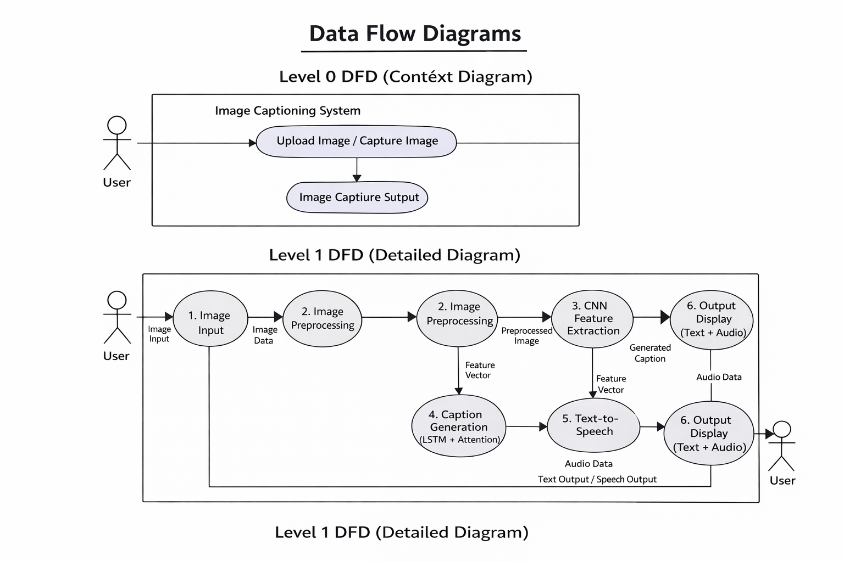

Fig 4.1 Data Flow Diagram

The Data Flow Diagram represents how data moves through the system from input to output. It shows the flow of image data through preprocessing, feature extraction, caption generation, and audio conversion stages. The diagram helps in understanding how different processes interact with each other. It provides a clear visualization of the system’s workflow.

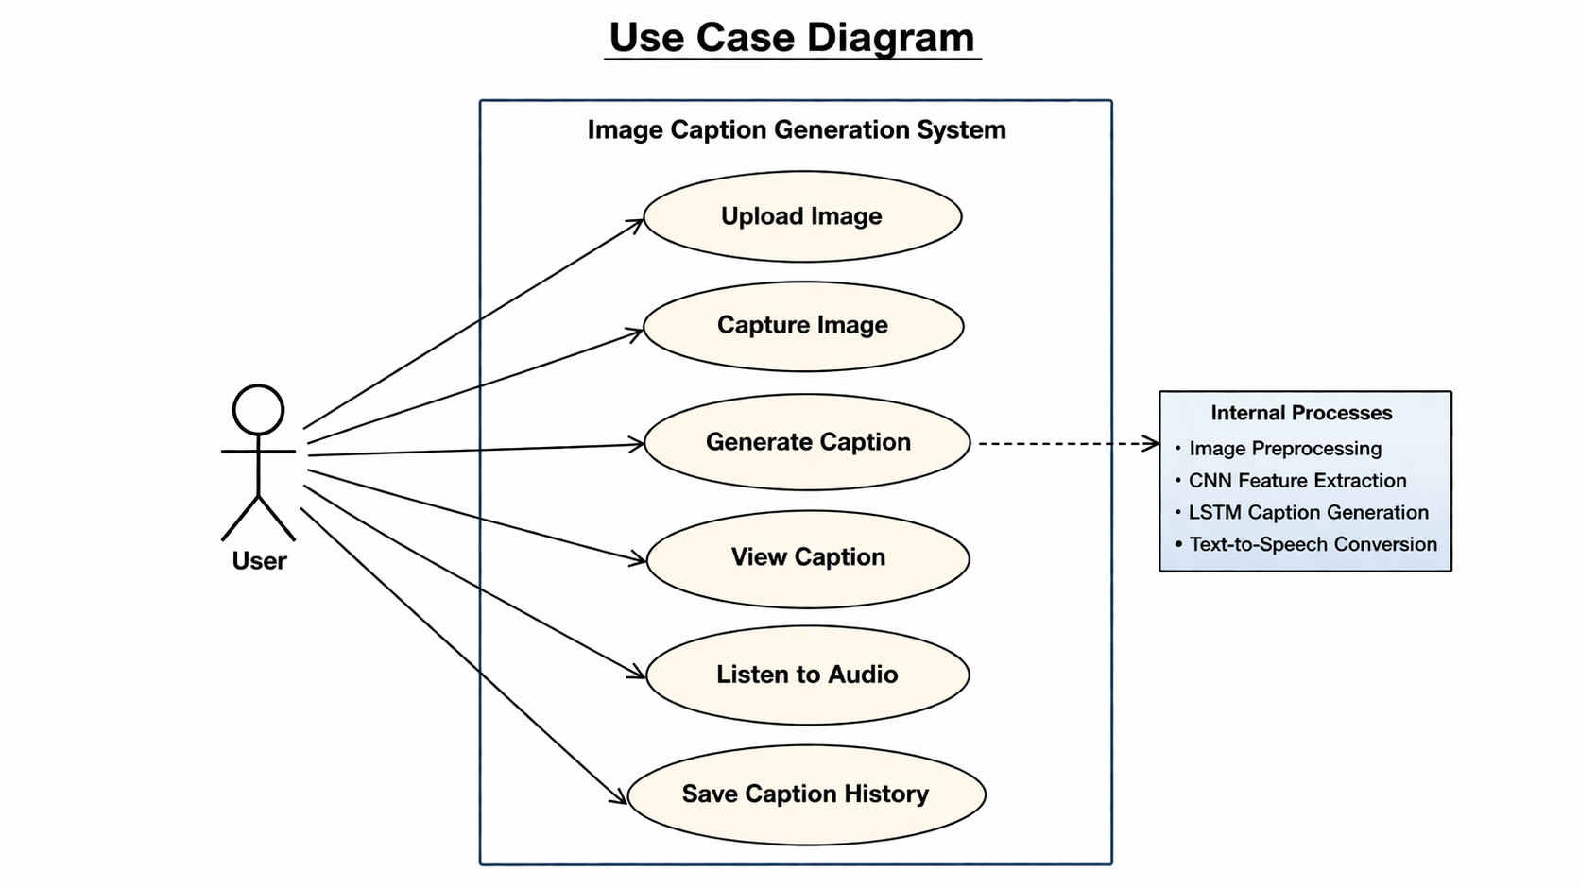

Fig 4.2 Use Case Diagram

The Use Case Diagram represents the interaction between the user and the image captioning system. It shows how the user can upload or capture an image and receive a generated caption along with audio output. The diagram highlights the main functionalities such as caption generation and history saving. It provides a clear overview of system behavior from the user’s perspective.

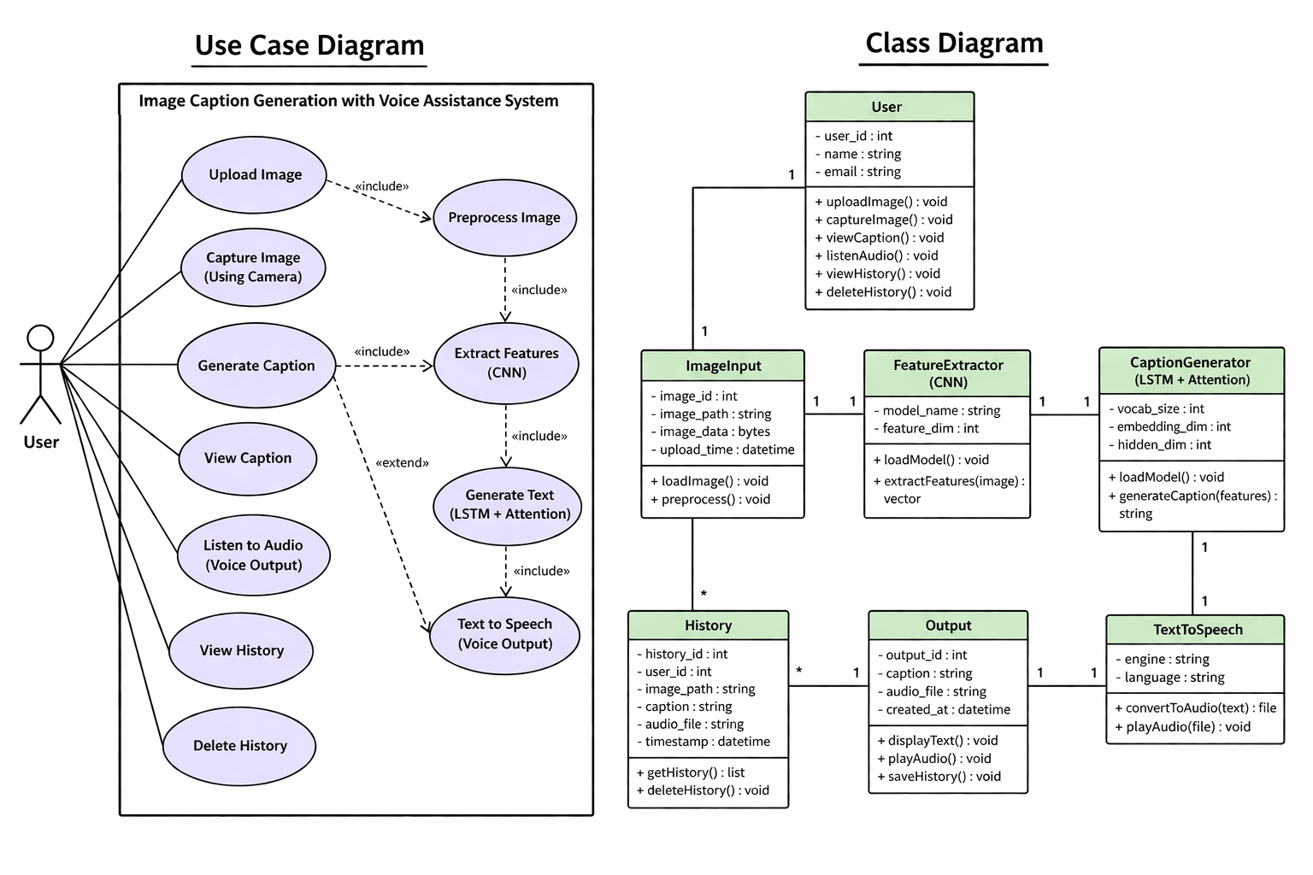

Fig 4.3 Class Diagram

The Class Diagram illustrates the internal structure of the system by defining classes, attributes, and methods. It shows how different components like image input, feature extraction, caption generation, and text-to-speech are connected. The relationships between classes help in understanding data flow and functionality. This diagram is essential for designing and implementing the system.

4.3 DATA DICTIONARY

The Data Dictionary provides a detailed description of all data elements used in the system. It defines the structure, type, and purpose of each data field, ensuring consistency and clarity throughout the system. The data dictionary helps in understanding how data is stored, processed, and used across different modules.
- User Data
Table 4.1 User data
Field Name | Data Type | Description
user_id | Integer (PK) | Unique identifier for the user
name | String | Name of the user

User data represents the individual interacting with the system. Although the system is simple and may not require full authentication, this entity helps in organizing user-specific data such as uploaded images and caption history.

- Image Data

Table 4.2 Image data

Field Name | Data Type | Description
image_id | Integer | Unique identifier for each image
user_id | Integer (FK) | Reference to the user who uploaded the image
image_path | String | Path/location of the image file
image_format | String | Format of the image (JPG, PNG, etc.)

This data represents the input images provided by the user. The system accepts images either through file upload or camera capture. Each image is uniquely identified and stored temporarily for processing.

- Preprocessing Data

Table 4.3 Preprocessing data

Field Name | Data Type | Description
image_array | Tensor | Processed image in numerical format
size | Integer | Resized dimensions of the image
normalized_values | Float | Pixel values normalized for model input

Before feeding the image into the model, it is preprocessed. This includes resizing, normalization, and conversion into tensor format. This step ensures compatibility with the CNN model.

- Feature Extraction Data

Table 4.4 Feature Extraction data

Field Name | Data Type | Description
feature_vector | Tensor | Extracted features from CNN
dimension | Integer | Size of the feature vector

The feature extraction module uses a CNN (ResNet-50) to convert images into feature vectors. These features represent important visual information such as objects and patterns in the image.

- Caption Data

Table 4.5 Caption data

Field Name | Data Type | Description
caption_id | Integer | Unique identifier for each caption
image_id | Integer (FK) | Reference to the related image
caption_text | String | Generated caption
confidence_score | Float | Probability score of generated caption

This data represents the output of the caption generation model. The caption is generated word by word using an LSTM model with attention and beam search.

- Voice Output Data

Table 4.6 Voice Output data

Field Name | Data Type | Description
audio_id | Integer | Unique identifier for audio output
caption_id | Integer (FK) | Reference to caption
audio_file | String | Path to generated audio file

The generated caption is converted into speech using text-to-speech technology. This data ensures that the audio output is properly linked to the corresponding caption.

- History Data

Table 4.7 History data

Field Name | Data Type | Description
history_id | Integer | Unique identifier
caption_id | Integer (FK) | Reference to caption
timestamp | DateTime | Time of caption generation

The history module stores previously generated captions along with timestamps. This allows users to revisit earlier outputs and improves usability.

The data dictionary defines all entities and their attributes used in the system. It ensures proper data organization, smooth data flow between modules, and efficient system implementation. It also helps developers and users understand how data is structured and managed within the application.

5 IMPLEMENTATION & RESLUTS
The implementation phase involves developing the proposed image caption generation system using deep learning techniques and integrating it into a user-friendly application. The system is implemented using the Python programming language along with various libraries such as PyTorch, Torchvision, OpenCV, PIL, and pyttsx3.
The project is divided into multiple modules, each responsible for a specific functionality. The implementation begins with the data preparation phase, where the dataset (Flickr30k) is used for training the model. The dataset contains images along with their corresponding captions, which helps the model learn the relationship between visual features and textual descriptions.
The training module is implemented using PyTorch, where an encoder–decoder architecture is developed. The encoder uses a pretrained CNN model (ResNet-50) to extract features from images, while the decoder uses an LSTM network to generate captions. An attention mechanism is incorporated to improve the relevance of generated captions. The model is trained using appropriate hyperparameters such as learning rate, batch size, and number of epochs.
The caption generation module takes an input image, preprocesses it, and extracts features using the trained CNN model. These features are then passed to the LSTM decoder, which generates captions word by word. Beam search is used to improve the quality and coherence of the generated sentences.
The application interface is developed using CustomTkinter, providing an interactive platform for users. The interface allows users to upload images or capture images using a webcam. Once an image is selected, the system generates a caption and displays it on the screen.
The text-to-speech module is implemented using pyttsx3, which converts the generated caption into audio output. This feature enhances accessibility, especially for visually impaired users.
The evaluation module is used to measure the performance of the model using metrics such as BLEU and METEOR scores. These metrics help in assessing the accuracy and quality of the generated captions.

5.1 METHOD OF IMPLEMENTATION

The implementation of the Image Caption Generation with Voice Assistance system uses deep learning techniques combining computer vision and natural language processing. The system processes an input image, extracts features using a CNN, generates captions using an LSTM with attention mechanism, and converts the output into speech. All components are integrated into a user-friendly application for smooth interaction.
The system can be implemented using Python environments like Jupyter Notebook or Google Colab. While Colab offers cloud-based accessibility, Jupyter Notebook is preferred for faster execution and easier local file handling.

Python
Python was developed by Guido van Rossum in the late 1980s at CWI, Netherlands, as a successor to the ABC programming language. Its implementation began in 1989, and Van Rossum led the project until 2018, after which a Steering Council was formed to manage its development. Python is known for its simplicity, flexibility, and wide usage in various fields. As of Python 3.11, improvements include faster execution and better error reporting.

Libraries and APIs used
For the proposed Image Caption Generation with Voice Assistance system, several libraries and APIs are required to build, train, and deploy the deep learning model efficiently. These libraries support tasks such as image processing, model development, data handling, and audio generation. The major libraries used in this project include:
- CustomTkinter
- PyTorch
- Torchvision
- Pandas
- NumPy
- OpenCV
- PIL (Python Imaging Library)
- pyttsx3

- CustomTkinter
CustomTkinter is a modern Python library built on top of the Tkinter framework, used for developing graphical user interfaces. It enhances the appearance of standard Tkinter widgets by providing a more modern design with improved styling features such as rounded corners and theme support. In this project, CustomTkinter is used to create an interactive interface for the image caption generation system. It allows users to upload images or capture images using a webcam. The interface provides buttons and labels to display the generated captions clearly. It also includes functionality to play audio output using the text-to-speech module. CustomTkinter supports both light and dark modes, improving user experience. It is easy to use and integrates well with backend logic. The library helps in building responsive and visually appealing applications. Overall, it enhances usability and makes the system more user-friendly.
- PyTorch
PyTorch is an open-source deep learning framework widely used for building and training neural networks. In this project, PyTorch plays a crucial role in implementing the encoder–decoder architecture for image caption generation. It provides flexibility through its dynamic computation graph, allowing developers to modify the model structure during runtime. PyTorch supports efficient tensor operations and automatic differentiation, which are essential for training deep learning models such as Convolutional Neural Networks (CNN) and Long Short-Term Memory (LSTM) networks.
i. Dynamic Computation Graph: PyTorch allows dynamic creation of neural networks, making it easier to debug and modify models.
ii. Efficient Training: Provides built-in support for backpropagation and optimization algorithms.
iii. GPU Support: Enables faster training using CUDA-enabled GPUs.
- Torchvision
Torchvision is a companion library to PyTorch that provides a wide range of tools specifically designed for computer vision tasks. It includes access to several pretrained models, datasets, and image transformation utilities, making it highly useful for image-based applications.
In this project, Torchvision is primarily used to access the pretrained ResNet-50 model, which acts as the encoder for feature extraction. Instead of training a CNN from scratch, transfer learning is applied by using the pretrained weights of ResNet-50. This approach reduces training time and improves model performance, as the network has already learned general image features such as edges, textures, and shapes.
Torchvision also provides image transformation functions such as resizing, normalization, and conversion to tensor format. These transformations are essential for preparing images before feeding them into the model. Additionally, Torchvision supports dataset handling, allowing efficient loading and processing of image data. The combination of pretrained models and transformation utilities makes Torchvision an essential component of the system.
- Pandas
Pandas is an open-source data analysis and manipulation library widely used for handling structured data. In this project, Pandas is used to manage caption data stored in CSV files. It provides powerful data structures such as DataFrames, which allow easy organization, filtering, and manipulation of large datasets.
One of the key functionalities of Pandas is data loading, as it supports reading data from various file formats such as CSV, Excel, and JSON. In this system, caption data is loaded into a DataFrame, where it can be easily accessed and processed. Pandas also provides tools for cleaning data, such as handling missing values, removing duplicates, and filtering irrelevant entries.
Another important feature of Pandas is data transformation. It allows operations such as grouping, merging, and reshaping data, which are useful during preprocessing. By organizing captions efficiently, Pandas helps in creating a structured dataset that can be used for training the model. Overall, Pandas plays a vital role in managing textual data and ensuring smooth data preprocessing.
- Numpy
NumPy is a fundamental library for numerical computing in Python and is widely used for handling arrays and mathematical operations. It provides support for multi-dimensional arrays and includes a large collection of mathematical functions that are optimized for performance.
In this project, NumPy is used to perform numerical operations on image data and feature vectors. Since images are represented as arrays of pixel values, NumPy allows efficient manipulation and transformation of these arrays. It is also used for operations such as normalization, scaling, and reshaping data.
NumPy’s efficient array operations significantly improve computational performance, especially when dealing with large datasets. It also supports linear algebra operations, which are essential for deep learning computations. The integration of NumPy with PyTorch further enhances the efficiency of data processing and model training.
- OpenCV
OpenCV (Open Source Computer Vision Library) is a powerful library used for real-time image processing and computer vision tasks. In this project, OpenCV is used to capture images from the webcam and perform basic image processing operations.
One of the key features of OpenCV is its ability to handle real-time video streams, which allows users to capture images directly through the application. This enhances the usability of the system by providing an additional input method apart from file upload. OpenCV also supports various image processing techniques such as resizing, filtering, and color conversion, which are useful during preprocessing.
The integration of OpenCV with the system enables real-time interaction and improves the overall user experience. It acts as a bridge between the physical world (camera input) and the digital processing pipeline.
- PIL (Python Imaging Library)
PIL, also known as the Python Imaging Library, is used for opening, manipulating, and saving image files. It provides a simple and efficient interface for handling different image formats.
In this project, PIL is used to load images and convert them into a format suitable for preprocessing and feature extraction. It supports operations such as resizing, cropping, and format conversion, which are essential steps before feeding images into the CNN model.
PIL also works seamlessly with Torchvision transformations, making it easier to integrate image preprocessing steps. Its simplicity and compatibility make it an important tool for image handling in the system.
- Pyttsx3
pyttsx3 is a text-to-speech conversion library used to convert generated captions into audio output. Unlike many other TTS systems, pyttsx3 works offline, making it suitable for applications that require independence from internet connectivity.
In this project, pyttsx3 is used to provide voice output for the generated captions. The text generated by the LSTM model is passed to the TTS engine, which converts it into speech. The library allows customization of voice properties such as speed, volume, and voice type, enhancing the quality of the audio output.
This feature is particularly beneficial for visually impaired users, as it allows them to understand image content through audio descriptions. The integration of pyttsx3 makes the system more accessible and user-friendly.

5.1.1 IMPLEMENTATION OF ALGORITHMS

The proposed Image Caption Generation with Voice Assistance system is implemented using a combination of deep learning algorithms that integrate computer vision and natural language processing techniques. The system primarily relies on Convolutional Neural Networks (CNN), Long Short-Term Memory (LSTM) networks, an Attention Mechanism, and Beam Search algorithm to generate accurate and meaningful captions for input images. Each algorithm plays a specific role in the overall functioning of the system, and together they form an efficient pipeline for caption generation.

- Convolutional Neural Network (CNN) for Feature Extraction
A Convolutional Neural Network (CNN) is a deep learning algorithm widely used for processing and analyzing visual data such as images, and it plays a crucial role in the Image Caption Generation system as a feature extractor. Unlike traditional neural networks, CNNs preserve the spatial structure of images and learn hierarchical patterns such as edges, textures, shapes, and objects through multiple layers. The core component of CNN is the convolutional layer, where filters slide over the image to generate feature maps that capture important visual information. These feature maps are passed through activation functions like ReLU to introduce non-linearity, enabling the model to learn complex patterns. Pooling layers are then used to reduce the spatial dimensions of the feature maps, which helps in lowering computational complexity and preventing overfitting while retaining important features. After several convolution and pooling operations, the output is flattened and passed through fully connected layers to form a compact feature representation. In this project, a pretrained CNN model such as ResNet-50 is used, where the final classification layer is removed, and the network outputs a feature vector representing the image. This feature vector is then provided to the LSTM network for generating captions. CNNs are highly efficient due to parameter sharing, require minimal manual feature extraction, and provide high accuracy in image-related tasks. Thus, CNN serves as a powerful component that enables the system to understand visual content and convert it into meaningful textual descriptions.
- Long Sort-Term Memory (LSTM) for Caption Generation
A Long Short-Term Memory (LSTM) network is a type of Recurrent Neural Network (RNN) designed to process sequential data and overcome the limitations of traditional RNNs, such as the vanishing gradient problem. In the Image Caption Generation system, LSTM acts as the decoder, responsible for generating captions based on the image features extracted by the CNN. Unlike standard neural networks, LSTMs maintain a memory of previous inputs using special units called memory cells, which allow the model to retain important information over long sequences. Each LSTM cell consists of three main gates: the input gate, forget gate, and output gate. The input gate controls how much new information is added to the memory, the forget gate decides which information should be discarded, and the output gate determines what information is passed to the next step. This gating mechanism enables LSTMs to capture long-term dependencies in data, making them highly effective for tasks involving sequences such as text generation. In this project, the LSTM takes the feature vector from the CNN along with previously generated words and predicts the next word in the caption sequence. This process continues step-by-step until a complete sentence is formed. The use of embedding layers further improves performance by converting words into dense vector representations. LSTMs are widely used due to their ability to generate coherent and contextually meaningful sentences. Thus, in this system, the LSTM plays a vital role in converting visual features into natural language descriptions, enabling accurate and fluent caption generation.
- Attention Mechanism (Bahdanau)

Bahdanau Attention, also known as additive attention, is a widely used attention mechanism introduced by Dzmitry Bahdanau in neural machine translation and later applied to tasks like image captioning. In the Image Caption Generation system, Bahdanau attention enhances the CNN-LSTM architecture by allowing the model to dynamically focus on different parts of the image while generating each word in the caption. Instead of using a single fixed feature vector from the CNN encoder, this mechanism computes attention weights for all extracted image features at every time step of the LSTM decoder. These weights are calculated using a small feedforward neural network that considers both the current hidden state of the LSTM and the image features, producing a score that indicates the importance of each feature. The scores are then normalized using a softmax function to obtain attention weights, which are used to compute a context vector as a weighted sum of image features. This context vector is combined with the LSTM hidden state to predict the next word in the sequence. By doing so, the model can selectively attend to relevant regions of the image depending on the word being generated, resulting in more accurate and context-aware captions. Bahdanau attention improves performance by capturing fine-grained visual details and maintaining better alignment between visual features and generated text, making it highly effective for image captioning tasks.
- Beam Search Algorithm
Beam Search is a heuristic search algorithm used in sequence generation tasks to produce more accurate and meaningful outputs by considering multiple possible sequences instead of selecting a single best option at each step. In the Image Caption Generation system, beam search is used during the caption generation phase to improve the quality and fluency of the generated sentences. Unlike greedy search, which selects the most probable word at each step, beam search keeps track of the top “k” most probable sequences, where “k” is called the beam width. At each time step, the algorithm expands all current candidate sequences by predicting the next possible words and computes their probabilities. It then selects the top “k” sequences based on cumulative probability scores and discards the rest. This process continues until an end token is generated or the maximum caption length is reached. By maintaining multiple candidate sequences, beam search reduces the chances of missing better sentence structures that may not have the highest probability at an early stage. As a result, it produces captions that are more coherent, grammatically correct, and contextually relevant. Although beam search requires more computational resources compared to greedy search, it significantly enhances the overall performance of the image captioning system by generating higher-quality descriptions.
- Text-to-Speech (TTS)
Text-to-Speech (TTS) is a technology that converts written text into spoken audio, enabling systems to communicate information audibly. In the Image Caption Generation with Voice Assistance system, TTS is used to convert the generated image captions into speech, making the system more accessible, especially for visually impaired users. After the caption is generated by the CNN-LSTM model, it is passed to the TTS module, which processes the text and produces a corresponding audio output. In this project, the pyttsx3 library is used for implementing TTS functionality, as it works offline and provides clear and natural-sounding speech. The TTS system allows customization of voice properties such as speech rate, volume, and voice type, enhancing the overall user experience. It operates by converting textual input into phonemes and then synthesizing speech signals that can be played through speakers. This integration ensures that users can not only read the caption but also hear it, improving usability and inclusivity. Although TTS systems may sometimes produce slightly robotic speech, they are highly effective in delivering information quickly and efficiently. Overall, the inclusion of TTS adds significant value to the system by bridging the gap between visual content and auditory understanding.

5.1.2 Output Screen

The Image Caption Generation with Voice Assistance system is designed as a single-screen application using CustomTkinter, integrating all functionalities into one interface for better user convenience. Users can upload or capture an image, which is displayed instantly on the same screen. The system then generates a caption using the CNN-LSTM model and shows the output clearly.
An audio feature is also provided, where the caption is converted into speech using a text-to-speech module, allowing users to listen to the output. This improves accessibility, especially for visually impaired users. Overall, the single-screen design ensures a smooth workflow and enhances usability.

Before Uploading any image:
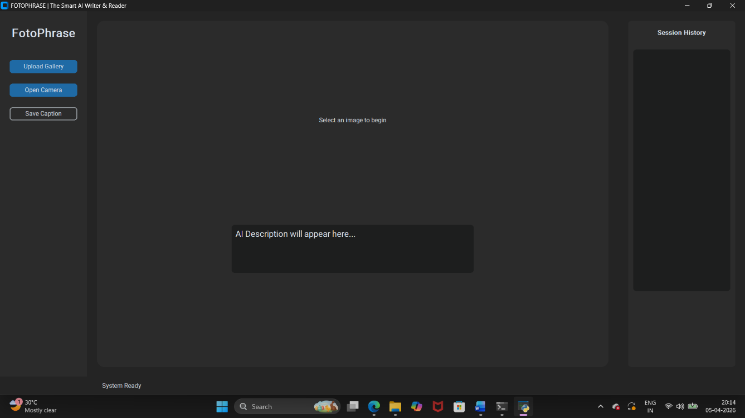
Fig 5.1 Output before uploading an image

After uploading the image:
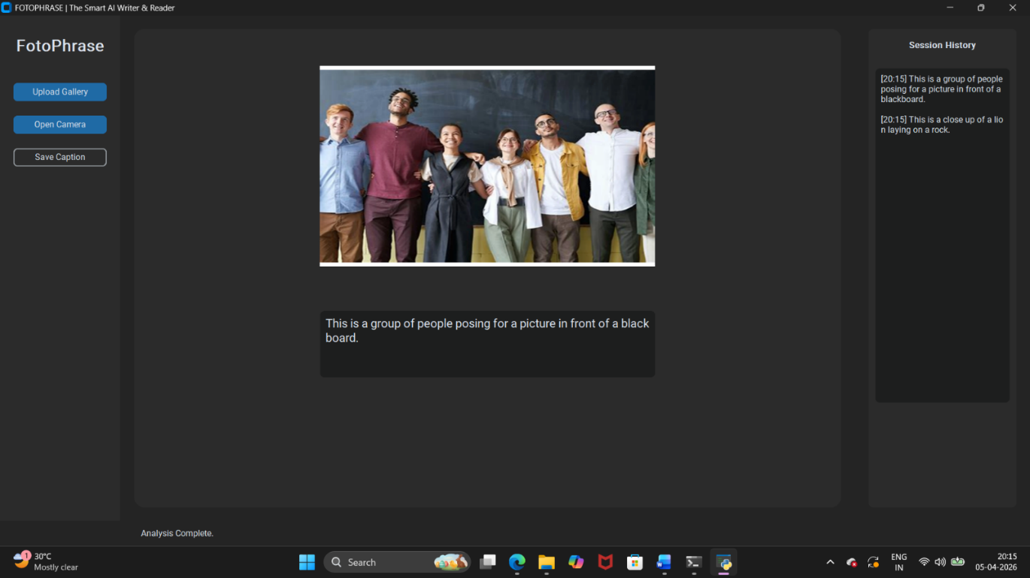
Fig 5.1 Output before uploading an image

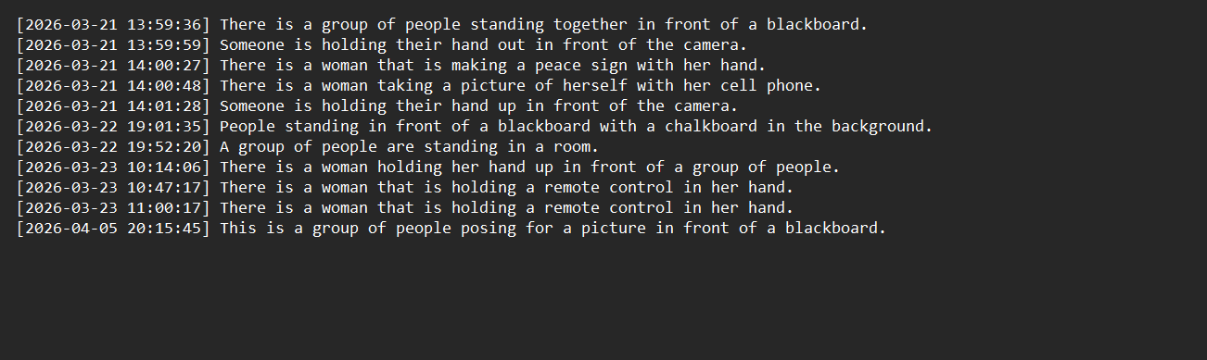

Fig 5.3 output of caption_log.txt

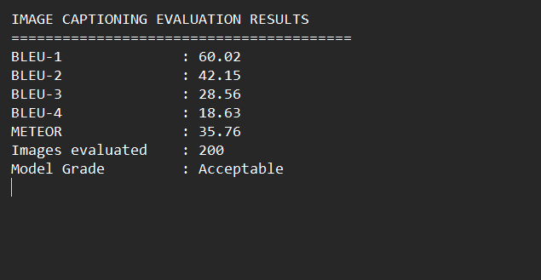
Fig 5.4 Output of Evaluation metics

5.1.3 RESULT ANALYSIS

The Image Caption Generation with Voice Assistance system operates through a sequence of steps. The user provides an image via upload or webcam through a CustomTkinter interface. The image is preprocessed by resizing, normalization, and conversion into tensor format. A pretrained CNN (ResNet-50) extracts visual features, which are then passed to an LSTM model to generate captions word-by-word. An attention mechanism helps focus on relevant image regions, and beam search improves caption quality. The final caption is displayed and converted into audio using a text-to-speech module. The system also maintains session history and allows caption saving for future use.
The system’s performance is evaluated based on caption accuracy and relevance using metrics like BLEU and METEOR scores. Results show that the model generates meaningful and contextually appropriate captions for various images. Although minor variations may occur, the system performs effectively and achieves its objective of converting images into both textual and audio descriptions.

Evaluation Metrics

Table 5.1 Evaluation Metrics
Metric | Value | Meaning
BLEU-1 | 60.02 | Measures basic word matching between generated and reference captions.
BLEU-2 | 42.15 | Evaluates phrase-level similarity.
BLEU-3 | 28.56 | Measures longer phrase consistency.
BLEU-4 | 18.63 | Indicates overall sentence quality and fluency.
METEOR | 35.76 | Considers semantic meaning, synonyms, and alignment.
Grade | Acceptable | Overall performance of the model based on evaluation metrics.

The results indicate that the model performs well in generating meaningful captions with good word-level accuracy. However, as the n-gram level increases, the scores decrease, showing challenges in forming longer and more complex sentences. The METEOR score reflects moderate semantic understanding. Overall, the system achieves an acceptable level of performance.

6 TESTING & VALIDATION

Testing and validation are essential phases in the development of the Image Caption Generation with Voice Assistance system to ensure that the application functions correctly, produces accurate captions, and delivers a smooth user experience. The system is tested at multiple levels, including functional testing, model validation, and user interface testing, to verify both the technical performance and usability of the application.

Functional Testing

Functional testing is carried out to ensure that each component of the system works as intended. The input module is tested by providing different types of images, including images uploaded from the system and those captured through a webcam. The preprocessing module is verified to ensure that images are correctly resized, normalized, and converted into tensor format. The CNN model is tested for accurate feature extraction, and the LSTM decoder is evaluated to confirm that it generates captions sequentially without errors. The text-to-speech module is also tested to ensure that the generated captions are correctly converted into audible speech.

Model Validation

The performance of the caption generation model is validated using standard evaluation metrics such as BLEU and METEOR scores. These metrics compare the generated captions with reference captions from the dataset to measure accuracy and quality. The model is tested on both training and unseen test images to evaluate its generalization ability. The results indicate that the model produces captions that are semantically meaningful and grammatically correct in most cases. Validation also helps in identifying issues such as overfitting or underfitting, allowing further tuning of hyperparameters if required.

User Interface Testing
The graphical user interface developed using CustomTkinter is tested to ensure smooth interaction and usability. All buttons, input options, and display components are verified to function correctly. The system is tested for responsiveness, ensuring that it handles user inputs without delays or crashes. Special attention is given to the integration between the interface and backend modules to ensure that results are displayed accurately and promptly.

Audio Output Testing
The text-to-speech functionality is tested to ensure that the generated captions are clearly converted into speech. The clarity, speed, and accuracy of the audio output are verified, and adjustments are made to improve voice quality and user experience. The system is also tested in offline mode to confirm that the TTS module works without internet dependency.

Validation with Real-Time Inputs
In addition to dataset testing, the system is validated using real-time images captured through a webcam. This ensures that the model performs well in practical scenarios and can handle variations in lighting, background, and object positioning. The results demonstrate that the system is capable of generating relevant captions even for real-world inputs.

6.1 FEATURES TO BE TESTED

- Image upload functionality from the local system
The system should allow users to select and upload images from their device without errors.
It must support common image formats and display the selected image correctly.
- Webcam image capture functionality
The application should capture images in real-time using the webcam.
The captured image must be clear and properly transferred to the processing module.
- Image preprocessing (resizing, normalization, tensor conversion)
The input image should be resized and normalized to match model requirements.
It must be converted into tensor format without loss of essential information.
- CNN-based feature extraction accuracy
The CNN should correctly extract meaningful visual features from the image.
These features must accurately represent the content of the image.
- LSTM-based caption generation correctness
The LSTM model should generate grammatically correct and meaningful captions.
The generated sequence must logically describe the image content.
- Attention mechanism performance
The attention mechanism should focus on relevant regions during caption generation.
It must improve caption accuracy by aligning words with image features.
- Beam search effectiveness
Beam search should generate more coherent and fluent captions than greedy methods.
It must select the best possible word sequence based on probability.
- Caption display on the user interface
The generated caption should be clearly displayed on the screen.
It must be readable and properly formatted for user understanding.
- Text-to-speech (TTS) audio generation and playback
The system should convert text captions into clear audio output.
The speech must be audible, understandable, and synchronized with the caption.
- User interface responsiveness and functionality
All buttons and UI elements should respond quickly to user actions.
The interface must remain stable without crashes or delays.
- Handling invalid or unsupported image inputs
The system should detect and handle invalid file formats or corrupted images.
Proper error messages must be displayed to guide the user.
- Processing time and system performance
The system should generate captions within a reasonable time.
Performance must remain consistent across different inputs.
- History session storage and retrieval
The system should store previously processed images and captions.
Users must be able to access and view past results easily.
- Caption saving functionality
The system should allow saving captions along with images for future use.
Saved data must be stored reliably without loss or corruption.
- Integration between frontend and backend
The GUI should communicate seamlessly with the backend model.
Inputs and outputs must flow correctly without errors or delays.

6.2 FEATURES NOT TO BE TESTED

- Internet-based functionality
The system is designed to work offline; hence internet connectivity and related features are not tested.
Any online API-based performance or dependency is outside the scope of this system.
- Third-party library internal working
Internal operations of libraries such as PyTorch, OpenCV, and pyttsx3 are not tested.
Only their integration and output within the system are verified.
- Model training process
The training phase of the deep learning model is not part of testing in this system.
Only the pretrained model’s performance during inference is evaluated.
- Hardware-level performance
Hardware-related aspects such as GPU performance, camera hardware quality, and system specifications are not tested.
The system assumes standard hardware functionality.
- Operating system compatibility variations
Testing across different operating systems (Windows, Linux, macOS) is not extensively performed.
The system is validated primarily in a specific development environment.
- Network security and cybersecurity features
Security aspects such as data encryption, hacking prevention, and secure transmission are not included.
The system does not involve sensitive data exchange over networks.
- Scalability for large-scale deployment
The system is not tested for handling large-scale concurrent users or cloud deployment.
It is designed for standalone or small-scale usage.
- Multi-language caption generation
The system generates captions only in English; multilingual support is not tested.
Language translation features are beyond the project scope.
- Advanced speech naturalness
The naturalness and human-like quality of speech output are not deeply evaluated.
Only basic clarity and functionality of TTS are verified.
- Database optimization and performance tuning
Advanced database operations such as indexing, optimization, and large-scale storage handling are not tested.
Only basic saving and retrieval functionality is considered.

6.3 TESTING TOOLS AND ENVIRONMENT

The testing of the Image Caption Generation with Voice Assistance system is carried out using a combination of advanced software tools and a well-defined development environment to ensure the correctness, efficiency, and reliability of the system. Proper testing tools and environment setup play a crucial role in identifying errors, validating model performance, and ensuring seamless integration between different components of the system. The tools used support various aspects such as coding, debugging, model evaluation, visualization, and user interface testing.
Testing Tools
The core programming language used for development and testing is Python, which is widely preferred due to its simplicity, readability, and extensive support for machine learning and data processing libraries. The application is developed and tested using an Integrated Development Environment (IDE) such as Visual Studio Code, which provides advanced features like syntax highlighting, debugging tools, extension support, and efficient code management.
For deep learning model implementation and validation, PyTorch is used as the primary framework. It allows efficient model testing, debugging, and evaluation through its dynamic computation graph and automatic differentiation capabilities. Torchvision is used alongside PyTorch for handling image-related tasks, including transformations and loading pretrained models such as ResNet-50 for feature extraction.
Data handling and preprocessing are tested using libraries like NumPy and Pandas. NumPy supports efficient numerical computations and array manipulations, while Pandas is used for managing and validating structured data such as captions stored in CSV format. These libraries ensure that data preprocessing steps such as normalization, tokenization, and formatting are performed accurately.
For image processing and input handling, OpenCV and PIL (Python Imaging Library) are used. OpenCV is particularly useful for testing real-time image capture through a webcam and verifying image processing operations such as resizing and filtering. PIL is used to load and manipulate images before passing them to the model, ensuring compatibility with the preprocessing pipeline.
Visualization tools such as Matplotlib and Seaborn are used to analyze and validate model performance. These tools help in plotting graphs for evaluation metrics like BLEU scores, loss curves, and other performance indicators, enabling better understanding of the model’s behavior.
The text-to-speech functionality is tested using the pyttsx3 library, which converts generated captions into speech. Testing ensures that the audio output is clear, synchronized, and functions correctly in an offline environment. Additionally, the graphical user interface built using CustomTkinter is tested manually to verify user interactions, layout consistency, and responsiveness.
Testing Environment
The system is tested in a controlled and stable computing environment to ensure consistent performance. The operating system used for testing is Microsoft Windows, which provides compatibility with all required libraries and tools. The development environment is configured with Python (version 3.x), along with all necessary dependencies installed using package managers such as pip.
The hardware configuration includes a system with a minimum of 4GB RAM and a standard Intel or equivalent processor. Since the project is designed to run without GPU dependency, all testing is performed on a CPU-based system. This ensures that the application is accessible and can run efficiently even on basic hardware configurations.
The system is tested in both offline and real-time scenarios. Offline testing is conducted using images from the Flickr30k dataset to evaluate model performance, while real-time testing is performed using webcam inputs to assess practical usability. The environment also ensures proper installation and functioning of drivers required for webcam access and audio output.
Special attention is given to dependency management and version compatibility to avoid runtime errors. All required libraries are installed and configured properly to ensure smooth execution of the application. The testing environment is also monitored for system performance, including memory usage and processing time, to ensure that the application runs efficiently.
The use of appropriate testing tools and a well-configured environment ensures that the system is thoroughly validated across all functional aspects. These tools help in detecting errors, improving model accuracy, and ensuring smooth interaction between different modules. The stable testing environment further guarantees reliable performance, making the system suitable for real-world applications and deployment.

6.4 DESIGN OF TEST CASES AND SCENARIOS
The design of test cases and scenarios is essential to ensure the reliability and correctness of the Image Caption Generation with Voice Assistance system. Test cases are created to validate each functionality, while test scenarios simulate real-world usage to verify system performance under different conditions.
The design process includes identifying key modules such as image input, preprocessing, feature extraction, caption generation, and audio output. Each module is tested with defined inputs, expected outputs, and validation criteria to ensure both individual and integrated functionality.
Test scenarios involve user interactions like uploading or capturing images and generating captions with audio output. Boundary and negative testing are also performed to handle edge cases and invalid inputs without system failure.
Additionally, performance testing evaluates response time and efficiency. Overall, this approach ensures comprehensive system validation and improves reliability and user satisfaction.

7 CONCLUSION & FUTURE ENHANCEMENT
CONCLUSION
The Image Caption Generation with Voice Assistance system represents an effective integration of computer vision and natural language processing techniques to bridge the gap between visual content and human understanding. The system is designed to automatically generate meaningful captions for images and convert them into speech, thereby enhancing accessibility and usability. By utilizing Convolutional Neural Networks (CNN) for extracting visual features and Long Short-Term Memory (LSTM) networks for sequential caption generation, the system is able to interpret image content and produce coherent textual descriptions.
The incorporation of the attention mechanism significantly improves the performance of the model by allowing it to focus on relevant regions of the image during caption generation. This results in more accurate and context-aware descriptions. Additionally, the use of beam search further enhances the quality of the generated captions by selecting the most appropriate sequence of words rather than relying on simple greedy approaches. These techniques collectively contribute to the robustness and efficiency of the system.
The application is developed with a user-friendly graphical interface using CustomTkinter, enabling users to easily interact with the system by uploading or capturing images. The integration of the text-to-speech module adds an important accessibility feature, allowing users, especially those with visual impairments, to listen to the generated captions. The system has been tested using both dataset images and real-time inputs, and the results indicate that it performs effectively in generating relevant and grammatically correct captions.
Despite its strengths, the system has certain limitations, particularly when dealing with highly complex images or scenes with multiple objects and interactions. In such cases, the generated captions may lack detail or fail to fully capture relationships between objects. These limitations are mainly due to constraints in training data and model complexity. However, the system successfully achieves its primary objective and demonstrates the practical application of deep learning in real-world scenarios. Overall, the project highlights the potential of combining vision and language technologies to create intelligent and accessible systems.

FUTURE ENHANCEMENT
The proposed Image Caption Generation system can be further enhanced in multiple ways to improve its performance, scalability, and usability. One of the major areas for improvement is the adoption of advanced deep learning architectures such as transformer-based models, including Vision Transformers (ViT) and BLIP. These models have shown superior performance in understanding complex visual scenes and generating more accurate and context-rich captions. Integrating such models can significantly enhance the quality of the system’s output.
Another important enhancement is the expansion of the training dataset. Using larger and more diverse datasets can improve the model’s ability to generalize across different types of images, including complex and real-world scenarios. This would help the system generate more detailed and precise captions. Additionally, incorporating data augmentation techniques can further improve robustness and reduce overfitting.
The system can also be extended to support multilingual caption generation, allowing captions to be generated in multiple languages. This would make the application more inclusive and accessible to users from different linguistic backgrounds. Similarly, improvements can be made to the text-to-speech module by integrating more advanced speech synthesis technologies that provide natural and human-like voice output.
From a usability perspective, the application can be developed into a web-based or mobile application, enabling wider accessibility and real-time usage. Cloud integration can also be considered to handle large-scale data processing and support multiple users simultaneously. Furthermore, features such as real-time video captioning, object detection, and scene understanding can be added to enhance the functionality of the system.
Future enhancements may also include personalized caption generation based on user preferences and adaptive learning mechanisms to continuously improve model performance. By incorporating these advancements, the system can evolve into a more powerful and versatile tool suitable for applications in accessibility, education, surveillance, and content management.

8 BIBLIOGRAPHY’

[1] P. Kotak and P. Kotak, “Image Caption Generator,” International Journal of Engineering Research & Technology (IJERT), vol. 10, no. 11, Nov. 2021. Available at: https://www.ijert.org/image-caption-generator
[2] Vinyals, O., Toshev, A., Bengio, S., & Erhan, D. (2015). “Show and Tell: A Neural Image Caption Generator,” Proceedings of the IEEE Conference on Computer Vision and Pattern Recognition (CVPR).
[3] Xu, K., et al. (2015). “Show, Attend and Tell: Neural Image Caption Generation with Visual Attention,” International Conference on Machine Learning (ICML). Available at: https://arxiv.org/abs/1502.03044
[4] Karpathy, A., & Fei-Fei, L. (2015). “Deep Visual-Semantic Alignments for Generating Image Descriptions,” Proceedings of the IEEE Conference on Computer Vision and Pattern Recognition (CVPR). Available at: https://arxiv.org/abs/1412.2306
[5] Vaswani, A., et al. (2017). “Attention is All You Need,” Advances in Neural Information Processing Systems (NeurIPS). Available at: https://arxiv.org/abs/1706.03762
[6] He, K., et al. (2016). “Deep Residual Learning for Image Recognition,” Proceedings of the IEEE Conference on Computer Vision and Pattern Recognition (CVPR). Available at: https://arxiv.org/abs/1512.03385
[7] Paszke, A., et al. (2019). “PyTorch: An Imperative Style, High-Performance Deep Learning Library,” Advances in Neural Information Processing Systems (NeurIPS). Available at: https://arxiv.org/abs/1912.01703
[8] Flickr30k Dataset. Available at: https://www.kaggle.com/datasets/hsankesara/flickr-image-dataset
[9] Brownlee, J. (2019). “Deep Learning Caption Generation Model in Python,” Machine Learning Mastery. Available at: https://machinelearningmastery.com/develop-a-deep-learning-caption-generation-model-in-python/
[10] PyTorch Documentation. Available at: https://pytorch.org/docs/

