REHAAB Autism- Data Collection Tool:
Complete Project Workflow

Frontend Development & UI/UX (Completed)
Created a frictionless, clinical-grade interface for medical professionals to input extensive patient data without cognitive overload.
- Requirements Gathering: Analysed the 17-section REHAAB data dictionary (Consent, Demographics, Lab Data, Amino Acid Profiles, etc.).
- Architecture Choice: Single-page application (SPA) structure using HTML, Tailwind CSS for rapid styling, and Vanilla JavaScript for DOM manipulation.
- Local Testing: Validated form state retention, responsive mobile views, and visual cues (required fields, success messages).
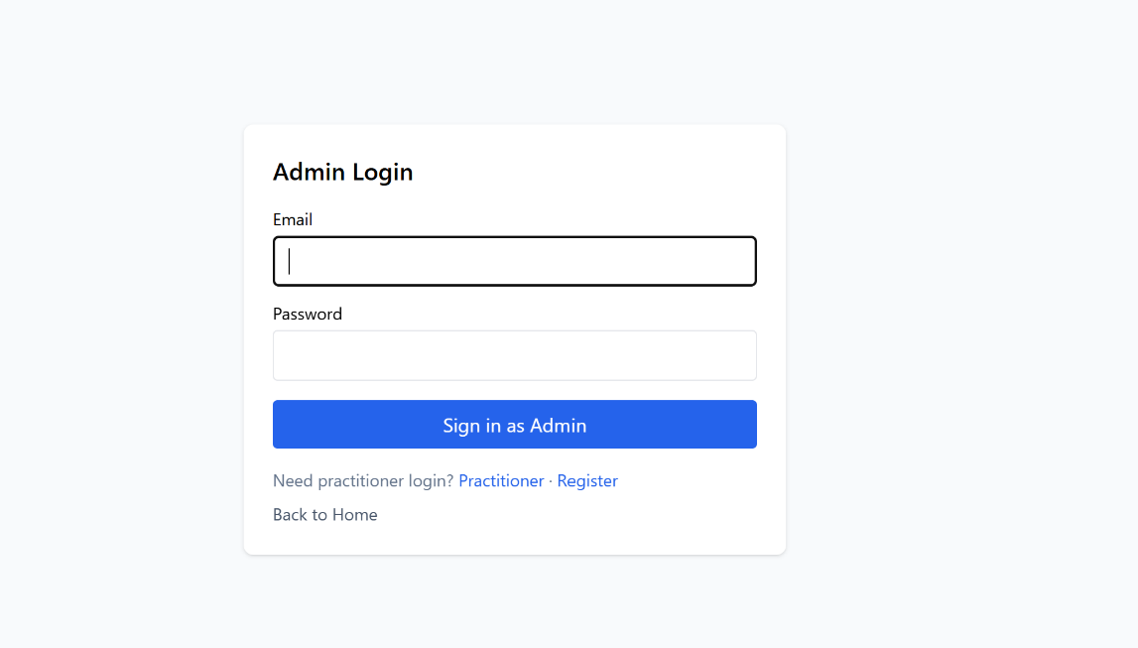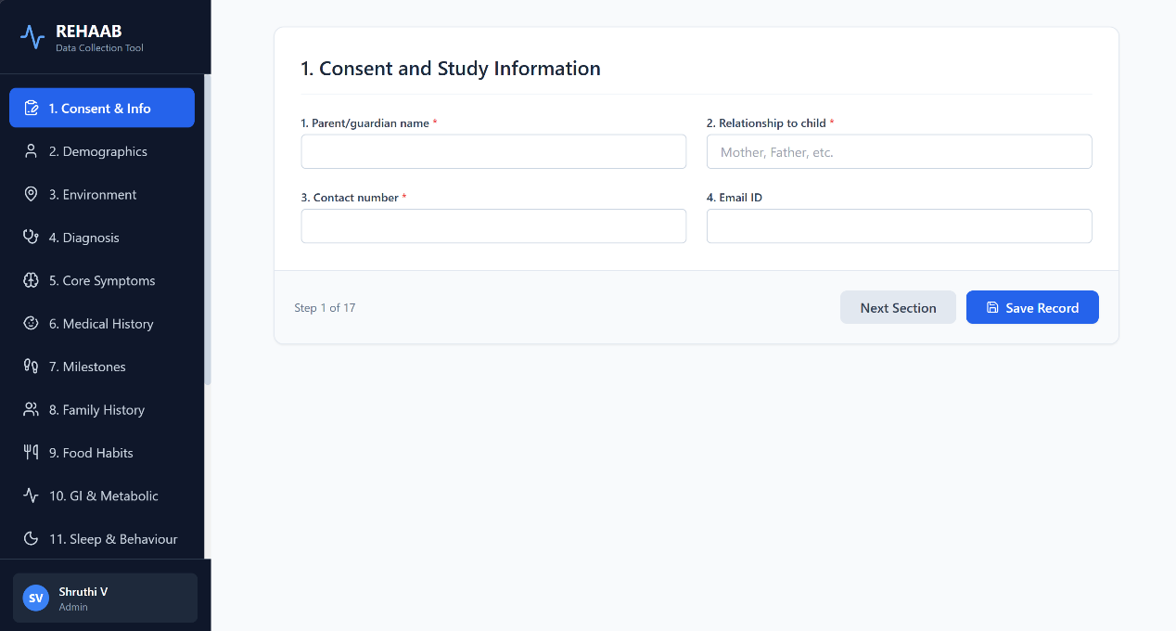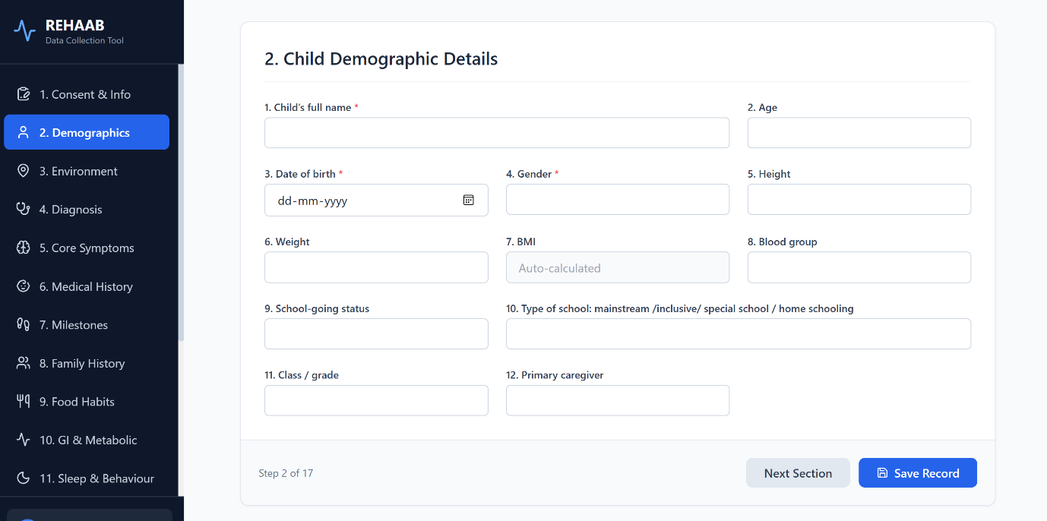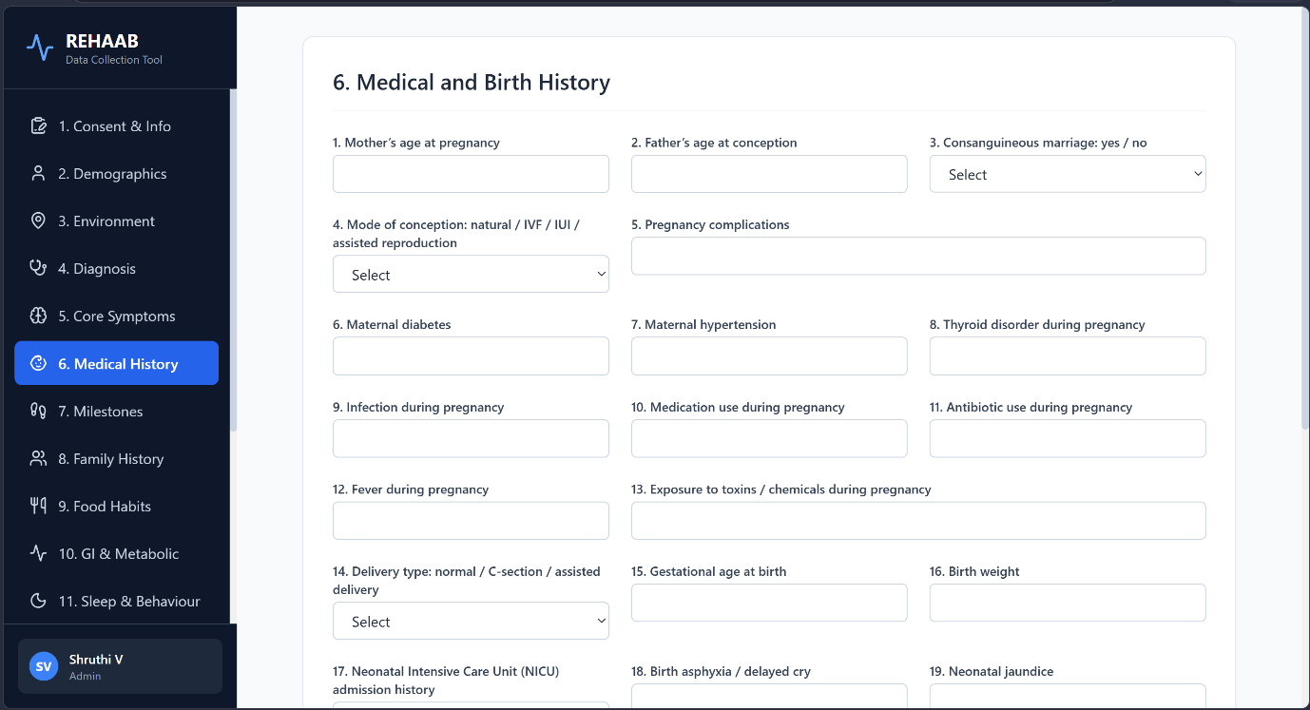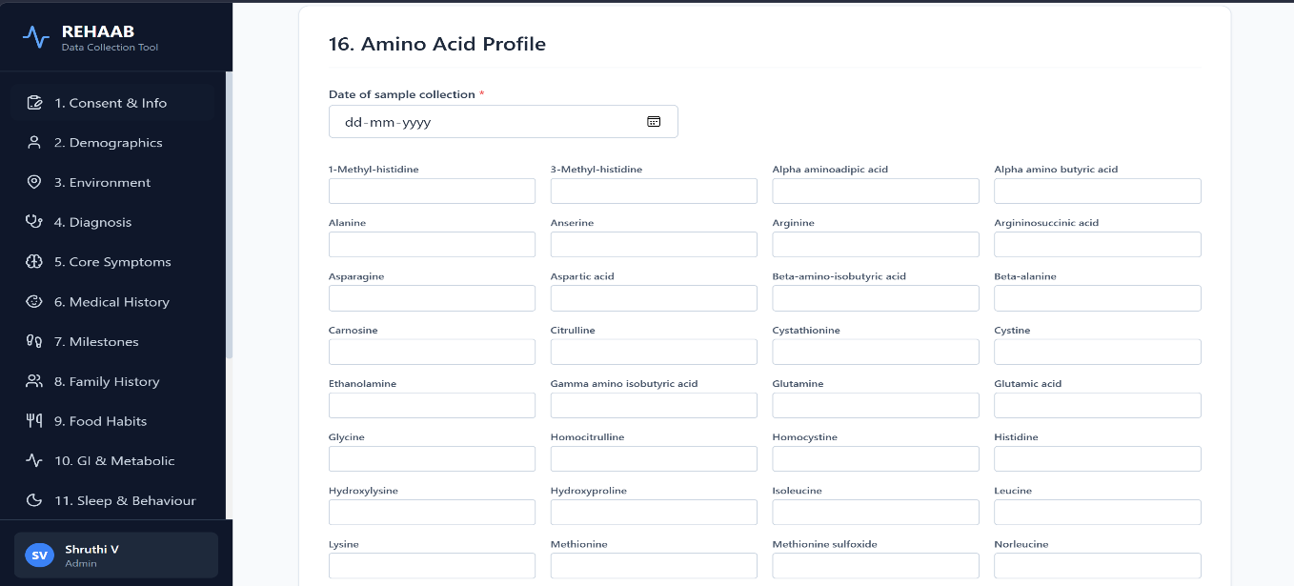
Backend Node.js
Workflow of backend connecting the frontend files with the Database
- User Request
Registration, Login, or Form Submission
- Frontend → Backend
Request sent to the Node.js/Express server
- Backend Processing
Validate data
Hash passwords using bcrypt
- Database Interaction
Connect to MySQL using mysql2
Execute secure parameterized queries
- Database Operations
Register User
Authenticate Login
Save Form Data
- Response
Success or Error message returned to the frontend
- Logging & Error Handling
Monitor database connection and query errors

Database Schema & Setup (Completed)
Design a robust relational structure to handle complex, nested medical data and ensure data integrity.
- Entity-Relationship Mapping:
  - Patients (Demographics, Consent)
  - Clinical_History (Medical, Birth, Family history)
  - Diagnoses_and_Symptoms (Autism specifics, Core symptoms, GI/Metabolic)
  - Interventions (Treatments, Medications, Diet)
  - Lab_Results (Blood work, Amino Acid profiles)
  - Documents (S3 file references)
- Database Selection: Provisioned a relational SQL database
- Local Connection Testing: Verified the backend can successfully perform CRUD (Create, Read, Update, Delete) operations on the local database instance.

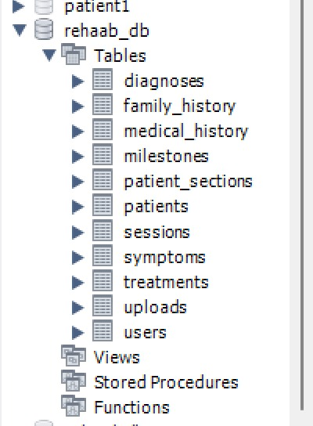

Parent table:
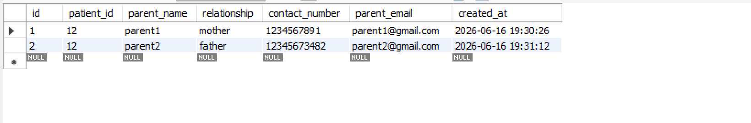
Patients:
Patient_environment:
Milestones:

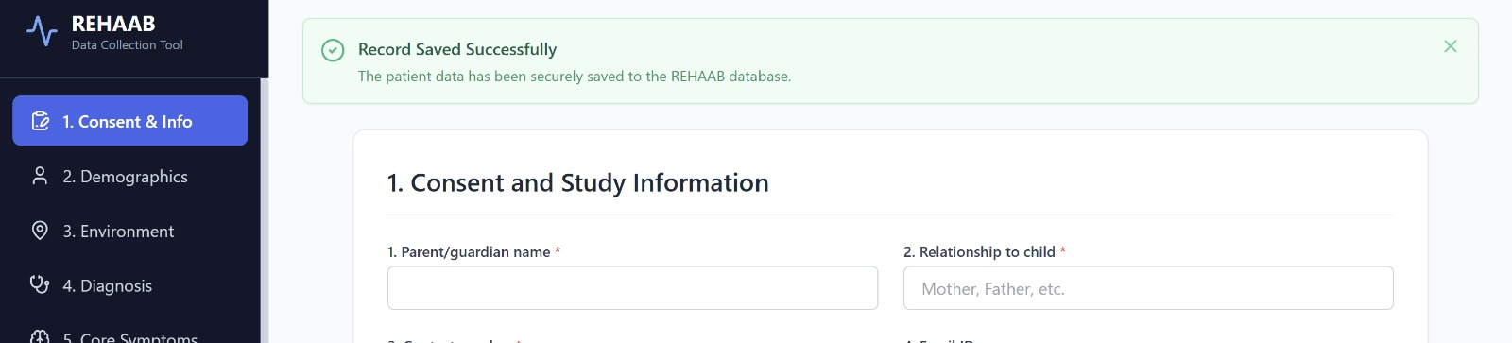

Production Deployment (Amazon Web Services)- inprogress
Goal: Migrate the application to a secure, scalable, and compliant production environment.

