**Table of Contents**

**NEWS ARTICLES CLASSIFIER**

1 Introduction 4

Terminology 4

2 Project Specifications 4

2.1 Requirements 4

2.2 Architecture Diagram 5

3 Technical Documentation 5

Installation & Process 5

#3.1 Source System 5

#3.2 Target System 5

4 Non functional Requirements 5

# Introduction

Classify News Articles into categories - With information overload today users are inundated with news articles of all topics, even the ones which may not be relevant to users. Design a system which can classify incoming news articles and appropriately tag the corresponding category. Develop a data pipeline which includes the all the following stages of Machine Learning Project Life Cycle :

1.Data Ingestion

2.Data Preparation

3.Data segregation & Model Training

4.Model Deployment

5.Model Prediction

## Terminology

|  |  |
| --- | --- |
| Terminology | Description |
|  |  |
|  |  |
|  |  |

# Project Specifications

## 

### 2.1 Requirements

For the implementation of News classifier the following are the requirements :

* Python IDE- VS Code
* Virtual Environment
* MongoDB as database storage
* Pyspark for stream processing
* POSTMAN for testing Flask API’s
* Apache Zookeeper + Kafka for message streams
* Tensorboard for monitoring the progress of model training
* MLFLOW for model versioning +hyper-parameters versioning
* Python cookiecutter templates for setting up project

### 2.2 Architecture Diagram

ss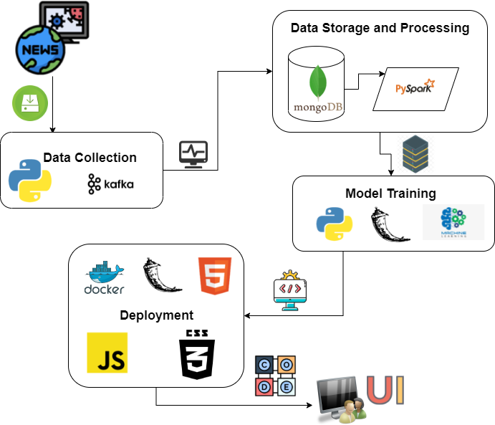

# Technical Documentation

## Installation & Process

### #3.1 Data Ingestion

Install Tooling:

Kafka:

To run Kafka and Zookeeper in the local systems below need to be installed :

* Installed Java 8 version and set the user variables and system variables Path.
* Installed Kafka from <https://archive.apache.org/dist/kafka/2.8.1/kafka_2.13-2.8.1.tgz>
* Configured MongoSinkConnector and stand alone bare properties in the kafka/config by changing the parameter values as mentioned in the screenshot.

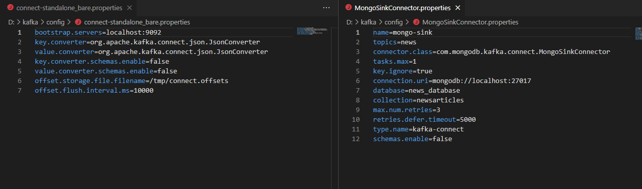

* Downloaded the jar file from the below link and placed it in the path kafka/lib.

<https://repo1.maven.org/maven2/org/mongodb/kafka/mongo-kafka-connect/1.6.1/>

MonoDB:

Installed Community edition of Mongo DB using link below:

<https://www.mongodb.com/try/download/community>

Python:

* Installed pip pacakges requests, json, kafkaproducer.

Steps for fetching Data:

Run the below commands after changing the Path:cd D:\kafka\bin\windows.

* ter-1: zookeeper-server-start.bat ../../config/zookeeper.properties
* ter-2: kafka-server-start.bat ../../config/server.properties
* ter-3:

1. kafka-topics.bat --create --zookeeper localhost:2181 --replication-factor 1 --partitions 1 --topic news
2. connect-standalone.bat ../../config/connect-standalone_bare.properties ../../config/MongoSinkConnector.properties

* ter-4: kafka-console-producer.bat --broker-list localhost:9092 --topic news

### #3.2 Data Processing

# Non functional Requirements