# **Week_1 Report**

**Kafka Installation:**

To run Kafka and Zookeeper in the local systems below need to be installed :

* Installed Java 8 version and set the user variables and system variables Path.
* Installed Kafka from <https://archive.apache.org/dist/kafka/2.8.1/kafka_2.13-2.8.1.tgz>
* Configure MongoSinkConnector and stand alone bare properties in the kafka/config by changing the parameter values as mentioned in the screenshot.

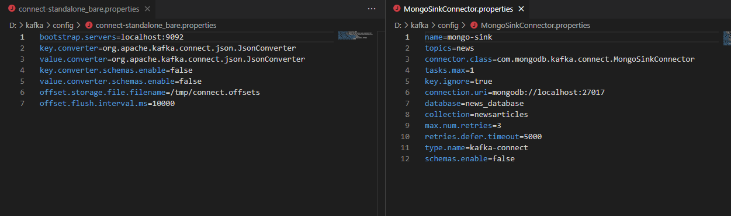

* Downloaded the jar file from the link below and placed it in the path kafka/lib.

<https://repo1.maven.org/maven2/org/mongodb/kafka/mongo-kafka-connect/1.6.1/>

**MonoDB Installation**:

* Installed Community edition of MongoDB using link below:

<https://www.mongodb.com/try/download/community>

**Python Installation**:

* pip install kafka-python

**Week1_steps:**

Ran the below commands after changing the Path:cd D:\kafka\bin\windows

**Terminal-1:**

Start the Zookeeper in a terminal

**zookeeper-server-start.bat ../../config/zookeeper.properties**

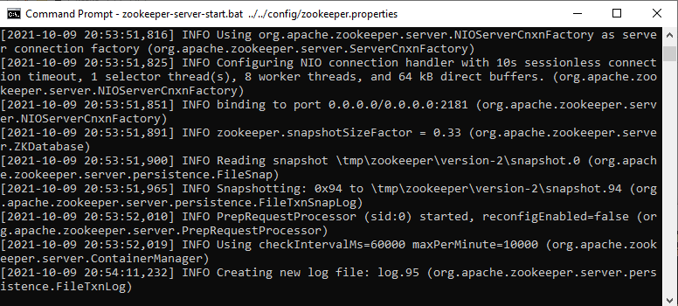

**Terminal-2:**

Start the kafka-server in another terminal

**kafka-server-start.bat ../../config/server.properties**

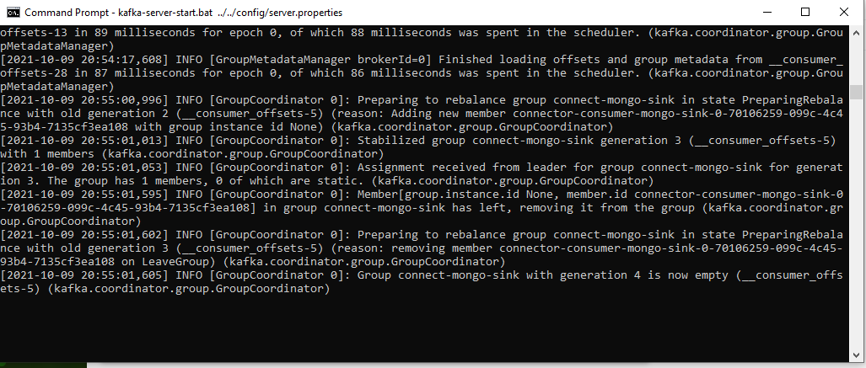

**Terminal-3:**

create the news topic in a new terminal

**kafka-topics.bat --create --zookeeper localhost:2181 --replication-factor 1 --partitions 1 --topic news**

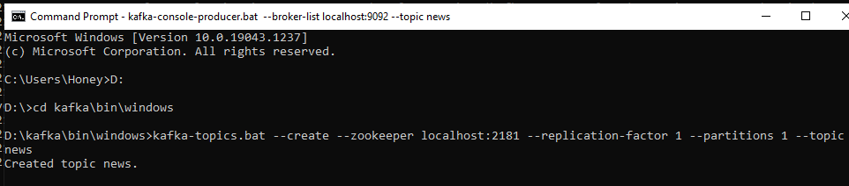

In the same terminal run the mongodb connector command

**connect-standalone.bat ../../config/connect-standalone_bare.properties ../../config/MongoSinkConnector.properties**

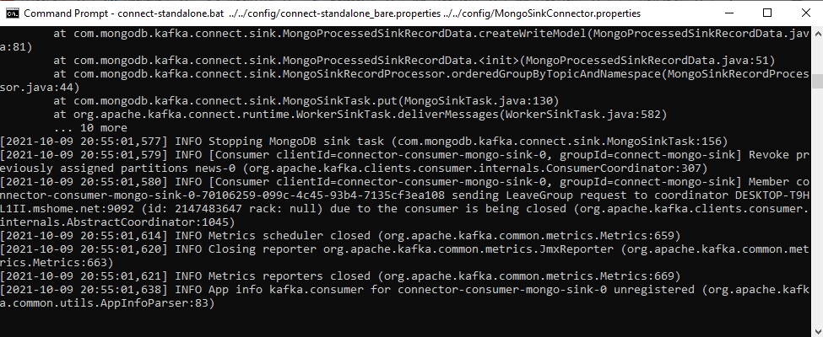

**Terminal-4:**

Creating Kafka Producer

**kafka-console-producer.bat --broker-list localhost:9092 --topic news**

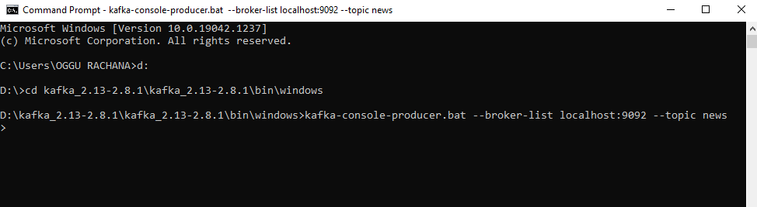

**Producer:**

Run the prodecur.py file which inserts the data into mongoDB

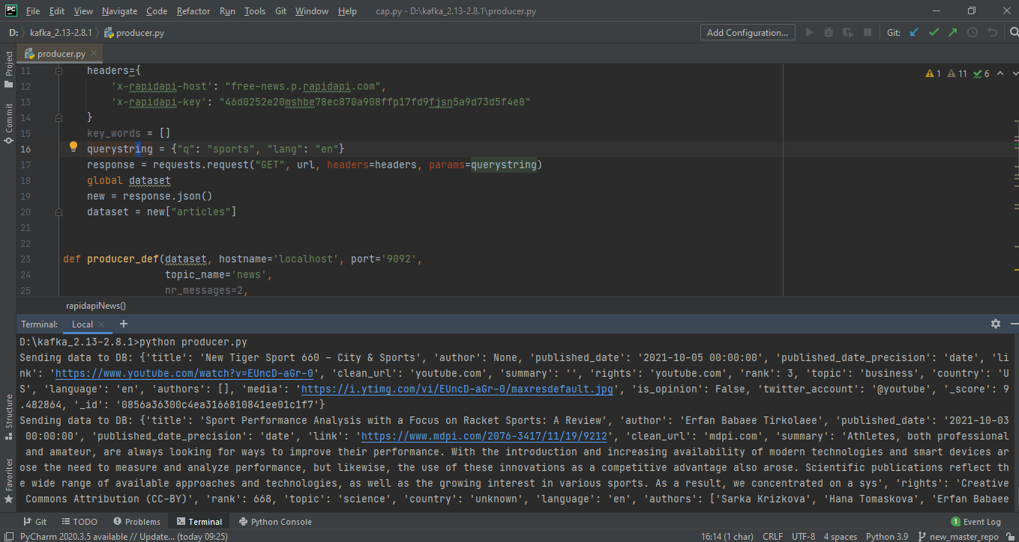

Data inserted into MongoDB

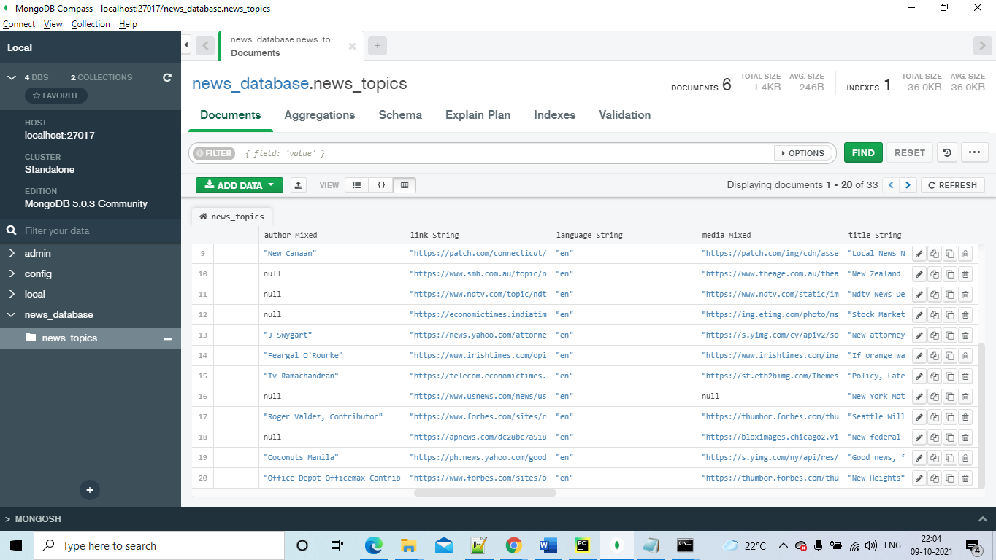

**Challenges Faced:**

* While connecting Kafka to MongoDB on the Local system faced issues with the configurations.
* Data wasn’t inserting into MongoDB through Kafka- producer.

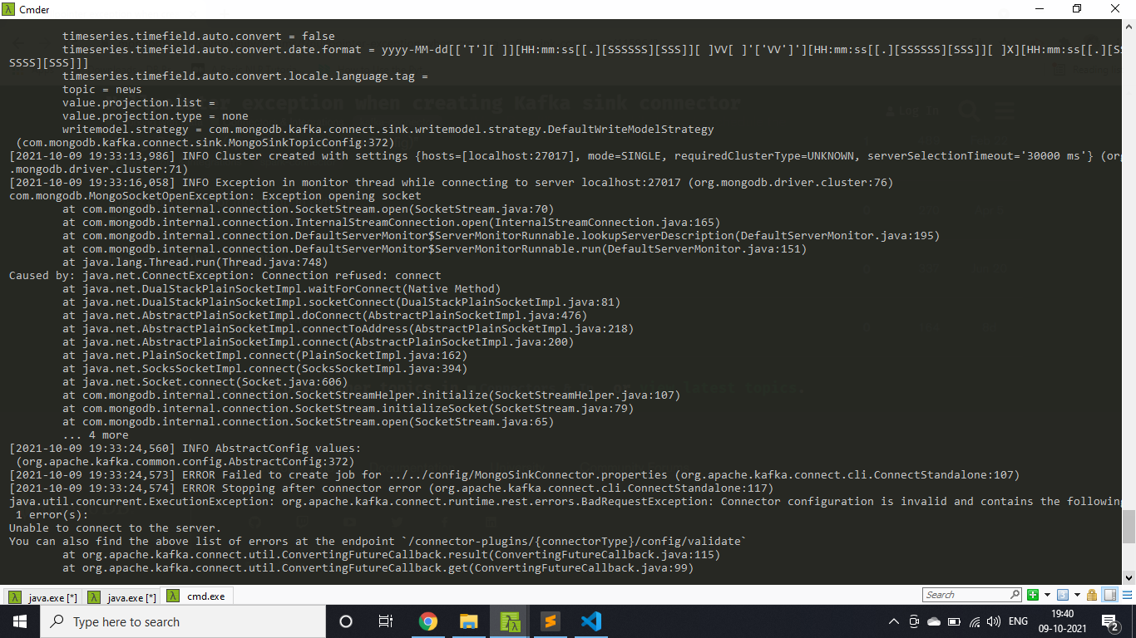

**Resolutions:**

* Reconfigured the property files and deleted the temp folder in the local device.
* Result is in the form of a dictionary as python cannot convert it into json we have defined a function to convert into encoding.