# Name :

# Student number -

# Back-end Web Development

# Instructor: Kelvin Gao

**Introduction:**

We have create a website which provides functionality for students to register, and credit and withdraw courses for their degree programs. We have implemented login module, withdraw module, and credit module.

**Database Design :**

We have created a script create_aumdb.sql file, which create the database, and generates three tables students, instructors, and courses and user id to access, modify the tables.

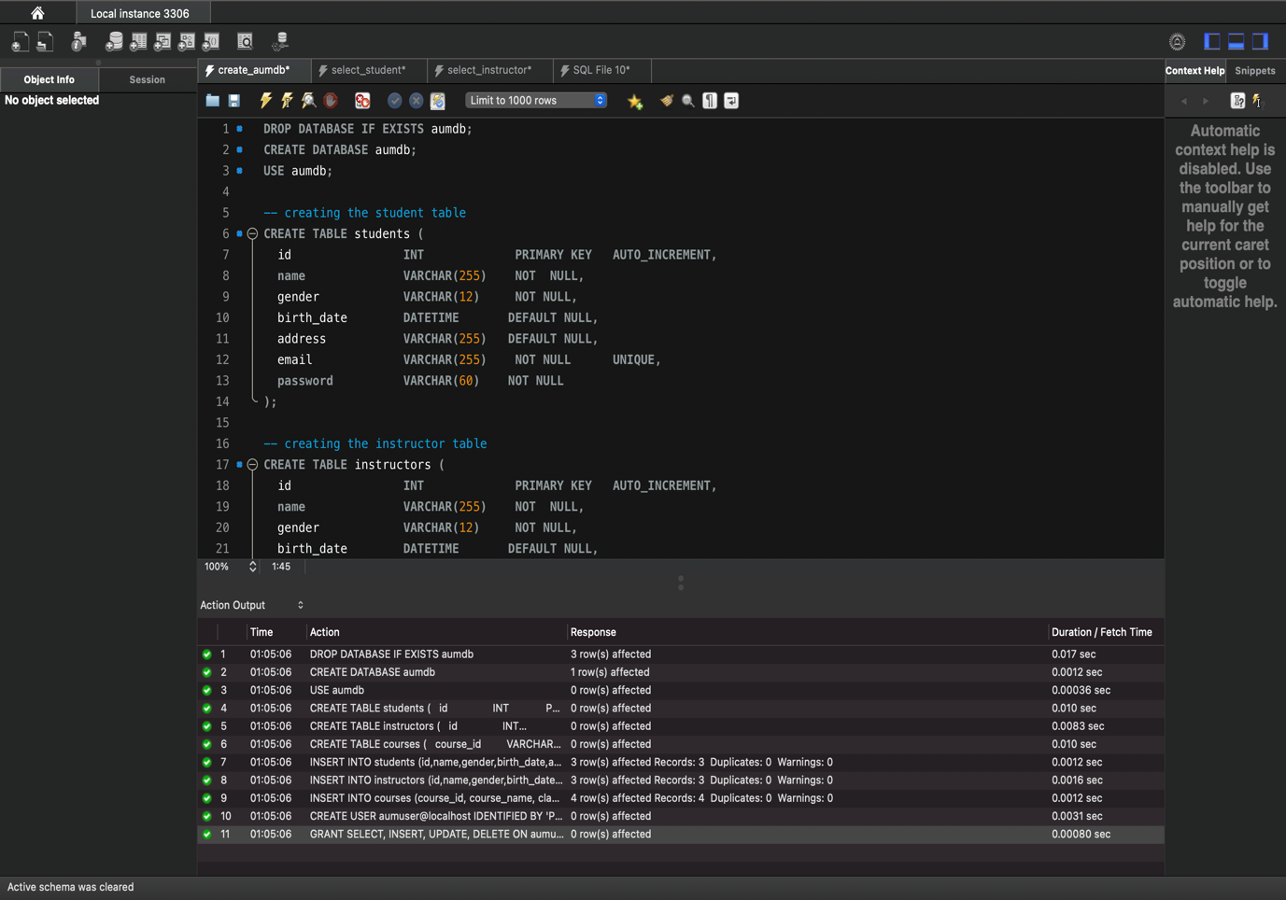

Screenshot 1 : Execution of create_aumdb.sql

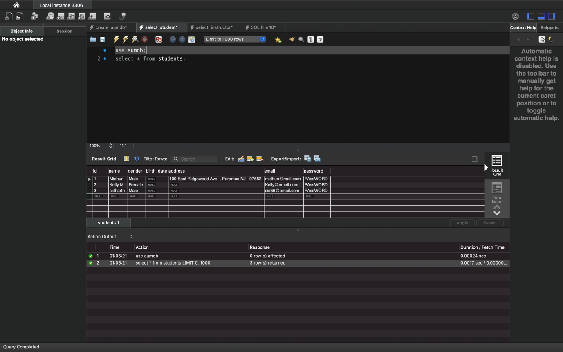

Screenshot 2 : Execution of select_student.sql

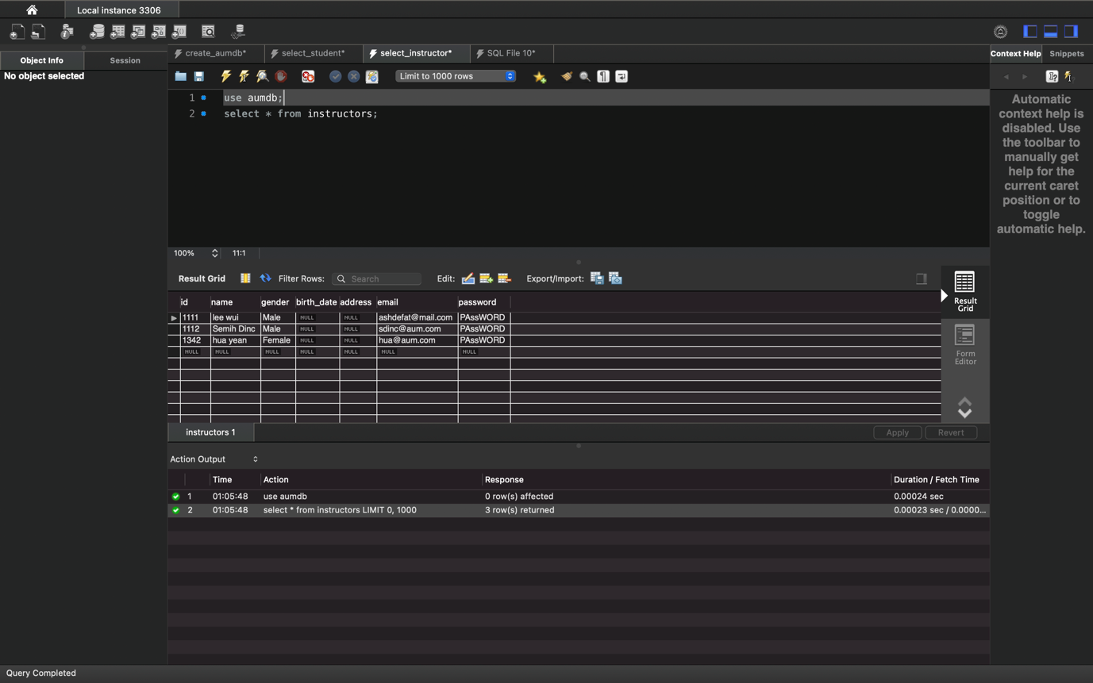

Screenshot 3 : Execution of select_instructor.sql

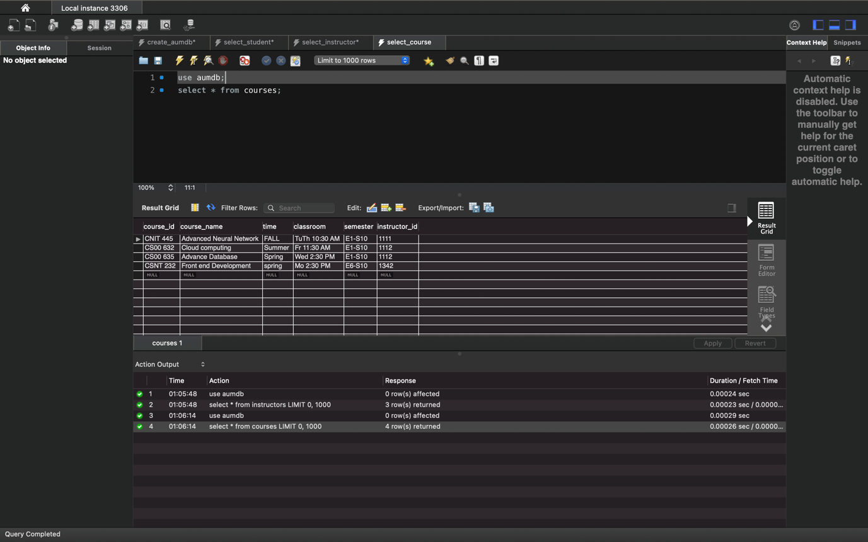

Screenshot 4: Execution of select_course.sql