Feature File:--

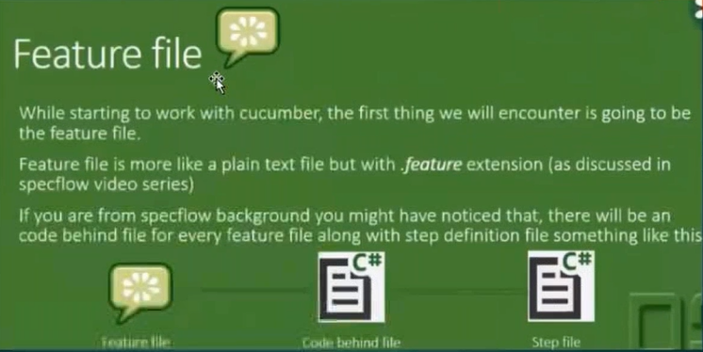

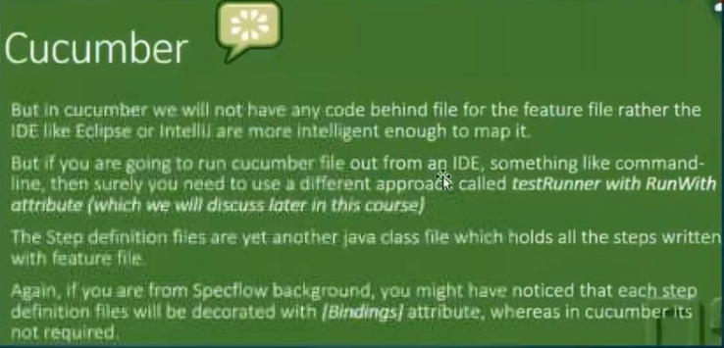



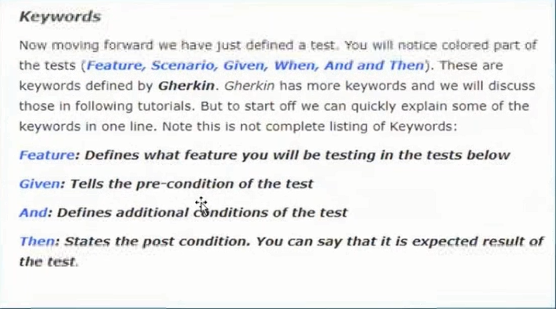





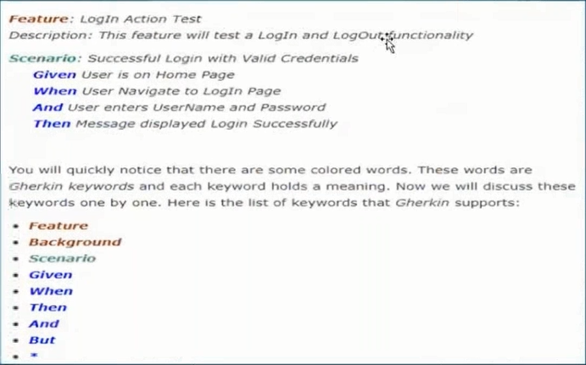

Login1.feature

Feature: Store login

This feature deals with the login functionality.

Scenario: Login with correct username and correct password

Given I navigate to login page

When I entered username and password

And I clicked signin button

Then Its navigated to the HomePage

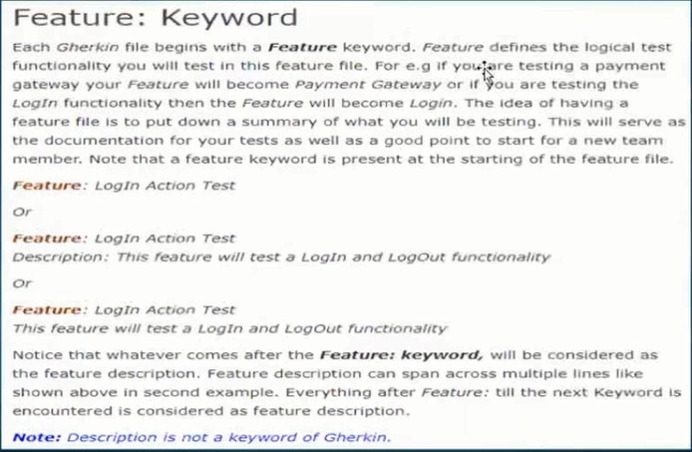

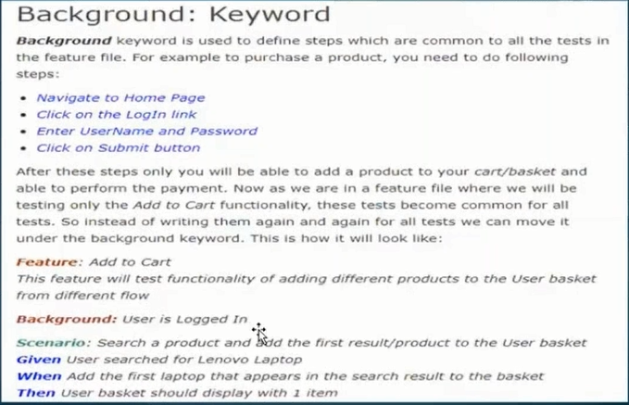

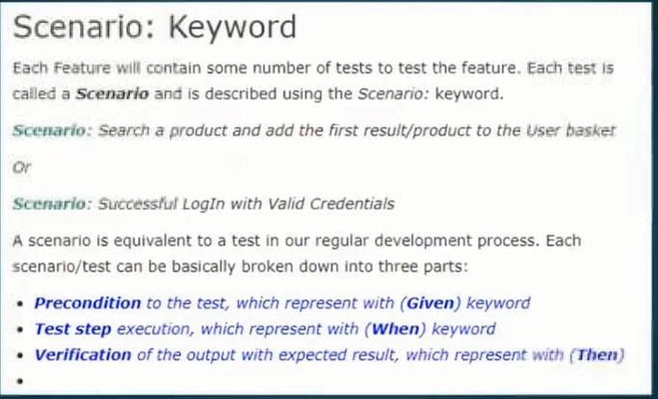

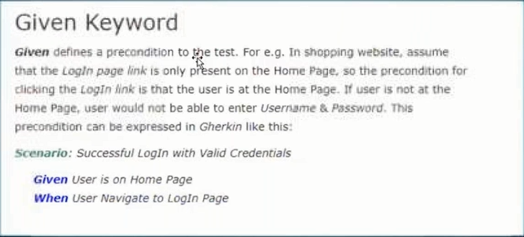

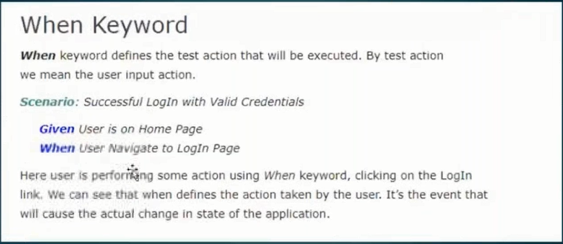

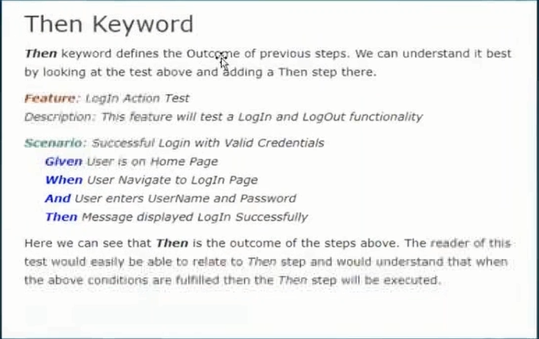

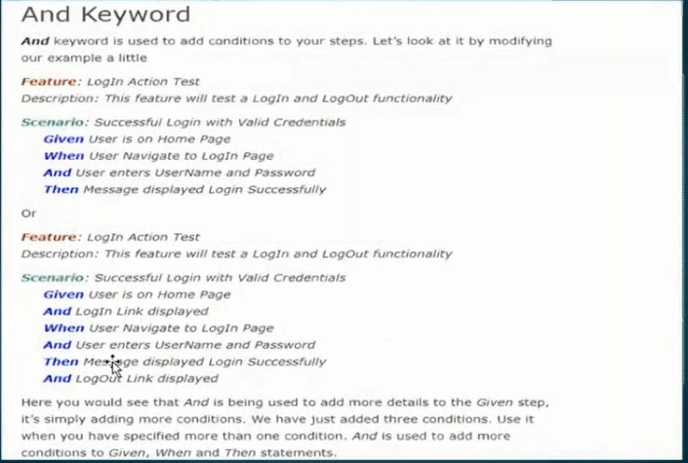

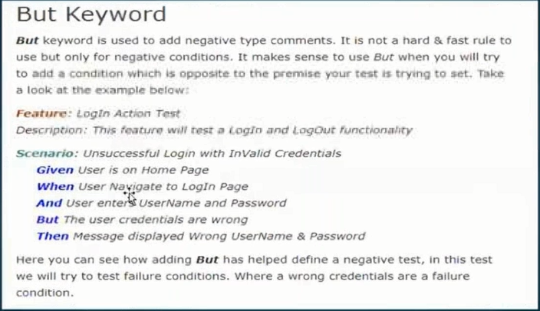

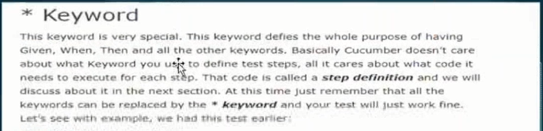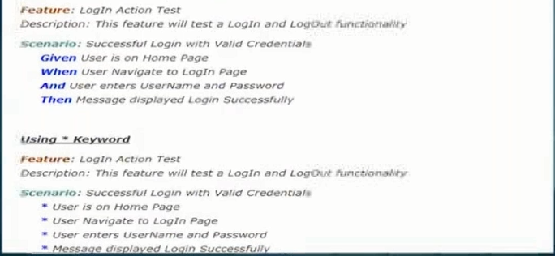



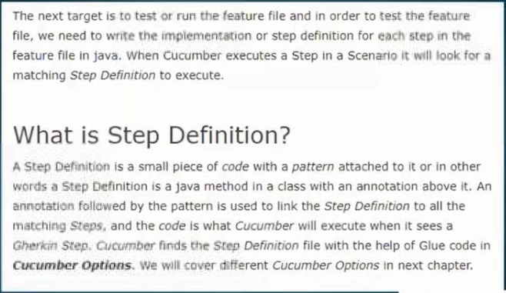

stepDef1.java :----

**package** stepDefinition;

**import** cucumber.api.java.en.Then;

**public** **class** stepDef1 {

@Given("^I navigate to login page$")

**public** **void** navigateToLoginPage(){

System.***out***.println("Navigated to the Login Page");

}

@Then("^Its navigated to the HomePage$")

**public** **void** navigateToHomePage(){

System.***out***.println("Navigated to the HomePage ");

}

@And("^I clicked signin button$")

**public** **void** clickSigninButton(){

System.***out***.println("clicked signin button");

}

@When("^I entered username and password$")

**public** **void** enterUsernamePassword(){

System.***out***.println("Entering correct username and password");

}}

-----------------------

To Glue feature & step definition :----

project --------- rt click --- run as ---- run configuration ------------- select cucumber feature – login.feature--- browse --- apply --- run

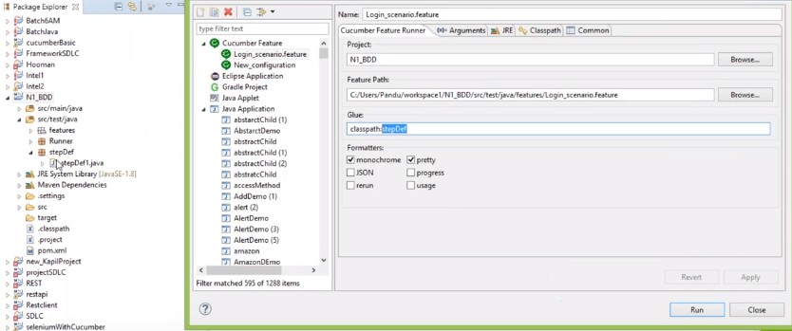

To Run Feature file:--

Rt click --- run as --- cucumber Feature

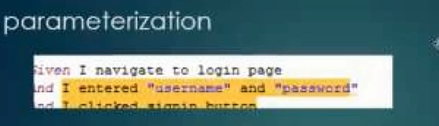

Example—2 :----

Parameterize:--

Regular expression

=================================

Login2.feature

**Feature:** Store login

This feature deals with the login functionality.

**Scenario:** Login with correct username and correct password

Given I navigate to login page

#And I entered username and password

*When* I entered "admin1" and "pass1"

*And* I clicked signin button

*Then* Its navigated to the home page

----------------

stepDef2.java

**package** stepDefinition;

**import** cucumber.api.java.en.And;

**import** cucumber.api.java.en.Given;

**import** cucumber.api.java.en.Then;

**public** **class** stepDef2 {

@Given("I navigate to login page")

**public** **void** i_navigate_to_login_page() {

System.***out***.println("Given called.....");

}

@And("I entered username and password")

**public** **void** i_entered_username_and_password() {

System.***out***.println(" username and password....");

}

@And("I clicked signin button")

**public** **void** i_clicked_signin_button() {

System.***out***.println("clicked signin .....");

}

@When("I entered {string} and {string}")

**public** **void** i_entered_and(String u, String p) {

System.***out***.println(u +" "+p);

}

@Then("Its navigated to the home page")

**public** **void** its_navigated_to_the_home_page() {

System.***out***.println("Homepage...");

}

}