

Hooks:--

The Anontations used in cucumber, to perform different actions , at different point of time.

It gives the prior information to the compiler ,to execute certain code.

In Java-cucumber we have only 2 types of Hooks,

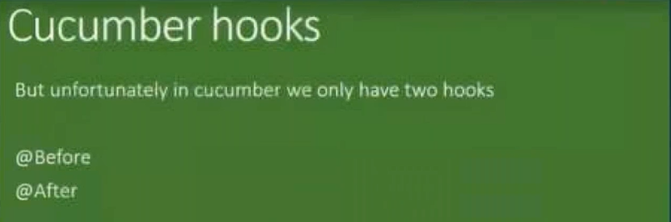

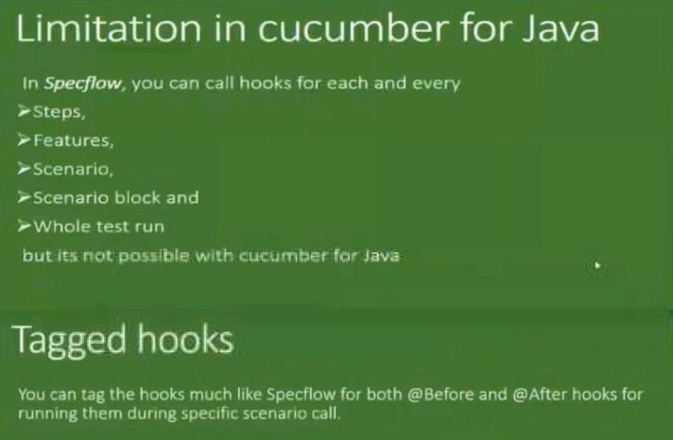

**public** **class** Hooks {

@Before

**public** **void** InitSetUp()

{

System.***out***.println("Environment is Ready...");

}

@After

**public** **void** Close()

{

System.***out***.println("Environment is closed....");

}

}

==============================

============================================================

Dependency Injection:---

This helps us to pass the data from one class to another class indirectly, using Helper class. ( without object)

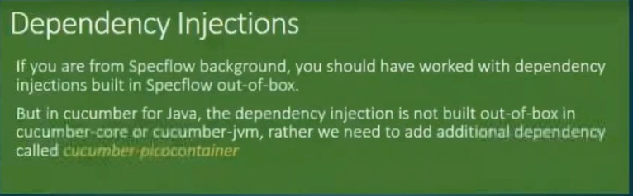

## Jar -----  [Cucumber JVM: PicoContainer](https://mvnrepository.com/artifact/io.cucumber/cucumber-picocontainer)

## <!-- https://mvnrepository.com/artifact/io.cucumber/cucumber-picocontainer -->

## <dependency>

## <groupId>io.cucumber</groupId>

## <artifactId>cucumber-picocontainer</artifactId>

## <version>2.4.0</version>

## <scope>test</scope>

## </dependency>

-------------



=================================================================================================================

Practical steps:--

1. Create a Base class ( Base.java) in package ( BaseUtil) – Declaration (driver)
2. Create ,Java class (Hooks.java) in package ( stepDefination) -- Initialization
3. Create a Feature file ( Login.feature) in package ( Features)
4. Create StepDefination file ( stepDef.java) in package ( stepDefination) – use the references

[NOTE: Keep together the Hook & setdef file in one package..]

**package** BaseUtil;

**public** **class** Base {

**public** **static** String *stepInfo*;}

-----------------------

**Feature:** Store login

This feature deals with the login functionality.

**Scenario Outline:** Login with correct username and correct password

Given I navigate to login page

#When I entered username and password

When I insert *<userName>* and *<passWord>*

*And* I clicked signin button

*Then* Its navigated to the home page

**Examples:**

| userName | passWord |

| admin1 | admin12 |

| admin2 | admin22 |

| admin3 | admin33 |

---------------------------------------------------

**package** stepDef;

**import** BaseUtil.Base;

**import** cucumber.api.java.After;

**import** cucumber.api.java.Before;

**public** **class** Hooks {

**private** **static** Base *baseUtil*;

**public** Hooks()

{

}

**public** Hooks(Base baseUtil)

{

**this**.*baseUtil* = baseUtil;

}

@Before

**public** **void** initBrowser()

{

System.***out***.println("opening the Browser : Hook");

*baseUtil*.*stepInfo* ="chrome";

}

@After

**public** **void** TearBrowser()

{

System.***out***.println("Closing the Browser : Hook");

}

}

------------------------------------------------------------------

**package** stepDef;

**import** java.util.ArrayList;

**import** java.util.List;

**import** BaseUtil.Base;

**import** cucumber.api.DataTable;

**import** cucumber.api.java.en.And;

**import** cucumber.api.java.en.Given;

**import** cucumber.api.java.en.Then;

**public** **class** stepDefination {

**private** **static** Base *b1*;

**public** stepDefination()

{

}

**public** stepDefination(Base b1)

{

**this**.*b1* = b1;

}

@Given("^I navigate to login page$")

**public** **void** navigateToLoginPage(){

System.***out***.println("the Driver name is :"+ *b1*.*stepInfo*);

System.***out***.println("Navigated to the Login Page");

}

@Then("^Its navigated to the home page")

**public** **void** navigateToHomePage(){

System.***out***.println("Navigated to the Home Page");

}

@And("^I clicked signin button")

**public** **void** clickSigninButton(){

System.***out***.println("clicked signin button");

}

@When("I insert {string} and {string}")

**public** **void** i_insert_and(String s1, String s2) {

System.***out***.println(s1+ " "+ s2);

System.***out***.println(*base*.*username*);

}

}

===============================================

Multiple Scenarios:--

Feature File:--

*@US01*

**Feature:** Validate the Login Functionaly

*@TC1*

**Scenario:** Validate for Valid Credencials.

*Given* Login page is Launched.

*When* Eneter the UNM and PWd

*And* Click on Signin Button

*Then* Should Login Successfully.

*@TC2*

**Scenario:** Validate for inValid Credencials.

*Given* Login page is Launched.

*When* Eneter the UNM and PWd

*And* Click on Signin Button

*Then* Should Fail login.

=========

**package** StepDefPKG;

**import** cucumber.api.java.en.And;

**import** cucumber.api.java.en.Given;

**import** cucumber.api.java.en.Then;

**import** cucumber.api.java.en.When;

**public** **class** stepdef {

@Given("^Login page is Launched\\.$")

**public** **void** login_page_is_Launched() {

System.***out***.println("Launched..");

}

@When("^Eneter the UNM and PWd$")

**public** **void** eneter_the_UNM_and_PWd() {

System.***out***.println(" input Entered....");

}

@And("^Click on Signin Button$")

**public** **void** click_on_Signin_Button() {

System.***out***.println("Clicked.....");

}

@Then("^Should Login Successfully\\.$")

**public** **void** should_Login_Successfully() {

System.***out***.println("successfull LOgin..");

}

@Then("^Should Fail login\\.$")

**public** **void** Should_Fail_login() {

System.***out***.println("LOgin.Filed..");

}

}

==============

**package** StepDefPkg;

**import** io.cucumber.testng.AbstractTestNGCucumberTests;

**import** io.cucumber.testng.CucumberOptions;

@CucumberOptions(features= {"src\\test\\java\\FeaturesPkg\\Login.feature"}

,glue="StepDefPkg"

,tags= {"@TC1" , “@Tc2”}

)

**public** **class** Runner1 **extends** AbstractTestNGCucumberTests

{

}

==================================

Background:--

Used to run the common steps for multiple scenarios.

Feature File:--

*@US01*

**Feature:** Validate the Login Functionaly

**Background:**

*Given* Login page is Launched.

*When* Eneter the UNM and PWd

*@TC1*

**Scenario:** Validate for Valid Credencials.

*And* Click on Signin Button

*Then* Should Login Successfully.

*@TC2*

**Scenario:** Validate for inValid Credencials.

*And* Click on Signin Button

*Then* Should Fail login.

=============

**package** StepDefPKG;

**import** cucumber.api.java.en.And;

**import** cucumber.api.java.en.Given;

**import** cucumber.api.java.en.Then;

**import** cucumber.api.java.en.When;

**public** **class** stepdef {

@Given("^Login page is Launched\\.$")

**public** **void** login_page_is_Launched() {

System.***out***.println("Launched..");

}

@When("^Eneter the UNM and PWd$")

**public** **void** eneter_the_UNM_and_PWd() {

System.***out***.println(" input Entered....");

}

@And("^Click on Signin Button$")

**public** **void** click_on_Signin_Button() {

System.***out***.println("Clicked.....");

}

@Then("^Should Login Successfully\\.$")

**public** **void** should_Login_Successfully() {

System.***out***.println("successfull LOgin..");

}

@Then("^Should Fail login\\.$")

**public** **void** Should_Fail_login() {

System.***out***.println("LOgin.Filed..");

}

}

===============

**package** StepDefPkg;

**import** io.cucumber.testng.AbstractTestNGCucumberTests;

**import** io.cucumber.testng.CucumberOptions;

@CucumberOptions(features= {"src\\test\\java\\FeaturesPkg\\Login.feature"}

,glue="StepDefPkg"

,tags= "@TC1"

)

**public** **class** Runner1 **extends** AbstractTestNGCucumberTests

{

}