Selenium – cucumber --- maven – Project:--

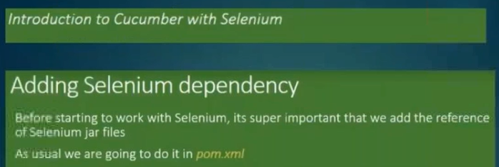

==============================================================================================================

To Login to the Application:----

Practical steps:--

1. Create a Base class ( Base.java) in package ( BaseUtil)
2. Create ,Java class (Hooks.java) in package ( stepDefination)
3. Create a Feature file ( Login.feature) in package ( Features)
4. Create StepDefination file ( stepDef.java) in package ( stepDefination)

Login.feature:--

Feature: Store login

This feature deals with the login functionality.

#https://demo.guru99.com/test/newtours/

Scenario Outline: Login with correct username and correct password

Given I navigate to login page

When I insert "<userName>" and "<passWord>"

And I clicked signin button

Then Its navigated to the home page

Examples:

| userName | passWord |

| mercury | mercury |

#| admin2 | admin22 |

#| admin3 | admin33 |

Base.Java:--

**package** BaseUtil;

**import** org.openqa.selenium.WebDriver;

**public** **class** Base {

**public** WebDriver driver;

}

Hooks.java:--

**package** Save;

**import** org.openqa.selenium.chrome.ChromeDriver;

**import** io.cucumber.java.After;

**import** io.cucumber.java.Before;

**public** **class** Hooks

{

**private** **static** Base *base*;

**public** Hooks (Base *base*)

{

**this**. *base* = *base*;

}

@Before

**public** **void** initBrowser()

{

System.***out***.println("opening the Browser : Chrome");

*base*.*driver* = **new** ChromeDriver();

}

@After

**public** **void** tearBrowser()

{

System.***out***.println("Closing the Browser : chrome");

*base*.*driver*.quit();

}

}

stepDef.java:--

**package** stepDefination;

**import** java.util.ArrayList;

**import** java.util.List;

**import** org.openqa.selenium.By;

**import** BaseUtil.Base;

**import** cucumber.api.DataTable;

**import** cucumber.api.Transform;

**import** cucumber.api.java.en.And;

**import** cucumber.api.java.en.Given;

**import** cucumber.api.java.en.Then;

**import** pages.LoginPage_PF;

**public** **class** stepDef {

**private** static Base b1;

//LoginPage_PF page = new LoginPage_PF(b1.driver);

**public** stepDef(Base b1)

{

**this**.b1 = b1;

}

@Given("^I navigate to login page$")

**public** **void** navigateToLoginPage(){

System.***out***.println("the Driver name is :"+ *b1*.*driver*);

System.***out***.println("Navigated to the Login Page");

*b1*.*driver*.get("https://demo.guru99.com/test/newtours/");

}

@Then("^Its navigated to the home page")

**public** **void** navigateToHomePage(){

System.***out***.println("Navigated to the Home Page");

*b1*.*driver*.findElement(By.*linkText*("SIGN-OFF")).isEnabled();

System.***out***.println("Navigated to home page...");

}

@And("^I clicked signin button")

**public** **void** clickSigninButton(){

System.***out***.println("clicked signin button");

*b1*.*driver*.findElement(By.*name*("submit")).click();

}

@When("^I insert ([^\"]*) and ([^\"]*)$")

**public** **void** enterUsernamePassword(String username , String password)

{

System.***out***.println("username :"+username);

System.***out***.println("password :"+password);

*b1*.*driver*.findElement(By.*name*("userName")).sendKeys(username);

*b1*.*driver*.findElement(By.*name*("password")).sendKeys(password);

}

}

Run

==============================================================================================================

To implement POM(Page object model):--

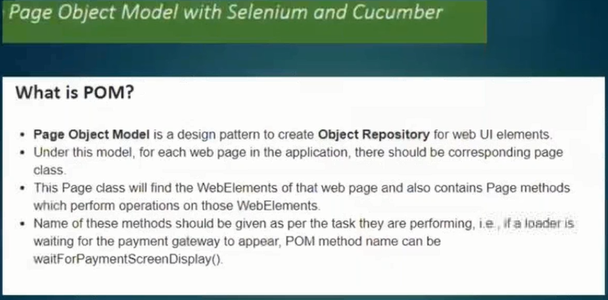

Practical steps:--

1. Create a Base class ( Base.java) in package ( BaseUtil)
2. Create ,Java class (Hooks.java) in package ( Hooks)
3. Create a Feature file ( Login.feature) in package ( Features)
4. Create StepDefination file ( stepDef.java) in package ( stepDefination)
5. Create LoginPage file ( LoginPage.java) in package ( Pages)

Login.feature:--

**Feature:** Store login

This feature deals with the login functionality.

**Scenario Outline:** Login with correct username and correct password

*Given* I navigate to login page

# When I entered username and password

*When* I insert *<userName>* and *<passWord>*

*And* I clicked signin button

*Then* Its navigated to the home page

**Examples:**

| userName | passWord |

| mercury | mercury |

#| admin2 | admin22 |

#| admin3 | admin33 |

Base.Java:--

**package** BaseUtil;

**import** org.openqa.selenium.WebDriver;

**public** **class** Base {

**public** static WebDriver driver;

}

Hooks.java:--

**package** stepDefination;

**import** org.openqa.selenium.chrome.ChromeDriver;

**import** BaseUtil.Base;

**import** cucumber.api.java.After;

**import** cucumber.api.java.Before;

**public** **class** Hook {

//object of class -- Base

**private** static Base baseUtil;

//using Dependency Injuction

**public** Hook(Base baseUtil)

{

**this**.baseUtil = baseUtil;

}

@Before

**public** **void** initBrowser()

{

System.***out***.println("opening the Browser : Chrome");

//System.*setProperty*("webdriver.chrome.driver", "C:\\Users\\Pandu\\Downloads\\imp--dont delete\\Drivers\\chromedriver.exe");

baseUtil.driver = **new** ChromeDriver();

//driver.navigate().to("http://www.newtours.demoaut.com/");

}

@After

**public** **void** tearBrowser()

{

System.***out***.println("Closing the Browser : chrome");

//baseUtil.driver.close();

}

}

=------------------

stepDef.java:--

**package** StepDefPkg;

**import** org.openqa.selenium.By;

**import** org.testng.Assert;

**import** io.cucumber.java.en.And;

**import** io.cucumber.java.en.Given;

**import** io.cucumber.java.en.Then;

**import** io.cucumber.java.en.When;

**public** **class** LoginClass {

**private** **static** Base *base*;

**public** LoginClass(Base base)

{

**this**.*base*= base;

}

@Given("^I navigate to login page$")

**public** **void** navigateToLoginPage(){

System.***out***.println("the Driver name is :"+ *base*.driver);

System.***out***.println("Navigated to the Login Page");

*base*.driver.get("https://demo.guru99.com/test/newtours/");

Assert.*assertEquals*(*base*.driver.getTitle(), "Welcome: Mercury Tours");

}

@Then("^Its navigated to the home page")

**public** **void** navigateToHomePage(){

System.***out***.println("Navigated to the Home Page");

*base*.driver.findElement(By.*linkText*("SIGN-OFF")).isEnabled();

System.***out***.println("Navigated to home page...");

Assert.*assertEquals*(0, 0);

}

@And("^I clicked signin button")

**public** **void** clickSigninButton(){

System.***out***.println("clicked signin button");

HomePage obj= **new** HomePage(*base*.driver);

obj.clickSubmitButton();

}

@When("I insert {string} and {string}")

**public** **void** enterUsernamePassword(String username , String password)

{

HomePage obj= **new** HomePage(*base*.driver);

obj.setUserName(username);

obj.setPassword(password);

}

}

---------------------------

LoginPage.java:--

**public** **class** HomePage

{

WebDriver driver;

**public** HomePage(WebDriver driver)

{

PageFactory.*initElements*(driver, **this**);

}

// locators

// action method

//By unm= By.name("userName");

@FindBy(name="userName") WebElement username;

@FindBy(how=How.***NAME*** , using="password")WebElement password;

@FindBy(how=How.***NAME*** , using="submit")WebElement submit_button;

//Driver initialization

**public** **void** setUserName(String uid)

{

username.sendKeys(uid);

}

**public** **void** setPassword(String pass)

{

password.sendKeys(pass);

}

**public** **void** clickSubmitButton()

{

submit_button.click();

}

**public** **void** login_to_FlightBooking(String uid, String pass)

{

username.sendKeys(uid);

password.sendKeys(pass);

submit_button.click();

//BrowserFactory.wait(1000,username.sendKeys(uid));

}

}

**package** StepDefPkg;

**import** org.junit.runner.RunWith;

**import** io.cucumber.junit.Cucumber;

**import** io.cucumber.junit.CucumberOptions;

@RunWith(Cucumber.**class**)

@CucumberOptions(features= {"src\\test\\java\\FeaturesPkg\\Login.feature"}

,glue="StepDefPkg"

)

**public** **class** Runner2 {

}