



Test Case:-

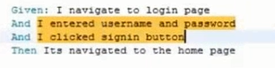

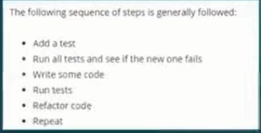

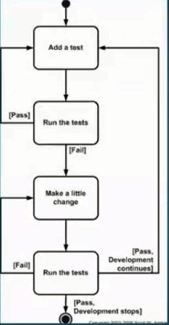





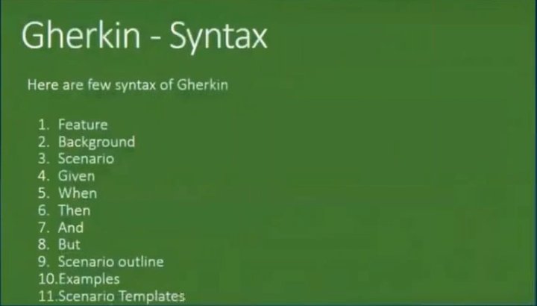

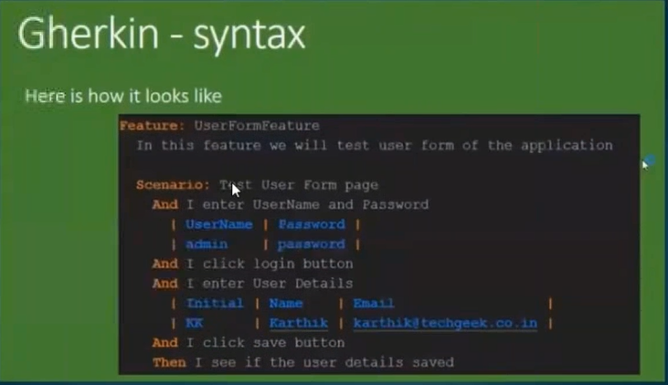

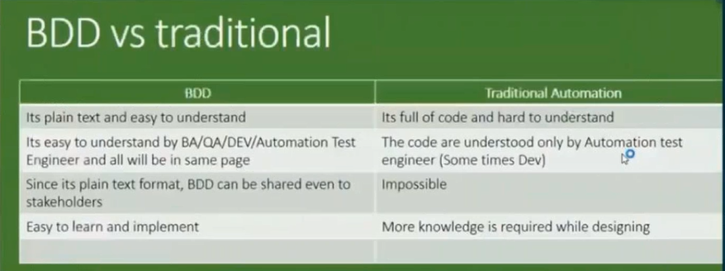





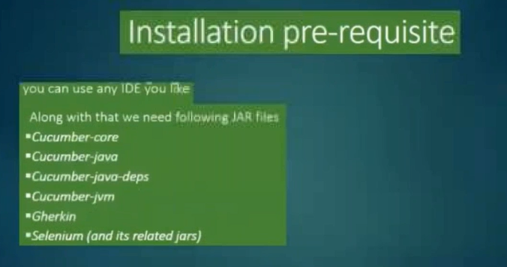

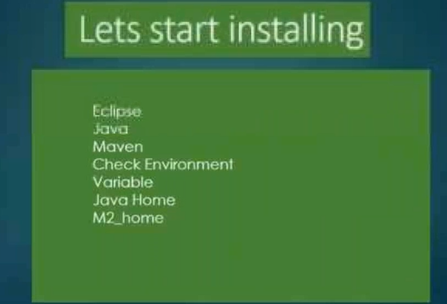

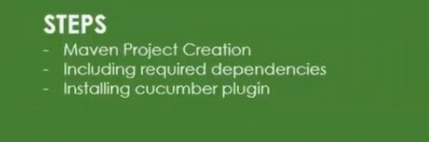

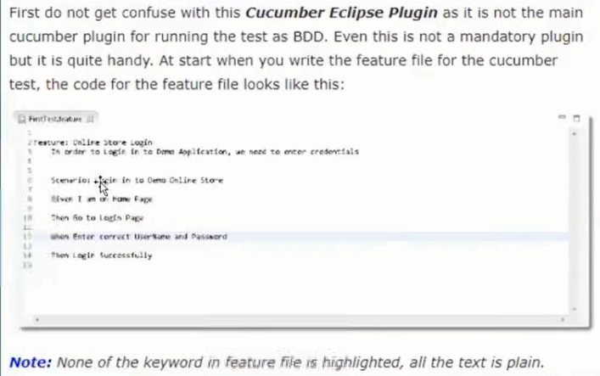

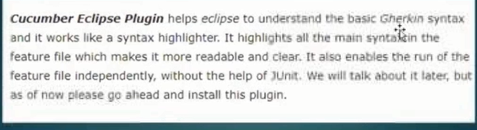

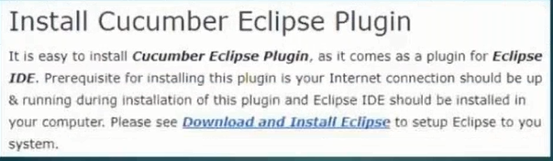

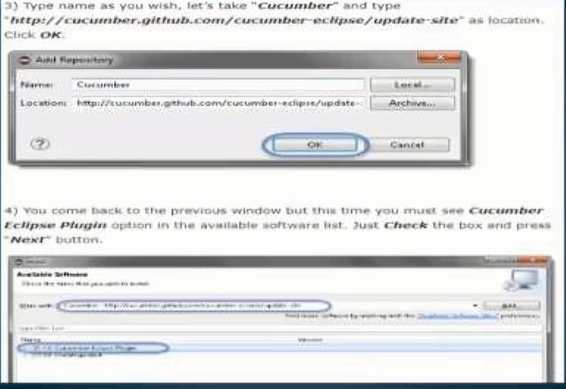

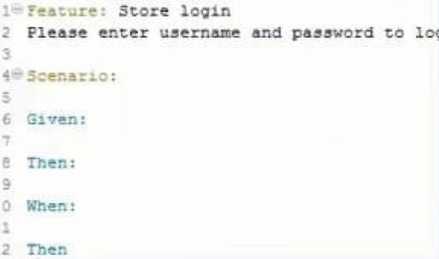

**Feature:** Store login

This feature deals with the login

**Background:**

*Given* I navigate to login page

*@TC1*

**Scenario:** Login with correct username and correct password

#Given I navigate to login page

*And I* entered username and password

*And* I clicked signin button

*Then* Itas navigated to the HomePage

*@TC2*

**Scenario:** Login with correct username and invlid password

#Given I navigate to login page

*And I* entered username and password

*But* Invalid pwd

*And* I clicked signin button

*Then* Itas navigated to the HomePage

========================

**package** StepDefPkg;

**import** cucumber.api.java.en.And;

**import** cucumber.api.java.en.But;

**import** cucumber.api.java.en.Given;

**import** cucumber.api.java.en.Then;

**public** **class** stepDef1 {

@Given("^I navigate to login page$")

**public** **void** i_navigate_to_login_page() **throws** Throwable {

System.***out***.println("Homepage launched...");

}

@And("^I entered username and password$")

**public** **void** i_entered_username_and_password() **throws** Throwable {

System.***out***.println("credencials Entered...");

}

@But("^Invalid pwd$")

**public** **void** invalid_pwd() **throws** Throwable {

System.***out***.println("invlid pwd");

}

@And("^I clicked signin button$")

**public** **void** i_clicked_signin_button() **throws** Throwable {

System.***out***.println("kO done...");

}

@Then("^Itas navigated to the HomePage$")

**public** **void** itas_navigated_to_the_HomePage() **throws** Throwable {

System.***out***.println("compeleted...");

}

}