Mobile Sales Analysis & Predictive Forecasting:
Data Set Overview:
The dataset used for this project consists of 1,000 transaction records capturing retail mobile sales. It offers a thorough understanding of regional demand, customer demographics, and sales performance.
Descriptions of Columns:
TransactionID: An alphanumeric code that is specific to each sale.
Date: The purchase date in string format (later converted to a datetime in Python for trend analysis).
Mobile Model: The specific model name of the device sold.
Brand: The mobile device's manufacturer.
Price: The mobile phone's retail price per unit.
Units Sold: The number of phones bought in a single transaction.
Total Revenue: The total financial value of the transaction
Customer Age: The buyer's age, ranging from 18 to 64 years.
Customer Gender: The customer's gender (Male, Female, or Other).
Location: The geographic city or region where the sale was recorded.
Payment Method: The payment method (cash, credit card, online, etc.) that is utilized.

Introduction:
This project is about looking at a large mobile sales dataset to find hidden patterns in how revenue is made. I made an end-to-end analytical solution by combining the data processing power of Python with the advanced visualization tools available in Power BI. The project transitions from raw data cleaning and exploratory analysis to building a predictive model that estimates future performance.

Objective:
This project aims to forecast future sales by analyzing sales trends. My goal is to identify key revenue drivers, such as top-performing products and locations, by analyzing past performance. Additionally, the project utilizes a machine learning algorithm to forecast sales for the next quarter, enabling proactive business planning based on data-driven trends.

Preparing and Cleaning Data
I used Python to prepare the dataset for analysis.
- Date Conversion:
I transformed the raw dates, which were strings, into a common datetime format.
- Feature Engineering:
To organize the sales data, I extracted the Year and Month into separate columns.
- Data Aggregation:
I compiled the total revenue to prepare the data for the charts and the machine learning model.
Exploratory Data Analysis (EDA):
I conducted an exploratory analysis using Python after the data had been cleaned.
- Product Revenue Analysis:
To determine which products made the biggest contributions to the company, I grouped the data by Mobile Model.
- Key Finding:
With $282,863.97 in revenue, the “huge" model was found to be the main source of income.
- Visualization:
I created a bar chart ranking the Top 10 models to show the gap between best-sellers and other inventory.
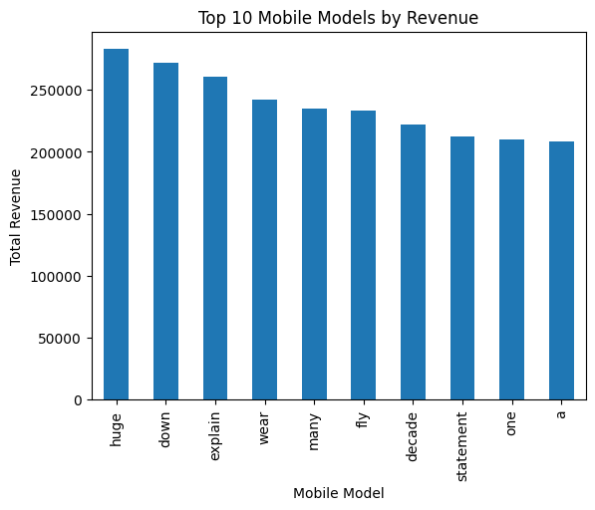
- Distribution by Region:
In order to determine the actual locations of the sales, I also examined the data by location.
- Finding:
With $185,827.20 in total sales, Lake Amanda was the best-performing location.
- Visualization:
I used a Pie Chart to show market share by city, which is crucial for organizing future distribution.
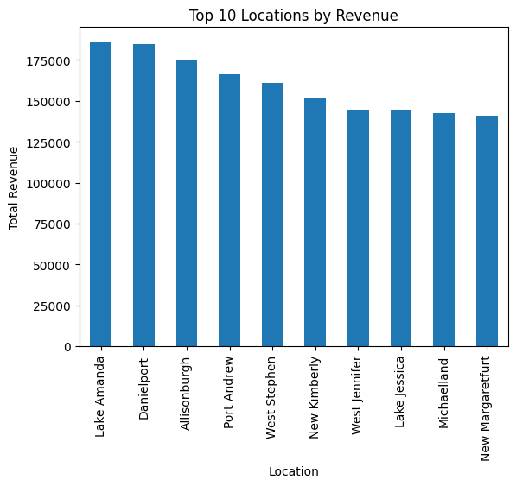
- Machine Learning and Forecasting :
In this part of the project, I used Predictive Modeling to look at past sales patterns and estimate how the business will perform in the future.
- The Model: Using the scikit-learn library, I created a Linear Regression model.
- Methodology:
I transformed the months into a numerical TimeIndex to help the model learn and follow the revenue trend.
- The Forecast: I exported a three-month revenue forecast as a bridge file to be used in the final dashboard.
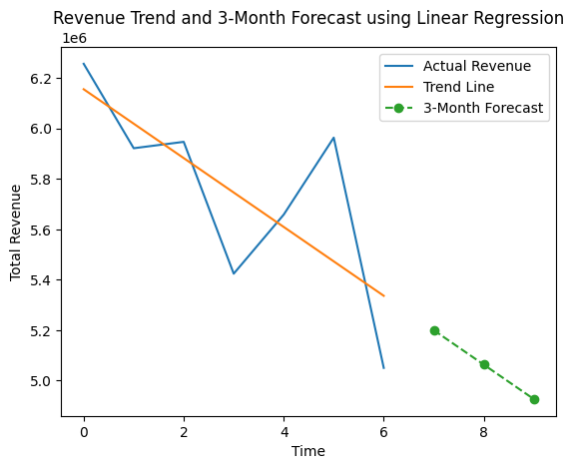

Conclusion & Final Dashboard:
In order to create an interactive dashboard, I imported the forecast results and the cleaned data into Power BI.

Visual Presentation:
I used pie charts for locations and bar charts for products, along with clear labels to show the total revenue. In order to show both the machine learning forecast and the historical sales, I also included a line chart.
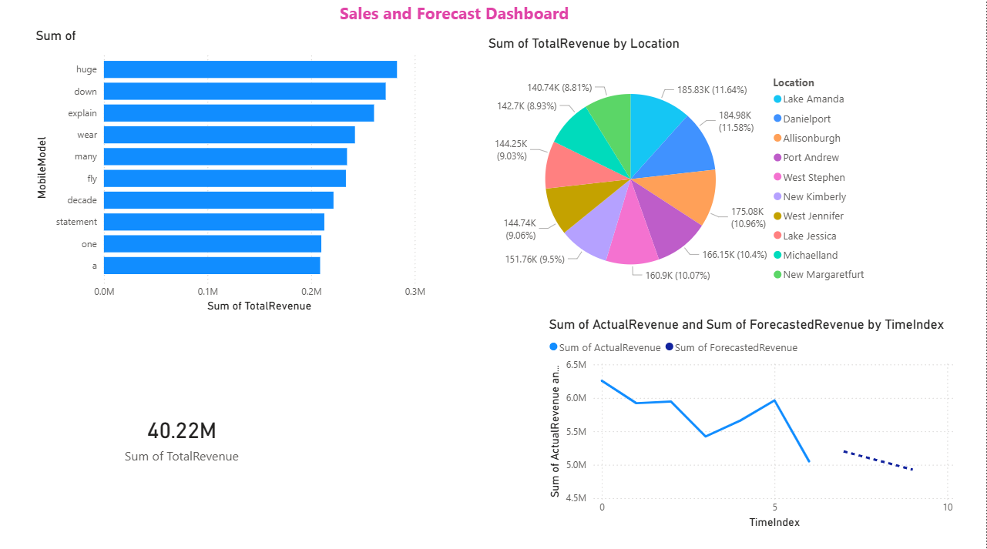

In conclusion, the analysis reveals a robust $40.22 million in total revenue. However, the machine learning model indicates a slight downward trend for the upcoming quarter.
To counter the predicted dip, I recommend a targeted marketing campaign in top regions like Lake Amanda.

