

GENERATIVE ARTIFICIAL INTELLIGENCE & LLM APPLICATION
COGNITIVENEXUS
AI-POWERED KNOWLEDGE AND PRODUCTIVITY ASSISTANT

TITLE
Team Name: Cognitive Crew
Course: Generative Artificial Intelligence & LLM Application
Technologies: Python, Streamlit, Hugging Face, RAG, Prompt Engineering

TEAM MEMBERS
1. Swathi S – B.Sc. Computer Science with Artificial Intelligence
2. Kalpana Y – B.Sc. Computer Science with CGS
3. Jayashree B – B.Sc. Computer Science with CGS
4. Kajoal C - B.Sc. Data Science with Artificial Intelligence

College Name: Shrimathi Devkunvar Nanalal Bhatt Vaishnav College for Women (Autonomous)
Chromepet, Chennai
Academic Year: 2026 to 2029

Abstract
CognitiveNexus is a Generative AI-based knowledge and productivity assistant designed to provide task-specific AI support within a single Streamlit application. The application brings together six AI modes—Research, Study, Analysis, Content, Creative, and General Chat—so that users can select an interaction style appropriate to their task. Its Smart Prompt Engineering layer helps transform user input into a more structured prompt before inference.
The project also provides PDF-based knowledge assistance using a retrieval workflow based on PDF text extraction, chunking, TF-IDF representation, and cosine similarity. During an active session, conversation context can be maintained using Streamlit session state. Personalized study functions include Auto Detect, Explanation, Summary, Quiz, Flashcards, and Learning Plan, while response evaluation presents estimates for relevance, completeness, accuracy, hallucination risk, and an overall score. These components are combined to create a unified AI assistant for research, learning, analysis, content, and creative tasks.

1. Introduction

1.1 Generative Artificial Intelligence
Generative Artificial Intelligence refers to AI systems that can generate new content such as text and other outputs from user instructions. In this project, Generative AI is used to produce responses that are adapted to the selected task and, when PDF assistance is used, to the retrieved document context.

1.2 AI Assistants
AI assistants can help users perform information, learning, writing, analysis, and creative tasks through natural-language interaction. A single assistant can reduce the need to switch between separate tools when the application provides different task-specific capabilities.

1.3 Need for Task-Specific AI Responses
Different user tasks require different response structures. A research request, a study quiz, an analytical comparison, a content-writing task, and a creative request do not necessarily benefit from the same prompt format. CognitiveNexus addresses this need through mode selection and Smart Prompt Engineering.

1.4 Purpose of CognitiveNexus
The purpose of CognitiveNexus is to combine multiple task-specific AI interactions, PDF-based knowledge retrieval, active-session conversation context, personalized study tools, and response evaluation in one application.

2. Project Overview
CognitiveNexus is an AI-powered knowledge and productivity assistant implemented as a Streamlit application. The project is organized around six AI modes and several supporting capabilities that help adapt the response to the user's task.

2.1 Six AI Modes
- Research – supports research-oriented information requests.
- Study – provides learning-oriented assistance and study formats.
- Analysis – supports structured analytical responses.
- Content – assists with content-generation tasks.
- Creative – supports creative-generation tasks.
- General Chat – provides general conversational assistance.

2.2 Smart Prompt Engineering
Smart Prompt Engineering identifies the nature of the user's task and applies a task-appropriate prompt structure. The intended flow is User Input → Task Detection → Prompt Optimization → Structured Prompt → AI Model.

2.3 RAG Knowledge Assistant
The RAG component allows a user to upload a PDF and ask questions about its contents. The application extracts text, divides the content into retrievable chunks, represents text using TF-IDF, compares the user query with document chunks using cosine similarity, and uses relevant retrieved content to support the generated response.

2.4 Conversation Memory
Conversation history is maintained during the active application session using Streamlit session state. This allows previous messages to be used as context within that session. It is not presented as permanent or cross-session memory.

2.5 Response Evaluation
Generated responses can be evaluated using relevance, completeness, accuracy, hallucination risk, and an overall score. These values are model-generated estimates and should not be treated as guaranteed ground-truth measurements.

2.6 Personalized Study Mode
- Auto Detect
- Explanation
- Summary
- Quiz
- Flashcards
- Learning Plan

3. Problem Statement
Users often need different AI tools for different tasks. Creating effective prompts manually can be difficult, searching information inside large PDF documents can be time-consuming, and research, study, analysis, content creation, and creative assistance may require separate workflows. Previous conversation context may also need to be repeated, while study tools and response-quality evaluation are not always available in the same application.
The problem addressed by CognitiveNexus is the need for a single AI assistant that can adapt its interaction to different user tasks while also supporting document-based questions, active-session context, personalized study functions, and response evaluation.

4. Objectives
- Develop a multi-purpose AI-powered knowledge and productivity assistant.
- Implement Smart Prompt Engineering.
- Provide task-specific AI responses.
- Implement PDF-based knowledge retrieval using a RAG workflow.
- Maintain conversation context during an active session.
- Evaluate generated AI responses.
- Provide personalized study assistance.

5. Existing System / Current Challenges
In a conventional workflow, users may depend on separate tools for research, study, analysis, content creation, document searching, and response evaluation. This creates a fragmented workflow and can require repeated prompt creation or repeated context.
Existing Approach | Challenge
Separate AI tools | Multiple applications may be required.
Manual prompt creation | Users must design suitable prompts themselves.
Manual PDF searching | Finding relevant information in large documents can be time-consuming.
Repeated context | Previous information may need to be repeated.
Separate study tools | Learning functions may require a different application.
No unified workflow | Research, study, analysis, content, creative work, retrieval, and evaluation are not necessarily combined.

6. Proposed Gen AI Solution
CognitiveNexus combines Generative AI, Smart Prompt Engineering, RAG-based PDF assistance, active-session conversation context, personalized study tools, and response evaluation in one Streamlit application.
User Task → Smart Prompt → LLM → AI Response → Evaluation → Final Output
For PDF questions, the workflow adds document retrieval: PDF → Text Extraction → Chunking → TF-IDF → Cosine Similarity → Relevant Chunks → Structured Prompt/LLM → Response with source/page support when available.

7. Tools & Technologies Used

Technology | Purpose
Python | Application development
Streamlit | Web application interface
Hugging Face Inference API | LLM inference
openai/gpt-oss-120b | Main language model
PyPDF | PDF text extraction
Scikit-learn | Retrieval processing
TF-IDF | Text representation
Cosine Similarity | Relevant chunk retrieval
GitHub | Version control and project repository

8. System Workflow / Architecture
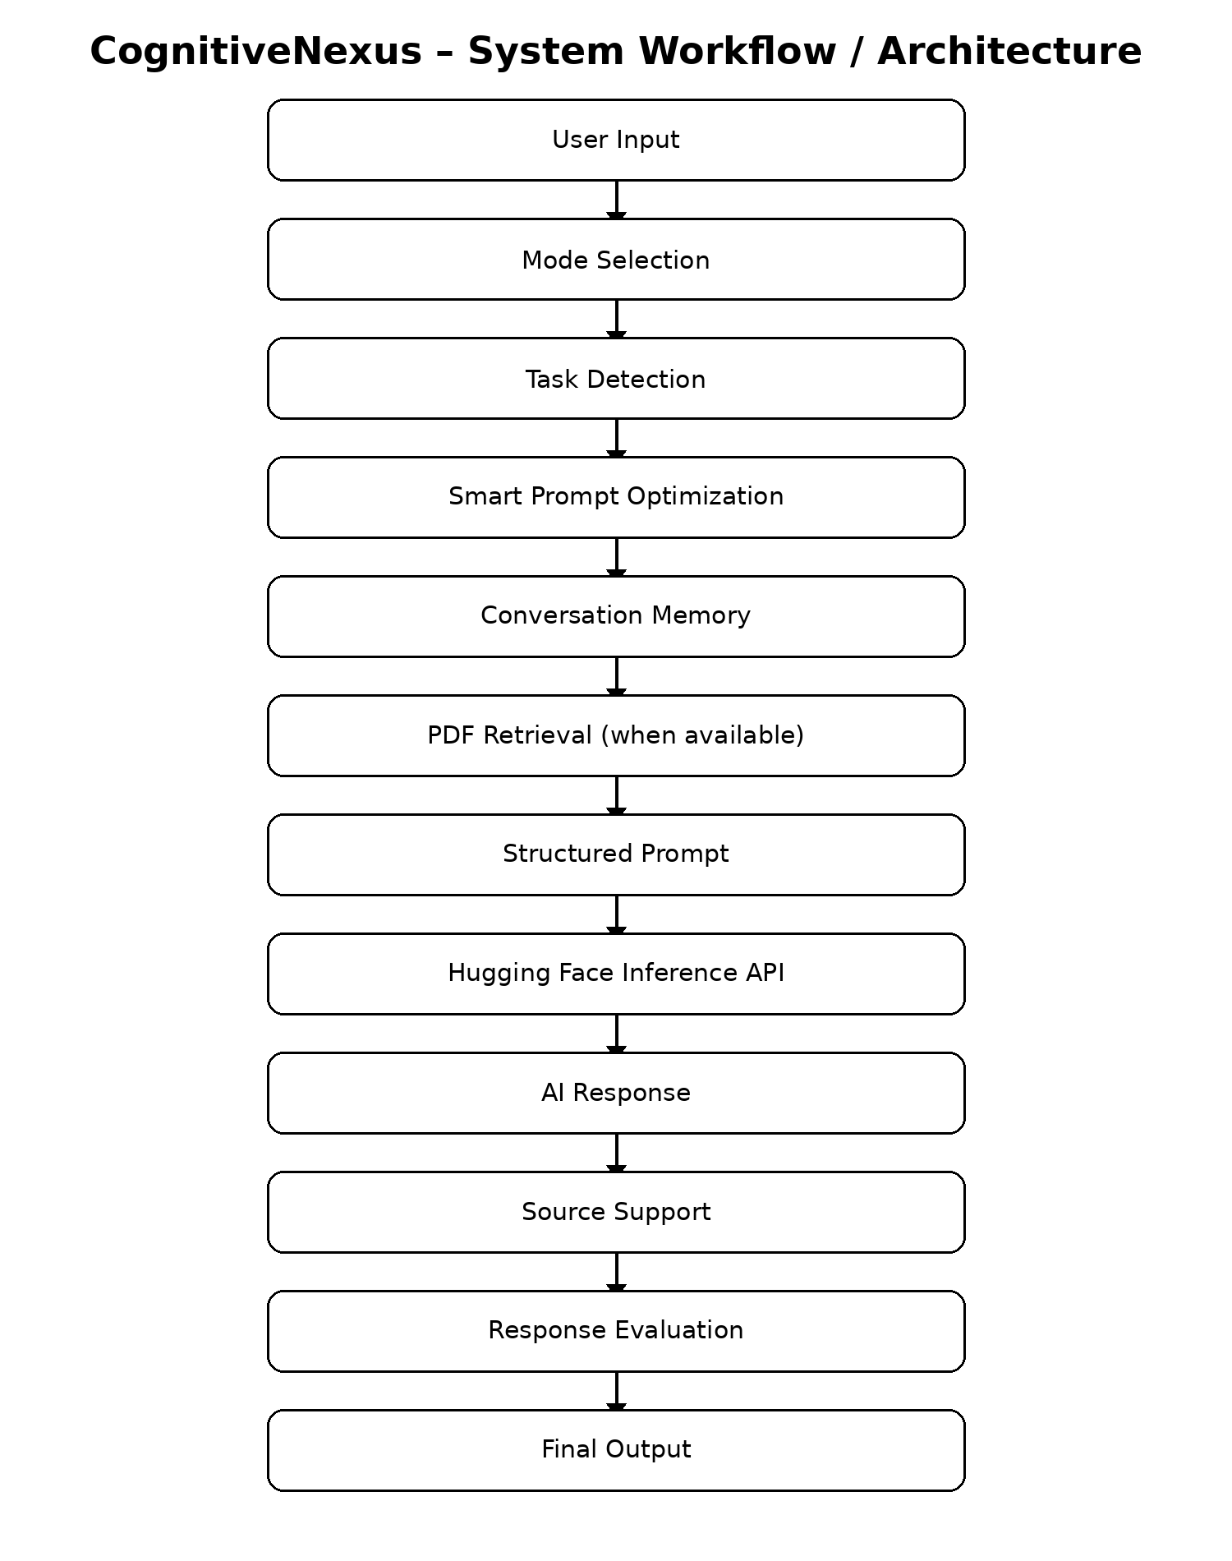
The architecture follows a sequential workflow. User input is first associated with a selected mode and task. Smart Prompt Engineering then optimizes the prompt. Conversation memory may provide active-session context, while PDF retrieval is used when document assistance is available. The resulting structured prompt is sent through the Hugging Face Inference API, after which the generated response can include source support and evaluation information before the final output is presented.
User Input: The user provides a natural-language task or question.
Mode Selection: The user selects one of the six AI modes.
Task Detection: The application determines the type of task to support the prompt structure.
Smart Prompt Optimization: The prompt is adapted to the task.
Conversation Memory: Previous messages from the active session can provide context.
PDF Retrieval: Relevant PDF content is retrieved when a document is available.
Structured Prompt: Task instructions and relevant context are combined for model inference.
Hugging Face Inference API: The language model inference service generates the response.
AI Response and Source Support: The generated answer is displayed, with source/page information when available.
Response Evaluation: The response can be evaluated using the defined criteria.

9. Implementation

9.1 User Interface
The user interface is implemented using Streamlit. The application provides controls for selecting AI modes, entering user requests, working with PDF-based assistance when available, and viewing generated responses and supporting information.

9.2 Six AI Modes
The six modes provide task-specific interaction styles: Research, Study, Analysis, Content, Creative, and General Chat. Mode selection helps the application apply a suitable prompt structure for the intended task.

9.3 Smart Prompt Engineering
The Smart Prompt Engineering layer is designed to improve task alignment by transforming the user's input into a structured prompt. The conceptual implementation flow is User Input → Task Detection → Prompt Optimization → Structured Prompt → AI Model.

9.4 RAG Knowledge Assistant
The PDF-based knowledge assistant follows a retrieval workflow. A PDF is uploaded, its text is extracted, and the text is divided into manageable chunks. TF-IDF is used to represent the text, and cosine similarity is used to identify chunks that are most relevant to the user's query. Relevant chunks are then supplied as context for the AI response. Source/page support can be displayed when available.

9.5 Conversation Memory
Conversation history is maintained using Streamlit session state during the active session. This allows subsequent interactions to use previous messages as context without claiming permanent user memory.

9.6 Response Evaluation
The response evaluation component considers relevance, completeness, accuracy, hallucination risk, and an overall score. The displayed values are model-generated estimates and should be interpreted as supporting indicators rather than guaranteed ground truth.

9.7 Personalized Study Mode
Personalized Study Mode provides multiple study-oriented formats. Auto Detect can determine an appropriate study response type, while the available formats include Explanation, Summary, Quiz, Flashcards, and Learning Plan.

10. Screenshots with Explanations
The following screenshots present the implemented features and outputs of CognitiveNexus. The following output screenshots demonstrate selected project workflows using the format Input → Output → Observation.

Shows the main application interface and the available AI modes:
01-main-interface.png
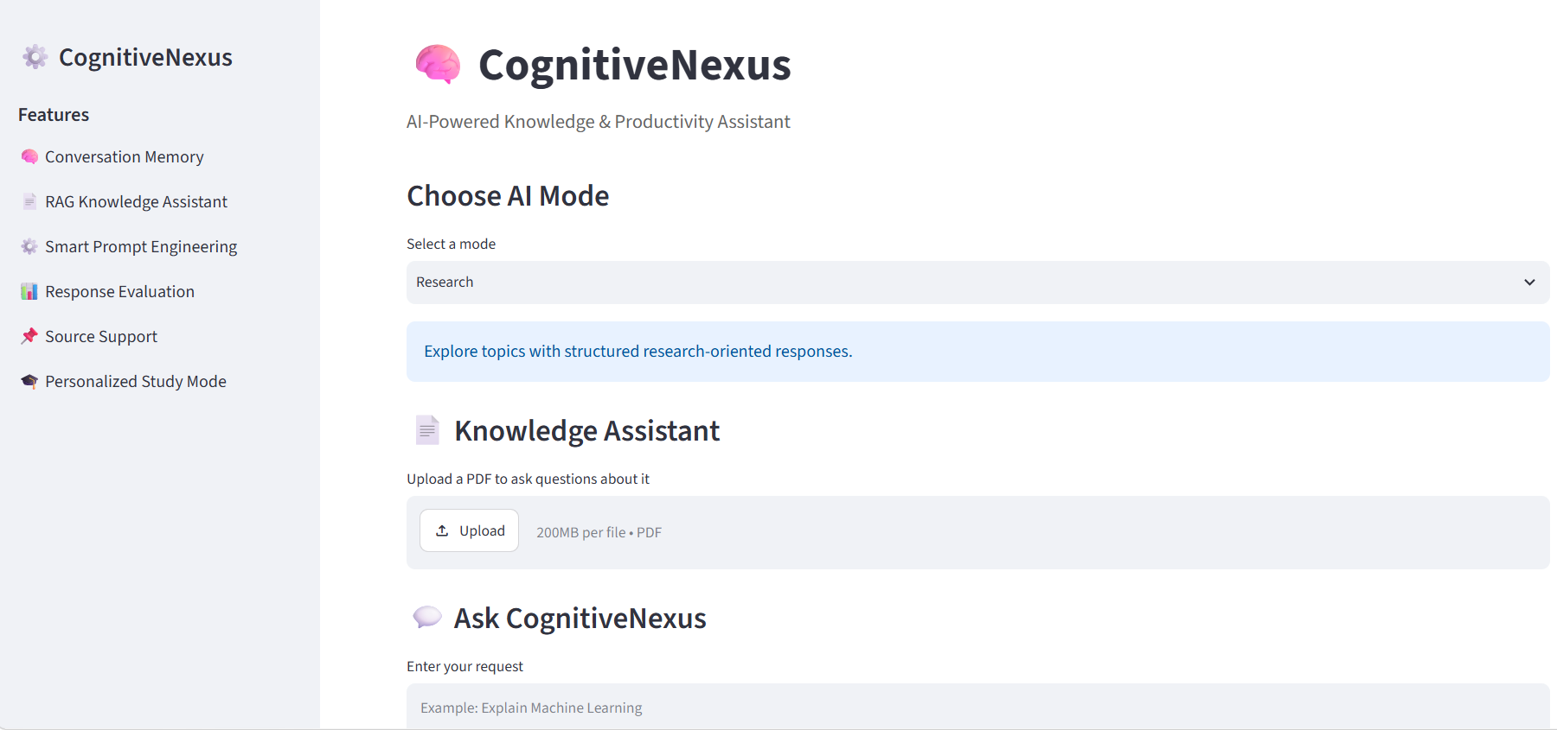
Figure 1 – Main CognitiveNexus Interface

Observation:
The interface provides access to multiple AI modes and supporting features through a single Streamlit application.

Shows a PDF-based question and the response generated using retrieved document information.
02-rag-pdf-response.png
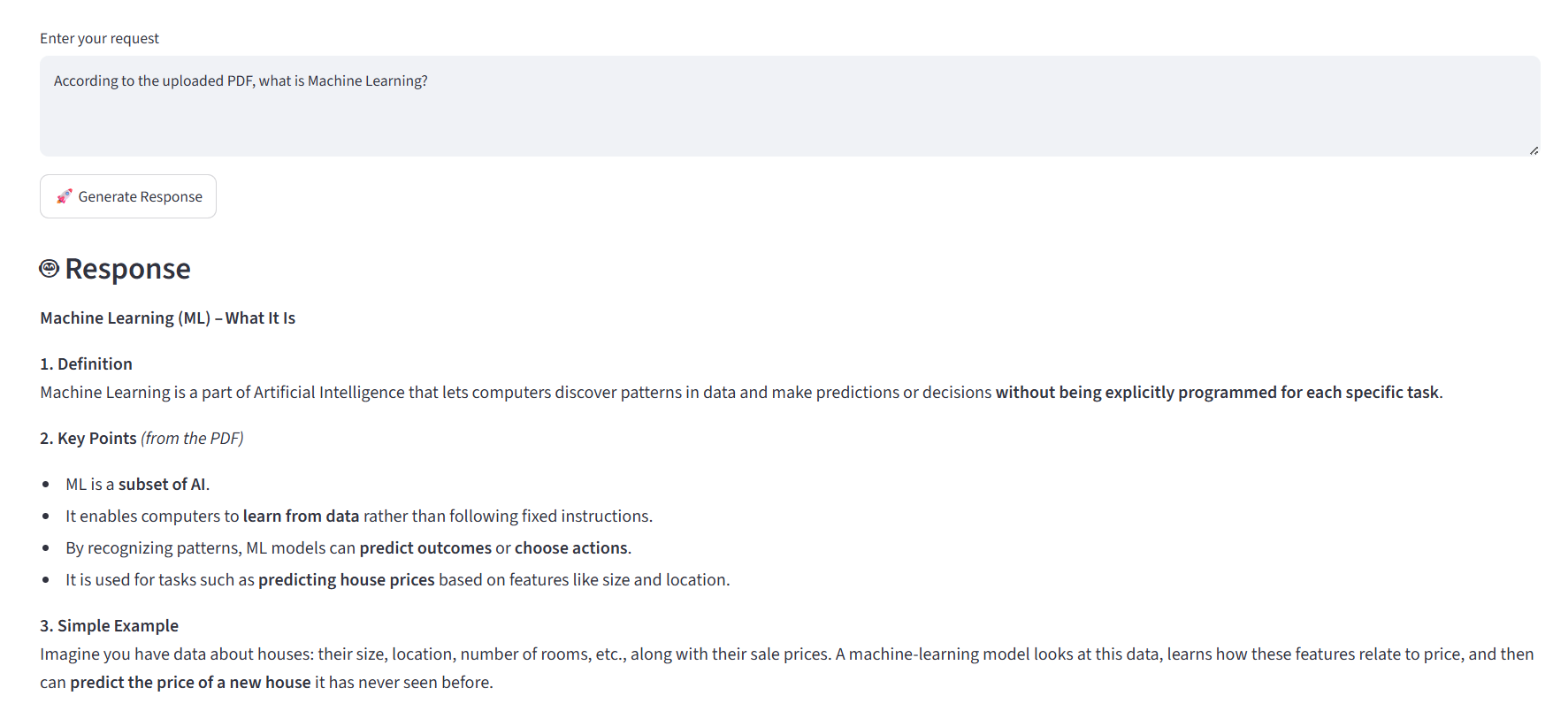
Figure 2 – RAG PDF Response
Observation:
The system retrieves relevant information from the uploaded PDF and generates a document-based response.

Shows source/page support and the response evaluation information:
03-source-and-evaluation.png
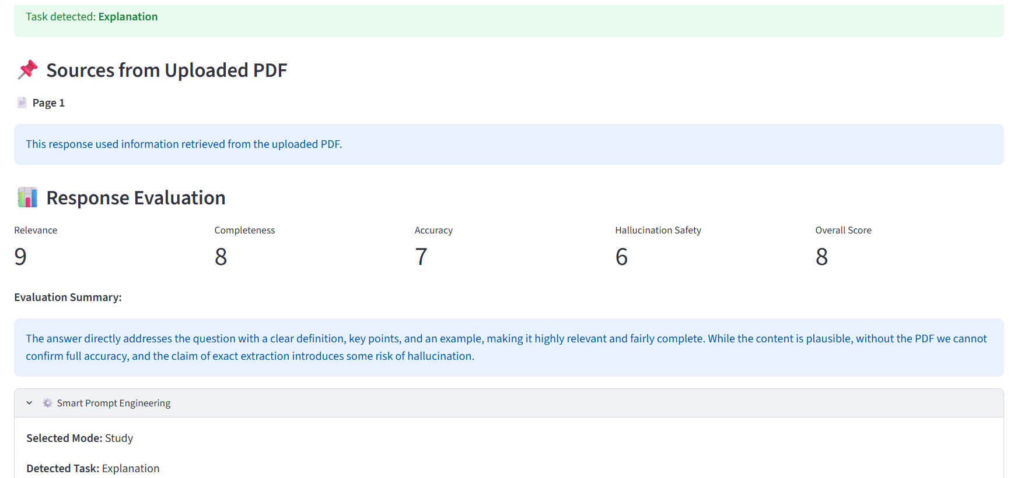
Figure 3 – Source Support and Response Evaluation
. Observation:
The output displays source information and evaluation scores for the generated response.
Shows task identification and the structured prompt/optimization workflow:
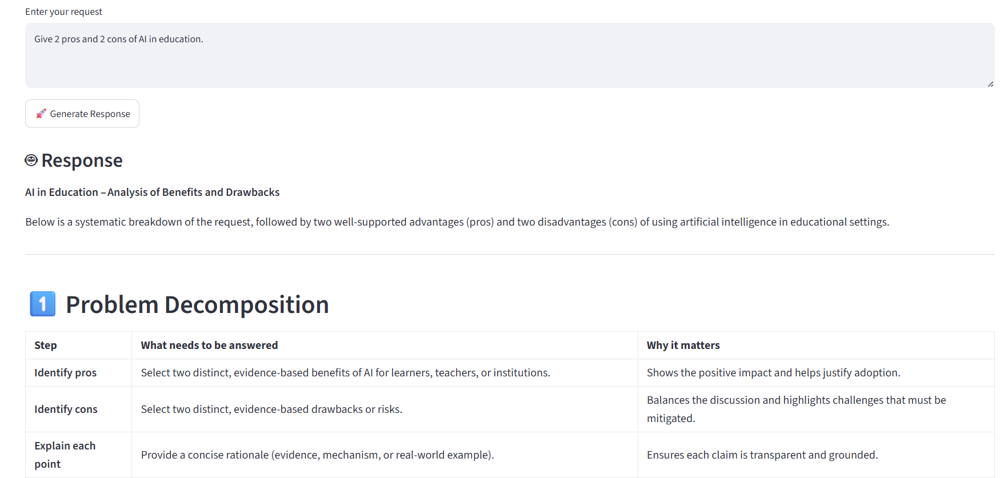
04-smart-prompt-engineering.png
Observation:
The system identifies the task and structures the response according to the selected requirement.

Shows the personalized study functionality and quiz output:
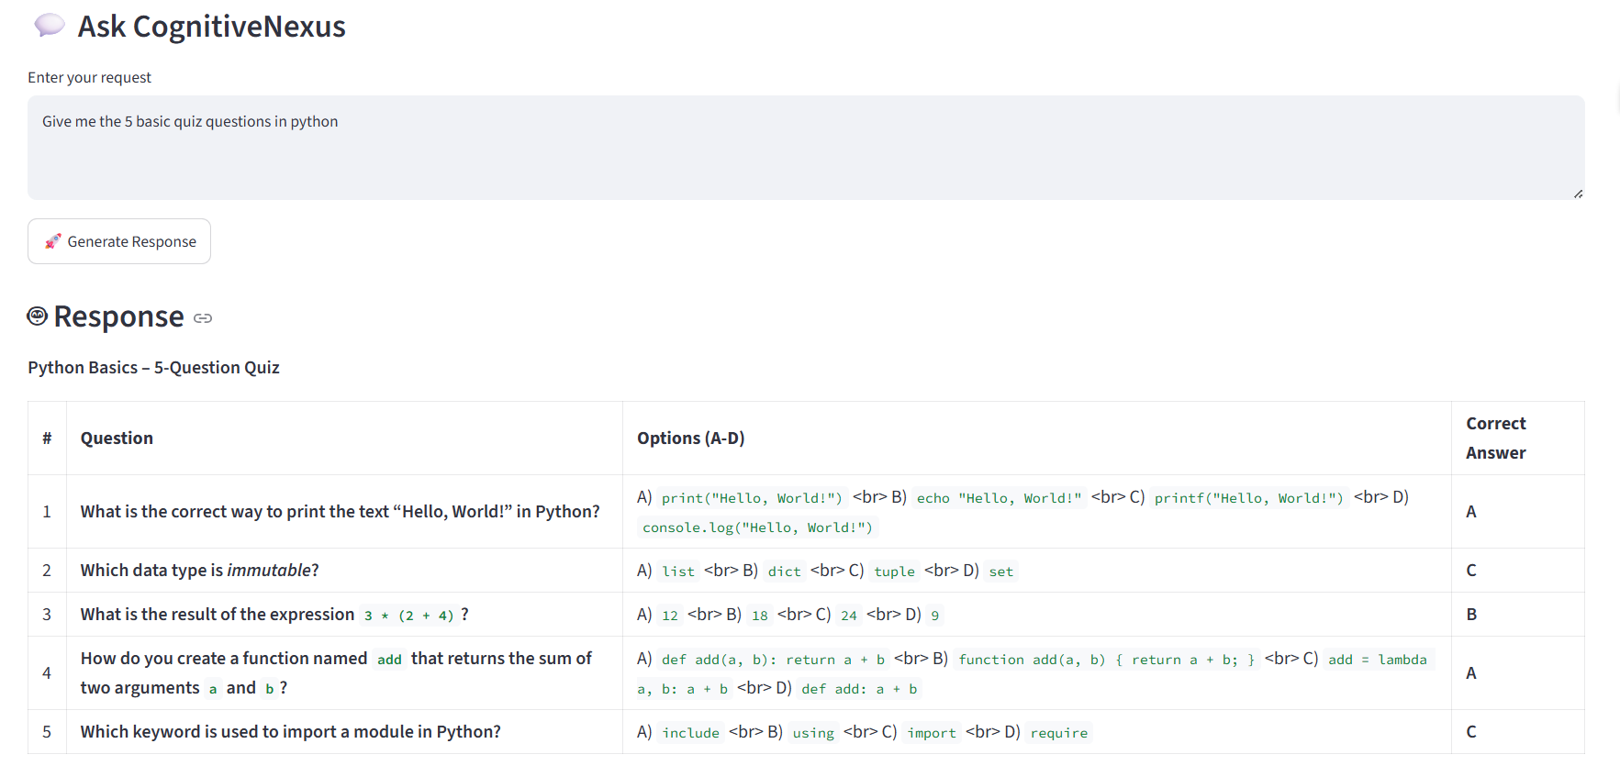
05-personalized-study-quiz.png
Observation:
The Study Mode generates five Python quiz questions with multiple-choice options and answers.

Shows a Creative Mode response and its evaluation information:
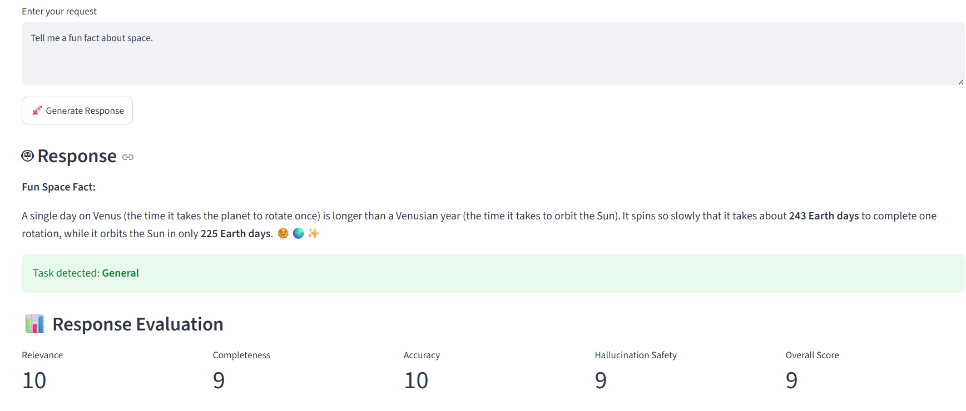
06-creative-mode.png
Observation:
Creative Mode generates a creative response and displays its evaluation information.

11. Testing & Test Cases
The following test cases are based on the project testing requirements supplied for the documentation. The final submission should retain only results that have been actually executed and recorded in the project's testing evidence.
Test Case | User Input | Expected Output | Result
1 – RAG | According to the uploaded PDF, what is Machine Learning? | Answer based on information retrieved from the uploaded PDF. | Passed (as supplied)
2 – Study Quiz | Give me the 5 basic quiz questions in Python. | Generate five Python quiz questions. | Passed (as supplied)
3 – Analysis | Give 2 pros and 2 cons of AI in education. | Provide two advantages and two disadvantages. | Passed (as supplied)
Additional testing can cover Conversation Memory, Flashcards, Learning Plan, Research, Content, and Creative Mode when corresponding execution evidence is available.

12. Output Screenshots
Important final output screenshots should be presented using the format Input → Output → Observation. The actual screenshots from the repository should be inserted here after verification.

Output 1 – RAG PDF Response
Input:
According to the uploaded PDF, what is Machine Learning?
Output:
Retrieved document-based explanation of Machine Learning.


Rag-PDF-response.png
RAG output: input question → retrieved-context response → observation

Observation:
The system retrieves relevant PDF information and generates a contextual response.

Output 2 – Personalized Study Quiz
Input:
Give me the 5 basic quiz questions in Python.
Output:
Five Python multiple-choice questions with options and correct answers.

personalized-study-quiz.png
Study output: quiz request → generated questions → observation

Observation:
The Study Mode generates a structured quiz for learning and practice.

Output 3 – Creative Mode
Input:
Tell me a fun fact about space.
Output:
A generated creative response about space.


creative-mode.png
Creative output: creative request → generated response → observation

Observation:
Creative Mode generates a response and provides response evaluation information

13. Challenges & Solutions

Challenge 1 – PDF Information Retrieval
Problem: Finding relevant information from uploaded PDFs.
Solution: A retrieval workflow using text extraction, TF-IDF representation, and cosine similarity is used to identify relevant document chunks.

Challenge 2 – Different User Tasks
Problem: Different tasks require different prompt structures.
Solution: Smart Prompt Engineering and task-specific prompt optimization are used to adapt the prompt to the selected task.

Challenge 3 – Response Evaluation
Problem: Users need additional information about response quality.
Solution: The application provides estimates for relevance, completeness, accuracy, hallucination risk, and an overall score.

Challenge 4 – AI Model Availability
Problem: Hugging Face inference can sometimes be affected by availability, limits, or temporary timeouts.
Solution: The project is tested using the available inference service, with applicable handling for inference failures.

14. Advantages & Limitations

14.1 Advantages
- Multiple AI modes in one application
- Smart Prompt Engineering
- PDF-based knowledge retrieval
- Source/page support
- Active-session conversation context
- Personalized study tools
- Response evaluation
- Simple Streamlit interface

14.2 Limitations
- Response quality depends on the underlying language model.
- PDF retrieval depends on extractable PDF text.
- Conversation memory is session-based.
- Hugging Face inference availability and usage limits can affect responses.
- Evaluation scores are model-generated estimates and are not guaranteed ground truth.

15. Future Enhancements
The following items are future enhancements and are not described as current implemented features:
- Persistent user memory
- Improved semantic/vector retrieval
- Multiple document support
- Support for additional document formats
- User authentication
- Improved response evaluation
- Additional study tools
- Deployment and scalability improvements

16. Conclusion
CognitiveNexus demonstrates how Generative AI, LLM inference, Smart Prompt Engineering, PDF-based RAG, active-session conversation context, personalized study tools, and response evaluation can be combined into a single AI-powered knowledge and productivity assistant. By organizing interaction through six AI modes, the application can adapt its response style to different user tasks.
The project also demonstrates how retrieved PDF context can support document-based questions and how study and evaluation features can be integrated into the same workflow. The application therefore provides a unified environment for research, study, analysis, content, creative, and general conversational assistance.

17. References
- Python Software Foundation. Python Documentation.
https://docs.python.org/3/
- Streamlit. Streamlit Documentation.
https://docs.streamlit.io/
- Hugging Face. Inference Providers Documentation.
https://huggingface.co/docs/inference-providers/
- Hugging Face. openai/gpt-oss-120b Model Documentation.
https://huggingface.co/openai/gpt-oss-120b
- pypdf. pypdf Documentation.
https://pypdf.readthedocs.io/
- Scikit-learn. Cosine Similarity Documentation.
https://scikit-learn.org/stable/modules/metrics.html
- GitHub. CognitiveNexus Project Repository.
https://github.com/swathiajay/CognitiveNexus

