**Objective Questions:**

**1. What is the total no. of tables present in the data?**

One table is present in the dataset for analysis.

**2. What is the total no. of attributes present in the data?**

The raw datasheet contains a total of 35 attributes for analysis, while the cleaned datasheet

contains 29 attributes.

**3. The data consists of some inconsistent and missing values so ensure that the**

**data used for further analysis is cleaned.**

The data was cleaned using various Excel functions, including aggregate, logical, conditional aggregation, text, date, lookup, and formatting functions.

**Renaming Columns:**

* _id: ID
* uid: User_ID
* guruName: Guru_Name
* gid: Guru_ID
* consulationType: Consultation _Type
* website: Consultation_Mode
* Created AT: Creation _Date
* chatStatus: Chat_Status
* timeDuration: Chat_Duration (seconds)
* userCallStatus: User_Call _Status
* astrologerCallStatus: Astrologer _Call _Status
* userOnCallDuration: User_Call _Duration
* astrologerOnCallDuration: Astrologer_Call_ Duration

**Excluded Columns:** is WhiteList User, queue, guru, updatedAt, statementEntryId, chatStartTime, chatEndTime, CallSid. __v to Version Key, Region

**Included Columns:** Creation_Date, Creation_Month, Creation_Year, Creation_Time, Creation_Hour, Chat_Seconds.

**Replacing Names:**

* "Dr Balkrisna," "Dr. Balkrisna," and "Astro Dr Balkrisna" were unified as "Astro Dr Balkrisna" (gid = 19).
* "Tarot Chanchal singh" and "Tarot Chanchal" were unified as "Tarot Chanchal singh" (gid = 101).
* "Astro Jha Guruji" and "Astro Jha" were unified as "Astro Jha Guruji" (gid = 174).
* "Astro Dr Shreyi" and "Dr. Shrey" were unified as "Astro Dr Shreyi" (gid = 195).
* "Astro Aacharya Dev" and "Acharya Dev" were unified as "Astro Aacharya Dev" (gid = 196).

**Handling Missing Values:**

* Blank spaces in the columns Chat_Status, Chat_Seconds, and Consultation_Type were filled with "Call."
* Blank spaces in the columns Call_Status, Call_channel, Call_IVR_type, User_Call_Status, Astrologer_Call_Status, User_Call_Duration, and Astrologer_Call_Duration were filled with "Chat_Service"
* Missing values in the Astrologer_Earnings column were replaced with "No Earnings."

**4. What is the change in daily call volume day by day and also find the average**

**daily call volume?**

* The average number of calls per day is 250. This was calculated using the formula

=AVERAGE (Call Volume Column).

* The daily changes in call volume are displayed in the "Change in Call Volume" column and can also be observed in the chart that shows the call volume for each day.

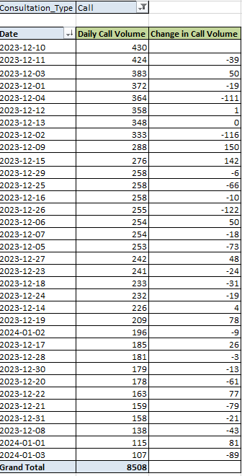 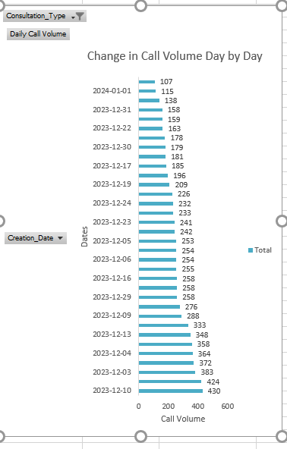

**5. Which months experienced the highest and lowest call volumes?**

* The data covers only 34 days, spanning two months: 31 days in December and 3 days in January.
* The highest call volume was on **December** 10, 2023, with 430 calls, calculated using the formula:

**= MAX (call volume column).**

* The **lowest** call volume occurred on **January** 3, 2024, with 107 calls, calculated using the formula:

**= MIN (call volume column).**

**6. What is the total operational cost for that month?**

* The operational cost for that month= Total net income of month – Astrologer income of month.

**DECEMBER:**

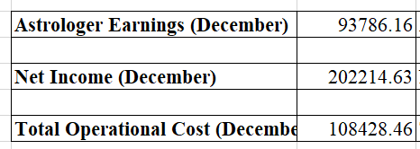

Astrologer Earnings(Formula):

**=SUMIF('Clean Data'!$I:$I,"December",'Clean Data'!$Z:$Z**)

Net Income(Formula):

**=SUMIF('Clean Data'!$I:$I,"December",'Clean Data'!$AA:$AA)**

Total Operational Cost(Formula): **Net Income - Astrologer Earnings**

**JANUARY:**

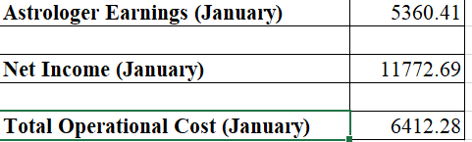

**7. What is the average number of calls handled per agent per day?**

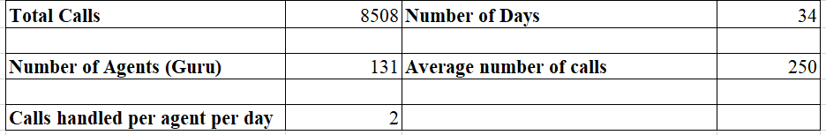

I used the COUNTIF () function to calculate the total number of calls and the COUNT (UNIQUE ()) function to find the number of agents (Gurus) and the number of days.

**Average number of calls per day**= Total calls / Number of days

= 5808 / 34

= 250.23

**Average number of calls handled by per agent per day** = Average number of calls per day / Number of Agent

= 250.23 / 131

= 1.91

So, we can say that each person handles about 2 calls per day on average.

**8. How many repeat callers are there, and what percentage of total calls do they represent?**

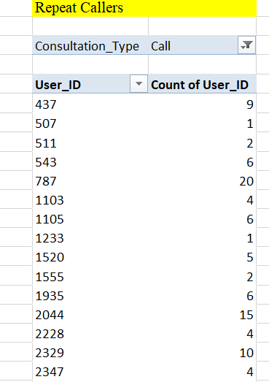 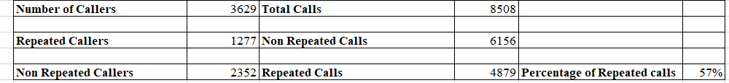

**Repeater Callers**: There are 1,277 callers who called more than once. This was calculated using the =COUNT () formula.

**Single-Time Callers (Non-Repeaters)**: These are the total callers minus the repeater callers.

* Non-Repeater Callers = 2,352.

**Percentage of Total Calls**:

* Total Number of Calls: 8,508 calls were made in total.
* Repeat Calls: Callers made 6,156 calls, including their first call. So, the repeat calls are calculated by subtracting the first calls made by repeat callers from the total repeat calls:

**Repeat Calls = 6,156 - 1,277 = 4,879.**

* Percentage of Repeat Calls: This is found by dividing the number of repeat calls by the total number of calls, then multiplying by 100:

**Percentage of Repeat Calls = (4,879 * 100) / 8,508 = 57.34%.**

**9. What are the total sales generated by the call centre for each product category?**

The product categories were referred to as "Website (Consultation_Mode)." The highest sales came from the App, while the Dashboard had the lowest sales.

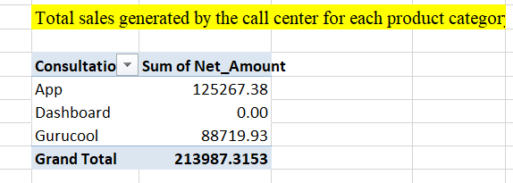

**10. How many calls were made for each user ID and guru ID?**

A total of 3,629 users utilized the call service, making 8,508 calls overall.



There are 131 gurus who have received calls from users.

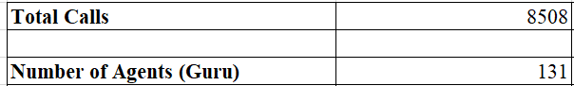

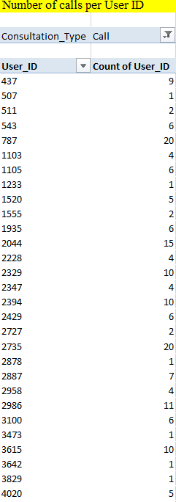 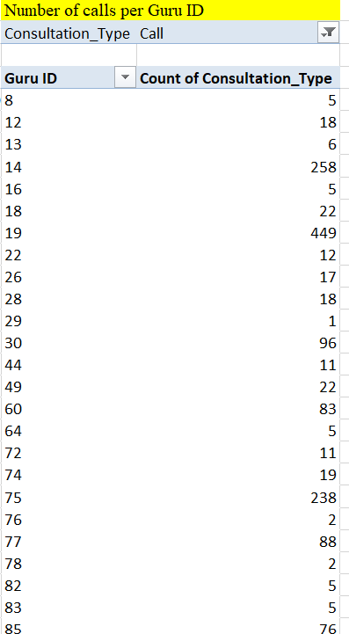

**11. What is the correlation between call duration and customer satisfaction?**

* The connection between call duration and customer satisfaction is almost zero, with a correlation of 0.0002.

Formula used: **=CORREL ('Clean Data’! $W: $W,'Clean Data'!AC:AC)**

* A correlation of (-0.0002025) shows a very tiny negative link between call duration and satisfaction. However, the number is so close to zero that it practically means there’s no significant relationship between them.

**12. Which guru has the highest and lowest customer satisfaction scores?**

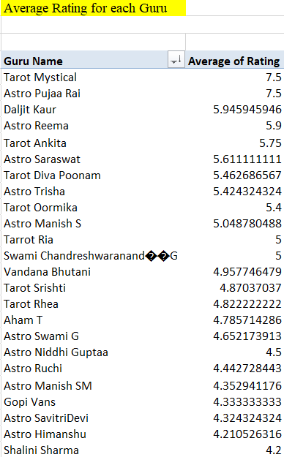 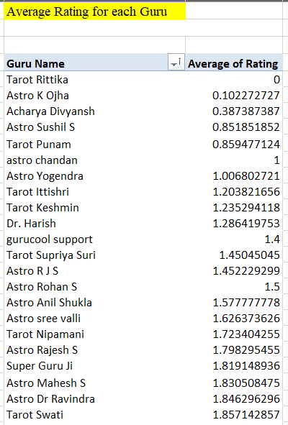

If we calculate the average rating for all gurus, Tarot Rittika (Guru ID – 80) received the lowest satisfaction score. However, this is based on only one consultation where a single user provided a rating. On the other hand, Tarot Mystical (Guru ID – 305) achieved the highest average rating, but this is based on just two consultations with the chat service.

**13. What is the average customer satisfaction score by month?**

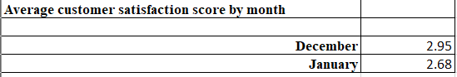

I used the AVERAGEIF() function to calculate the monthly average of customer satisfaction scores.

Formula: **=AVERAGEIF('Clean Data'!$I:$I,"December",'Clean Data'!$AC:$AC)**

**=AVERAGEIF('Clean Data'!$I:$I,"January",'Clean Data'!$AC:$AC)**

**14. How many categorical columns are there in the data? [Search about categorical and continuous data, and try to answer this question]**

* **Categorical Data**: Represents discrete groups or categories (e.g., text data, boolean values).
* **Continuous Data**: Represents numerical values that can take on any value within a range (e.g., float or integer data that is not categorical).
* The dataset contains 35 columns with varying data types. To determine the number of categorical and continuous columns:

Here is a list of the **23 categorical columns** in the dataset:

1. _id
2. user
3. chatStatus
4. guru
5. guruName
6. consultationType
7. website
8. refundStatus
9. isWhiteListUser
10. queue
11. freeCall
12. freeChat
13. updatedAt
14. statementEntryId
15. chatStartTime
16. chatEndTime
17. callChannel
18. callIvrType
19. callStatus
20. CallSid
21. astrologerCallStatus
22. region
23. userCallStatus

Here is the list of the **8 continuous columns** in the dataset:

1. chatSeconds
2. timeDuration
3. amount
4. astrologerOnCallDuration
5. astrologersEarnings
6. netAmount
7. userOnCallDuration
8. rating

**Subjective Question:**

**1. Should the investment be used to hire more agents, improve training**

**programs, or upgrade call centre technology?**

**Need for Hiring:**

* Analyzed agent workload distribution using a pivot table showing the average call duration per agent.
* Findings: Agents handling more calls tend to have lower ratings.
* Recommendation: Hire additional agents during peak hours to improve response times and alleviate current workload issues, especially when call volumes exceed handling capacity.

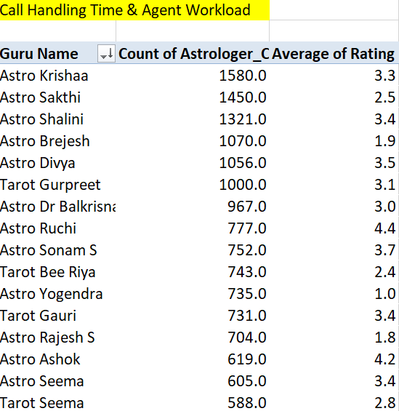

**Need for Improved Training:**

* Analyzed customer satisfaction trends by creating a pivot table for ratings by each agent.
* Findings: Satisfaction scores below 4, despite manageable call volumes, indicate a potential issue with customer interactions.

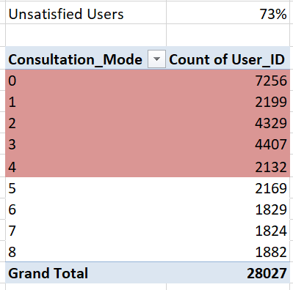

**Unsatisfied user (Rating-0,1,2,3,4) = 73 %**

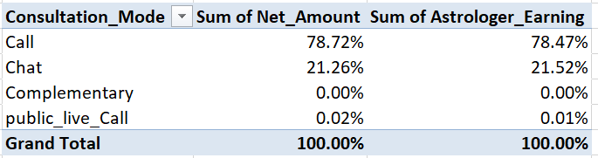

78.72% of the company's total net income comes from the call service alone, while 78.46% of the astrologer's total income is also derived from the call service. Since the call service is a key revenue driver, investing in training programs would be a strategic move to sustain and enhance its success.

**Need for upgrade call centre technology**

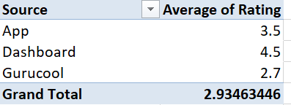  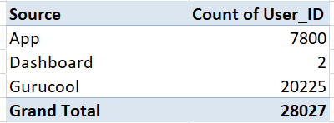

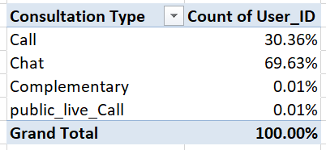

Technology upgrades are essential as 69.62% of the total users rely on the chat service. Gurucool is currently the only platform offering this service to users. However, its average rating of 2.71 clearly indicates user dissatisfaction. Therefore, it is crucial to enhance the technology to improve user satisfaction. Investing in these upgrades will not only enhance the overall user experience but also boost user retention. That said, it is important to acknowledge and address potential risks associated with upgrading the technology.

**2. What are the potential risks of each investment option (hiring, training,**

**technology upgrades), and how can they be mitigated?**

**Name the chart/spreadsheet function you will use for solving the problem.**

**Challenges of Hiring the Wrong Employee and Mitigation Strategies:**

* **High Onboarding Costs:** The company incurs significant expenses during onboarding, including payments to recruitment agencies to find the ideal candidate.
* **Training Expenses:** Time and money spent training a new hire who doesn’t fit well can result in wasted resources.
* **Short Tenure:** If the new employee leaves soon after joining, the investment of time and resources goes unrewarded.
* **Skill Mismatch:** Hiring someone with inadequate skills can lead to poor performance and additional effort to correct mistakes.
* **Reputation Risk:** Unethical or inappropriate behaviour by new hires can harm the company’s image.

**Ways to Mitigate These Risks:**

* Conduct thorough interviews across 4–5 rounds.
* Clearly communicate job responsibilities and expectations.
* Assess for cultural fit during the hiring process.

**Technology Upgrades:**  
Upgrading technology is essential as 63.72% of users rely on the chat service, and Gurucool is currently the sole platform offering it. However, the platform’s average rating of 2.71 highlights user dissatisfaction. Enhancing technology can greatly improve user experience and boost retention. Despite these benefits, potential risks must be addressed carefully.

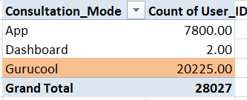 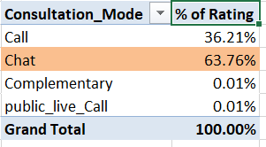

**Key Risks:**

* **High Costs:** Expenses for hardware, software, licenses, maintenance, and staff training.
* **Training Requirements:** Employees need to be trained to effectively use new systems.
* **Performance Issues:** New technology might fall short of expectations or require more resources.
* **Data Loss:** There is a risk of losing or corrupting data during the upgrade process.

**Risk Mitigation Strategies:**

* Develop a detailed budget to control upgrade costs.
* Provide comprehensive training and continuous support for employees.
* Backup all data to ensure security before implementing system changes.

**Training:**

Currently, only 27.49% of users are satisfied with the company's services. To improve this, investing in employee training is recommended. With a total of 28,027 users, those who rated the service highly (5 to 8) account for the satisfied percentage, while 72.51% remain unsatisfied (ratings 0 to 4).

**Key Risks:**

* High Costs: Training with external experts and certifications can be expensive.
* Employee Turnover: Skilled employees might leave for better opportunities.
* Irrelevant Training: Programs may not align with company goals.

**Risk Mitigation Strategies:**

* Focus on cost-effective in-house training programs.
* Build a positive work environment, offer growth opportunities, and use contract agreements to retain employees.

**3. How does AstroSage's call center performance compare to AstroGuru's**

**average call volume, customer satisfaction, and agent performance?**

**Will you use any aggregation function or a visualization here to solve the**

**problem?**

* Call services account for 78.72% of the company's total net income and 78.46% of the astrologer's total income, underscoring their critical role as a primary revenue generator. Given this significance, prioritizing investments in training programs for call service teams would be a strategic initiative to sustain and further enhance performance.
* The percentage contribution of call services to total income can be calculated using the formula:  
  Percent of call income = (Call income × 100) / Total income

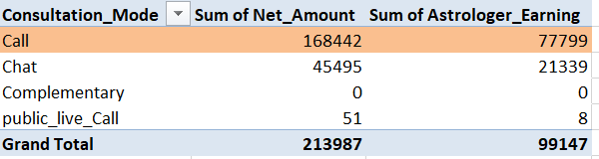

* Agent performance plays a pivotal role in the company's success, as there is a strong interconnection between agent earnings and net income. With a correlation coefficient of 0.9970, the relationship between these variables is remarkably strong and positive. This means that as agent earnings increase, net income also rises in a highly predictable manner.
* For context, a correlation coefficient near 1 indicates an almost perfect positive linear relationship, where changes in one variable are closely mirrored by proportional changes in the other.
* Investing in agent performance optimization and fostering their skills through targeted initiatives could further amplify the success of call services and drive overall company growth.

**4. How can the call centre improve its handling of peak call periods to ensure**

**high customer satisfaction?**

The bar chart illustrates the call volume by hour, highlighting peak periods. Based on this, here are recommendations for the call centre:

**Peak Call Hours (High Activity)**:

* The highest call volumes occur between **6 AM and 8 AM**, with the volume exceeding 1,500 calls per hour, peaking around **7 AM**.
* Another significant period of high activity is between **10 AM and 5 PM**, where call volumes remain consistently high.

**Off-Peak Hours (Low Activity)**:

* The lowest call volumes are during the night, from **12 AM to 4 AM**, with minimal activity.
* After **8 PM**, call volumes gradually decline until reaching their lowest levels by **11 PM**.

**Stable Call Periods**:

* Between **10 AM and 5 PM**, call volumes are steady, indicating a consistent demand for services during business hours.

**Recommendations:**

**Optimized Staffing:**

* **Peak Hour Coverage:** Assign more staff during critical times, such as 6 AM - 8 AM and 10 AM - 5 PM, to efficiently manage the increased call load.
* **Off-Peak Adjustments:** Reduce staffing during low-demand periods, particularly between 12 AM and 4 AM, to improve resource utilization and minimize costs.

**Skill Development:**

* **Targeted Training:** Equip employees with the necessary skills to handle high-pressure scenarios during peak hours, ensuring a seamless customer experience.

**Service Promotion:**

* **Off-Peak Marketing**: Launch initiatives or special offers during quiet hours (e.g., late nights or early mornings) to balance call volume and improve resource efficiency.

**5. Based on historical data, what strategic initiatives should be prioritized to**

**improve efficiency and customer satisfaction?**

**Optimize Interaction Duration**:

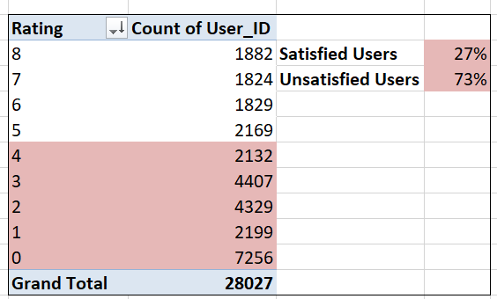

**Formula = Sum (Rating (0,1,2,3,4) * 100 / Total Users**

**Training agents to resolve issues quickly without compromising quality:**

This will help reduce the time spent on each call while maintaining a positive experience.  
Utilizing pre-chat questionnaires: These forms can gather key details from customers before the conversation begins, enabling agents to address the issue more effectively and saving time during the interaction.

**Enhancing Customer Experience During Peak Seasons:**

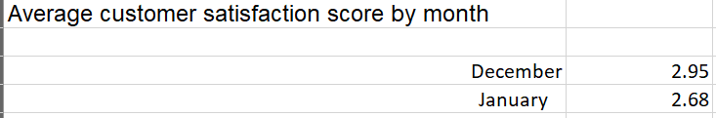

Customer satisfaction in December (2.95) outperforms January (2.68), suggesting challenges during peak periods. To address this:

• Recruit additional personnel during peak times to manage higher demand.

• Provide incentives, such as discounts or promotional codes, to enhance customer value and

increase satisfaction.

**Enhance Chat Consultations:**

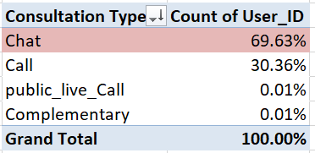

Since 69.6% of consultations occur through chat, focus on refining this channel:

* Improve chat systems (e.g., automation, enhanced UI/UX).
* Consistently review chat transcripts to gain insights into customer challenges."

**Monitor and Respond to Feedback:**

Drive consistent improvements in service quality:

* Establish a system to regularly analyze low-rated interactions, identifying recurring issues and areas for improvement.
* Use customer feedback proactively to enhance service delivery and optimize operational practices.

**Optimize Consultation Method Distribution:**

Focus on the most frequently used channels:

* Prioritize resources for popular customer service methods, such as chat and phone calls.
* Evaluate the necessity of less-utilized methods (e.g., live public calls) to determine if they add sufficient value to justify their continuation.

**6. What can be the key factors contributing to high customer satisfaction scores,**

**and how can these be leveraged to improve overall performance? What is the**

**basis for the suggestions? And mention how you decided if the satisfaction**

**score affects the ratings.**

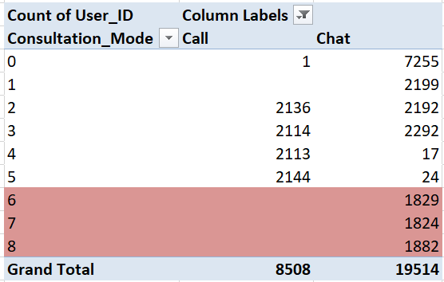 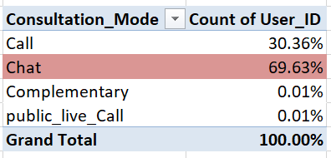

**Chat Service Usage:** Approximately 69.63% of all users utilize the chat service, making it the most widely used communication channel.

**High Satisfaction Ratings:** Ratings of 6, 7, and 8 are classified as indicators of high user satisfaction. Notably, these ratings are exclusively given by users of the chat service.

**Critical Role of Chat Service:** Since the majority of users rely on the chat service and all high satisfaction scores come from it, the chat service is a primary contributor to overall user satisfaction.

**Recommendations:**

**Enhanced User Experience:** Introduce AI-powered chatbots to streamline interactions and provide quicker resolutions.

**Employee Training:** Invest in training programs to help employees adopt new tools and technologies that support the chat service, enabling them to deliver better support and adapt to evolving user needs.

**7. How should the call centre balance the workload among agents to ensure**

**optimal performance and avoid burnout? Mention your approach and**

**spreadsheet function for the answer.**

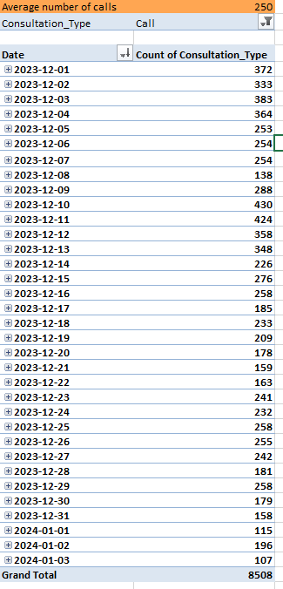 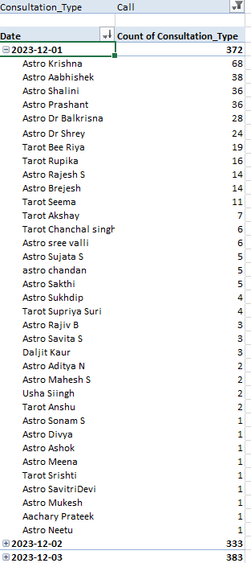

**The Average Number of Calls per day is 250**

**Workload Distribution:**

* Unbalanced Workloads: If some agents handle more queries than others, it can cause stress and burnout over time.
* Real-Time Monitoring Benefits: Tracking call volume in real-time helps distribute the workload evenly, particularly during peak hours. This prevents any one agent from being overwhelmed.

**Operational Efficiency:**

* Fair Workload Allocation: Distributing tasks evenly among agents ensures that service quality remains steady. This leads to improved operational efficiency and greater customer satisfaction.
* Enhanced Efficiency: When the workload is balanced, agents can focus more effectively on solving problems, which results in quicker responses and a smoother workflow.

**Human Factors:**

* Reducing Stress with Fair Distribution: Assigning fair shifts and workloads helps reduce stress among agents.
* Boosting Motivation: Agents who are not overburdened and feel supported tend to stay motivated, which leads to better performance and higher-quality service for customers.

**8. What new technologies or tools could be implemented to enhance call centre**

**operations and customer service?**

**Technologies and Tools to Improve Call Centre Operations:**

* AI Chatbots:
* Handle common customer questions 24/7, lessening the burden on agents.
* Provide quick answers to improve customer satisfaction.
* Predictive Analytics:
* Analyse past data to forecast call volumes and adjust staffing accordingly.
* Help prepare for customer needs in advance.
* Omni-Channel Support:
* Combine email, social media, and chat into one platform for smoother communication.
* CRM Systems:
* Store customer information in one place for agents to access instantly.
* Allow agents to give more personalized service based on customer history.
* Sentiment Analysis:
* Analyse conversations to understand how customers feel.
* Allow for early identification of issues and quick resolution.
* Call Analytics Tools:
* Track key performance metrics like average call time and first call resolution which help to improve agent performance and customer service efficiency.

**9. What metrics should be included in the final dashboard to comprehensively**

**view call centre performance and guide investment decisions?**

**Metrics that are included in Dashboard**

* Key Performance Indicators:
* Total Revenue
* Total Users
* Average Call Duration
* Total Astrologer Earnings
* Charts:
* Source of Consultation
* Call Duration: User vs Astrologer
* Top Earning Astrologer
* Earnings by Hour
* Call Status Analysis
* Revenue vs Consultation Type
* Rating Distribution
* User Chat Status
* Day by Day Call Volume

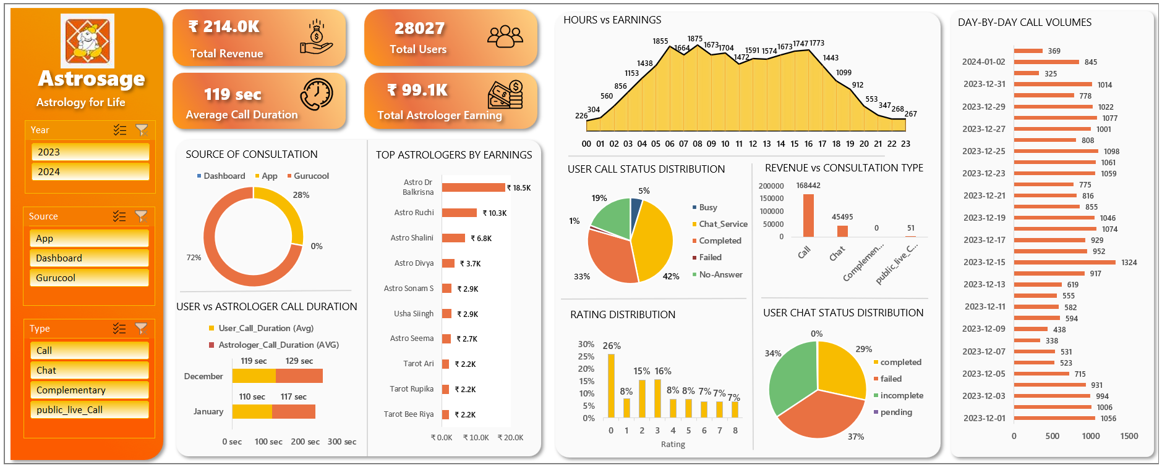

**10. How would you allocate a 1 crore rupee investment to optimize operational**

**efficiency, enhance customer satisfaction, and boost profitability, and what**

**analysis-based recommendations would you offer to support this?**

**Investment Allocation Strategy for Call Centre Optimization**

**Operational Efficiency (₹40 Lakhs):**

* Modernize call center infrastructure and integrate AI-powered chatbots for routine tasks.
* Implement workforce management software to boost efficiency and streamline operations.

**Customer Satisfaction (₹30 Lakhs):**

* Organize training sessions to enhance employees' service capabilities.
* Develop user-friendly self-service platforms and ensure better support accessibility.

**Profitability (₹30 Lakhs):**

* Allocate funds to marketing campaigns and strategies for retaining customers.
* Emphasize high-revenue services and gather customer feedback to improve satisfaction.