**CS590BD BIG DATA ANALYTICS & APPS**

**LAB #2**

**Swathi Boyanapalli**

**16175340**

**Data Collection based on Accelerometer data and GPS data from BLE Sensor Tag and Android Mobile Device:**

I have downloaded the zip folder that is given in the tutorial, later extracted into eclipse which consists of code.

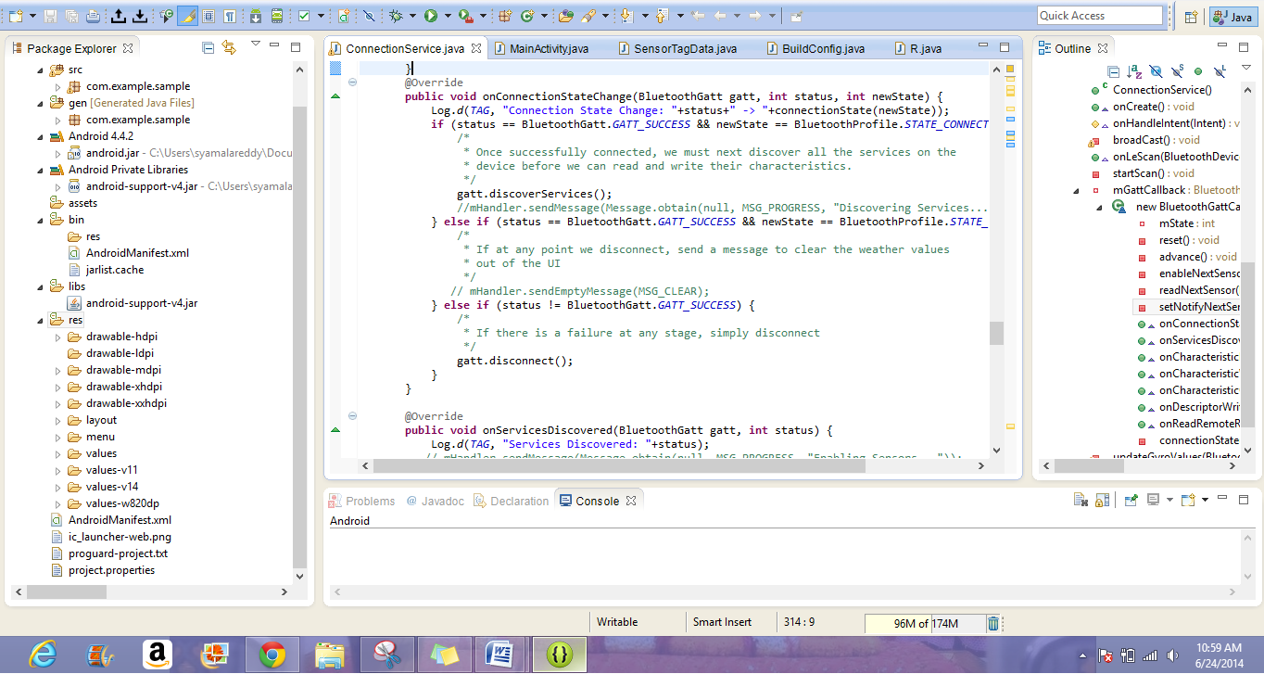

Later I attached my source-files to Github. By using Sensor Tag services I developed the code in order to measure temperature, humidity, pressure and gyroscope. Then this application is imported into eclipse. After running this application, the output for the code is obtained by enabling the sensor.

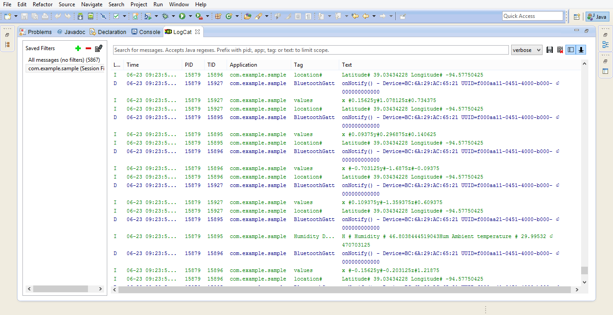

I have coded the following data along with the previous data and is shown in the following figure.

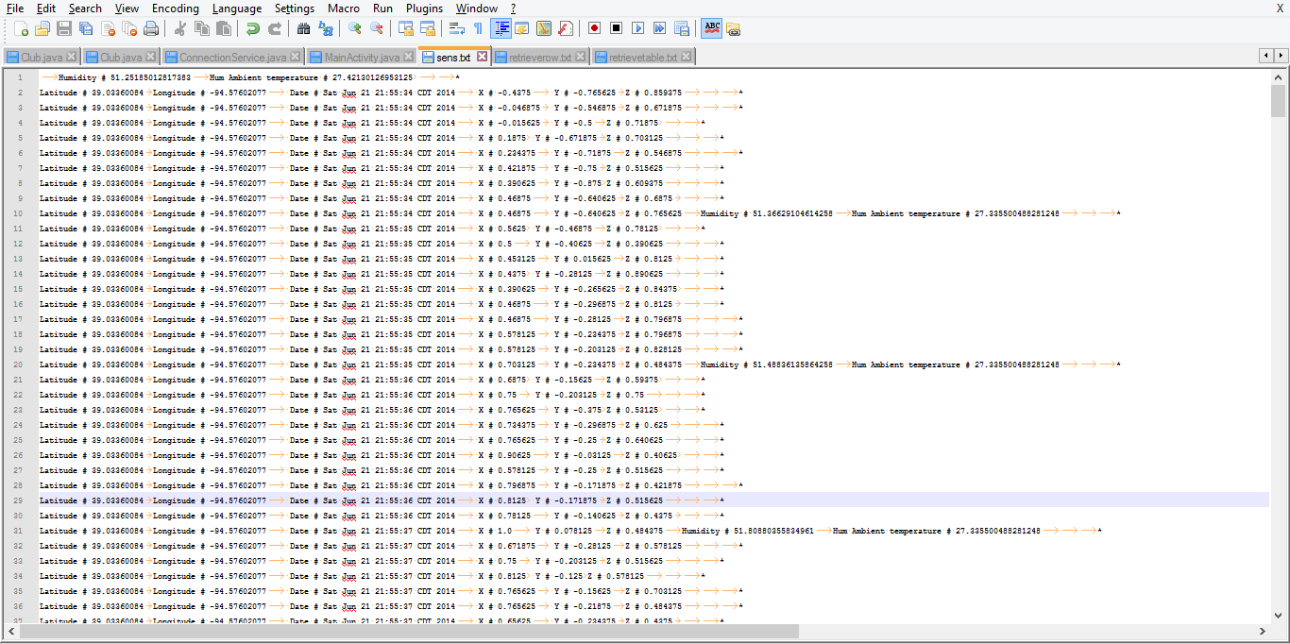

Uploading the data into HBase:

I have pushed the obtained data into HBase and later I have developed HBaseClient.Java to write my file in the HBase (Cloudera Manager) table as given in the tutorial.

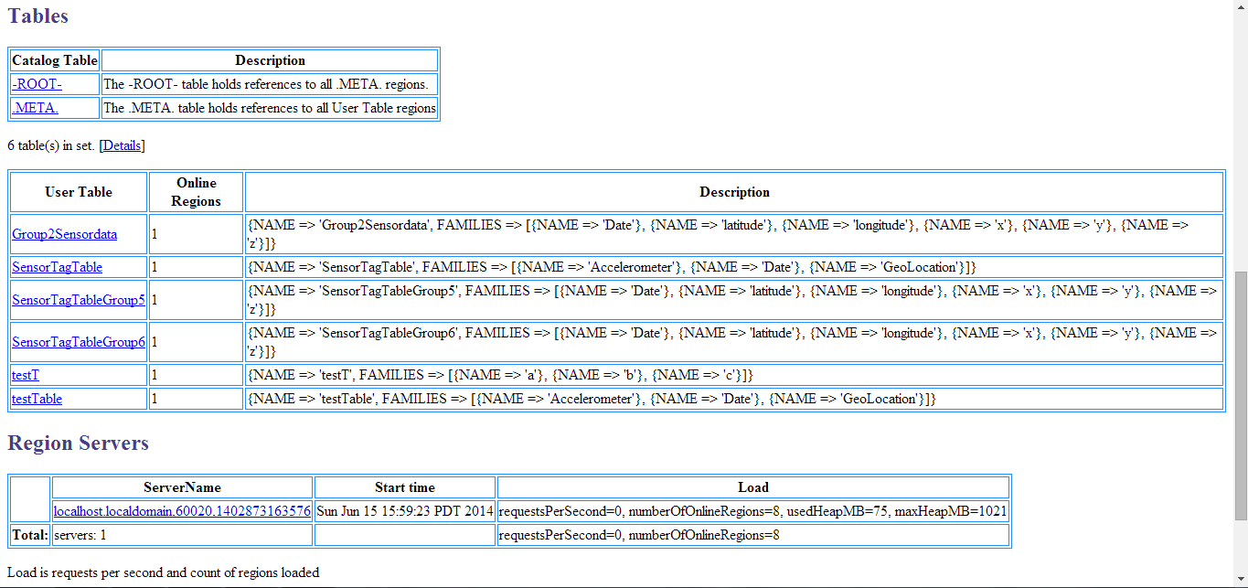

I have successfully retrieved the data entries by using the command retrievetable ( )

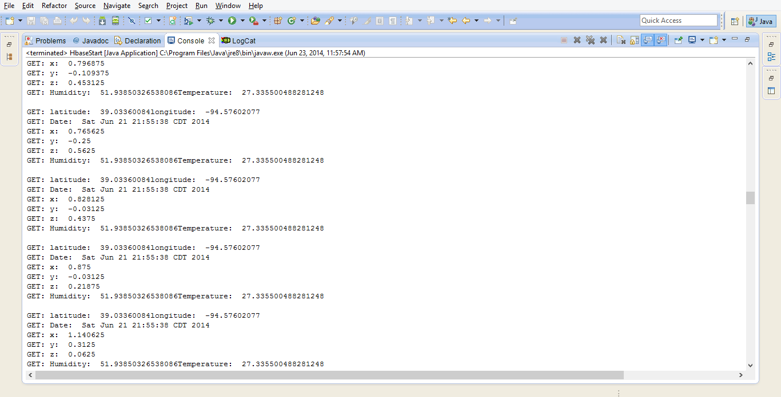

By using the command Getallrow (), the data has been successfully retrieved and also by using the command Getalltable (), the data is retrieved from all the row entries as shown in the figure.

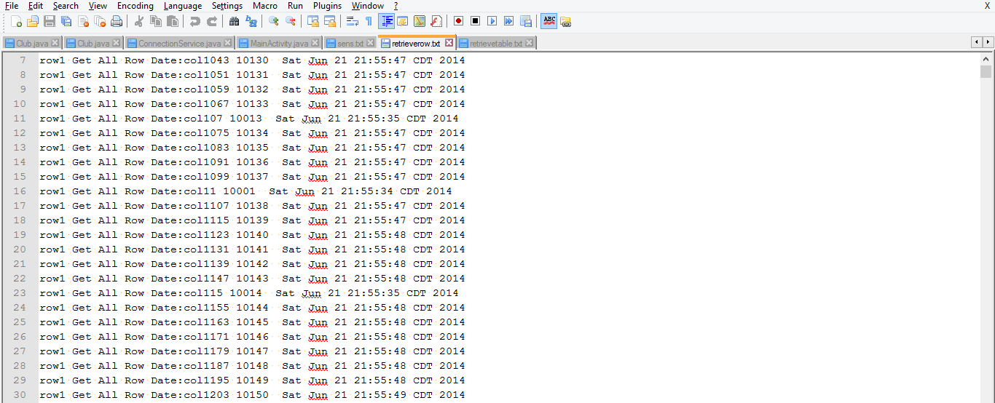

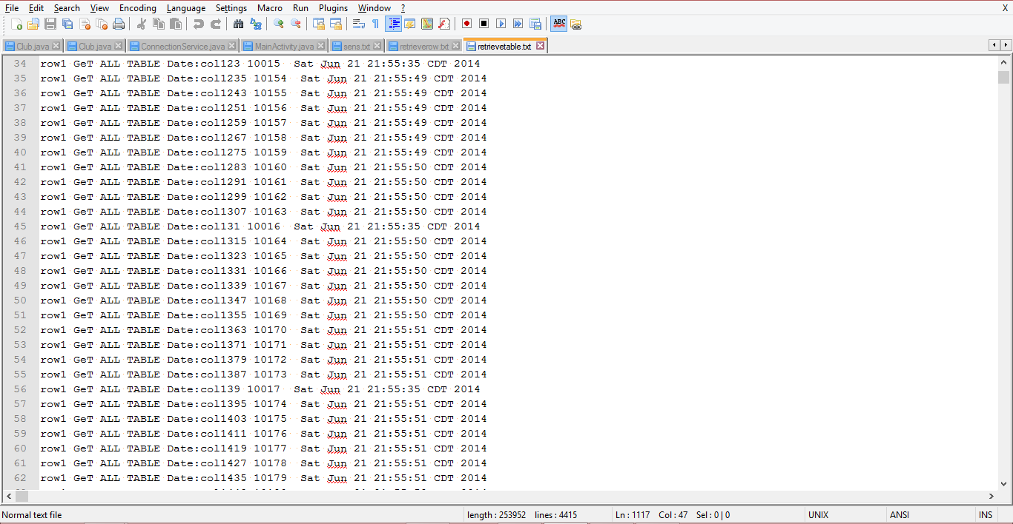

In this way by using the commands I created, read, updated and deleted in the HBase.