**CS590BD BIG DATA ANALYTICS & APPS**

**LAB #3**

**Swathi Boyanapalli**

**16175340**

**BUILDING A JAVA BASED RESTFUL SERVICE:**

* In order to develop a java based restful service I installed OEPE Juno from the link that was given in the tutorial.
* I have also installed Jdk 1.7 and Jre 1.7. Later I extracted OEPE Juno and start it on the eclipse platform.
* There I selected Window option and choose Open Perspective and there I preferred Java EE.
* I also downloaded HBaseWS from the link that was given in the tutorial and later imported into this workbench.

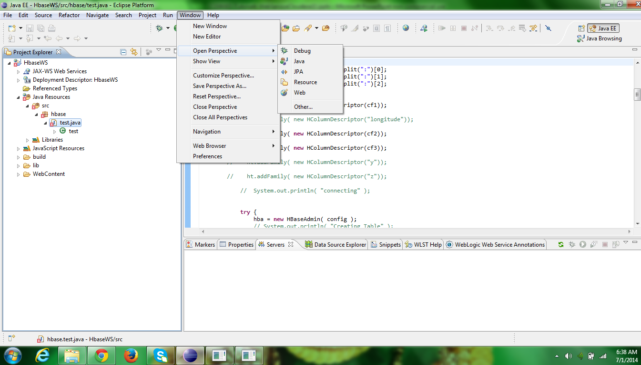

* In that Java EE perspective, I have chosen a new server i.e. Glassfish Server Open Source Edition 3 (Java EE 6).
* Later I added Jre 1.7 and Jdk 1.7 files in the library using properties option in the HBaseWS.
* Run the Glassfish Server. After that the server gets started.

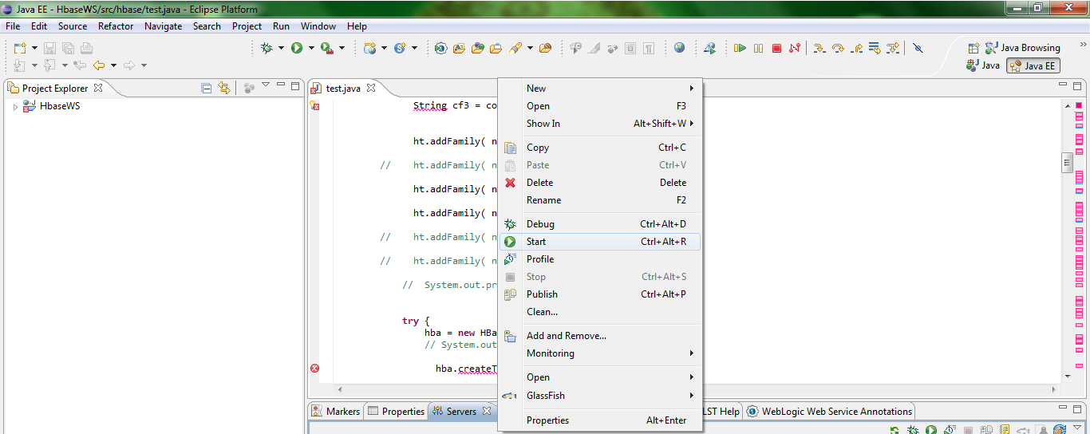

* Generate the WAR file by exporting the HBaseWS into WAR format.

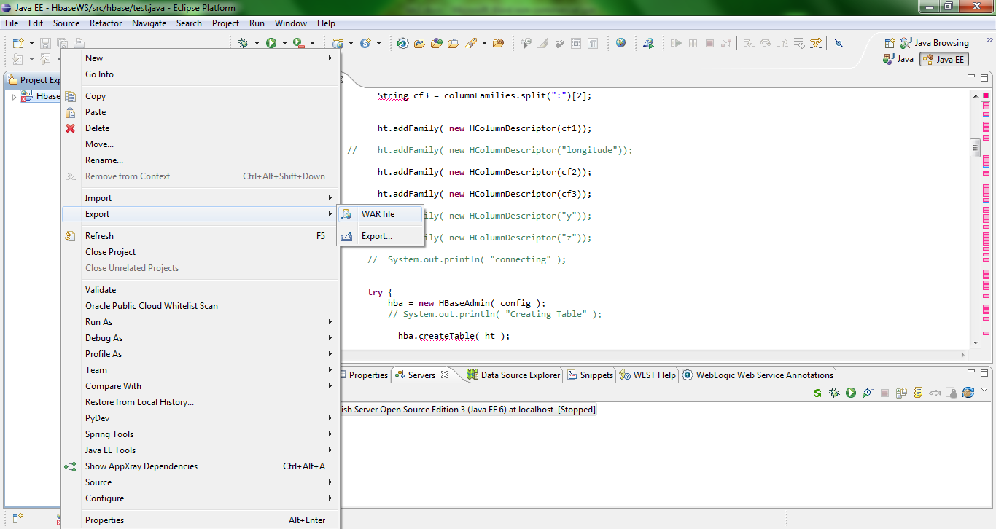

* The deployment is done by adding this to the Deployment Assembly through the properties option.

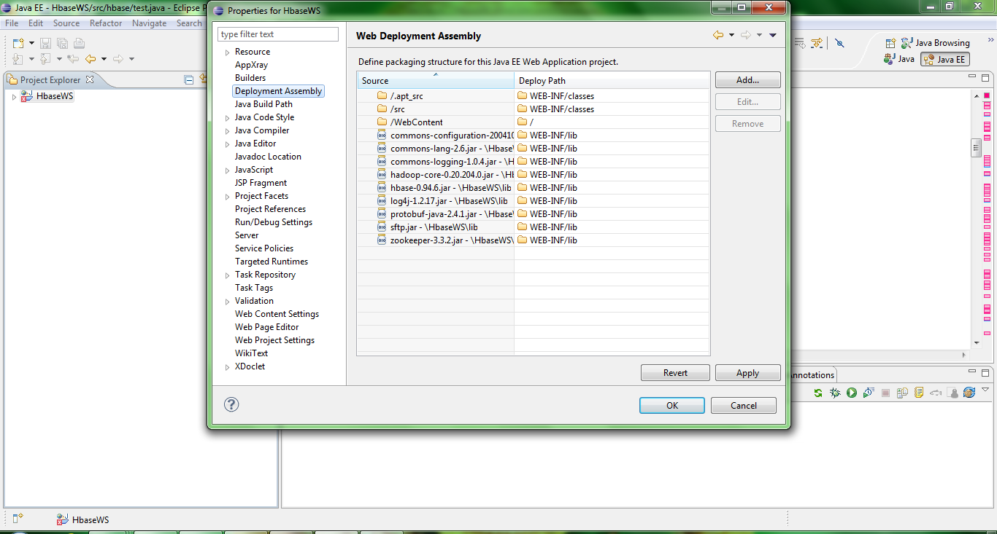

* The glassfish login was opened by using the URL that was given in the tutorial.

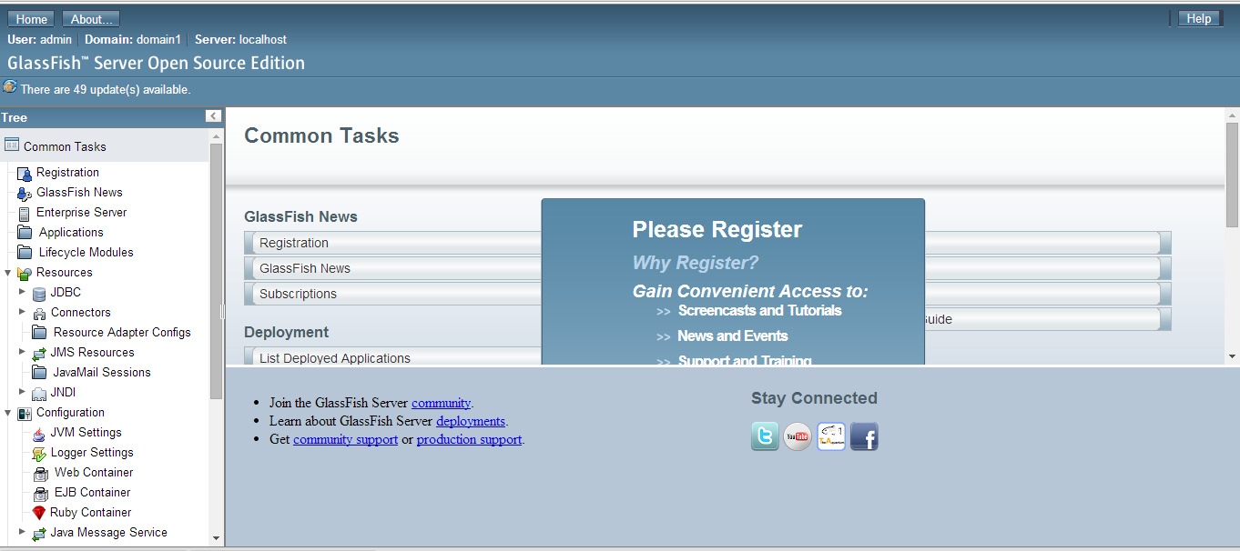

* Later HBaseWS is deployed in the glassfish by selecting the deployment and is browsed from the system and then it is launched.

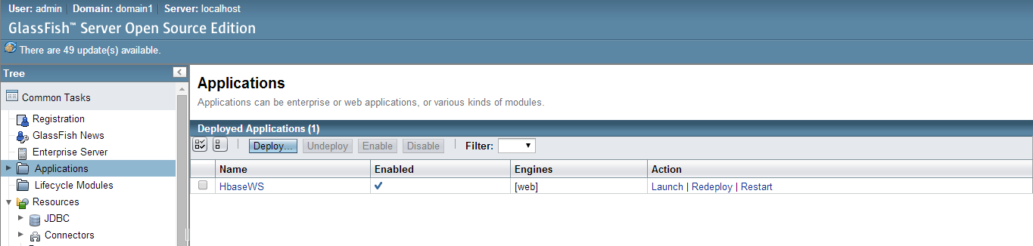

* In order to create the table I entered the following link http://localhost:8080/HbaseWS/jaxrs/generic/hbaseCreate/testTableswathiboyanapalli/GeoLocate:Data:Location and the table Swathiboyanapalli was created and we can view this from the HBase.

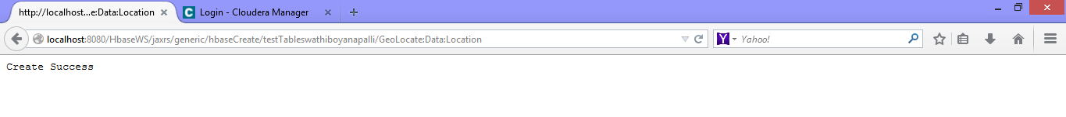

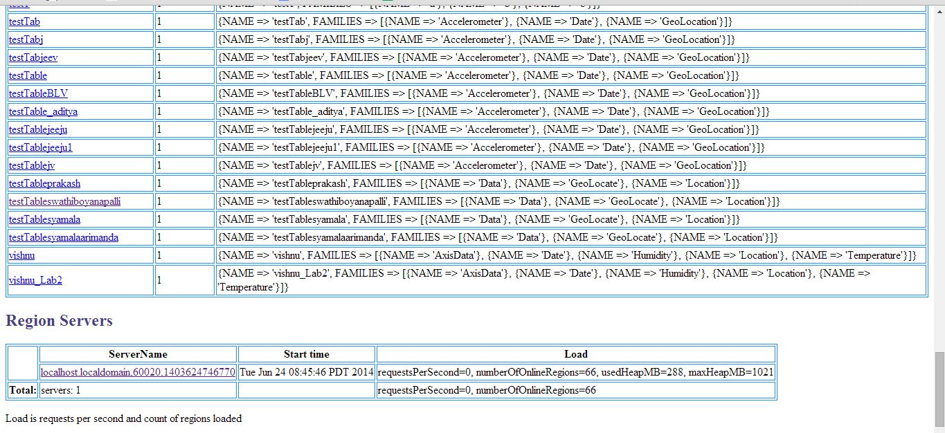

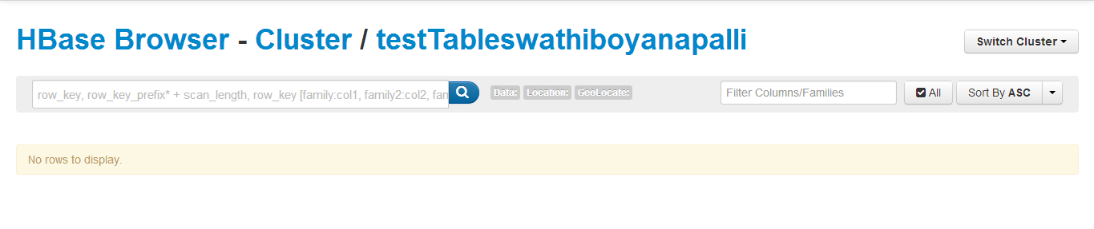

* I can insert the columns Data, Geolocate, Location by using the command http://localhost:8080/HbaseWS/jaxrs/generic/hbaseInsert/testTableswathiboyanapalli/C:-Users-syamalareddy-downloads-data.txt/Geolocate:Data:Location



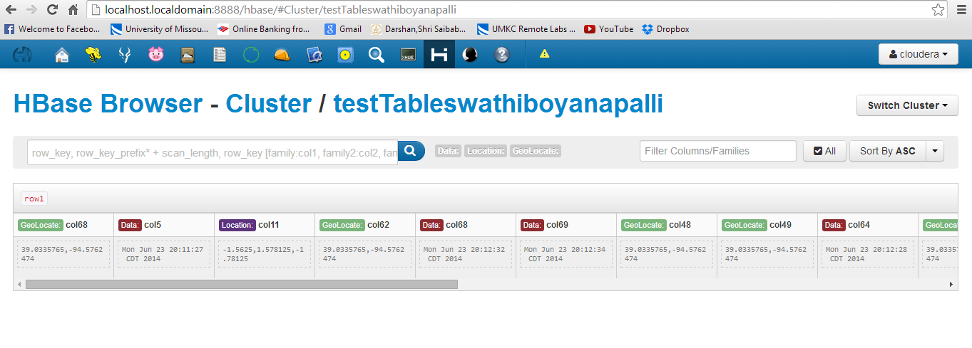

* I can retrieve the data by using the command <http://localhost8080/HbaseWS/jaxrs/generic/hbaseRetrieveAll/testTableswathiboyanapalli>.

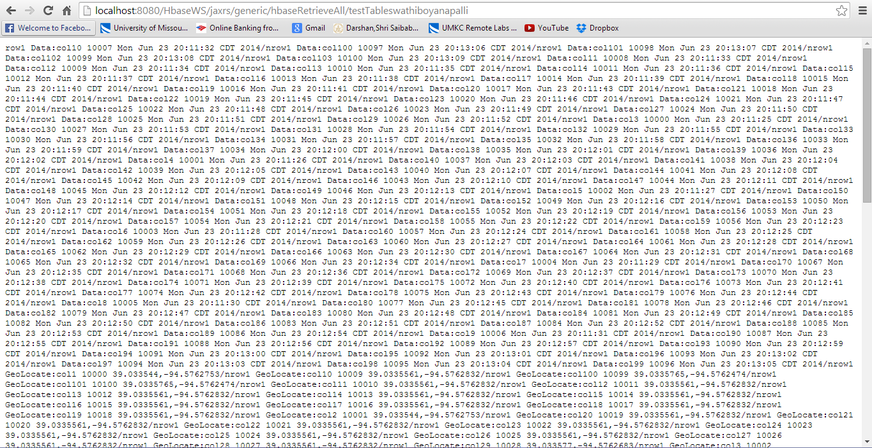

* I can also delete the table by using the following URL: [http://localhost8080/HbaseWS/jaxrs/generic/hbaseDelete/testTableswathiboyanapalli](http://localhost8080/HbaseWS/jaxrs/generic/hbaseRetrieveAll/testTableswathiboyanapalli)

**HBase CRUD Operations:**

I also developed an android app and in this I created a table, insert the values, retrieve the data and delete the table.

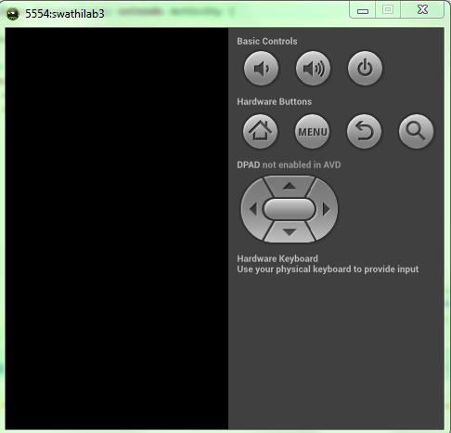

* **Table Creation:**

By giving the table name and column families the table is created and is stored in HBase.

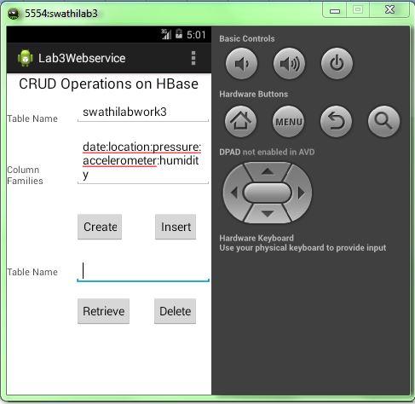

**After that it displays the table is created by giving a message “Create Success.”**

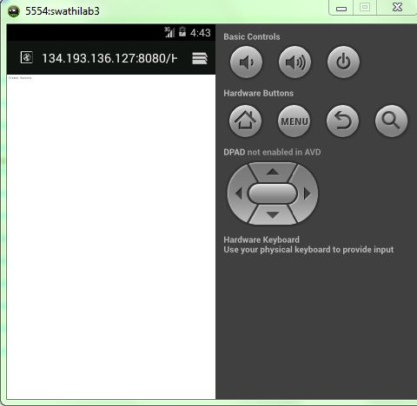

* **Inserting values into the table:**

Later the values are inserted by giving the table name and column families and we have to click the Insert button, and it pop ups a message “Insert Success.”

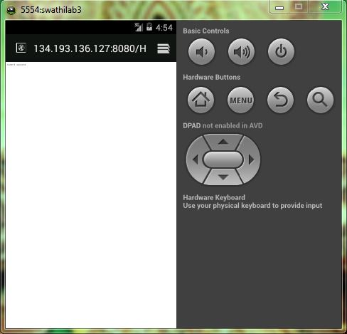

* **Retrieving the values from the table:**

The values are retrieved by giving the table name and column families and we have to click the Retrieve button, and it displays the values.

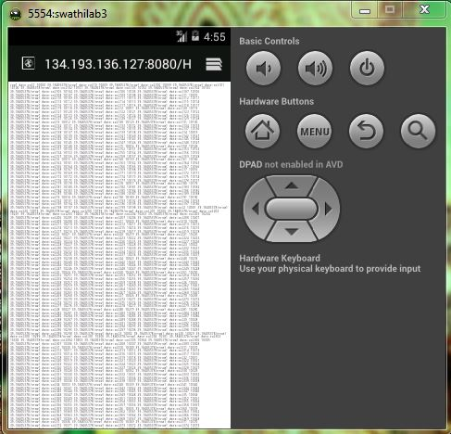

* **Deleting the table:**

Inorder to delete the table we have to enter the table name, column families and press the Delete button.