**CS590BD BIG DATA ANALYTICS & APPS**

**LAB #4**

**Swathi Boyanapalli**

**16175340**

I collected data files with respect to the sensor movements, i.e.

* Left to Right
* Right to Left
* Top to Bottom

The text files are shown below:

1. Left to Right:



1. Right to Left:



1. Top to Bottom:



And also I generated the file in which the all movements are captured i.e. left to right, right to left and top to bottom.



After that I connected to the Secure Shell Client.

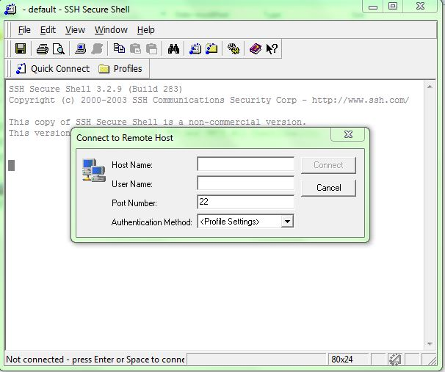

After entering the host name and user name, the password is displayed.

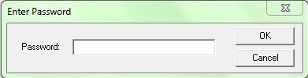

Later I drag and drop my text files into the remote machine by using Secure Shell Client.

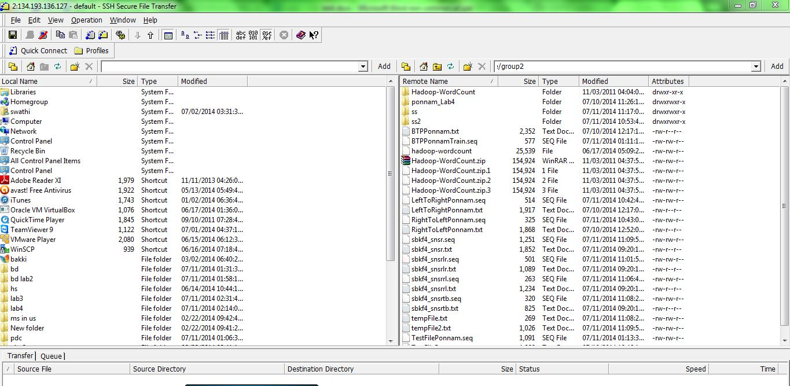

I generated the sequence files by using the commands or URL’s i.e. given in the tutorial.

1. **Sequence file i.e. generated for Left to Right Movement:**

By using the following URL I generated the sequence file for the Left to Right movement and it is automatically saved in the remote system.

<http://134.193.136.127:8080/HMMWS/jaxrs/generic/TrainFileOperation/-home-group2-sbkf4_snsrlr.txt/-home-group2-sbkf4_snsrlr.seq>

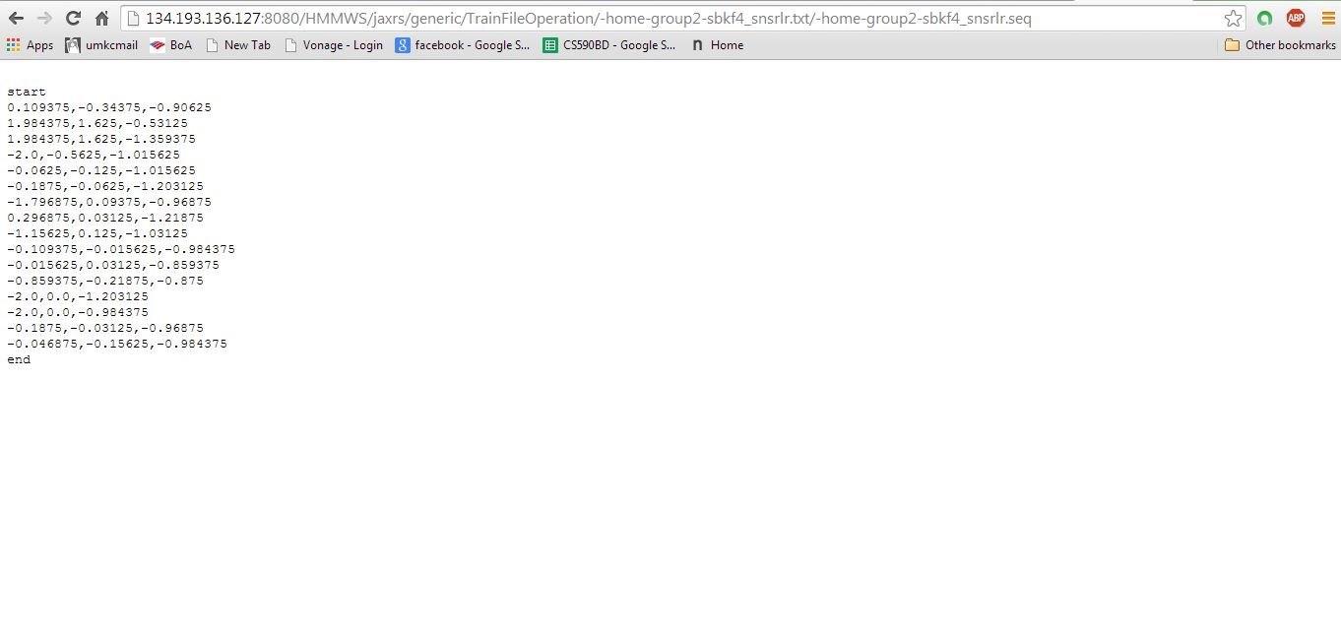

1. **Sequence file i.e. generated for Right to Left Movement:**

By using the following URL I generated the sequence file for the Right to Left movement and it is automatically saved in the remote system.

<http://134.193.136.127:8080/HMMWS/jaxrs/generic/TrainFileOperation/-home-group2-sbkf4_snsrrl.txt/-home-group2-sbkf4_snsrrl.seq>

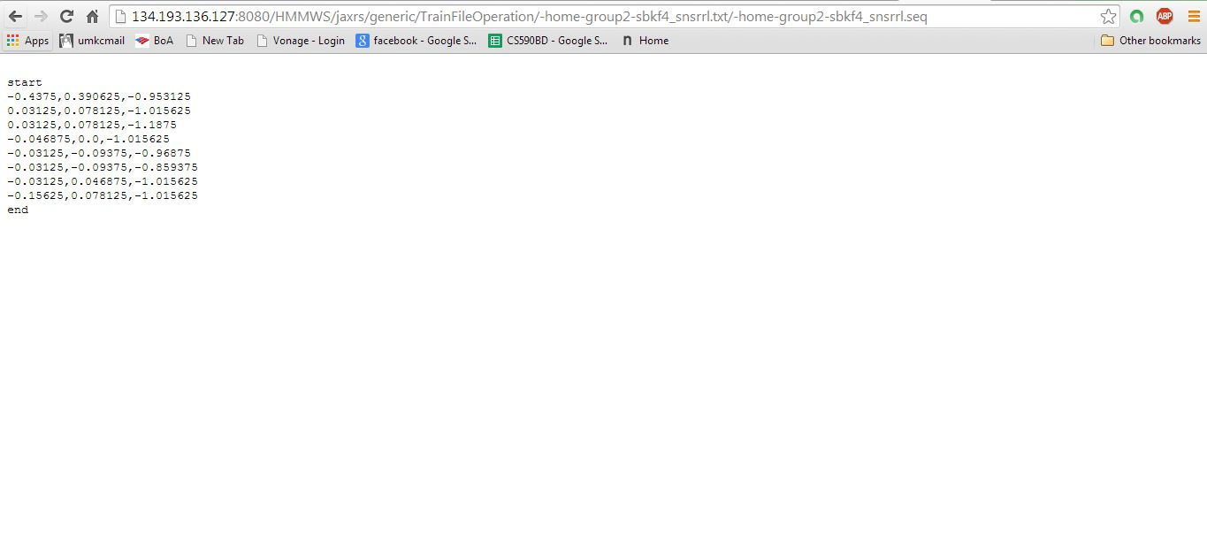

1. **Sequence file i.e. generated for Top to Bottom Movement:**

By using the following URL I generated the sequence file for the Top to Bottom movement and it is automatically saved in the remote system.

<http://134.193.136.127:8080/HMMWS/jaxrs/generic/TrainFileOperation/-home-group2-sbkf4_snsrtb.txt/-home-group2-sbkf4_snsrtb.seq>

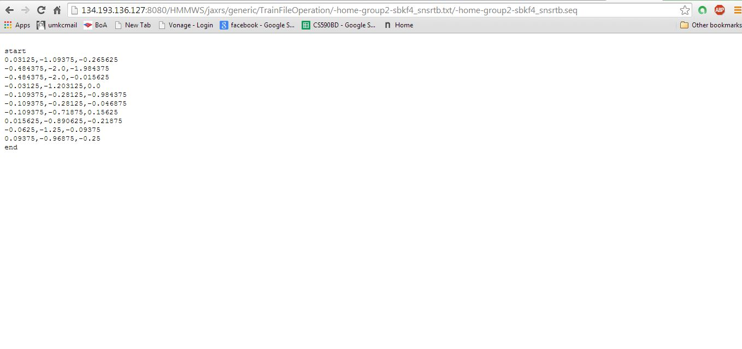

1. **Sequence file i.e. generated for all the combined movements:**

By using the following URL I generated the sequence file for the all the combined movements and it is automatically saved in the remote system.

<http://134.193.136.127:8080/HMMWS/jaxrs/generic/TestFileOperation/-home-group2-sbkf4_snsr.txt/-home-group2-sbkf4_snsr.seq>

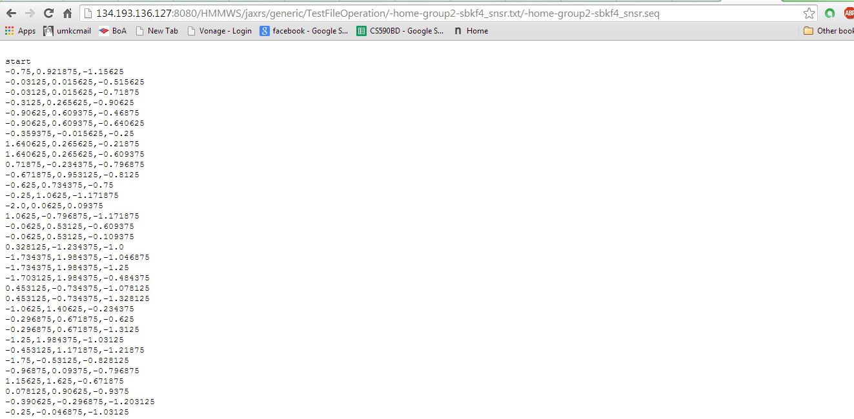

1. **Training Test is also performed:**

I also performed the training test by using the generated sequence files in the remote machine.

<http://134.193.136.127:8080/HMMWS/jaxrs/generic/HMMTrainingTestThree/-home-group2-sbkf4_snsrlr.seq/-home-group2-sbkf4_snsrrl.seq/-home-group2-sbkf4_snsrtb.seq/-home-group2-sbkf4_snsr.seq>

