**CS590BD BIG DATA ANALYTICS & APPS**

**LAB #5**

**Swathi Boyanapalli**

**16175340**

* I have selected an android application game i.e. Tetris and downloaded the game from Github which works on eclipse platform.
* In this game we have blocks with different shapes that come from the top of the screen.
* We can move the blocks from left to right, right to left and can also rotate the blocks by using left arrow, right arrow and up arrow. In order to bring the blocks down we can use down arrow.
* By this the blocks can reach the floor faster. I have downloaded the game from the link which is shown below. <https://github.com/semenoh/Tetris>
* I have collected data from nexus phone using Sensor-tag. I collected the data for temperature, accelerometer and humidity by moving the sensor-tag left to right, right to left and rotation.
* Later I made changes in the code in the way that I can play this Tetris game with the help of sensor tag.

1. Now instead of using left-arrow I can play the game by moving my sensor-tag from left to right.
2. Inorder to move the block from right to left, we can move the sensor-tag from right to left.
3. To rotate the block now we can use the rotation movement of the sensor-tag.

* By these actions or usage of sensor-tag there is no need of using buttons, also we can play the game as similar as the previous game (i.e. with buttons).
* I modified the code in such a way that the game can be played with sensor-tag. Following are the screen-shots related to the code.

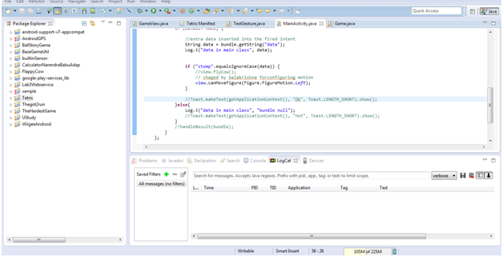

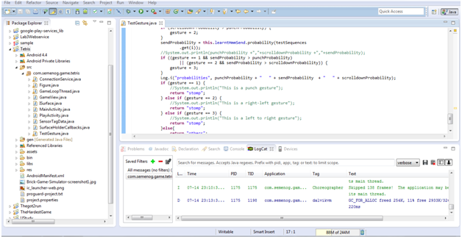

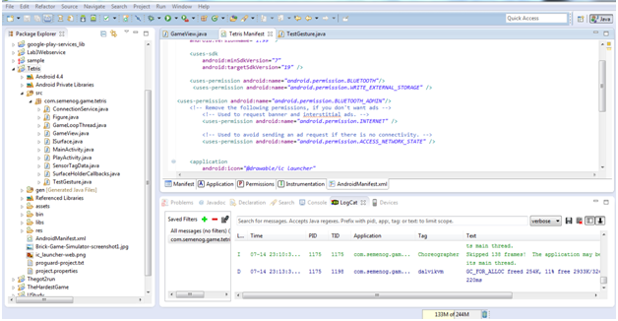



* After running the modified code in android application the emulator is pop-up with Tetris modified version.
* Later I played the game with the help of sensor-tag.
* Following screen-shots are related to the Tetris game which I had played by using sensor-tag.

