**Project Second Increment**

**CS551**

Submitted by

Arimanda,Syamala Reddy

Boyanapalli,Swathi

Vakalapudi,Vinod Kumar

Katib,Rayan Faru

**Introduction:**

Preparation is an important task and is highly in demand for the students in the case of selecting the universities. To qualify the gre and toefl exams, you need to know each and every detail about the exam, logon to their websites and surf about them. Also, it will be difficult to adapt to different patterns and designs as each website has their own in built design. To avoid these problems, our project acts as a single stop where in user can find different websites in one place with a common user interface (UI). This project provides feasibility to have sample exams and model papers all in a single application both through mobile and web applications.

**Overall goal:**

Our project gives clear idea about many things that are necessary for a student at the time of choosing a school to pursue his degree and also after attending the school.We have many features in our project which provides many answers to various types of questions that were really necessary and helpful to the students at the selection process of a school. We divide various questions into some groups.

Example: Admission Procedure is a group in which it can answer many questions like

1. What are the steps to be followed to apply to the school ?

Ans: student should have gre, toefl/ ielts score card, transcripts, sop, lor etc.

2. What are the required scores that are mandatory to apply?

Ans: gre 300+ particularly having quant score more than 160 and Toefl with a score of 100 minimum or ielts with minimum of 6.5

3. Is the school accepts ielts score less than 6.5?

Ans: Yes, the school will also accepts the score of 6 but student must have to attend a test i.e., ALI.

Once the student decides his school then he will be provided with model test papers of both the gre and toefl/ielts exams with all the sections covered in it.

Example: We provide sections like quant,verbal,analytical writing under gre exam and sections like speaking,listening,writing and reading under toefl exam.

**Proposed System:**

**Functional Requirements (Prioritized):**

* Students can register with their details, login and then update their profile if required.
* Students can choose the required exam and under that the required category in the website.
* Navigation and route maps are provided to the students about the universities.
* Statistics are provided to the students at different categories of exams like gre and toefl.

**Functional Requirements:**

* Our online service will be student friendly and easy to use.
* available on every day i.e., 24*7
* Loading our web application is fast as it uses very less bandwidth.

**System Architecture Diagram:**

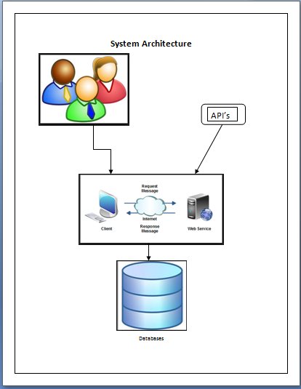

**Use Case Diagram:**

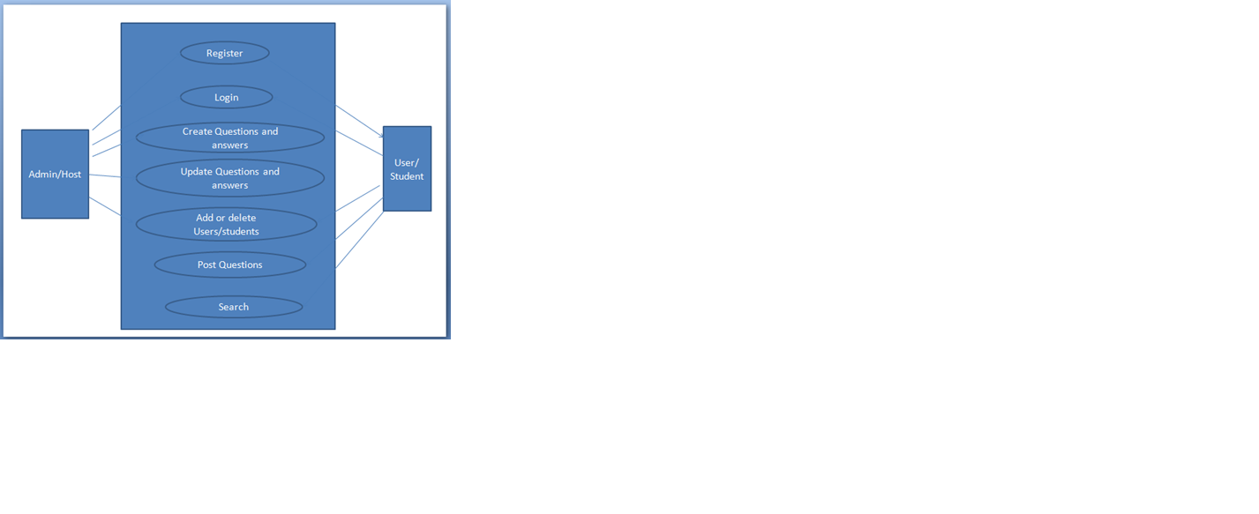

**Implementation Status Report:**

**Work Completed till 2nd Increment:**

In second increment, along with the 1st increment development we designed web services. We have also created web services for the registration and login of user.

**Detail Design of Web Services:**

The web services which we developed were:

1) Login web service

2) Topics find

Login web services have the following methods:

1) Student Login check

2) Student Profile update

3) Student Profile retrieval

4) Student Registration

**Implementation of Services :**

Below services developed as part of this increment is:

* Shopping Cart services

**Screenshots of Web Application:**

**Home Page:**

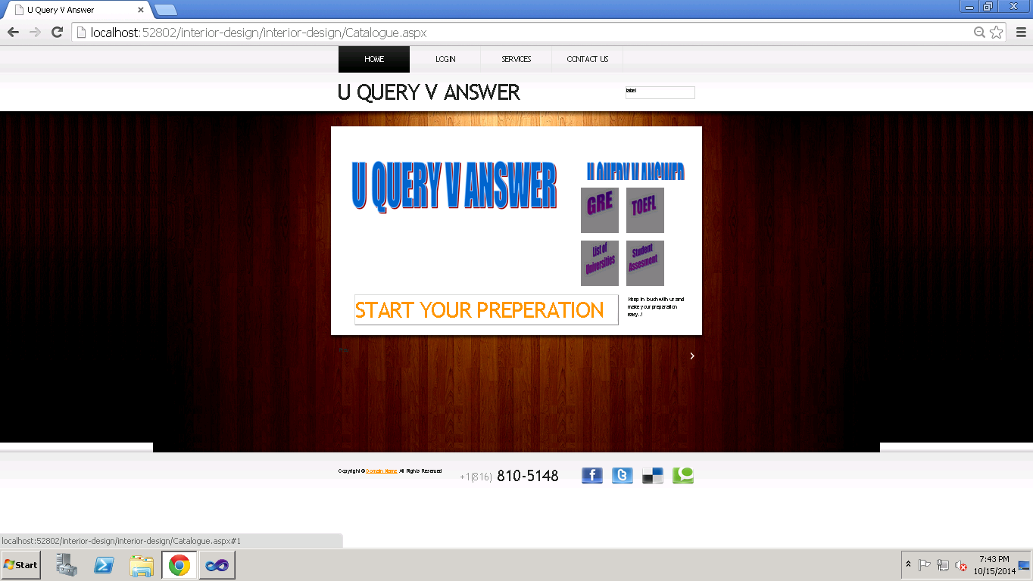

**Login Page:**

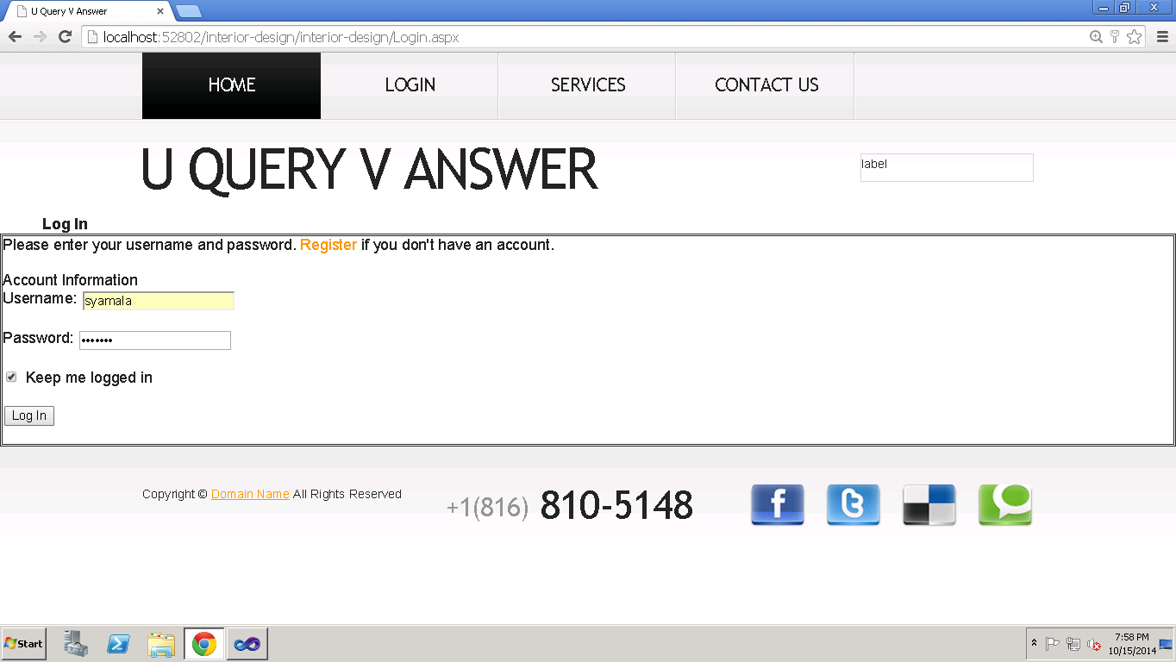

**Student Profile:** After login the student is redirected to set of options of editing his student details and also to choose among list of available services as below.

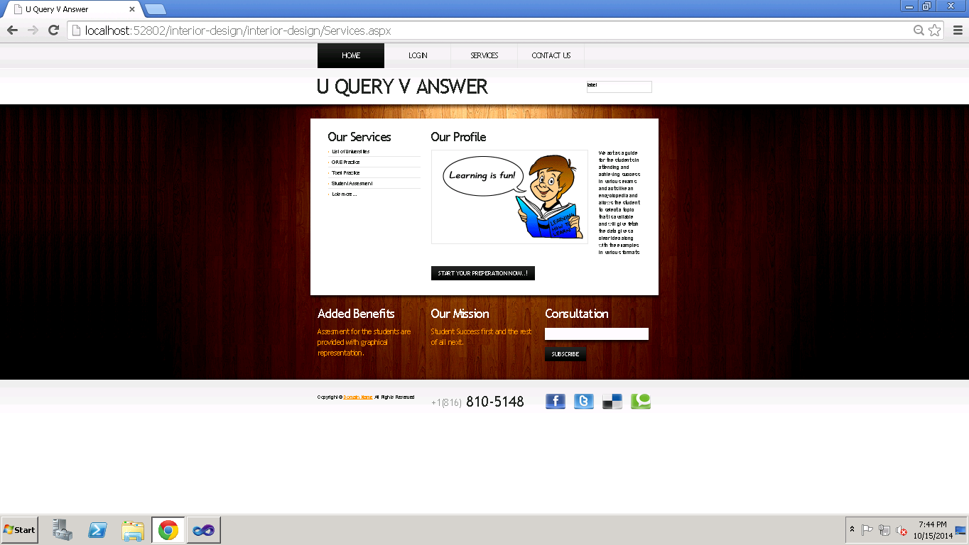

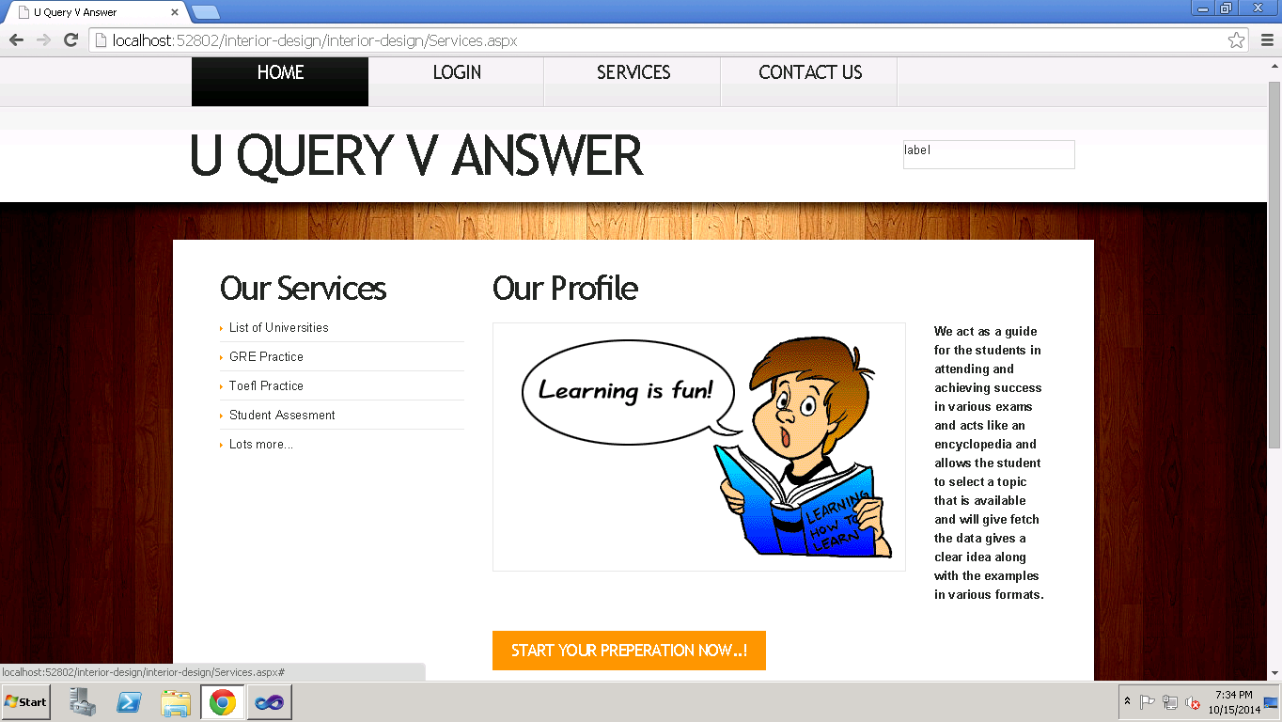

**Database tables:**

We have created tables for the Contact Us page with the rows name,email,phone number,message and the login and register page for the students.

**Student Details Table:**

In this table we have attributes like student name, password, email, contact number and zip code.

Queries used on these tables were:

1. Insert into table registration values (student name, password, email, contact number, zip code). These values are picked from the end student feed.
2. Select student name, email, contact number, zipcode from registration where student name=’studname’ and password=’pwd’
3. Update registration (student name=studname, email=email, zip code=zip, contact number=contactno)

**Publisher Details Table:**

In this table we have attributes like publisher name, password, email, contact number and zip code.

Queries used on these tables were:

1. Insert into table publisher values (publisher name, password, email, contact number, zip code). These values are picked from the end publisher feed.
2. Select name, email, contactno, zipcode from publisher where publisher name=‘pbname’ and password=’pwd’
3. Update vendor (publisher name=pbname, email=email, contact number=contactno, zip code=zip)

**Topics_Menus Table:**

This topics table consists of all the topics and their details for each and every admin. All details like topic name and description will be saved along with the topic type.

Queries Used for this table were:

a) Insert into topics_menus values( topic_name, topic_desc, topic_type, admin_name)

b) Update into topics_menus values( topic_name, topic_type, topic_desc where admin_name =”xxx”)

c) Select * from topics_menus where admin_name=”xxx”

**Work Completed As Part Of 2nd Increment:**

We implemented the web services in second increment and linked it to database.

**Responsibilities:**

|  |  |  |  |
| --- | --- | --- | --- |
| **S.No** | **Task** | **Person involved** | **Estimated Time** |
| 1. | Created web services for login and registration of student and admin. | Swathi  Syamala  Vinod | 12 hours |
| 2. | Created web services for Different Topics retrieval, addition and update. | Swathi  Syamala  Rayan | 10 hours |
| 3. | Testing web services using Nunit testing | Swathi  Syamala  Rayan | 3 hours |
| 4. | Documentation work | Swathi  Syamala  Vinod | 3 hours |

**Work to be completed in 3rd increment:**

**Responsibilities:**

|  |  |  |
| --- | --- | --- |
| **Sl.No** | **Task** | **Person involved** |
| 1. | Student capability will be displayed on bar or pie chart | Syamala  Vinod  Swathi |
| 2. | Implementing Google search engine option | Syamala |
| 3. | Further enhancements to second increment will be implemented. | Swathi  Vinod |
| 4. | Logo images to be inserted to each and every admin. | Rayan |
| 6. | Android web pages will be designed | Vinod |
| 7. | Testing | Swathi  Syamala |
| 8. | Documentation | Syamala  Vinod  Swathi  Rayan |