SUPPLY CHAIN ANALYSIS REPORT

Project Name: CDACL-003 supply chain analysis
Prepare By: swathi chilakala
Tool used: MYSQL, Power BI

Projective objective:

The objective of this project is to analyze the supply chain performance using MYSQL and Power BI. The project focuses on revenue, product sales, inventory, logistics, supplier performance, manufacturing costs, and product quality. The dashboards help identify business trends, compare product performance, and provide insights for better decision-making.

Dataset information:

Project Name: supply chain analysis
Dataset Name: supply chain data
Data Source: MYSQL Database
Visualization Tool: Microsoft Power BI
Total Records: 100
Total Tables: 2
Tables Used: supply_chain_data and supplier_performance

Dax measure and Data Cleaning:

Data Cleaning:
- Imported the dataset from MYSQL into Power BI.
- Verified the data types of all columns.
- Checked for null values.
- Checked for duplicate records.
- Validate the dataset for consistency.
- Create DAX measures for KPI calculations.
DAX measure:
DAX measures were created to calculate key performance indicators (KPIs). These measures were used in KPI cards and dashboard visuals to analyze the supply chain analysis.
- Total revenue: calculates the total revenue generated.
- Total products sold: calculates the total number of products sold.
- Average shipping cost: calculates the average shipping cost.
- Average manufacturing cost: calculate the average manufacturing cost.
- Average defect rate: calculate the average defect rate.
- Total production volume: calculate the total production volume.
- Total order quantity: calculates the total order quantity.
- Average lead time: calculates the average lead time

Supply chain performance dashboard:

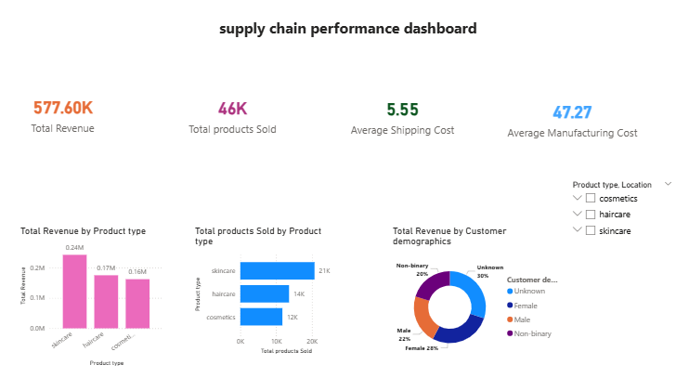

Supply chain performance dashboard analysis:
Supply chain performance dashboard provides an overview of the company’s overall supply chain performance. It displays key performance indicators such as total revenue, total products sold, Average shipping cost, and Average manufacturing cost. These KPIs help management quickly understand the overall business performance.
Key observations:
- the dashboard provides an overall view of business performance.
- Revenue is compared across different product types.
- Product sales are analyzed by product category.
- Customer demographics are used to understand revenue distribution.
- KPI cards help monitor important business metrics at a glance.

Operations & logistics dashboard:

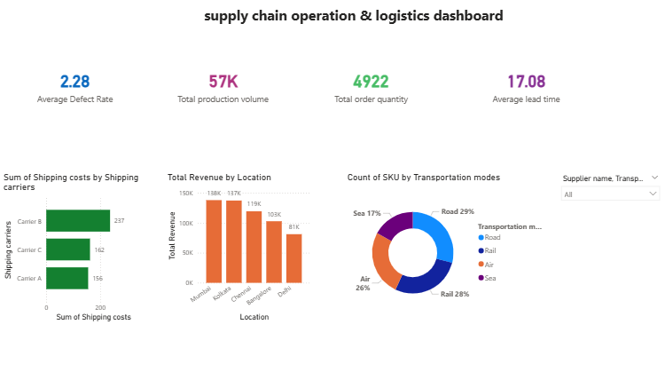

Operations & logistics dashboard analysis:
The operations and logistics dashboard focuses on supply chain operations and logistics performance. It provides insights into shipping costs, revenue by location, transportation modes, production volume, order quantity, and lead time. This dashboard helps monitor operational efficiency and supports better logistics planning.
Key observations:
- shipping costs are compared across different shipping carriers.
- Revenue is analyzed by location.
- Transportation modes are visualized to understand distribution patterns.
- Production volume and order quantity KPIs help evaluate operational performance.
- Lead time and defect rate KPIs support supply chain monitoring.

Quality & inventory dashboard:

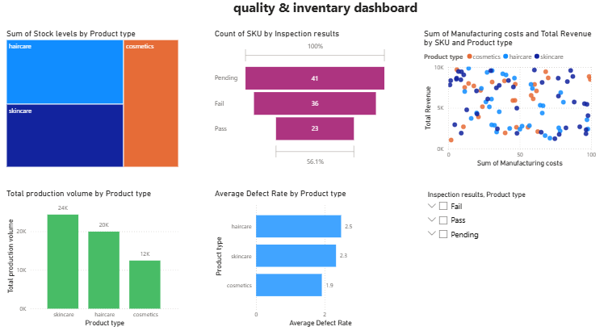

Quality & inventory dashboard analysis:
The quality and inventory dashboard provides insights into product quality, inventory levels, manufacturing costs, production volume, and defect rates. It helps identify quality issues, monitor inventory distribution, and evaluate manufacturing performance to support better operational decisions.
Key observations:
- stock levels are compared across different product types.
- Inspection results help monitor product quality.
- Manufacturing cost and revenue relationship can be analyzed.
- production volume varies by product category.
- Defect rates help identify quality improvement opportunities.

Comparison report

Product type comparison:
- Haircare generated the highest revenue and also had the highest production volume.
- Cosmetics showed moderate performance in terms of revenue and production.
- Skincare generated comparatively lower revenue and production volume.
Operational comparison:
- Road transportation is the most frequently used transportation mode.
- Shipping costs vary among different shipping carriers.
- Revenue differs across supplier locations, indicating performance differences between locations.
Quality comparison:
- A higher number of products are in pending (41) inspection status compared to pass (23).
- Defects rates vary across product types, showing differences in product quality.
- Stock levels are not same for all product types, indicating different inventory requirements.

Diagnostic report

Issues identified:
- The inspection results show 41 pending products, indicating delays in the quality inspection process.
- 36 products failed inspection, indicating quality issues.
- Shipping costs vary across different carriers.
- Product performance varies across different product types.
Recommendations:
- Improve the inspection process to reduce pending inspections.
- Strengthen quality control to reduce failed inspections.
- Optimize shipping carrier selection to reduce logistics costs.
- Regularly monitor KPIs using Power BI dashboards

Analysis report

The analysis report provides an overall evaluation of the supply chain performance based on the Power BI dash boards. The dashboards analyze revenue, product sales, logistics, inventory, manufacturing, and quality performance. The analysis helps identify business trends, operational performance, and areas that require improvement for better decision-making.
Overall business insights:
- The company generated a total revenue of 577.60K
- A total of 46K products were sold during the analysis period.
- Haircare products generated the highest revenue and production volume among all product types.
- the average shipping cost is 5.55, while the Average manufacturing cost is 47.27.
- the total production volume is 57K, with a total order quantity of 4,992.
- Road transportation (29%) is the most frequently used transportation mode.
- the quality inspection results show 41 Pending, 36 fail and 23 pass, indicating opportunities to improve quality management.
- The Power BI dashboards provide clear insights that help management monitor KPIs and support data-driven business decisions.

Conclusion

The supply chain analysis project was successfully completed using MYSQL and Power BI. The dashboard provided valuable insights into revenue, product sales, logistics, inventory, manufacturing, and quality performance. The analysis helped identify business trends, compare product performance, and evaluate supply chain operations. Overall, the project demonstrates how Power BI dashboards can support effective monitoring of key performance indicators (KPIs) and enable better business decision-making.

