PROJECT DOCUMENTATION

Retail Sales & Business
Performance Analytics Using SQL
Database Design • SQL Analysis • Power BI Dashboard

Tools: MySQL (SQL script) | Power BI | ER Diagram
Prepared from the supplied project SQL script, ER diagram and dashboard screenshot.

1. Project Overview
This project focuses on designing a relational database for a retail business and analysing sales and business performance using SQL. The database stores information about customers, products, categories, regions, employees, orders, order items and payments. SQL queries are used to explore sales trends, product performance, customer contributions, order status and payment information. A Power BI dashboard presents key measures and interactive views.

2. Project Objectives
- Design a relational database with connected tables and key constraints.
- Store and organize retail data about customers, products, employees, orders and payments.
- Use filtering, sorting, aggregation and joins to answer business questions.
- Apply subqueries, CTEs and window functions for deeper analysis.
- Create reusable database objects such as a view, stored procedure, function and trigger.
- Use indexes and EXPLAIN to examine query execution plans.
- Present key business performance indicators in a Power BI dashboard.

3. Tools and Technologies
Tool / Technology | Purpose
MySQL / SQL | Database creation, data manipulation and business analysis queries
Power BI | Interactive dashboard and visual reporting
ER Diagram | Visual representation of entities and table relationships

4. Database Design
The RetailSalesDB database contains the following main tables: regions, categories, customers, products, employees, orders, order_items, payments and returns. The supplied diagram also shows supporting objects for product price auditing and transaction demonstration, plus the vw_sales_summary view.
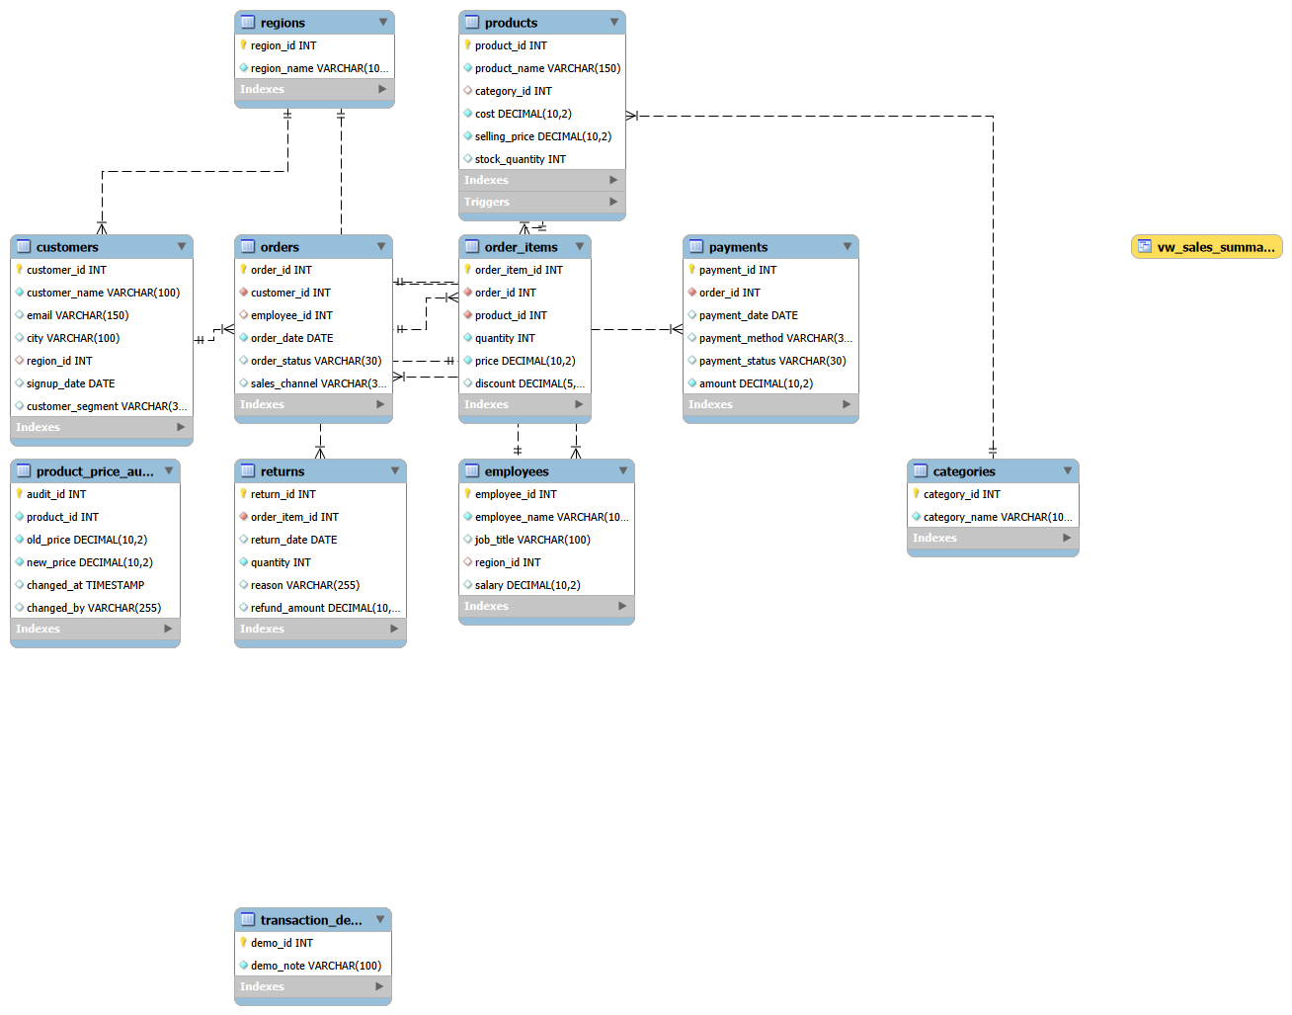
Figure 1. Entity Relationship (ER) diagram supplied for RetailSalesDB.

5. Database Structure and Sample Data
The supplied SQL script creates the database and defines primary keys, foreign keys, unique constraints, default values and CHECK constraints. The inserted sample data contains:
Table | Number of records
Regions | 5
Categories | 5
Customers | 10
Products | 15
Employees | 5
Orders | 25
Order items | 30
Payments | 25
The returns table is created in the script, but no return records are inserted in the supplied data-loading section.

6. SQL Concepts and Analysis Performed

Database definition and data loading
CREATE DATABASE, CREATE TABLE, INSERT, primary keys, foreign keys and constraints.

Basic querying
SELECT, WHERE, BETWEEN, IN, LIKE, ORDER BY and LIMIT.

Aggregate analysis
COUNT, SUM, AVG, GROUP BY and HAVING.

Relational analysis
INNER JOIN and LEFT JOIN across customers, orders, order items, products, categories, regions and employees.

Advanced querying
Subqueries, common table expressions (CTEs), CASE expressions and COALESCE.

Window functions
RANK, LAG and cumulative SUM for ranking and time-based comparisons.

Reusable database objects
A sales summary view, date-range stored procedure, discounted-item function and product-price audit trigger.

Data quality checks
Checks for missing values, invalid numeric values, duplicate customer emails, broken relationships and payment/order differences.

Performance and transactions
Indexes, EXPLAIN, START TRANSACTION, COMMIT and ROLLBACK.

7. Main SQL Query Outputs
The following result images were generated by executing the compatible table-creation, data loading and analytical SELECT logic against the supplied sample data in a local SQLite-compatible environment. They are formatted result captures for documentation; they are not screenshots from the MySQL Workbench interface. MySQL-specific routines and administrative statements were not executed in that environment.

Monthly sales
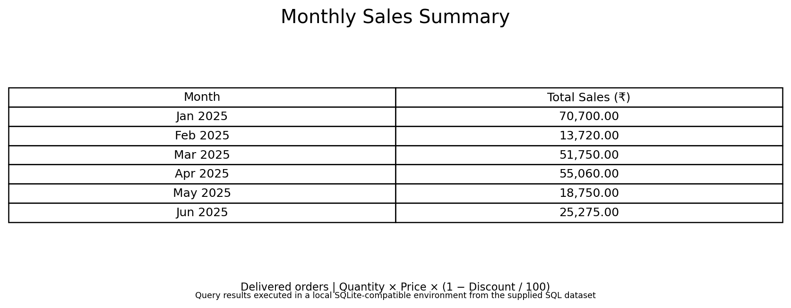
Figure: Monthly delivered sales from January to June 2025.

Top products
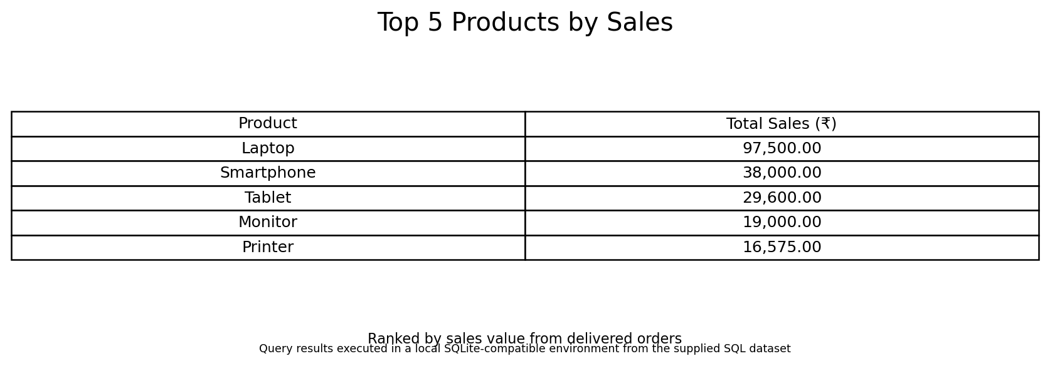
Figure: Five products with the highest delivered sales value.

Average order value
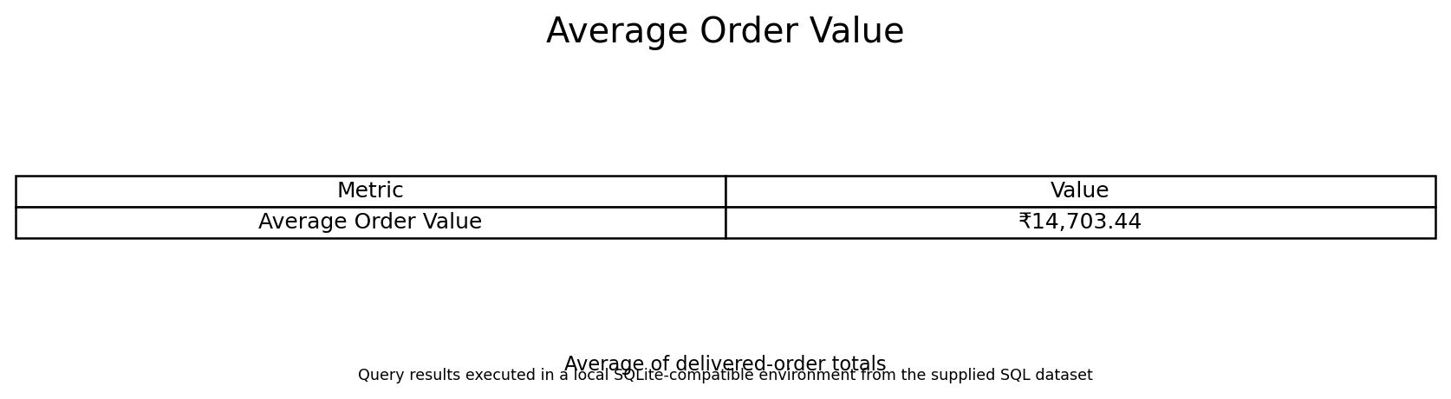
Figure: Average value of delivered orders.

Category units
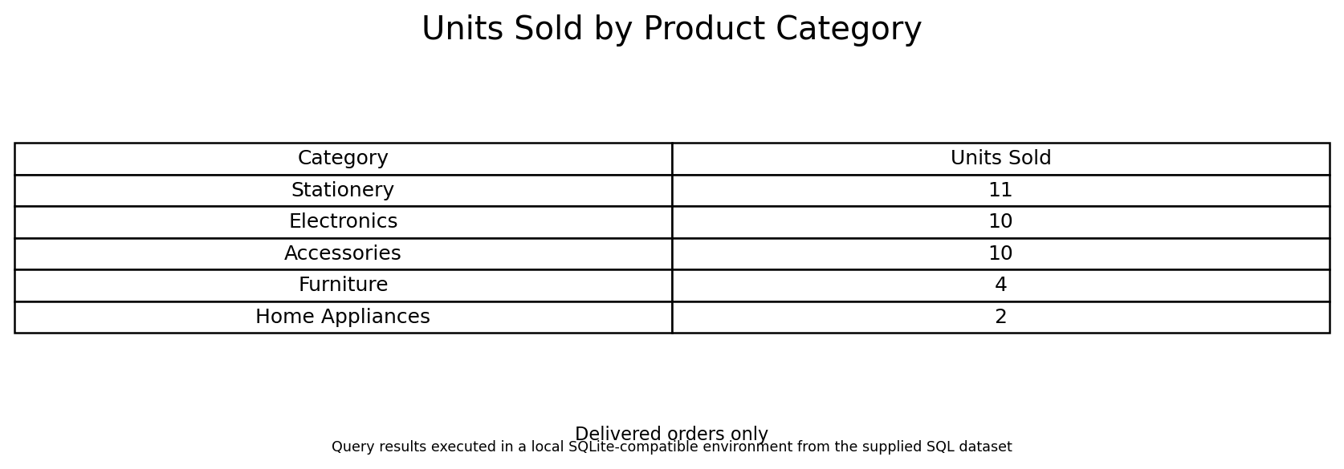
Figure: Number of units sold by product category.

Region and channel
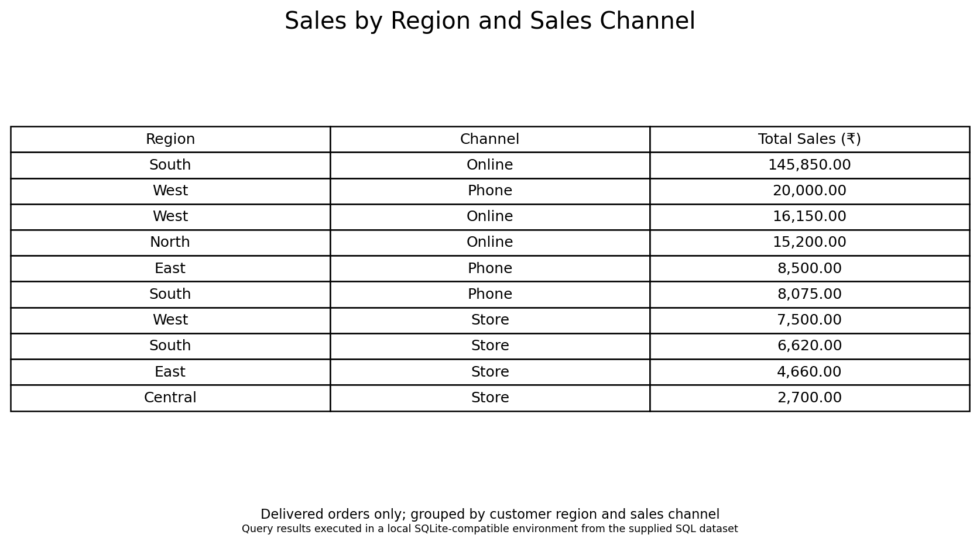
Figure: Delivered sales grouped by customer region and sales channel.

Order status
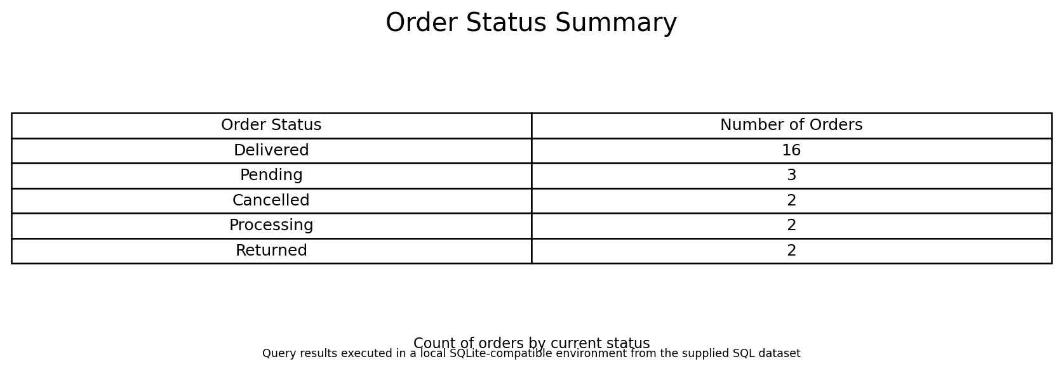
Figure: Order counts by status.

Customer sales
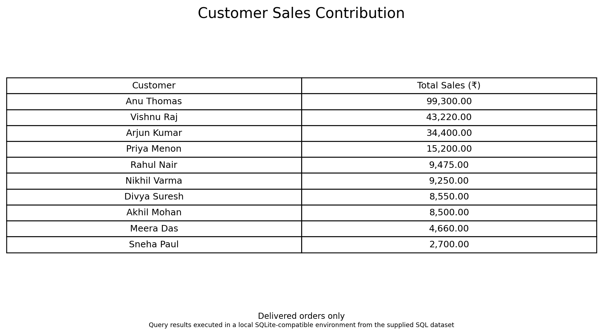
Figure: Delivered sales contribution by customer.

Employee sales
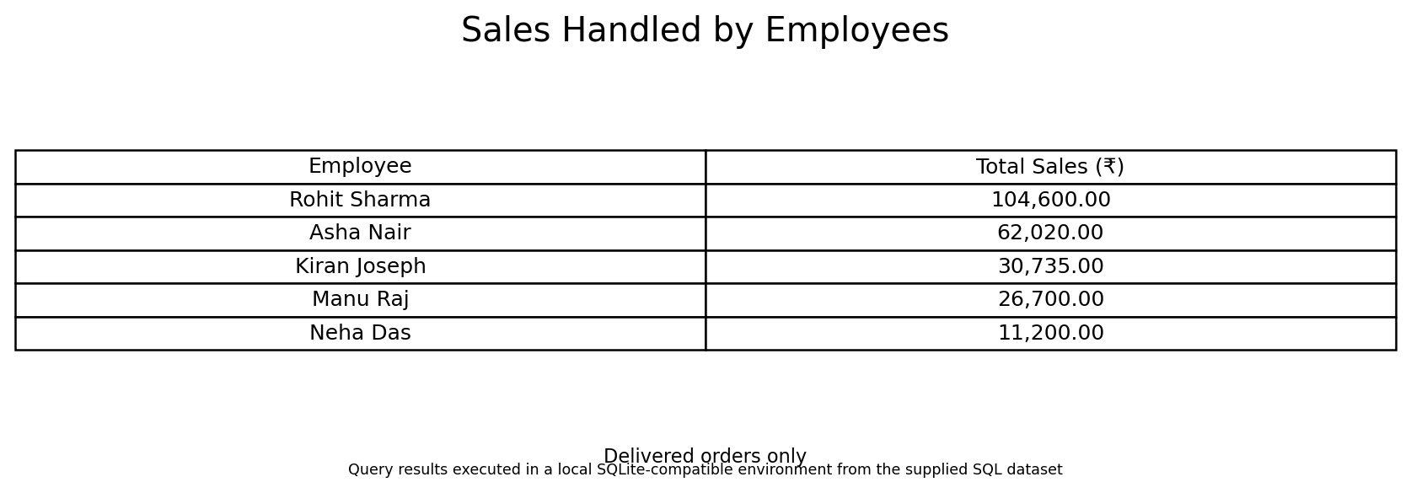
Figure: Delivered sales handled by employee.

Payment status
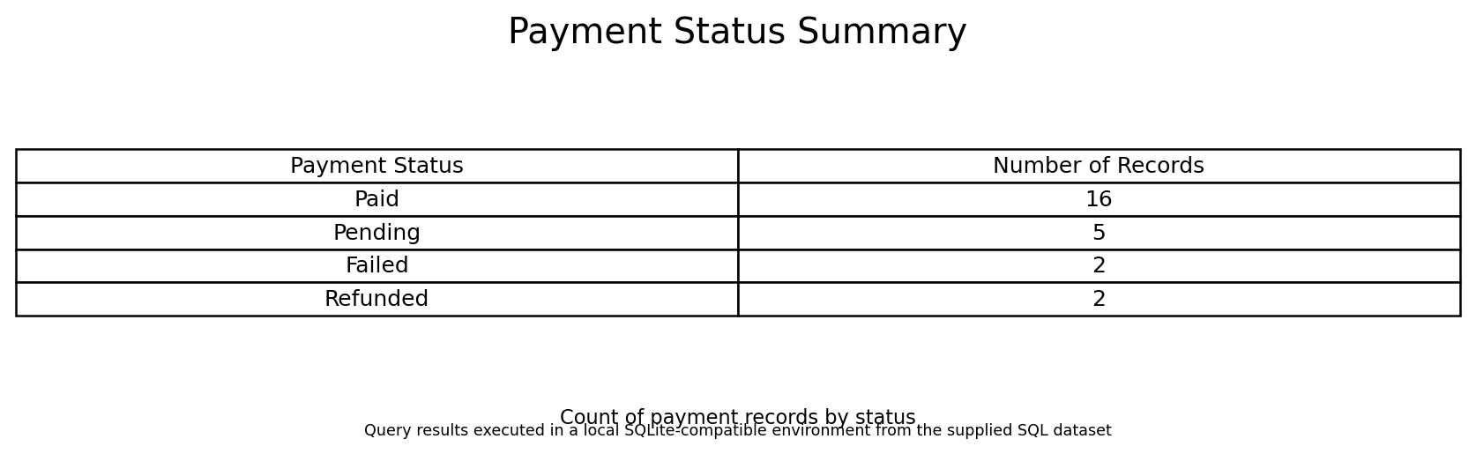
Figure: Payment record counts by payment status.

8. Power BI Dashboard
The supplied Power BI dashboard is titled Retail Sales Performance Dashboard. It displays delivered sales, total customers, total orders and products sold as KPI cards. It also includes sales by category, monthly sales trend, orders by status and sales by channel. Slicers are provided for order date, product category and region.
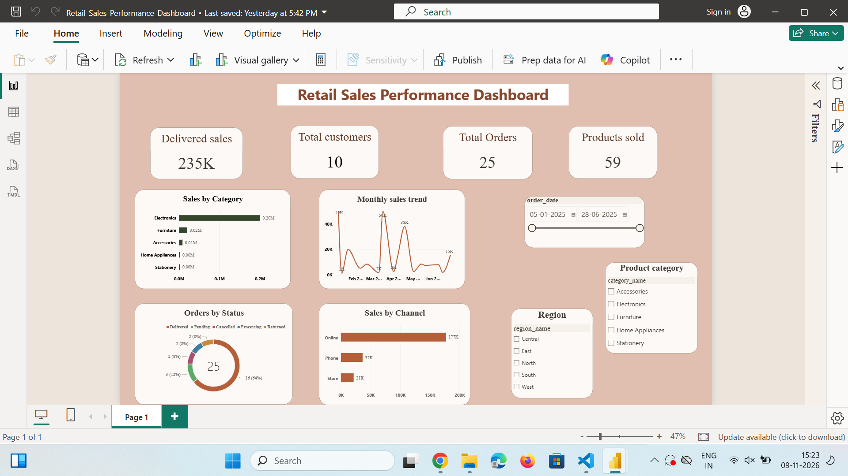
Figure 2. Power BI Retail Sales Performance Dashboard screenshot supplied for the project.
The screenshot displays 235K delivered sales, 10 customers, 25 orders and 59 products sold. The dashboard also shows a 16-order delivered share (64%) in the order-status chart, with additional pending, cancelled, processing and returned orders.

9. Key Business Findings
- Total delivered sales calculated from the supplied order-item data are ₹235,255 (displayed as 235K in the dashboard).
- January 2025 has the highest monthly delivered sales (₹70,700), while February 2025 has the lowest (₹13,720).
- Laptop is the top product by delivered sales value (₹97,500).
- Anu Thomas is the highest-contributing customer by delivered sales (₹99,300).
- South region and Online channel form the largest region-channel sales combination in the query results.
- There are 25 orders: 16 Delivered, 3 Pending, 2 Cancelled, 2 Processing and 2 Returned.
- Payment records include 16 Paid, 5 Pending, 2 Failed and 2 Refunded records.

10. Recommendations
- Monitor stock levels and prioritize replenishment for products with low available quantities.
- Continue strengthening the online channel while monitoring the performance of store and phone channels.
- Review pending, cancelled and returned orders to identify operational issues.
- Investigate differences between order totals and paid amounts before closing financial reports.
- Use the customer and product analysis to support targeted retention and product-promotion decisions.

11. Limitations and Execution Notes
The SQL file is written for MySQL. For this documentation, the core table definitions, sample data and analytical SELECT queries were checked using a SQLite-compatible execution environment. MySQL-only syntax and database objects such as stored procedures, functions, triggers, DELIMITER blocks, SHOW TABLES, information_schema queries and EXPLAIN plans were not run in MySQL Workbench here. Their definitions are described from the supplied SQL script, not represented as verified execution screenshots. The returns table has no sample rows in the supplied insert statements.

12. Conclusion
This project demonstrates how a relational database and SQL analysis can support retail business decisions. The database design connects key business entities, while SQL queries provide insights into sales trends, products, customers, regions, channels, orders and payments. The Power BI dashboard brings the key measures together in an interactive visual report.

