High-Level Workflow
The Story
A worker has finished a long 15-hour shift, and we’ve entered their Crew Sheet (timesheet) into FieldVu. We want to ensure that:
- the hours are entered correctly,
- the expected meals and breaks were either received or compensated for, and
- everything aligns with the relevant rules.
FieldVu should check the Crew Sheet against those rules and return whether it meets them, or not, and why.
Story Setting:
- Job site is located in Alberta, Canada
- NMA-AB union agreement is applicable to this job (using just this one to keep story simple)
- Worker is a Pipefitter-Journeyman
- Worker is a unionized employee
- Worker is currently on a work schedule of 5x8 (Mon-Fri)
- Worker is currently staying in site’s Camp accommodations
- Date of field service was Wednesday, September 17, 2025
- This service was not a callout event for this worker
What Actually Happened in the Field that Day:
- This pipefitter worked and received as follows:
- Hours worked: 15.0 total
- Meals received: 1 company-provided
- Meal Breaks received: 1 paid

Step 1: PDF-Text Conversion

The first technical step is to convert the raw, unstructured PDF document into a machine-readable text format, ensuring all original formatting, tables, and section breaks are captured and preserved with source markers. This is the foundation upon which the entire LLM workflow is built.
Step 2: Classify Labour-Related Context and Chunk Appropriately

The goal here is to drastically reduce the 43 pages of the NMA document to just the Articles that contain rules for validation (compensation, time, and subsistence), and then chunk them logically.

A. Context Classification and Filtering

The LLM system filters the NMA document text, retaining only the Articles relevant to the labour timesheet validation
B. Intelligent Chunking

The filtered text is then broken down into semantic chunks to preserve context for the LLM:

Strategy: Use each numbered article and sub-article (e.g., 9.100, 15.600, 15.600(i)) as the logical chunk boundary.

Result: The LLM receives dedicated chunks for "15.300(a) Five Eight Hour Days" and "15.604 Overtime Meal Allowance for those on Subsistence," ensuring no related clauses are split.
This approach is subjected to change based on outcome at testing

Step 3: Identify Topics and Their Main Sections
The LLM identifies and establishes the following Topic Rule Cards based on semantic analysis of the retained Articles. This level ensures efficient filtering for core timesheet validation and minimizes overlap.
This fixed level of granularity allows the Rule Evaluation Engine to use the Timesheet's context (e.g., "staying in camp") to directly select the most important topics—Labour Hours, Meal Provisions, and Subsistence—for the Pipefitter's validation.
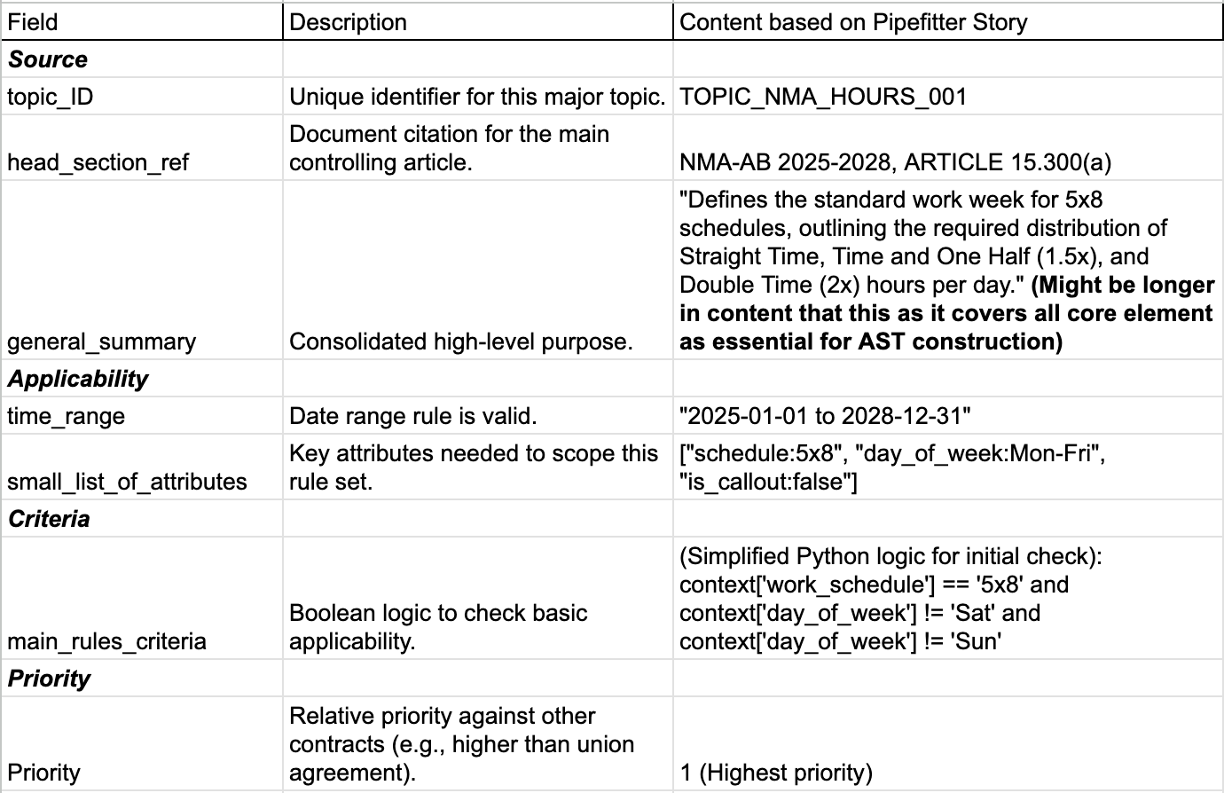
(This is a high level standard fields subjected to change based on rule extraction and granularity of topic )

General Summary -
(Topic Summary) for AST Creation

The goal here is to take all relevant raw text (Articles 15.600, 15.602, 15.604) and condense it into a single Topic Summary that will serve as the primary source for the final executable logic (the Topic AST).

Topic Summary Generated (for AST Purpose)

The LLM aggregates the text from the NMA-AB document (particular topic classified)and summarizes the entire flow, including the implied relationships:

"For an employee on a standard daily shift working beyond ten (10) hours (Art. 15.600), the primary obligation is to provide a company meal and a 30-minute paid break. This primary obligation is then subject to two conditions: 1. If it is impractical to provide the meal (Art. 15.602), the obligation is substituted with a $40 allowance and a 45-minute paid break equivalent. 2. If the employee is staying in camp (Art. 15.604), the obligation to pay the $40 meal allowance is removed, as camp subsistence supersedes the payment."
Human-in-the-Loop Evaluation
A Subject Matter Expert (SME) reviews this classification before proceeding to ensure the boundaries are correct.
The expert ensures only rules that deal with meal entitlements due to overtime are included, maintaining the correct focus for validation. This prevents unnecessary rules from being compiled into the validation code.

Step 4: Defining Elemental Rule Cards

The system formally defines the three Elemental Rule Cards (Nodes) based on the logical divisions identified in the summary in a particular topic.
Just for sample -
This is a sample detailed construction of the Elemental Rule Cards that fall under the "Overtime Meal and Break Entitlements" topic, using the structure we provided and the facts from the Pipefitter story and the NMA-AB document.
creating three distinct elemental rules, as they represent separate, testable units of logic.

Elemental Rule Card Construction: Overtime Meal Topic

1. R2.Meals: Primary Obligation (Art. 15.600)
This rule establishes the initial requirement for a meal and break.
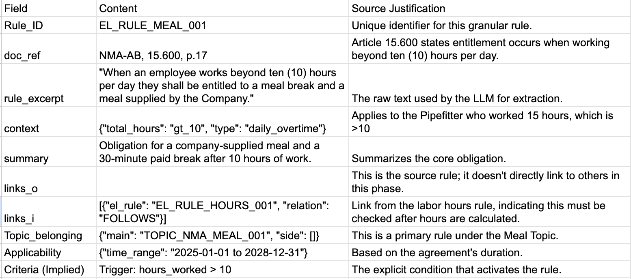
2. R3.Allowance: Substitution Operation (Art. 15.602)
This rule defines the substitution that occurs if the meal is not provided.
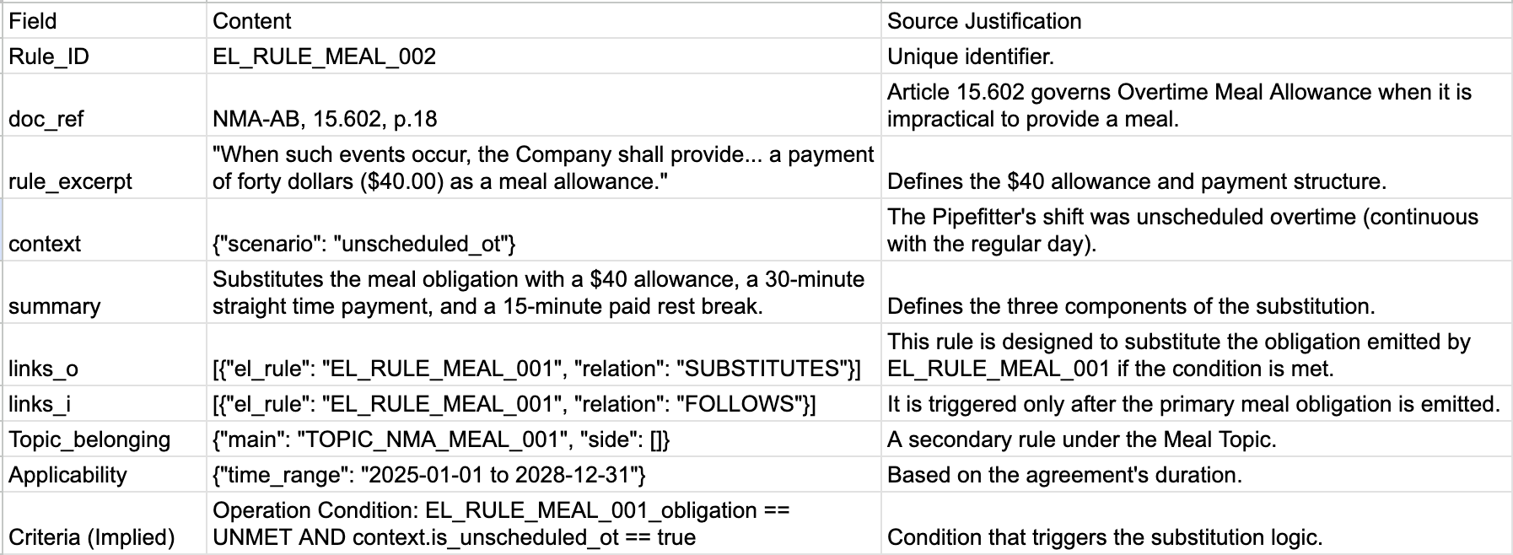

3. R4.Camp: Removal/Exception Operation (Art. 15.604)
This rule creates an exception/removal based on the Pipefitter's camp status.

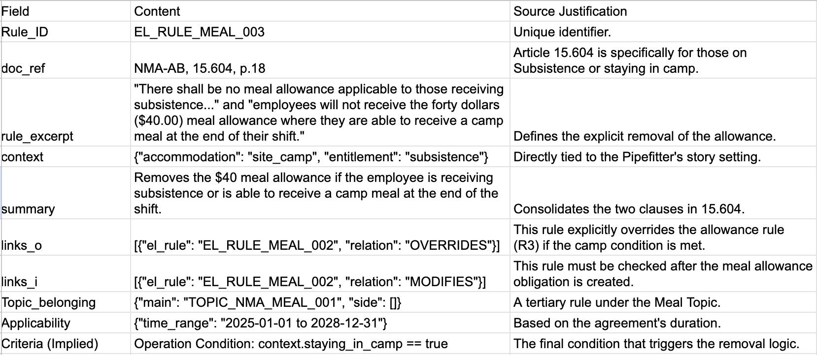
Step 5: Relationship and Missed Link Identification
5a. The LLM system formally defines the links between the Elemental Rule Cards, which dictates the logic for the final AST.
5b. Identify External Relations (Outside the Topic)
This step ensures the meal rules connect back to the foundational rules defined in other topics, validating the entire flow of logic.
5c. Scan Full Documents for Missed Links and Rules
The LLM performs a targeted semantic search across the entire NMA-AB text to ensure all contextual overrides are captured.(Special rules like call-out might be captured in these stages)
The output of this stage is a fully enriched Directed Graph where all elemental rules are not only connected within their topic but are also correctly linked to rules in other topics, creating a complete validation network.
Step 7: Topic AST Creation (Logic Compilation)
The LLM compiles the logic dictated by the graph and the elemental rules into a single Abstract Syntax Tree (AST), which is then used to generate the final executable validation code.
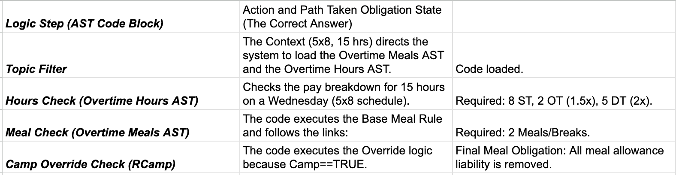
Final Reconciliation and Feedback (for example)
The system compares the compiled required obligations to the entered facts.
- Result on Hours (FAIL): The code compares the required hours (8 ST, 2 OT, 5 DT) to the logged hours (9 ST, 3 OT, 2.5 DT).
It fails because the total hours are miscategorized.
- Result on Meals (PASS): The code confirms that no meal allowance is owed due to the camp exception (RCamp​), so the $0 financial exposure is correct.
The system returns a FAIL status to the timekeeper, with the specific reason pointing to the incorrect hours breakdown.
Strategy for Upscaling: New Documents and Categories
The core idea is to treat the initial NMA-AB, One union and One customer contract as a reference template. We are not starting from scratch; we are leveraging the schema, the successful prompts, and the validated topic structure.

1. New Documents: Replication and Transfer Learning
When introducing a new document (e.g., a Customer Agreement or a different Union Contract), the process is one of replication:
- PDF Conversion & Filtering: The reliable approach developed for the NMA (Step 1-2) is immediately applied to the new PDF to get structured, chunked text.
- Topic Transfer: Instead of having the LLM guess the topics, we first instruct it to map the new document's content against our existing, validated Topic Rule Cards (e.g., Overtime Meals, Wage Premiums). The LLM identifies which sections in the new document correspond to the existing topics.
- Targeted Tuning: we use the Few-Shot Learning method by providing the LLM with corrected examples from the NMA-AB (the source document) to help it extract rules from the new document. This accelerates the process because the LLM is already tuned to the task of rule extraction and only needs minor adjustments for the new language.

2. New Categories: Incremental Graph Expansion
When expanding to a completely new category, such as Equipment Time or Third-Party Services, we expand the graph structure incrementally:
- New Topic Definition: Define a new high-level Topic Rule Card (e.g., TOPICEQUIPMENT​). This requires human supervision to set the correct granularity.
- Variable Definition: we must define all major variables required for this new category (e.g., equipment_type, rental_rate, third_party_vendor). These new variables are then incorporated into the validation script's data structure.
- Elemental Rule & Link Building: The LLM is instructed to extract elemental rules specific to equipment time (e.g., "Crane time is paid at 1.5x on weekends"). Crucially, the LLM must also find links between the new topic and existing ones (e.g., an Inclusive link from a Labour Hours rule that requires simultaneous logging of a man-hour).
- Real Data Testing: we use small samples of real data entry examples for the new category to test the resulting validation code, ensuring the graph logic is correct before full deployment.

3. Quality Control (The Human-in-the-Loop)
our system's flexibility relies on the human feedback loop at every stage that involves the LLM:
- For every new topic or document, we need Subject Matter Experts (SMEs) to provide immediate feedback to the LLM on incorrect extractions or faulty link definitions.
- Gradual Complexity: we start by defining simple Elemental Rules and gradually allow the graph complexity to increase only after the foundational rules and relationships are proven reliable. This is our primary de-risking strategy.

1. Why this approach over Two-Pass Validation (Client's Method)
The client's method, relying on Phase 1: Emission and Phase 2: Operations, is fundamentally limited because it treats rules as a flat list with simple precedence.
Advantage of (Graph-to-AST) | Limitation of Two-Pass Method
Models Non-Hierarchical Logic | Struggles with complex logic like "If Rule A is an exception to Rule B, but only for Pipefitters."
Guarantees Correct Order | Requires the programmer to manually define the order of operations (e.g., must removals happen before substitutions?), which is error-prone.
Handles Cross-Document Rules | Limited in modeling rules that have complex dependencies across different documents (NMA → Customer Contract).
Auditable Path | Provides no inherent audit trail of why a decision was made, only the final result.

2. Why this approach over Full BPMN Implementation
While BPMN is excellent for visualization, using it for real-time compliance is typically too heavy and rigid.
Advantage of (Graph-to-AST) | Limitation of Full BPMN Systems
Dynamic and Fast Execution | BPMN engines are often slow due to overhead from constantly traversing complex nodes and edges for every single timesheet check.
Simple Maintenance | If a rule is changed(change order), the entire BPMN model needs to be visually redesigned and re-compiled, which is time-consuming and requires specialized software.
Focus on Logic, Not Flow | BPMN forces to model every step as an activity, which adds unnecessary complexity. AST focuses only on the conditional logic that impacts the final decision.
Small Output | The output is one highly-optimized, small Python function that executes instantly. A full BPMN system generates massive, difficult-to-debug execution logs.

Conclusion: The Best of Both Worlds
Graph-to-AST Compiler strategy provides the best balance:
Feature | Provided By | Benefit
Precision | Directed Graph | Accurately models complex dependencies (exceptions, overrides, inclusions) through explicit links.
Speed | AST/Python Compilation | Compiles the entire decision flow into a single, optimized function that executes instantly during real-time data entry.
Maintainability | Graph Structure | Allows for easy updating of rules (versioning a single rule node) without manually changing the validation code for every dependent rule.

