LAB5
1.
Select e.eno,e.ename ,d.dno,d.dname from employee e, dept d
where e.deptno= d.dno ;
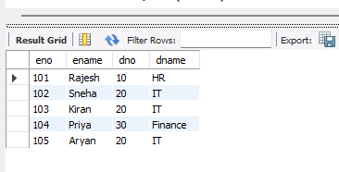

2.
select eno ,ename from employee
where eno not in (select eno
from assignd_to);
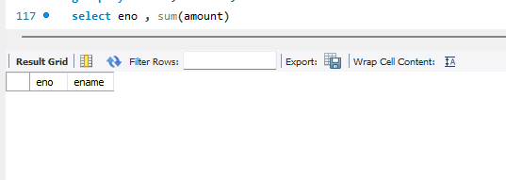
3.
select d.dno , d.dname , avg(e.sal) , max(e.sal) from dept d , employee e
where d.dno = e. deptno group by d.dno ,d.dname ;

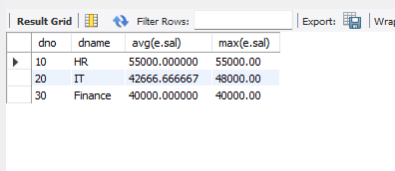

4.
select eno , sum(amount) from incentives
group by eno ;
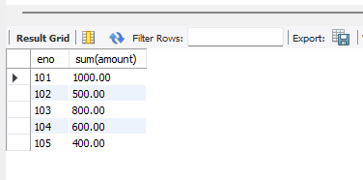

6.
select dno, dname from dept
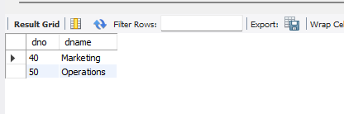
where dno not in (select deptno from employee );

7. SELECT
m.Eno AS Manager_ID, m.Ename AS Manager_Name,
COUNT(e.Eno) AS Direct_Report_Count FROM
Employee m LEFT JOIN
Employee e ON m.Eno = e.Mgrno GROUP BY
m.Eno, m.Ename ORDER BY
Direct_Report_Count DESC;
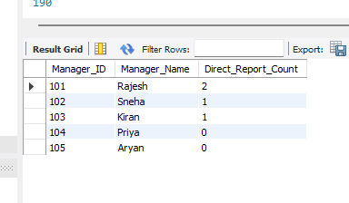

8. SELECT
e.Eno AS Employee_ID, e.Ename AS Employee_Name, COUNT(i.Pno) AS Project_Count

FROM
Employee e JOIN
incentives i ON e.Eno = i.Eno GROUP BY
e.Eno, e.Ename HAVING
COUNT(i.Pno) > 1;



5. SELECT
e.Eno , e.Ename , p.Pname , p.Ploc , i.Amount , i.Adate

FROM
Employee e JOIN
incentives i ON e.Eno = i.Eno JOIN
Project p ON i.Pno = p.Pno WHERE
p.Pname = 'product launch';
