Lab 4
Lab 4
Employee database:
create database employeee;
use employeee;
CREATE TABLE Dept (
Dno INT PRIMARY KEY,
Dname VARCHAR(30),
Dloc VARCHAR(50)
);
CREATE TABLE Employee (
Eno INT PRIMARY KEY,
Ename VARCHAR(50),
Mgrno INT,
Hiredate DATE,
Sal DECIMAL(10,2),
Deptno INT,
FOREIGN KEY (Deptno) REFERENCES Dept(Dno)
);
CREATE TABLE Project (
Pno INT PRIMARY KEY,
Pname VARCHAR(50),
Ploc VARCHAR(50)
);
CREATE TABLE Assignd_To (
Eno INT,
Dno INT,
JobRole VARCHAR(50),
PRIMARY KEY (Eno),
FOREIGN KEY (Eno) REFERENCES Employee(Eno),
FOREIGN KEY (Dno) REFERENCES Dept(Dno)
);
CREATE TABLE incentives (
Eno INT,
Pno INT,
Amount DECIMAL(10,2),
Adate DATE,
PRIMARY KEY (Eno, Pno),
FOREIGN KEY (Eno) REFERENCES Employee(Eno),
FOREIGN KEY (Pno) REFERENCES Project(Pno)
);

INSERT INTO Dept (Dno, Dname, Dloc)
VALUES
(10, 'HR', 'Mumbai'),
(20, 'IT', 'Bangalore'),
(30, 'Finance', 'Delhi'),
(40, 'Marketing', 'Chennai'),
(50, 'Operations', 'Hyderabad');

INSERT INTO Employee (Eno, Ename, Mgrno, Hiredate, Sal, Deptno) VALUES
(101, 'Rajesh', NULL, '2019-03-12', 55000, 10),
(102, 'Sneha', 101, '2020-07-19', 48000, 20),
(103, 'Kiran', 101, '2021-01-25', 42000, 20),
(104, 'Priya', 102, '2022-05-10', 40000, 30),
(105, 'Aryan', 103, '2023-09-15', 38000, 20);

INSERT INTO Project (Pno, Pname, Ploc) VALUES
(201, 'Recruitment', 'Mumbai'),
(202, 'ERP Upgrade', 'Bangalore'),
(203, 'Audit System', 'Delhi'),
(204, 'Product Launch', 'Chennai'),
(205, 'Logistics Hub', 'Hyderabad');

INSERT INTO Assignd_To (Eno, Dno, JobRole) VALUES
(101, 10, 'Manager'),
(102, 20, 'Analyst'),
(103, 20, 'Coordinator'),
(104, 30, 'Accountant'),
(105, 20, 'Software Engineer');

INSERT INTO incentives (Eno, Pno, Amount, Adate) VALUES
(101, 202, 1000, '2024-01-10'),
(102, 204, 500, '2024-06-25'),
(103, 204, 800, '2024-07-18'),
(104, 205, 600, '2024-09-12'),
(105, 202, 400, '2024-12-05');

SELECT * FROM Dept;
SELECT * FROM Employee;
SELECT * FROM Project;
SELECT * FROM Assignd_To;
SELECT * FROM incentives;

select distinct i.eno , p.ploc
from incentives i , project p
where i.pno = p.pno and p.ploc in ("bangalore","hyderabad");

Output:

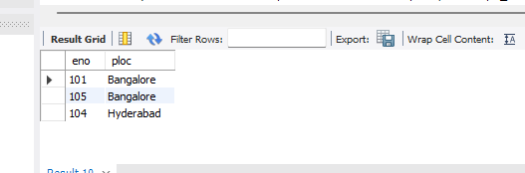

select eno
from employee
where eno not in ( select eno from incentives);

Output:
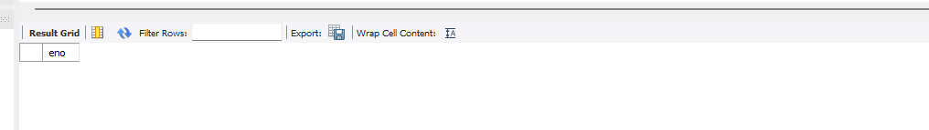

SELECT
E.Ename,
E.Eno,
(SELECT Dname FROM Dept WHERE Dno = E.Deptno) AS Dept_Name,
(SELECT JobRole FROM Assignd_To WHERE Eno = E.Eno) AS Job_Role,
(SELECT Dloc FROM Dept WHERE Dno = E.Deptno) AS Dept_Location,
(SELECT P.Ploc
FROM incentives I, Project P
WHERE I.Eno = E.Eno AND I.Pno = P.Pno) AS Project_Location
FROM Employee E
WHERE (SELECT Dloc FROM Dept WHERE Dno = E.Deptno) =
(SELECT P.Ploc
FROM incentives I, Project P
WHERE I.Eno = E.Eno AND I.Pno = P.Pno);


