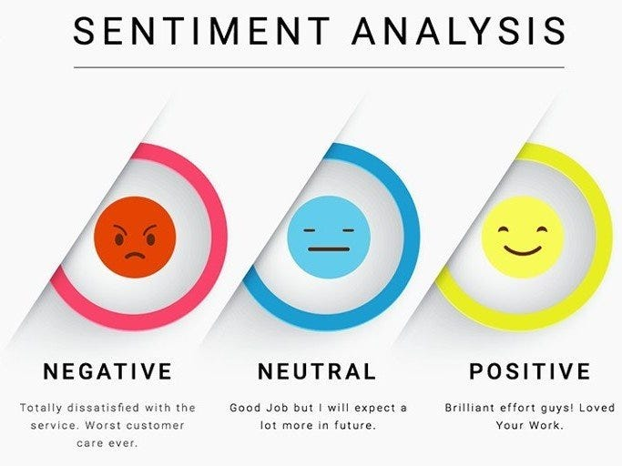

**Sentiment Analysis for Marketing**

**Introduction:**

Sentiment analysis is a powerful tool in the field of marketing that allows businesses to gain insights into how customers perceive their products, services, and brand. By analysing customer reviews, social media posts, and other forms of user-generated content, sentiment analysis helps marketers understand the emotional tone expressed in text data, whether it's positive, negative, or neutral. This technology leverages artificial intelligence and natural language processing to automate the process of gauging customer sentiment, enabling data-driven decision-making and more effective marketing strategies.

In this introductory exploration of sentiment analysis for marketing, we will delve into the following key aspects:

**Understanding Customer Sentiment:**

Sentiment analysis categorizes text data into different sentiment categories, providing businesses with a clear understanding of customer opinions and emotions. Marketers can use this information to assess customer satisfaction, identify areas for improvement, and tailor their marketing efforts accordingly.

**Data Sources:**

Sentiment analysis draws from a wide range of unstructured text data sources, including customer reviews, social media conversations, blogs, forums, surveys, and customer support interactions. These sources offer a rich dataset for evaluating customer feedback and sentiment.

**Marketing Benefits:**

**Product Enhancement:**

By analysing sentiment, businesses can pinpoint specific strengths and weaknesses of their products and services, helping them refine their offerings and improve customer satisfaction.

**Brand Reputation Management:**

Monitoring sentiment on social media and other platforms enables companies to manage their brand reputation effectively. It allows them to address negative sentiment and leverage positive sentiment for marketing purposes.

**Customer Feedback Analysis:**

Sentiment analysis simplifies the task of processing vast amounts of customer feedback, allowing marketers to extract actionable insights regarding customer preferences and pain points.

**Competitor Analysis:**

Sentiment analysis can also be applied to assess public sentiment toward competitors, providing valuable insights for competitive positioning and strategy development.

**AI and NLP Technologies:**

Artificial intelligence and natural language processing technologies play a pivotal role in sentiment analysis. Advanced machine learning models, such as recurrent neural networks, convolutional neural networks, and transformer models, are employed to understand the nuances and context of text data. NLP techniques like tokenization and part-of-speech tagging are used for data preprocessing and analysis.

**Challenges and Limitations:**

1. **Context Comprehension**:
   1. Understanding context, sarcasm, and irony can pose challenges for sentiment analysis models.
2. **Multilingual and Cross-Cultural Considerations**:
   1. Effective sentiment analysis must work across various languages and cultural contexts.
3. **Data Imbalance:**
   1. Datasets often exhibit imbalances in the distribution of positive, negative, and neutral sentiments, which can impact model performance.
4. **Tools and Platforms:**
   1. Various AI tools and platforms offer sentiment analysis capabilities, including Python libraries (NLTK, spaCy), cloud-based services (Google Cloud Natural Language API, Microsoft Azure Text Analytics), and open-source machine learning frameworks (Scikit-Learn, Hugging Face Transformers).

**Dataset Link:** [**https://www.kaggle.com/datasets/crowdflower/twitter-airline-sentiment**](https://www.kaggle.com/datasets/crowdflower/twitter-airline-sentiment)

**Given dataset:**

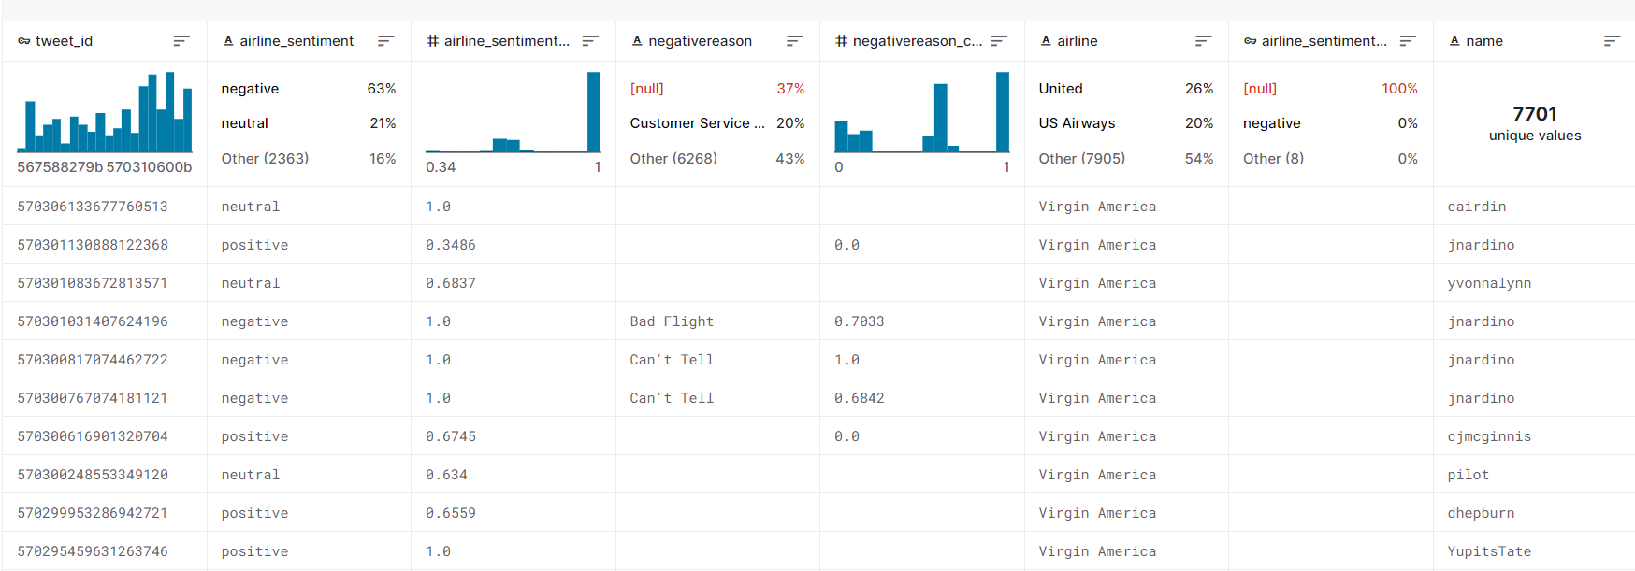

[14640 rows x 15 columns]

**Some tools and software commonly used in the process:**

**1.Programming Language**:

Python is the most popular language for machine learning due toits extensive libraries and frameworks , libraries likeNumPy,pandas, scikit-learn, and more.

**2. Integrated Development Environment (IDE):**

Choose an IDE for coding and running machine learning experiments. Some popular options include Jupyter Notebook, GoogleColab, or traditional IDEs like PyCharm.

**3. Machine Learning Libraries:**

You'll need various machine learning libraries, including: - scikit-learn for building and evaluating machine learning models. - TensorFlow or PyTorch for deep learning, if needed. - XGBoost, LightGBM, or CatBoost for gradient boosting models.

**4. Data Visualization Tools:**

Tools like Matplotlib, Seaborn, or Plotly are essential for data exploration and visualization.

**5. Data Preprocessing Tools:**

Libraries like pandas help with data cleaning, manipulation, and preprocessing.

**6. Version Control:**

Version control systems like Git are valuable for tracking changes in your code and collaborating with others.

**Design thinking**

**Empathize:**

* We conduct sentiment analysis to deeply understand the sentiments, needs, and challenges expressed by all stakeholders within the context of US airline experiences, including passengers, airline staff, and the general public.
* We collect data through sentiment analysis, surveys, and social media listening to uncover what passengers value in their airline experience and what aspects are most critical to their satisfaction.

**Define:**

* We clearly articulate the problem statement, such as "How can we enhance customer satisfaction and reputation management for US airlines using sentiment analysis?"
* We identify the key objectives, like improving customer satisfaction, addressing negative sentiment, and enhancing the overall brand image.

**Ideate:**

* We brainstorm innovative solutions and data sources to analyze and address the sentiments expressed towards US airlines.
* We encourage collaboration across disciplines to generate a wide range of ideas, including sentiment analysis tools, improved customer service strategies, and real-time response mechanisms.

**Prototype:**

* We develop prototype sentiment analysis models based on the ideas generated during the ideation phase.
* We test and refine these prototypes to identify the most effective approaches in improving sentiment analysis for US airlines.

**Test:**

* We gather feedback from Twitter users and stakeholders by testing the sentiment analysis models with real-time Twitter data.
* We assess how well the models meet the defined objectives and make adjustments based on user feedback.

**Implement:**

* We develop a production-ready sentiment analysis solution for US airlines, integrating the best-performing algorithms and data sources.
* We implement measures to ensure transparency in sentiment analysis results to build trust among users.

**Evaluate:**

* We continuously monitor the performance of the sentiment analysis model to ensure it remains accurate and relevant in the ever-changing landscape of Twitter discussions about US airlines.

**Iterate:**

* + We apply an iterative approach to refine the sentiment analysis model based on ongoing feedback and changing sentiment trends.
  + We continuously seek ways to enhance the accuracy and relevance of sentiment analysis.

**Scale and Deploy:**

* Once the sentiment analysis model has been optimized and validated, we deploy it to serve a broader audience, including US airline companies, travelers, and industry experts.
* We ensure that the model is accessible through user-friendly interfaces and can be integrated into real-time social media monitoring workflows.

**Educate and Train:**

* We provide training and educational resources to help users understand how the sentiment analysis model works, what factors it considers, and its limitations.
* We promote a culture of data literacy among stakeholders to enhance trust in the sentiment analysis technology.

**DESIGN INTO INNOVATION**

1. **Data Collection:**

Gather a comprehensive dataset that includes features such as location, size, age, amenities, nearby schools, crime rates, and other relevant variables.

1. **Data Preprocessing:**

Clean the data by handling missing values, outliers, and encoding categorical variables. Standardize or normalize numerical features as necessary.

1. **Feature Selection:**

Identifying and selecting the most impactful features influencing sentiment in our marketing context, such as keywords, product attributes, and customer feedback sentiment scores.

1. **Model Development:**

Constructing a robust sentiment analysis model using advanced machine learning techniques, customized for our marketing objectives to provide accurate sentiment predictions and explanations.

1. **Real-Time Sentiment Analysis:**

Implement real-time sentiment analysis within our marketing infrastructure for swift and informed decision-making in campaigns, feedback monitoring, and social media management.

**PYTHON PROGRAM:**

from PIL import Image

from sklearn import svm

from sklearn.feature_extraction.text import TfidfTransformer

from sklearn.feature_extraction.text import TfidfVectorizer

from sklearn.metrics import accuracy_score

from sklearn.metrics import roc_curve

from sklearn.naive_bayes import MultinomialNB

from sklearn.neighbors import KNeighborsClassifier

from wordcloud import WordCloud, STOPWORDS, ImageColorGenerator

import collections

import matplotlib as mpl

import matplotlib.pyplot as plt

import numpy as np

import operator

import pandas as pd

tweets = pd.read_csv('Tweets.csv')

tweets.head()

**#Output**

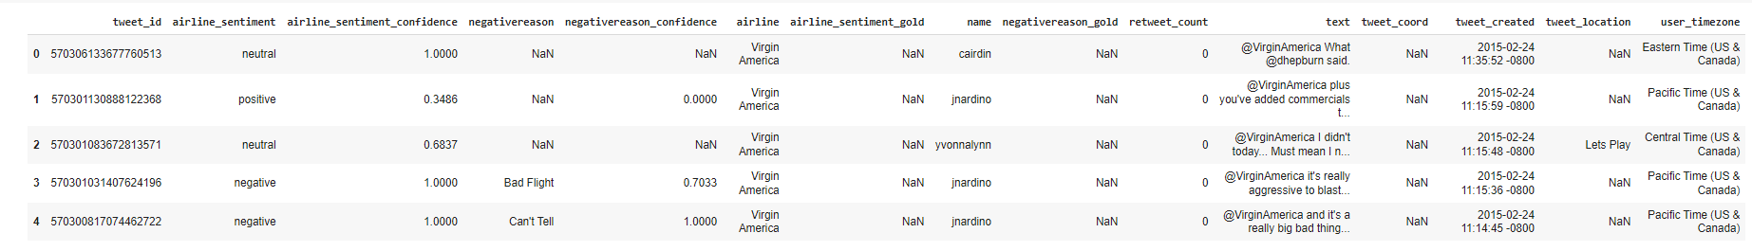

tweets['negativereason_gold'].value_counts()

**#Output**

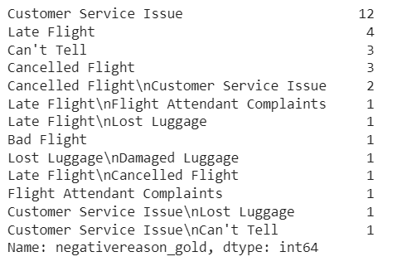

tweets['airline_sentiment_gold'].value_counts()

**#Output**

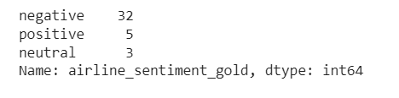

tweets['retweet_count'].value_counts()

**#Output**

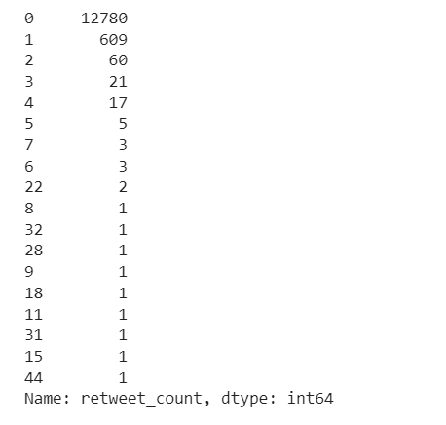

tweets.drop('negativereason_gold', axis=1, inplace=True)

tweets.drop('airline_sentiment_gold', axis=1, inplace=True)

tweets.drop('retweet_count', axis=1, inplace=True)

tweets.drop('tweet_coord', axis=1, inplace=True)

tweets.drop('tweet_location', axis=1, inplace=True)

tweets.drop('tweet_created', axis=1, inplace=True)

tweets.drop('user_timezone', axis=1, inplace=True)

tweets.drop('name', axis=1, inplace=True)

list(tweets.columns)

**#Output**

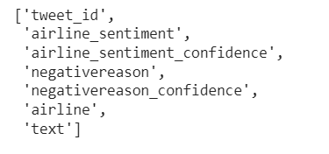

unmeaningful = ['i', 'you', 'me', 'to', 'the', 'a', 'my', 'is', 'in', 'and', 'for', 'on', 'of',

'your', 'so', 'was', 'have', 'it', 'at', 'with', 'that', 'from', 'do', 'get',

'but', 'this', 'can', 'just', 'they', 'we', 'are', 'an', 'be', "i'm", 'will',

'if', 'had', 'our', 'about', 'there', 'has', 'been', '-', 'by', 'like', 'or',

'as', 'he', 'she', 'it', 'us', 'has' ,"i've", "it's", "don't", 'would', 'am',

'flight', 'customer', 'any', 'very', "didn't", "you've", 'thing', 'take',

'other', 'u', '', ' ']

def clean_text(str_in):

res = ""

str_in = str_in.lower()

str_arr = str_in.split(' ')

for word in str_arr:

word = word.lower()

if '@' in word or word == '' or word[:1] == '&':

continue

if word.lower() in unmeaningful:

continue

if word.isnumeric():

continue

res = res + " " + word

return res

tweets["text"] = tweets["text"].apply(clean_text)

tweets.head(5)

**#Output**

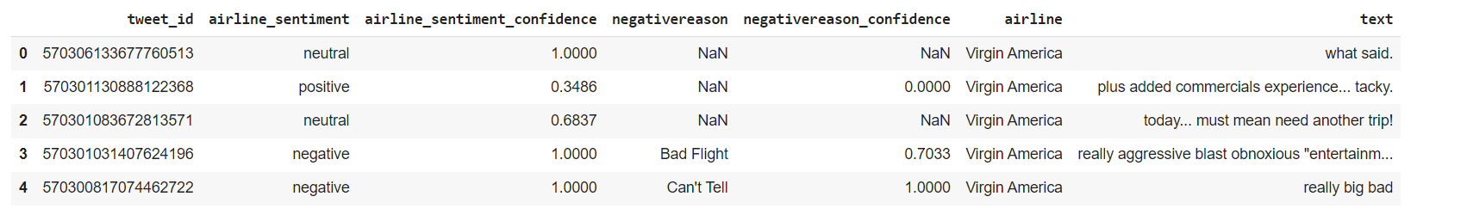

data = tweets

data['airline_sentiment'] = data['airline_sentiment'].astype('category')

X = data['text']

y = data['airline_sentiment']

X_train, X_test, y_train, y_test = train_test_split(X, y, test_size=0.2, random_state=42)

tokenizer = BertTokenizer.from_pretrained('bert-base-uncased')

X_train_encodings = tokenizer(list(X_train), padding=True, truncation=True, return_tensors='pt', max_length=128)

X_test_encodings = tokenizer(list(X_test), padding=True, truncation=True, return_tensors='pt', max_length=128)

y_train_encodings = torch.tensor(y_train.cat.codes.values)

y_test_encodings = torch.tensor(y_test.cat.codes.values)

class SentimentDataset(Dataset):

def __init__(self, encodings, labels):

self.encodings = encodings

self.labels = labels

def __getitem__(self, idx):

item = {key: val[idx] for key, val in self.encodings.items()}

item['labels'] = self.labels[idx]

return item

def __len__(self):

return len(self.labels)

train_dataset = SentimentDataset(X_train_encodings, y_train_encodings)

test_dataset = SentimentDataset(X_test_encodings, y_test_encodings)

model = BertForSequenceClassification.from_pretrained('bert-base-uncased', num_labels=3)

optimizer = AdamW(model.parameters(), lr=1e-5)

**#Output**



device = torch.device('cuda' if torch.cuda.is_available() else 'cpu')

model.to(device)

train_loader = DataLoader(train_dataset, batch_size=32, shuffle=True)

model.train()

**#Output**

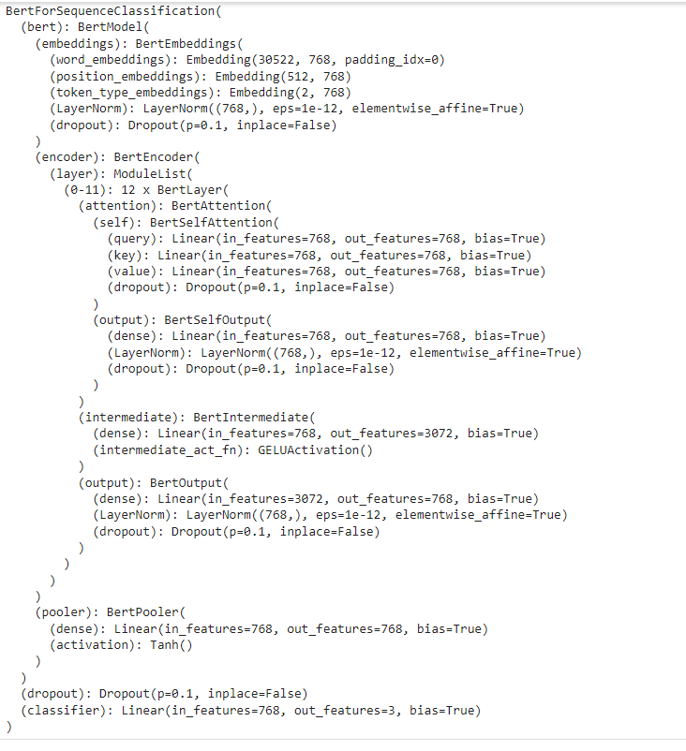

model.eval()

test_loader = DataLoader(test_dataset, batch_size=64)

predictions = []

for batch in test_loader:

input_ids = batch['input_ids'].to(device)

attention_mask = batch['attention_mask'].to(device)

with torch.no_grad():

outputs = model(input_ids, attention_mask=attention_mask)

logits = outputs.logits

predicted_labels = F.softmax(logits, dim=1).argmax(dim=1)

predictions.extend(predicted_labels.cpu().numpy())

accuracy = accuracy_score(y_test_encodings, predictions)

print("Accuracy:", accuracy)

print(classification_report(y_test_encodings, predictions))

**#Output**

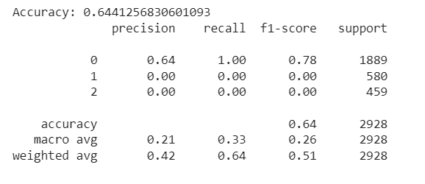

sentiment_counts = data['airline_sentiment'].value_counts()

plt.figure(figsize=(8, 5))

plt.bar(sentiment_counts.index, sentiment_counts.values, color=['red', 'green', 'blue'])

plt.title('Sentiment Distribution')

plt.xlabel('Sentiment')

plt.ylabel('Count')

plt.show()

**#Output**

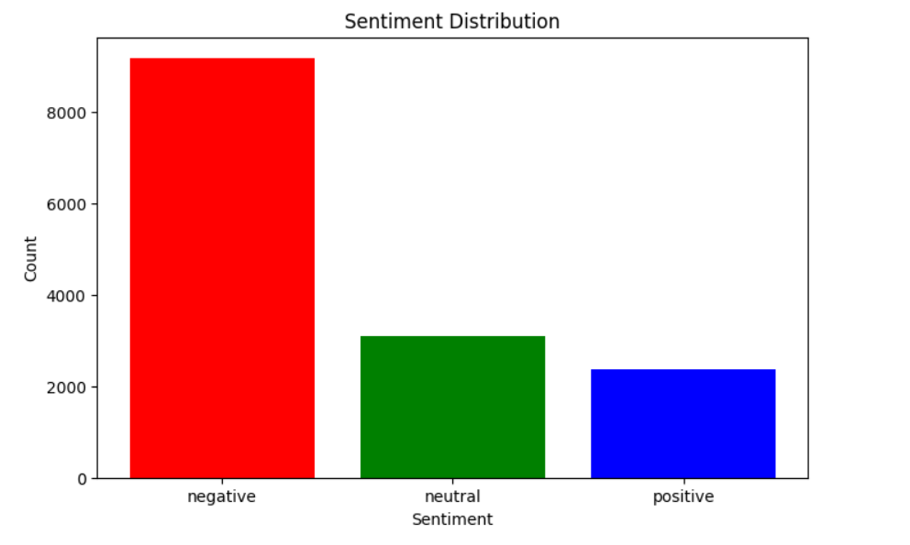

**Feature Selection:**

Identify the most relevant features that influence sentiment in our marketing context, including specific keywords, customer demographics, the timing of our campaigns, and the attributes of our products.

**Interpretability:**

Ensure that our sentiment analysis model offers clear insights into how these features impact sentiment. This empowers our marketing teams to comprehend and interpret the influence of each factor on sentiment predictions, enabling informed decision-making.

**Ethical Considerations:**

Vigilantly ensure that our sentiment analysis model upholds ethical standards, refraining from introducing or perpetuating biases in our marketing decisions. Implement fairness and transparency measures to prevent any form of discrimination and conduct regular audits to identify and rectify potential ethical concerns.

**Innovation:**

Champion innovation in our approach to sentiment analysis. Consider incorporating additional data sources, such as social trends, competitor performance, and market data, to enhance the accuracy of our sentiment predictions. Stay at the forefront of developments in Natural Language Processing (NLP) and sentiment analysis techniques to continually boost our model's performance and relevance in the dynamic marketing landscape

**ADVANTAGES:**

* + **Accuracy**:

Machine learning can also provide highly accurate sentiment analysis by examining diverse data sources and subtle nuances in customer sentiment. This accuracy leads to more reliable insights for marketing decisions.

* + **Complex Data Handling:**

Machine learning's ability to handle complex, non-linear relationships is invaluable in deciphering intricate language expressions and contextual subtleties in sentiment analysis. It uncovers hidden patterns and interactions among various factors affecting customer sentiment.

* + **Continuous Learning:**

In the realm of marketing, continuous learning ensures that sentiment analysis models stay current with shifting consumer behavior and market trends, allowing businesses to adapt their strategies in response to evolving sentiment.

* + **Efficiency:**

Efficient sentiment analysis is pivotal for comprehending how marketing campaigns are received, enabling marketing teams to make real-time adjustments for improved results.

* + **Data Integration:**

Much like integrating a wide array of data sources is beneficial for comprehensive property assessment, it also applies to marketing. Integrating diverse data sources equips marketers with a more comprehensive understanding of customer sentiment and its influencing factors.

* + **Reduced Bias:**

Machine learning can mitigate human bias in both property valuation and sentiment analysis. In marketing, this results in more objective, data-driven decisions that resonate effectively with the target audience.

* + **Market Insights:**

Just as machine learning provides insights into market trends, it's equally adept at offering valuable insights into customer behavior and market trends. This information empowers businesses to make well-informed marketing decisions.

* + **Transparency:**

Transparent explanations for predictions are essential in both property valuation and marketing to foster trust among stakeholders. Clear explanations aid in understanding the rationale behind specific marketing decisions based on sentiment analysis.

* + **Scalability:**

Scalability is advantageous not only for assessing property values in large portfolios but also in marketing, where scaling sentiment analysis across a wide customer base is beneficial for decision-making.

* + **Time and Cost Savings:**

Time and cost savings are highly relevant to marketing as well. Automated sentiment analysis can save significant time and resources compared to manual analysis of customer feedback and market trends.

* + **Customization:**

Customization allows machine learning models to cater to specific markets and customer segments, just as they can be tailored to specific types of properties in the real estate context. Top of Form

**Disadvantages:**

* **Data Quality:**
  + Just as in property valuation, data quality is paramount in sentiment analysis. Noisy or biased data can lead to incorrect insights.
* **Subjectivity:**
  + Sentiment analysis models may struggle with highly subjective or ambiguous language, such as sarcasm, irony, or nuanced expressions.
* **Contextual Understanding:**
  + Understanding context is challenging for machines, and sentiment analysis may sometimes misinterpret the sentiment of a statement without considering the context.
* **Cultural and Language Variations:**
  + Sentiment analysis models may perform differently in different languages and cultures, requiring adaptation and fine-tuning.
* **Data Volume and Variety:**
  + Gathering and managing diverse data sources, including social media, reviews, and customer feedback, can be complex and resource-intensive.
* **Model Overfitting:**
  + Overfitting can occur when models are too finely tuned to training data, leading to poor generalization to new data.
* **Scalability:**
  + As the volume of data grows, scaling sentiment analysis to handle large datasets can be computationally demanding and require significant infrastructure.
* **Human Validation:**
* In some cases, human validation and expert review are necessary to ensure the accuracy and relevance of sentiment analysis results.

**CONCLUSION:**

Predicting customer sentiment in marketing using machine learning is a transformative and promising approach that has the potential to revolutionize the way businesses engage with their audience. Throughout this exploration, we have uncovered the remarkable capabilities of machine learning in providing more accurate, data-driven, and nuanced insights into customer sentiments. As we conclude, several key takeaways and implications emerge:

**Improved Decision-Making**:

Machine learning models consider a multitude of factors, including various data sources, to offer more accurate and comprehensive sentiment analysis. This empowers businesses to make informed decisions, create targeted marketing strategies, and respond to customer feedback effectively.

**Data-Driven Insights:**

These models provide valuable insights into customer behavior, market trends, and factors influencing sentiment. This information is invaluable for marketers, enabling them to tailor their campaigns, enhance customer satisfaction, and adapt to changing market conditions.

**Efficient Marketing**:

Increased accuracy in sentiment analysis leads to more efficient marketing strategies, with content that resonates with the target audience. This contributes to higher engagement, conversion rates, and overall marketing efficiency.

**Challenges and Considerations**:

Sentiment analysis using machine learning is not without its challenges. Data quality, model interpretability, and ethical considerations are vital factors for responsible deployment. Addressing these issues is essential for ethical and transparent marketing practices.

**Continual Advancement:**

The field of machine learning is continually evolving, and as it does, the accuracy and capabilities of sentiment analysis models will continue to improve. With access to more data and enhanced algorithms, we can expect even more sophisticated insights in the future.

In conclusion, the application of machine learning in predicting sentiment analysis for marketing is a groundbreaking development with significant implications. It empowers businesses to better understand and engage with their customers, create more effective marketing strategies, and enhance the customer experience. However, it is crucial to approach this technology with a clear understanding of its potential and limitations, ensuring that its benefits are harnessed responsibly for the betterment of the marketing industry and customer relationships as a whole. As machine learning continues to advance, we can look forward to a future where marketing becomes increasingly data-informed and customer-centric.