LAB 8.1 : Install Kubernetes, Pod Configuration, and Joining another Linux node to cluster

This section will show you how to:

This lab has 4 subsections:

8.1.1 Install Docker

8.1.2 Install kubernetes

8.1.3 Initialize kubernetes

8.1.4 Configure pod network

8.1.5 Add a Linux node to the kubernetes cluster

**Step 8.1.1** Install Docker.

Run the command below in the terminal to ensure that the apt-get package is updated successfully.

sudo apt-get update

Allow HTTP access to apt-get package repositories and sources by running the command mentioned below:

sudo apt-get install apt-transport-https -y

Run the commands mentioned below to install Docker. (Run the command even if you have installed docker while performing demos of previous lessons)

sudo apt-get install docker.io -y

sudo apt-get install -y curl apt-transport-https docker.io

Enable Docker service to start on system boot and execute the commands mentioned below:

sudo systemctl start docker

sudo systemctl enable docker

**Step 8.1.2** Install kubernetes.

To download and add the key to allow kubernetes installation, execute the commands mentioned below:

sudo su

curl -s <https://packages.cloud.google.com/apt/doc/apt-key.gpg> | apt-key add -

sudo echo deb <http://apt.kubernetes.io/> kubernetes-xenial main > /etc/apt/sources.list.d/kubernetes.list

Update the apt-get package by executing the command mentioned below:

sudo apt-get update

Install the kubernetes and the tools required to manage it. Run the command mentioned below in the terminal.

sudo apt-get install -y kubelet kubeadm kubectl

**Step 8.1.3** Initialize kubernetes.

Update the apt-get package by executing the command mentioned below:

sudo apt-get update

Run the command mentioned below to initialize kubernetes cluster to run it as master.

sudo kubeadm init

After execution, you must receive the output mentioned in the screenshot.

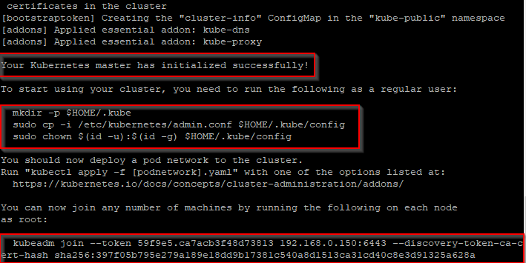

To complete the setup, execute the commands below:

mkdir -p $HOME/.kube

sudo cp -i /etc/kubernetes/admin.conf $HOME/.kube/config

sudo chown $(id -u):$(id -g) $HOME/.kube/config

**Step 8.1.4** Configure pod network

Apply network configurations to kubernetes cluster. It allows pod-to-pod communication, and it is a dependency for kube-dns. Execute the commands mentioned below in your terminal:

sudo kubectl apply -f <https://raw.githubusercontent.com/coreos/flannel/master/Documentation/kube-flannel.yml>

sudo kubectl apply -f <https://raw.githubusercontent.com/coreos/flannel/master/Documentation/k8s-manifests/kube-flannel-rbac.yml>

Execute the command mentioned below to check the result of all pods.

sudo kubectl get pods --all-namespaces

You should ensure that all the pods are running successfully as shown in the screenshot:

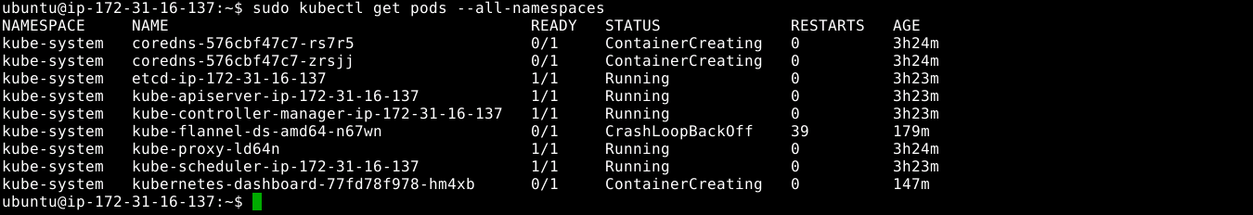

**8.1.5** Add a Linux node to the kubernetes cluster.

Execute the command mentioned below to add a node to the existing cluster.

sudo kubectl apply -f <https://raw.githubusercontent.com/kubernetes/dashboard/v2.0.0-beta1/aio/deploy/recommended.yaml>

Execute the command mentioned below to check the result of all pods.

sudo kubectl get pods --all-namespaces