**Project Title: Deployment of WordPress Application on Kubernetes**

**Note: This is a solution document on how to deploy a WordPress application on Kubernetes using Jenkins.**

Run the command below in your terminal:

sudosystemctl restart Jenkins

Open your browser and go to the URL https://localhost:8080

Click on New Item→ Enter the name “KuberenetesDeploy”→ Select “Freestyle Project”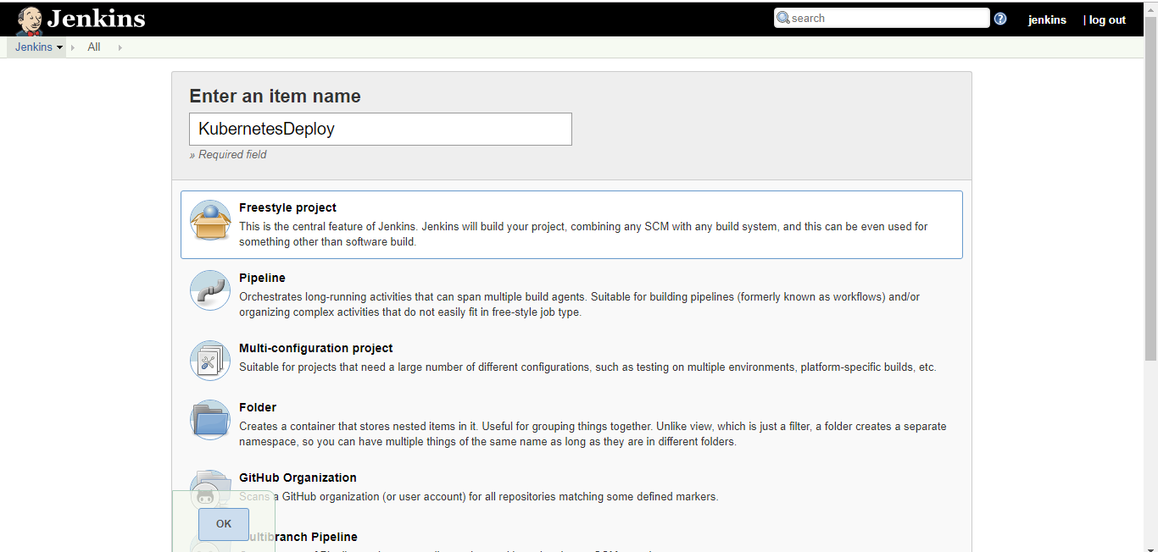

Fork the Git repository from the URL:<https://github.com/Simplilearn-Edu/DevOps-WordPress-Kubernetes-Deployment>.

Once job is created, please provide your Git Repository and Build details in Jenkins CI/CD job as shown in the example below:

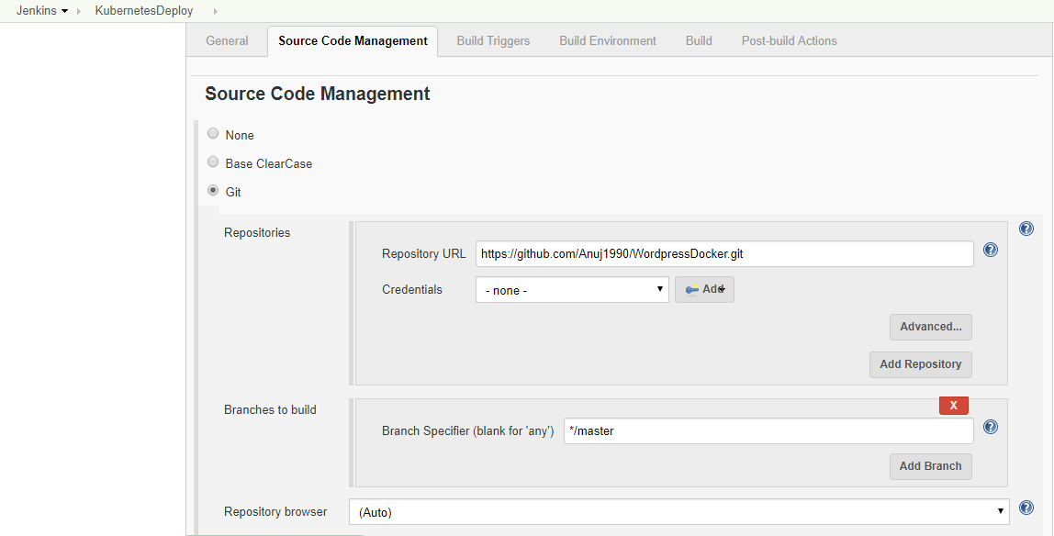

Delete the “config” file available in your Ubuntu instance.

sudo rm /.kube/config

Rerun again to create another file to avoid errors.

sudo cp -i /etc/kubernetes/admin.conf $HOME/.kube/config

sudochown $(id -u):$(id -g) $HOME/.kube/config

Run the following commands:

export kubever=$(kubectl version |base64| tr -d ‘\n’)

kubectl apply -f "<https://cloud.weave.works/k8s/net?k8s-version=$kubever>"

Check if the master node is running. Replace <Name> with your node name.

kubectl get nodes

kubectl describe nodes <Name>

Go to Jenkins page, configure and add Kubernetes to Jenkins.

Manage Jenkins→ Manage Plugins→ Available. Enter the packages mentioned below:

* Kubernetes::Pipeline::Kubernetes Steps
* Kubernetes credentials
* Kubernetes Cli
* Kubernetes
* ElasticBox Jenkins Kubernetes CI/CD

And select 

Add Kubernetes to the Jenkins system:

Manage Jenkins → Configure System

Scroll down and click on **Add a new cloud**

Add name as **kubernetes**

Add URL as **https://192.168.99.100:8443**

Host Docker image to Kubernetes using the command mentioned below:

docker build –t wordpress .

kubectl run wordpress --image=wordpress:latest --port=80 --image-pull-policy=Never

kubectl expose deployment/ wordpress --port=80 --target-port=80 --type=NodePort

kubectl describe services wordpress | grep -i port

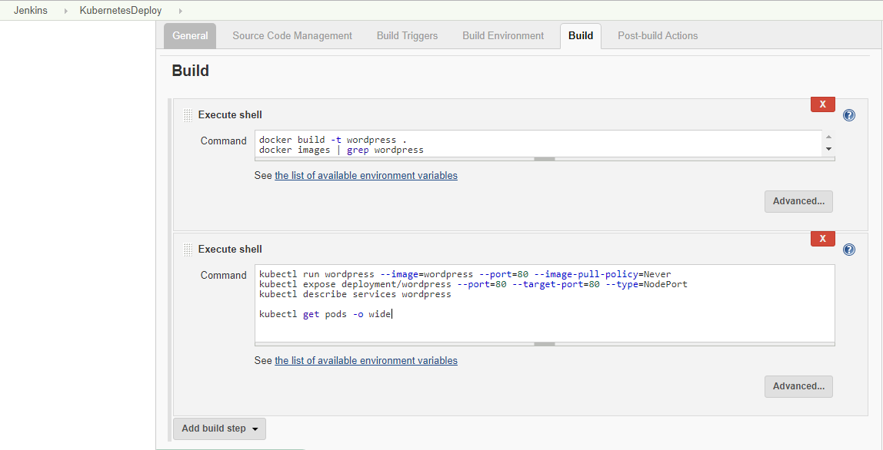

Once job details are mentioned, please run the job using **Build Now** option as shown below:

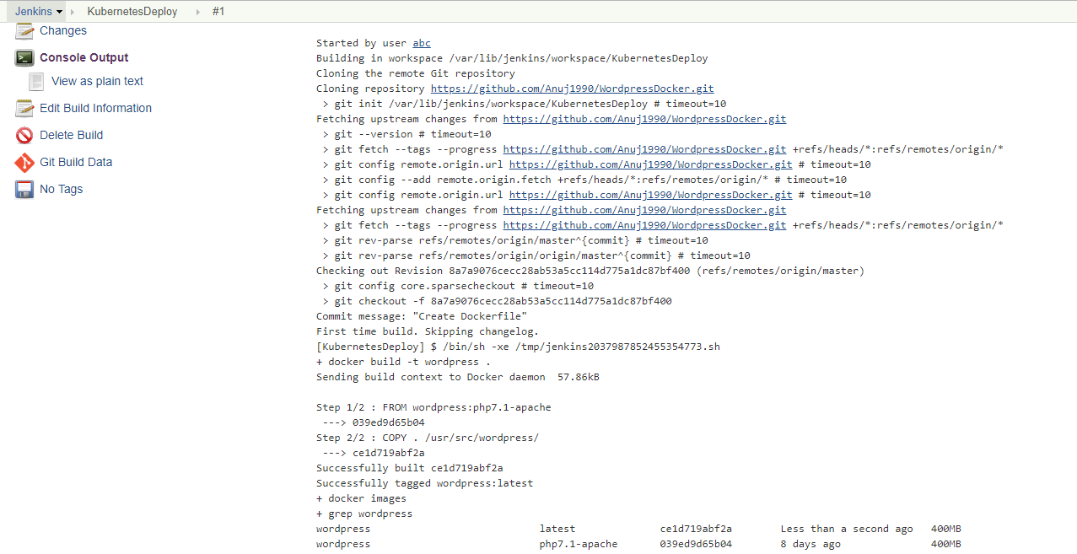

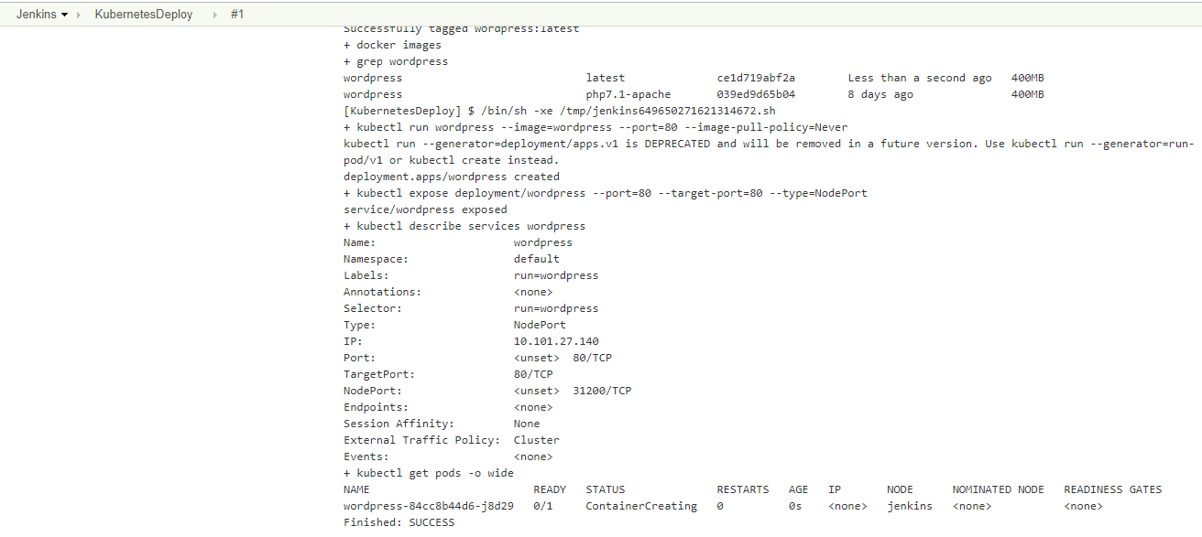

Once application is successfully rolled out, you can access it using web browser at **35.196.88.164:31200/wp-admin/setup-config.php**.

