Lab 4.1 TDD with JUnit 5

This section will guide you to:

* Use Java and eclipse throughout the demonstration.
* Download the eclipse from the official site.
* Use JUnit to demonstrate test-driven development.

**Note:** You do not have to install Java and Eclipse. It is already installed in your labs, and you can check the Java version from the terminal by executing “**java -version**”.

**Step 4.1.1:** Clone the repository from Git.

Execute the following command from the terminal. Create a new directory named “**DevOps-Lesson-04**” and clone the repository from Git.

mkdir devops-lesson-04

git clone <https://github.com/SimplilearnDevOpsOfficial/Lesson-04-JUnitTDD.git>

Check the path where you have created the folder and downloaded the source codes using **pwd from** the terminal.

**Step**  Import the project in eclipse.

Click on eclipse and select the workspace where you would like to place your work. Click on **File** → **Open Projects from File System…** → navigate to the folder “**Lesson-04-JUnitTDD**” you just downloaded from git.

**Step 4.1.3:** Manipulation of codes.

You may find JUnit 4 already available with your project. You need to remove JUnit 4 from the build path. Right-click on **JUnit 4** and select **Build Path** -> **Remove from Build Path** as shown below:

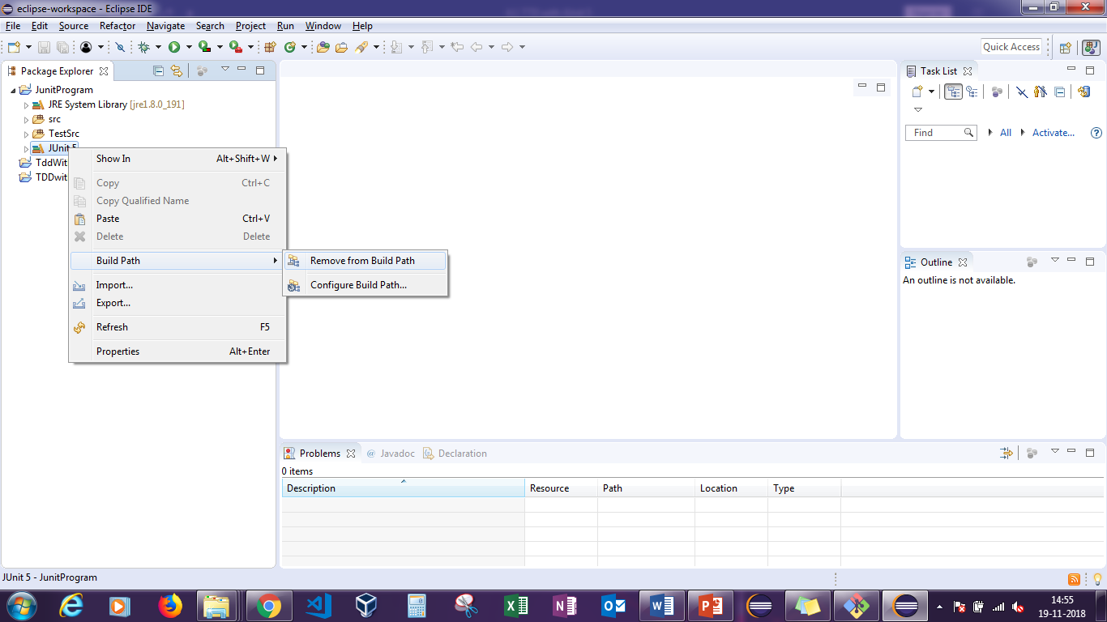

Navigate to **TestSrc** -> **com.tddjunit.java** ->**MathsTest.java,** and copy the entire code, and paste it in any document temporarily and delete the **com.tdd.junit.java package**.

**Note:** The required Java code for development is already written, and you will find the source codes in the **src** folder. Do not change the codes available in the **src**.

Now, navigate to the **src** directory and right-click on **Maths.java**. Select **New->Junit Test Case.**

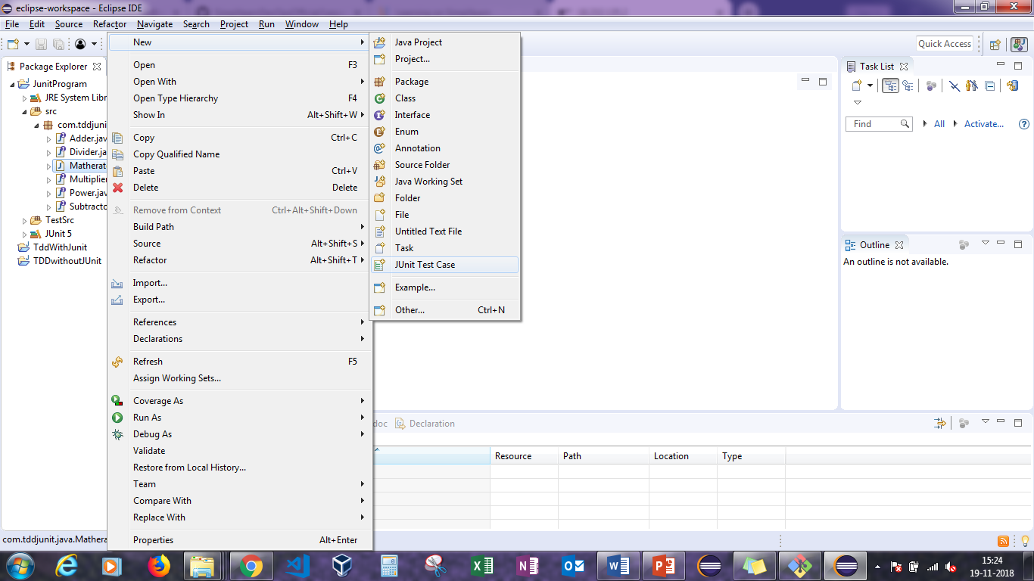

Click on **Browse** to change the directory from **src** to **TestSrc** and click on **Finish**.

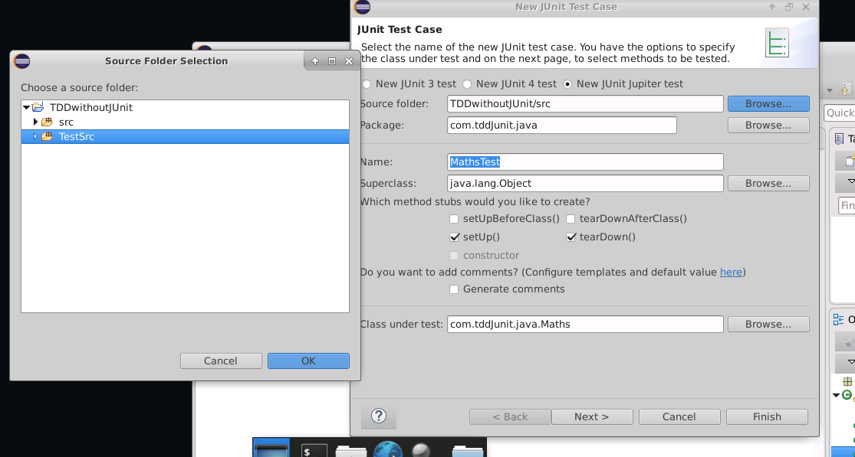

It will generate a test file in the **TestSrc** directory and JUnit 5 libraries in the project. Do not change any files in the JUnit 5 libraries.

Run the **MathsTest.java** file, and confirm that the test cases will fail. Now, replace the existing code with the codes saved in the temporary file(**MathsTest.java** file), and perform the following changes:

* Comment out – Comments 1, 2, 4, and 6.
* Delete comments – Comments 3 and 5.

Rerun the test cases, and confirm that the test cases will pass without any errors or warnings. 