First we will be creating the VM instance o ubuntu in GCP

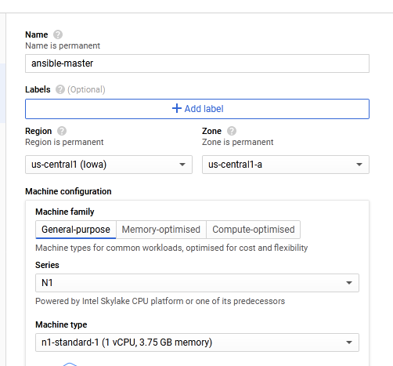

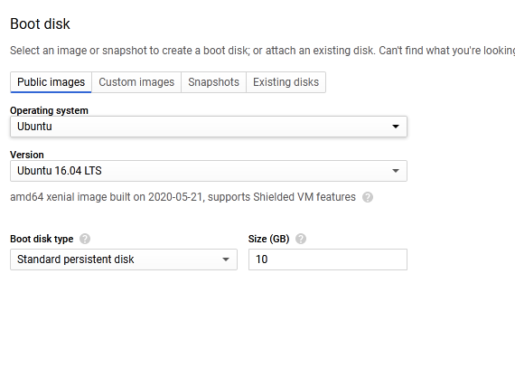

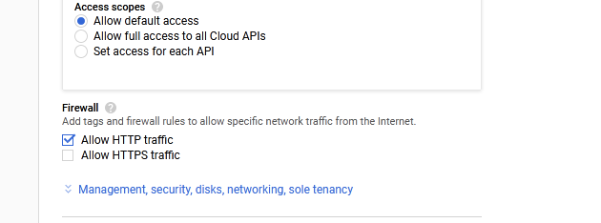

Now we will be installing ansible on that ubuntu instance.

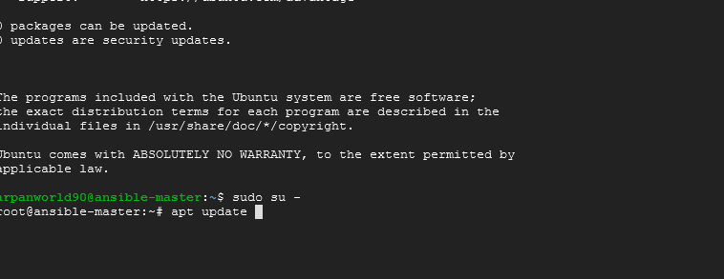

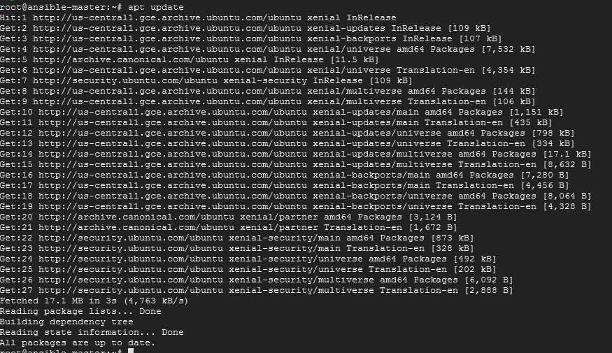

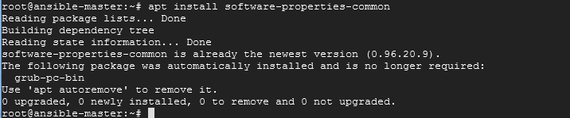

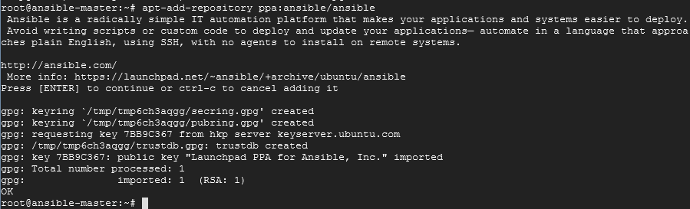

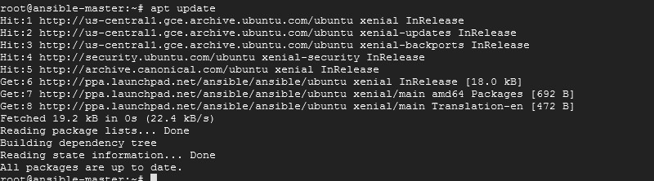

Then execute apt install ansible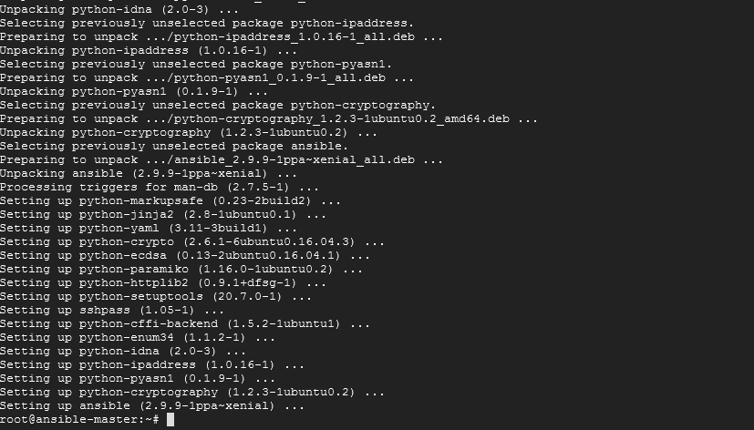

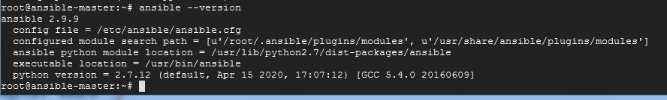

Establish SSH key pair in linux system to have SSH connectivity with localhost using following commands:

ssh-keygen -t rsa

cat .ssh/id_rsa.pub >> .ssh/authorized_keys

ssh localhost “date”

Ansible for Weekly system reboots.

First we will write some preboot tasks

Here we are installing vsftpd package in ubuntu as follows

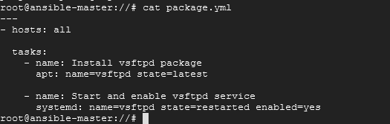

Now we will check or the syntax errors as follows

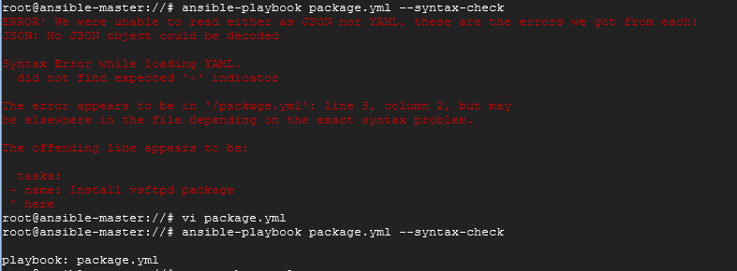

Once the error is removed

We could see the result as above

Now we will check whether the package for vsttpd is already installed or not,I not installed then we will install it thru ansible playbook.

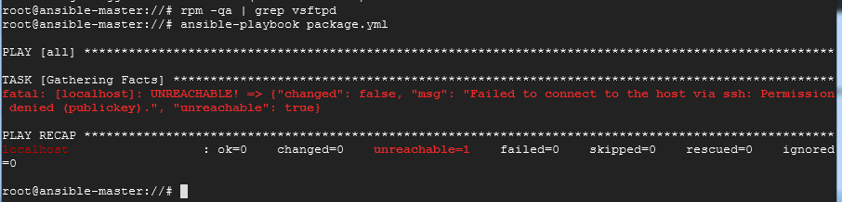

We were unable to connect to local host hence we faced the error,resolved it by following ways.

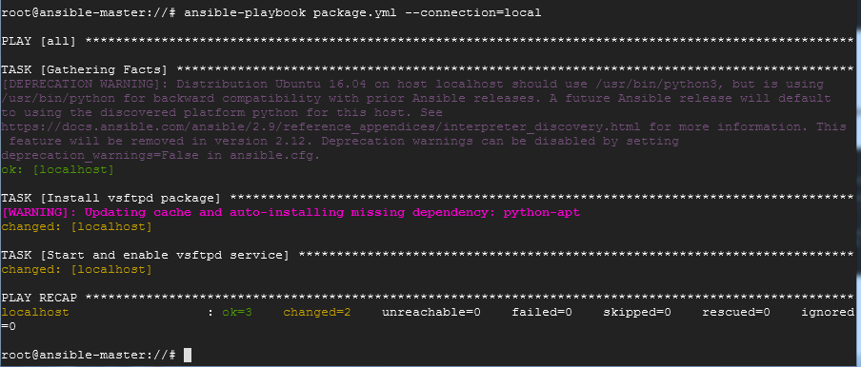

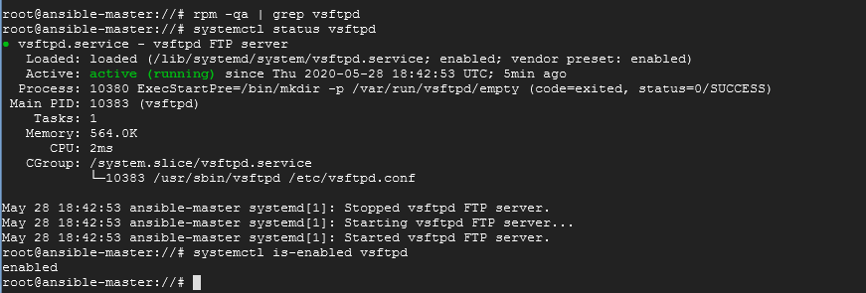

We could see that vsftpd service is enabled ,inthis way we can perform the preboot tasks like installation or upgradation etc

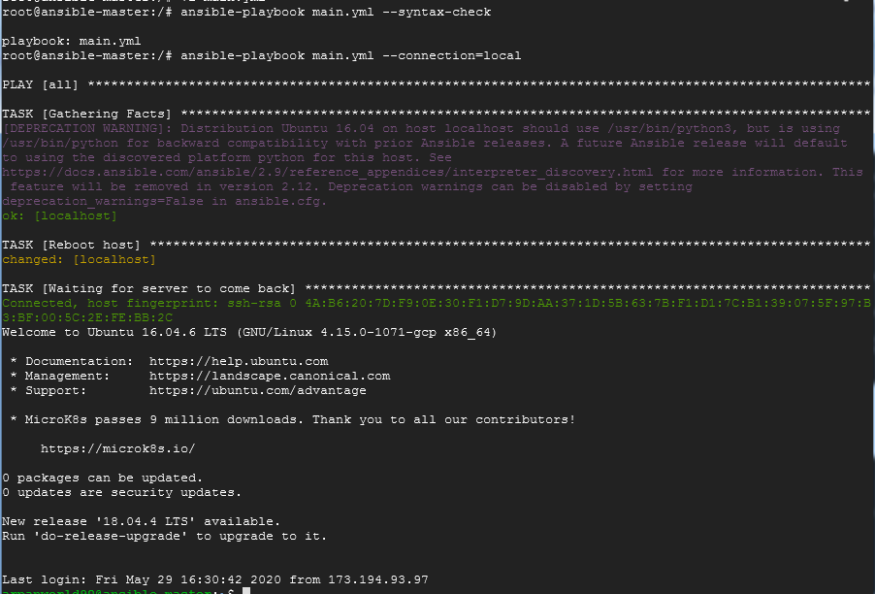

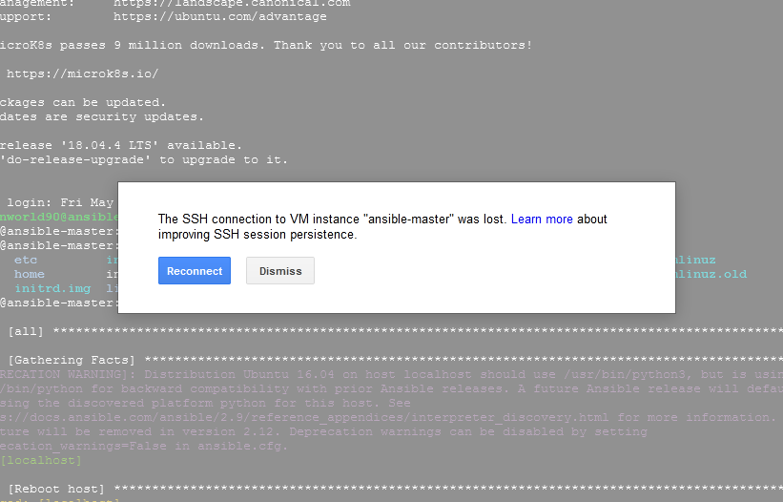

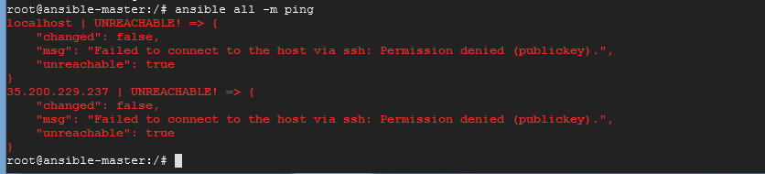

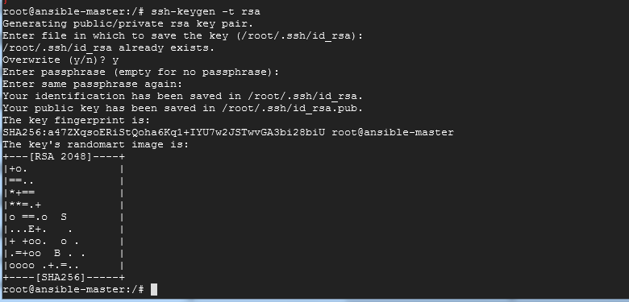

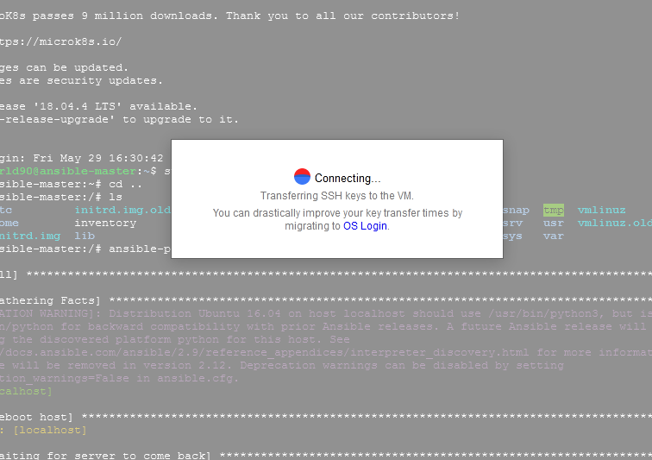

Security guidelines for server in ansible

Now we will be creating user accounts and set passowords

We can generate the encrypted password using openssl for a user



We will create group as follows

We could see the groups added in /etc/group

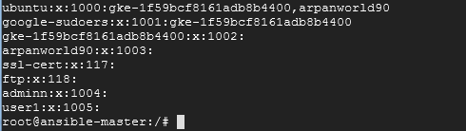

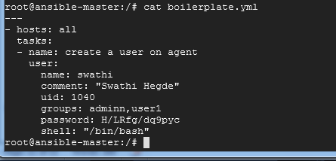



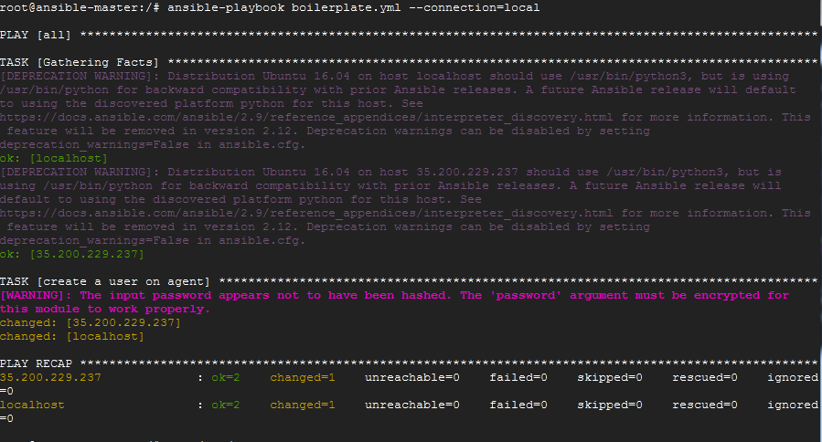

Now we could see the new user created

Cat /etc/passwd



Cat /etc/group



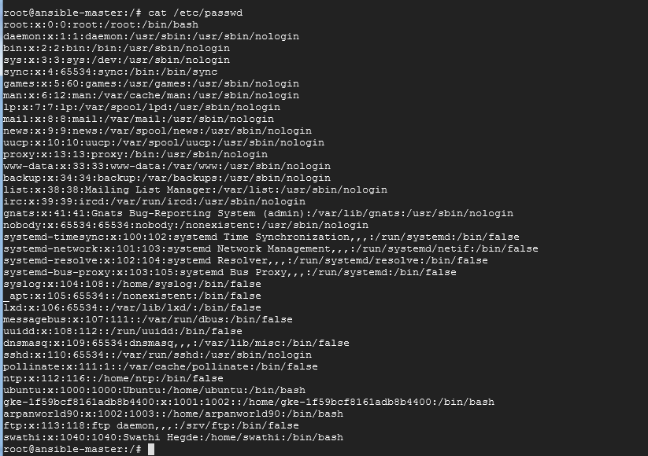

Also in /etc/group we could see the user added

Cat /etc/group





