**Front-End UI/UX Mini Project**

**Recipe Book**

**1. Title Page**

* **Project Title**: *e.g., "Recipe Book"*
* **Submitted By**: 
  + *Swathi P, S M Tejashree Kashyap*
  + *2460478, 2460440*
  + [*swathi.p@btech.christuniversity.in*](mailto:swathi.p@btech.christuniversity.in) *,* [*sm.tejashree@btech.christuniversity.in*](mailto:sm.tejashree@btech.christuniversity.in)
* **Course**: *UI/UX Design Fundamentals*
* **Instructor Name**: *Dhiraj alate*
* **Institution**: *Christ University*
* **Date of Submission**: *26/09/2025*

**2. Abstract**

*This project focuses on developing an interactive and responsive* ***Recipe Book Website*** *where users can explore, filter, and view recipes. The website highlights user-friendly navigation with visually appealing recipe cards, a search and filter system, and a detailed recipe view. By leveraging* ***HTML, CSS, Bootstrap, JavaScript, and jQuery****, the project showcases modern UI/UX principles while maintaining simplicity and accessibility. The responsive design ensures seamless browsing on desktop, tablet, and mobile devices.*

**3. Objectives**

* *Display recipes in a card-based layout with images and short descriptions.*
* *Implement search and filter functionality for categories, cuisines, and difficulty levels.*
* *Provide a detailed recipe view with ingredients and preparation steps.*
* *Use Bootstrap for responsive design and UI components.*
* *Enhance interactivity with JavaScript/jQuery.*

**4. Scope of the Project**

* *Front-end project only; no backend database integration.*
* *Features recipe listing, search & filter options, and detailed recipe view.*
* *Responsive and mobile-friendly using Bootstrap Grid System.*
* *Focus on intuitive navigation and clean UI.*

**5. Tools & Technologies Used**

|  |  |
| --- | --- |
| Tool/Technology | Purpose |
| HTML5 | Markup and content structure |
| CSS3 | Styling and layout management |
| Bootstrap | Responsive design and UI components |
| JavaScript | Logic and interactivity |
| jQuery | Simplified DOM manipulation and event handling |
| VS Code | Code editor |
| Chrome DevTools | Testing and debugging |

**6. HTML Structure Overview**

* *Semantic tags: <header>, <main>, <section>, <footer>.*
* *Recipe cards inside <section class="recipes">.*
* *Navigation bar created using Bootstrap <nav>.*
* *Separate recipe details page linked from each recipe card.*

**7. CSS Styling Strategy**

* *External stylesheet with organized comments.*
* *Flexbox/Grid for responsive pet cards.*
* *Pastel color palette with rounded corners.*
* *CSS variables for color themes.*
* *Checkbox hack for filtering without JavaScript.*

**8. Key Features**

|  |  |
| --- | --- |
| Feature | Description |
| Recipe Listing | Card-based layout with images, titles, and short descriptions. |
| Search & Filter | Search bar + filter options (cuisine, difficulty, dietary preference). |
| Detailed Recipe Page | Ingredients, preparation steps, and cooking time. |
| Responsive Design | Optimized for desktop, tablet, and mobile via Bootstrap. |
| Interactive UI | JavaScript/jQuery for filtering and dynamic display. |

**9. Challenges Faced & Solutions**

|  |  |
| --- | --- |
| Challenge | Solution |
| Handling multiple filter criteria | Used jQuery to dynamically hide/show recipes. |
| Maintaining responsive layout | Bootstrap grid system and media queries. |
| Aligning recipe card content | Used Flexbox utilities from Bootstrap |

**10. Outcome**

*Developed a fully responsive and interactive* ***Recipe Book Website*** *that allows users to browse and filter recipes easily. The project demonstrates strong skills in* ***UI/UX design, Bootstrap-based responsiveness, and JavaScript interactivity***

**11. Future Enhancements**

* *Connect to a backend/database for real-time recipe updates.*
* *Add a* ***“Favorites” feature*** *with local storage.*
* *Implement user-generated recipe submissions.*
* *Include nutritional information and cooking videos.*

**12. Sample Code**

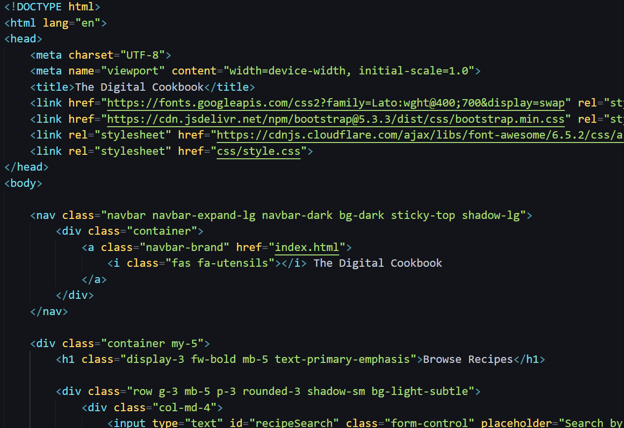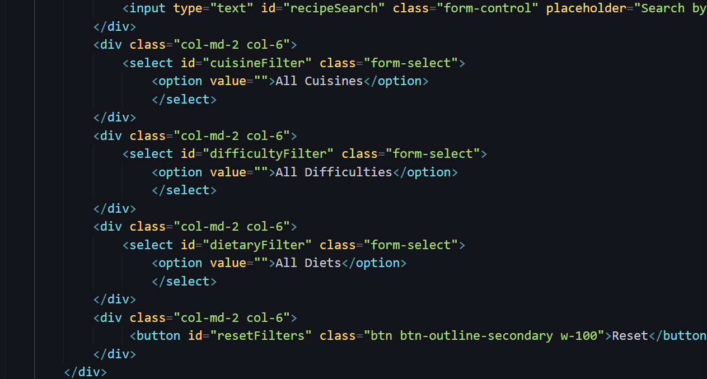

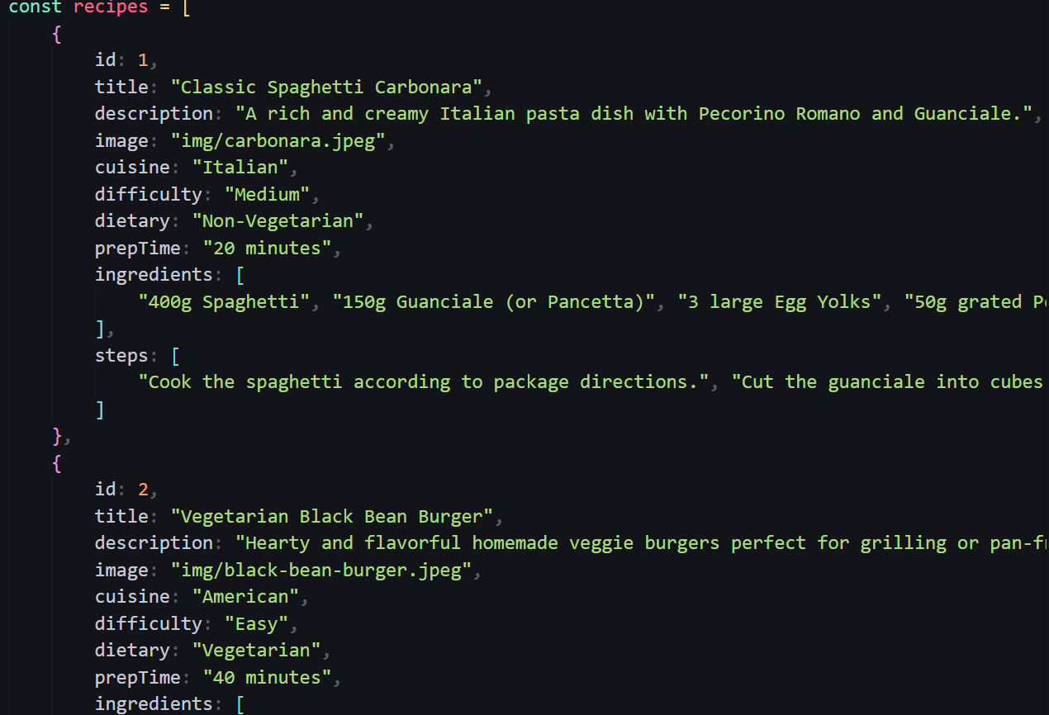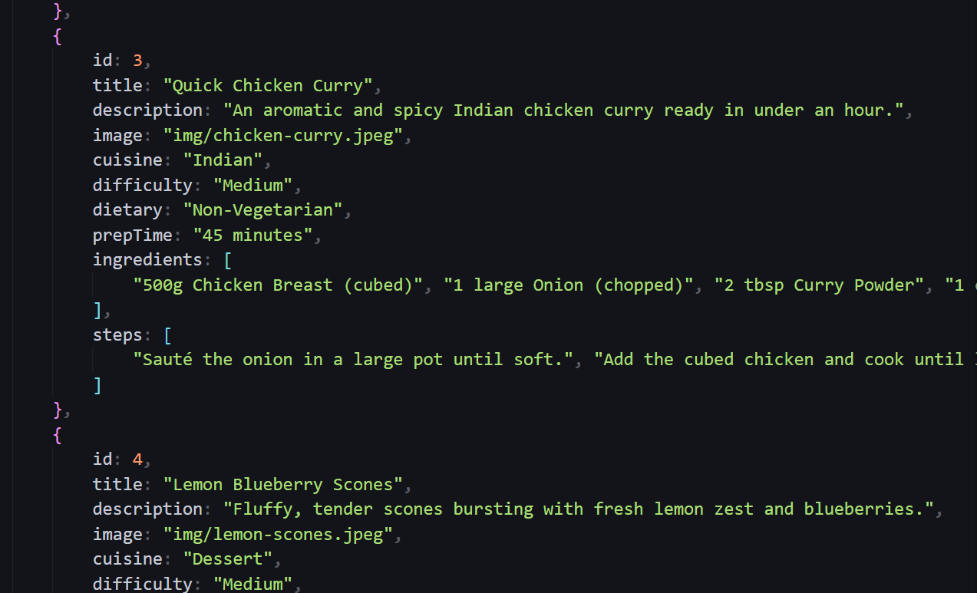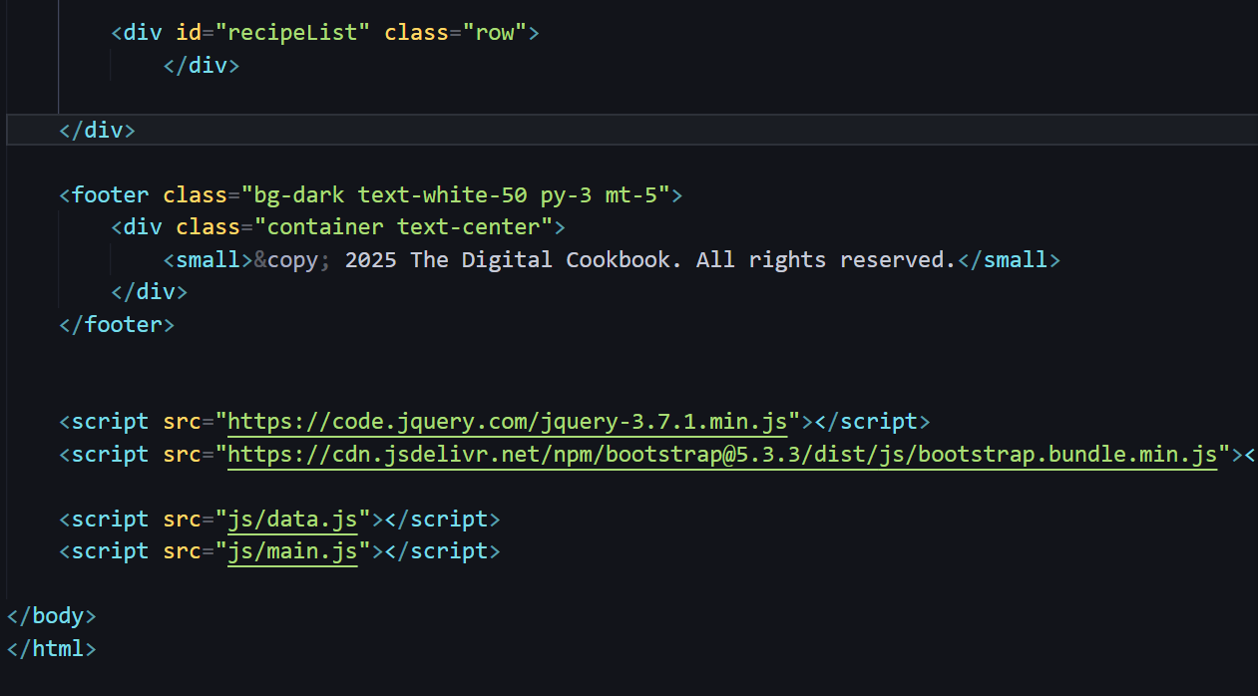

**13. Screenshots of Final Output**

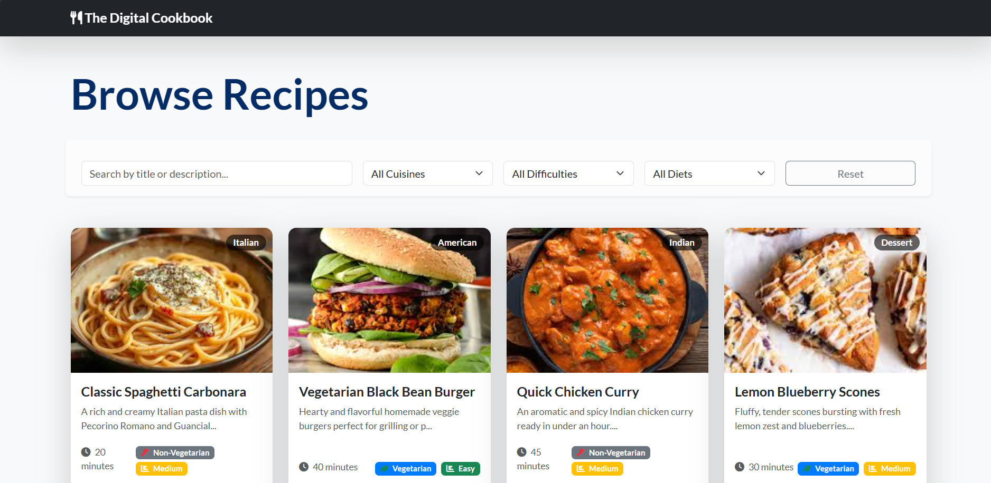

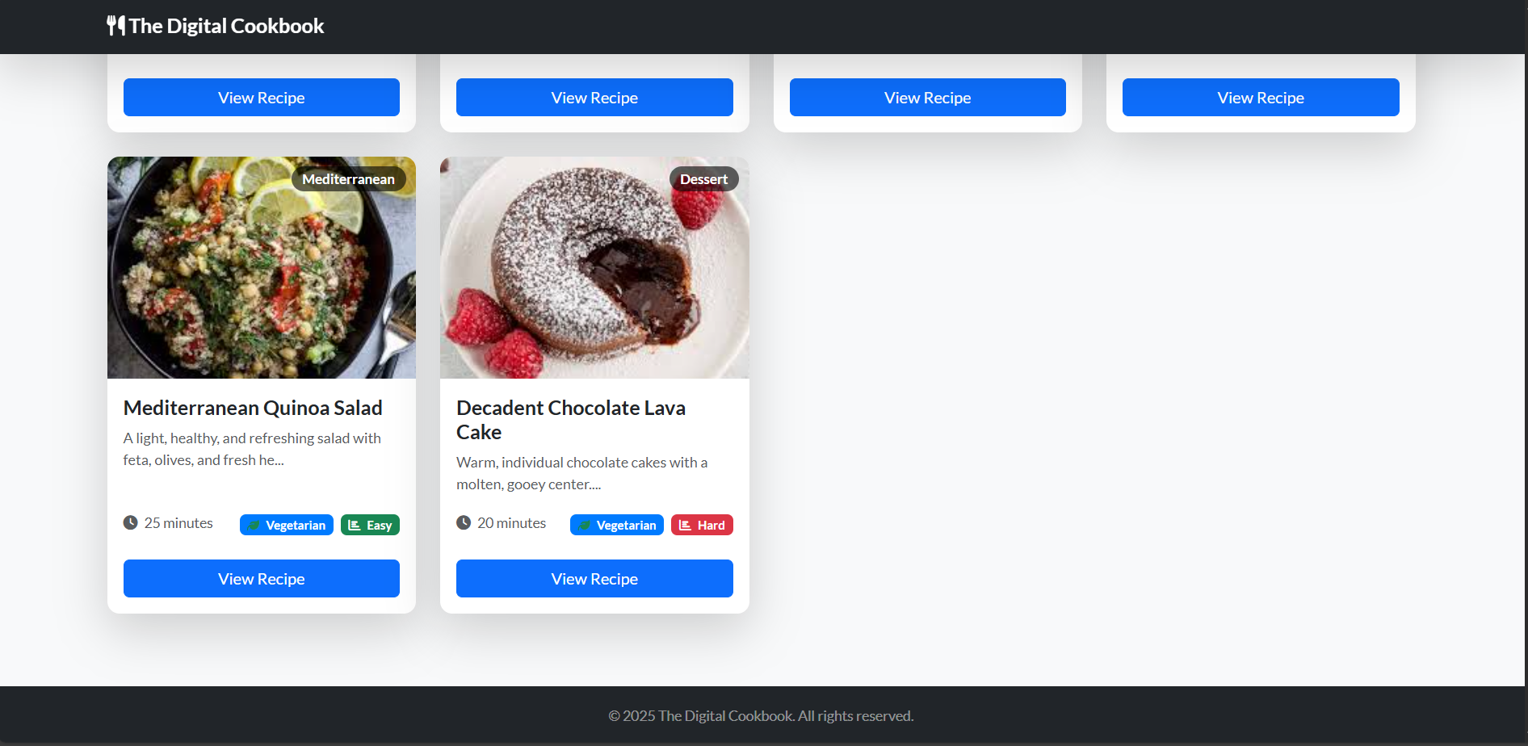

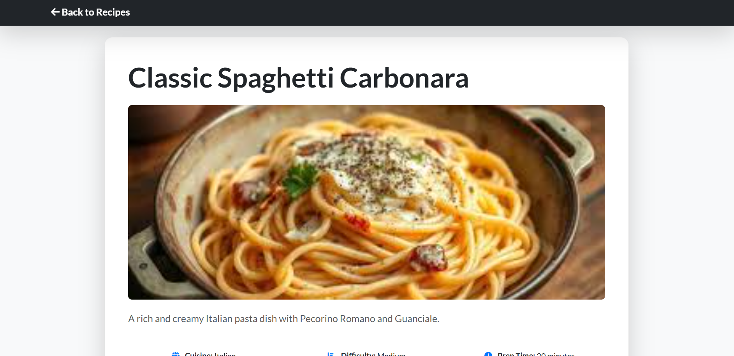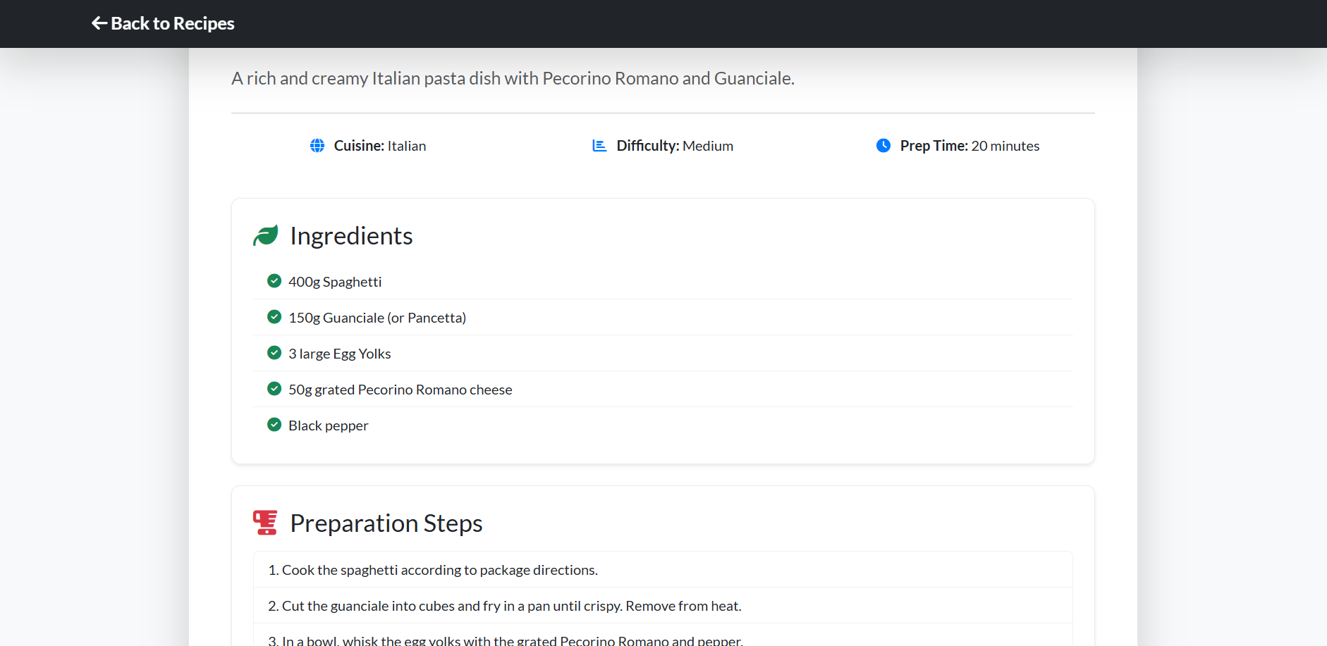

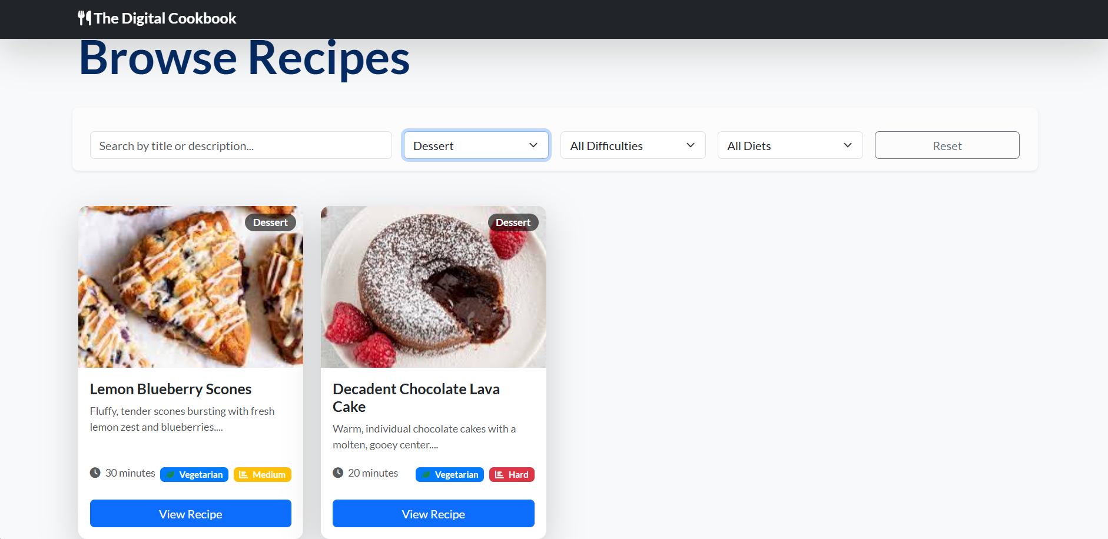

**11. Conclusion**

*This project improved my understanding of* ***responsive design using Bootstrap****,* ***UI layout structuring****, and* ***enhancing interactivity with JavaScript/jQuery****. It provided hands-on practice in combining aesthetics with functionality to create a user-friendly recipe browsing experience.*

**12. References**

* L&T LMS: <https://learn.lntedutech.com/Landing/MyCourse>
* Bootstrap Documentation: https://getbootstrap.com
* jQuery Documentation: https://jquery.com