**Front-End UI/UX Mini Project**

**Event Countdown Landing Page (Static Layout)**

**1. Title Page**

* **Project Title**: *e.g., "Event Countdown Landing Page (Static Layout)"*
* **Submitted By**: 
  + *Swathi P, S M Tejashree Kashyap*
  + *2460478, 2460440*
  + [*swathi.p@btech.christuniversity.in*](mailto:swathi.p@btech.christuniversity.in) *,* [*sm.tejashree@btech.christuniversity.in*](mailto:sm.tejashree@btech.christuniversity.in)
* **Course**: *UI/UX Design Fundamentals*
* **Instructor Name**: *Dhiraj alate*
* **Institution**: *Christ University*
* **Date of Submission**: *12/08/2025*

**2. Abstract**

*This project focuses on designing a visually captivating single-page countdown for an event, product launch, or conference using HTML and CSS. The layout uses full-screen sections based on viewport units, a CSS-animated countdown timer, speaker profiles, and a schedule section. The design is fully responsive and accessible, demonstrating the use of vh/vw units, keyframe animations, and modern front-end design principles.*

**3. Objectives**

* *Build a single-page static countdown using CSS animations.*
* *Structure a responsive full-screen layout with vh/vw units.*
* *Highlight event details, speakers, and schedule in a user-friendly manner.*

**4. Scope of the Project**

* *Focused on front-end design only (HTML & CSS).*
* *Includes four sections: Available Pets, Adoption Process, Success Stories, Volunteer Form.*
* *No JavaScript or backend integration.*
* *Fully responsive for desktop, tablet, and mobile.*

**5. Tools & Technologies Used**

|  |  |
| --- | --- |
| *Tool/Technology* | *Purpose* |
| *HTML5* | *Markup and content structure* |
| *CSS3* | *Styling and layout management* |
| *VS Code* | *Code editor* |
| *Chrome DevTools* | *Testing and debugging* |

**6. HTML Structure Overview**

* Used semantic tags: <header>, <nav>, <main>, <section>, <footer>
* Structured into reusable sections: About, Projects, Contact
* Navigation menu using <ul> and anchor links for smooth scrolling

**7. CSS Styling Strategy**

* *External stylesheet with organized comments.*
* *Flexbox/Grid for responsive pet cards.*
* *Pastel color palette with rounded corners.*
* *CSS variables for color themes.*
* *Checkbox hack for filtering without JavaScript.*

**8. Key Features**

|  |  |
| --- | --- |
| Feature | Description |
| Animated Countdown | Show dogs, cats, or all using CSS checkbox hack |
| Responsive Layout | Flexbox/Grid adapts to all devices |
| Speaker Profiles | “Playful”, “Shy” badges for each pet |
| Event Timeline | Warm, friendly look with rounded corners |

**9. Challenges Faced & Solutions**

|  |  |
| --- | --- |
| Challenge | Solution |
| Countdown without JS | **Used CSS checkbox hack** |
| Maintaining proportions in images | **Used object-fit with fixed aspect ratio** |
| Full-screen scaling | **Applied vw/vh units consistently** |

**10. Outcome**

*Produced a fully functional static countdown page with engaging animations and responsive design using only HTML & CSS.*

**11. Future Enhancements**

* *Add "Add to Calendar" functionality.*
* *Implement live countdown with JavaScript.*
* *Include registration form.*

**12. Sample Code**

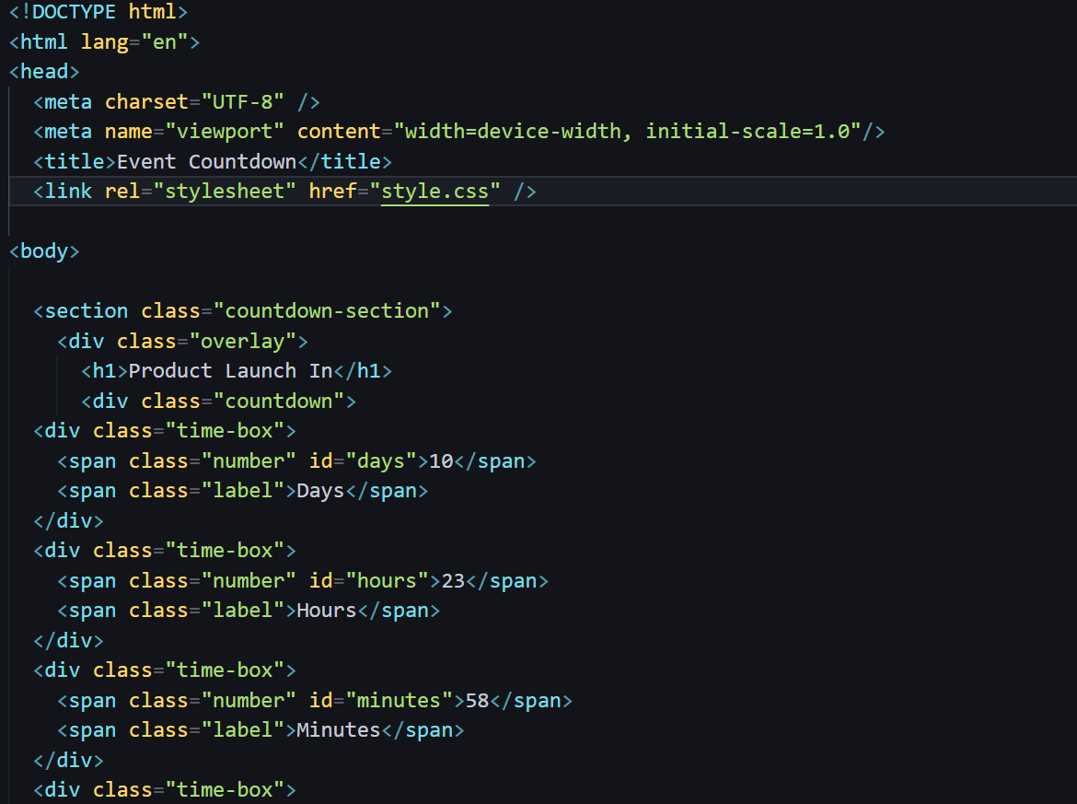 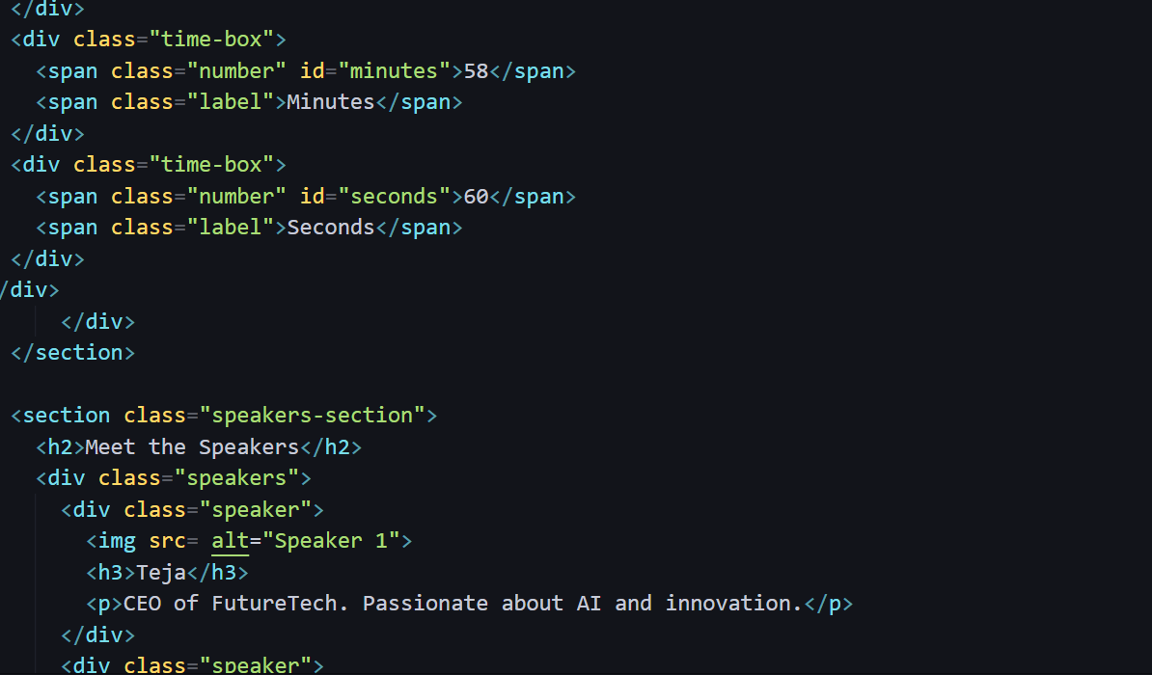 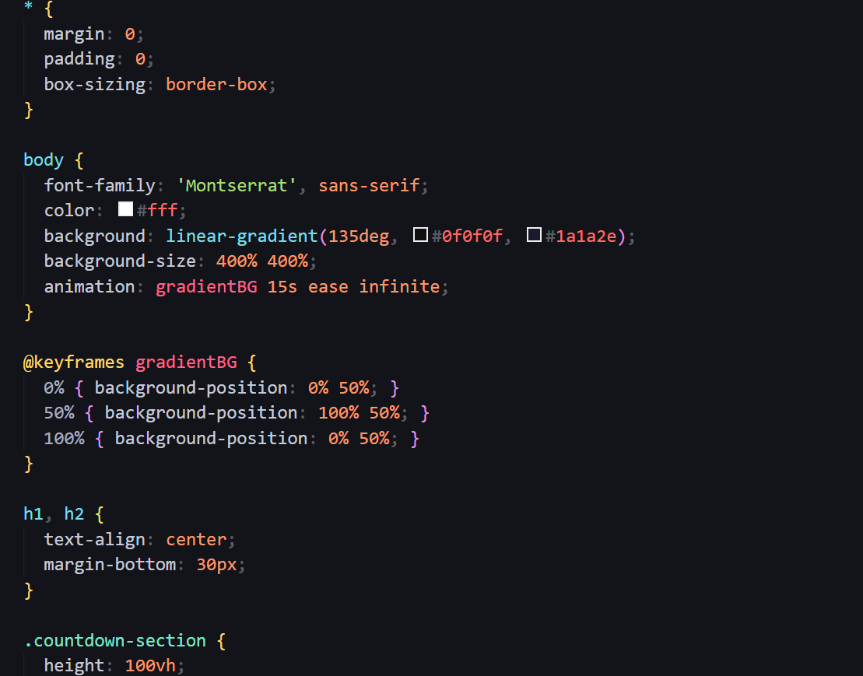 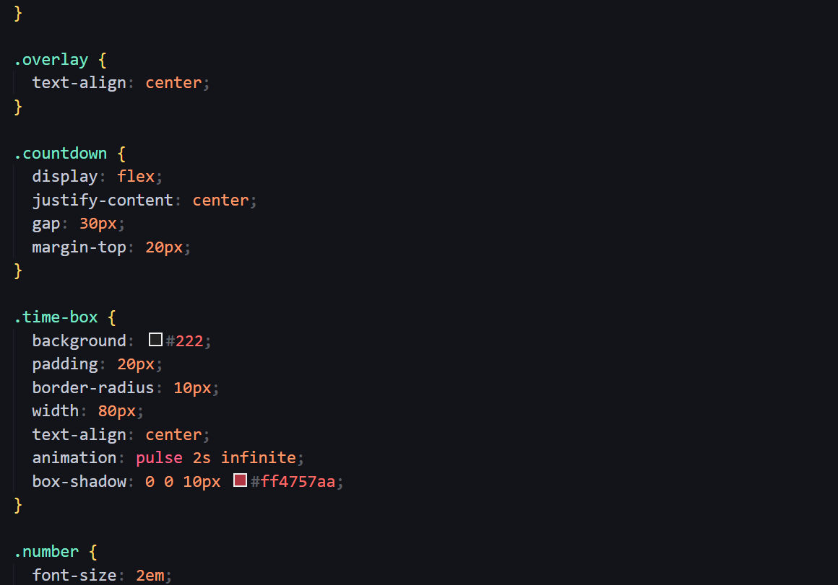

**13. Screenshots of Final Output**

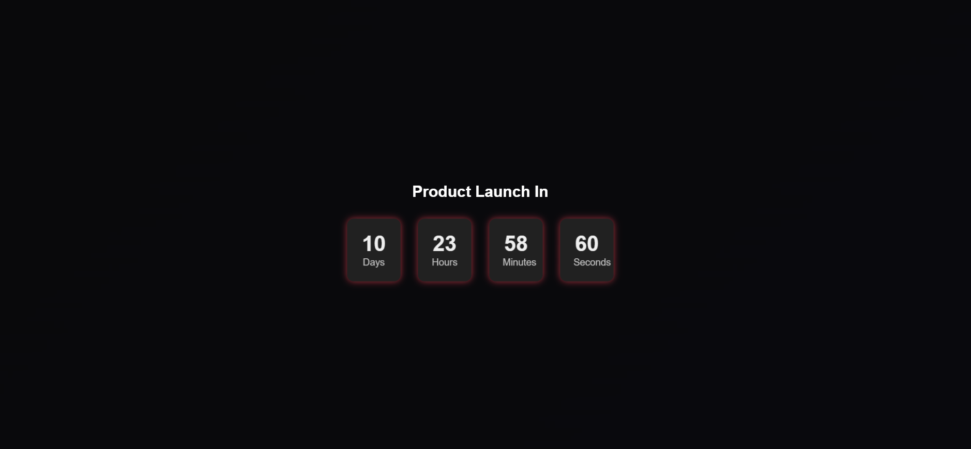 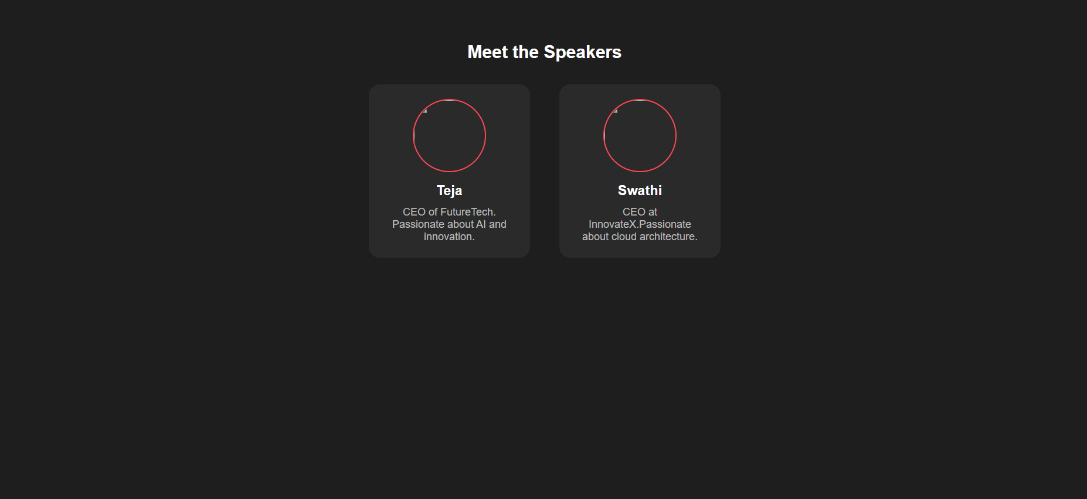 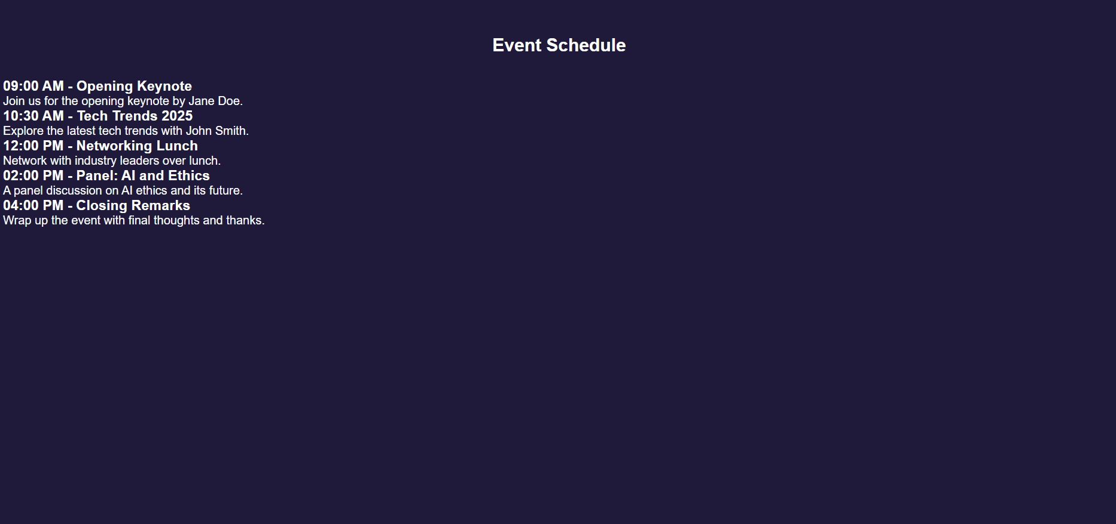

**11. Conclusion**

*This project strengthened my knowledge of CSS animations, responsive design with viewport units, and the art of building visually appealing static landing pages without JavaScript.***12. References**

* L&T LMS : https://learn.lntedutech.com/Landing/MyCourse