|  |
| --- |
| Step1:Create two linux instances,Use the first free linux AMI  Step2:Launch both instances using Mobaxterm  Step4:Host html login webpage on both servers  (Refer video for steps)  NOTE:Make change in the label of the second sever html configuration  HTML code for login page:  <form action="action_page.php" method="post">  <div class="imgcontainer">  <img src="img_avatar2.png" alt="Avatar" class="avatar">  </div>  <div class="container">  <label for="uname"><b>Username</b></label>  <input type="text" placeholder="Enter Username" name="uname" required>  <label for="psw"><b>Password</b></label>  <input type="password" placeholder="Enter Password" name="psw" required>  <button type="submit">Login</button>  <label>  <input type="checkbox" checked="checked" name="remember"> Remember me  </label>  </div>  <div class="container" style="background-color:#f1f1f1">  <button type="button" class="cancelbtn">Cancel</button>  <span class="psw">Forgot <a href="#">password?</a></span>  </div>  </form>  Step5:Check is application is deployed on both servers by copy pasting the public ip of the servers into the browser.  Step6:Create a application Load balancer with the above two instances as targets  Step7:Check the functioning of ELB |

Linux Instances Running: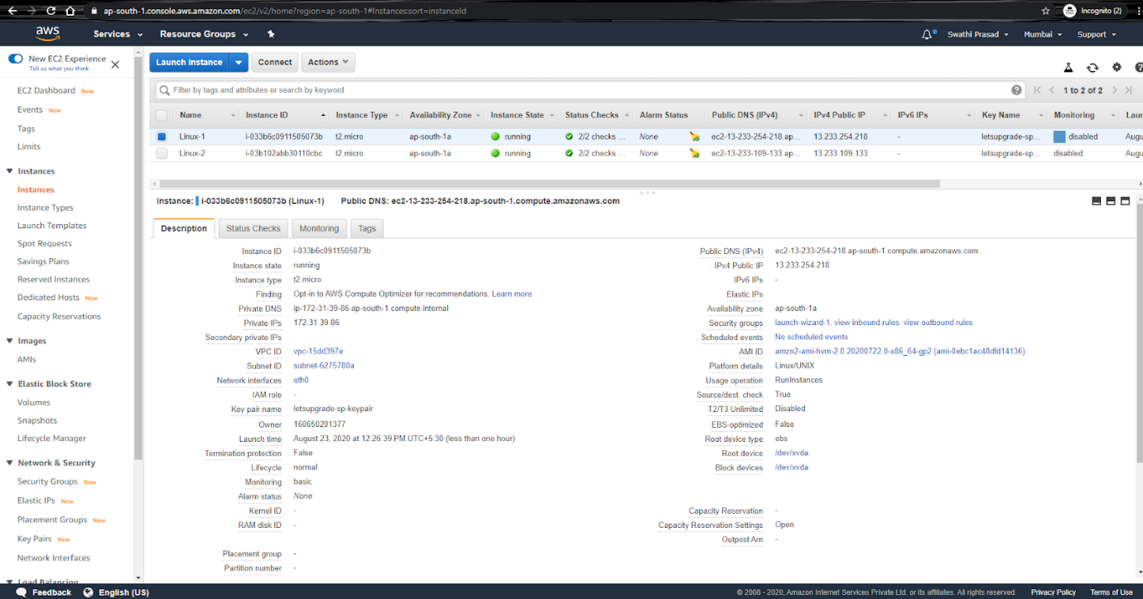

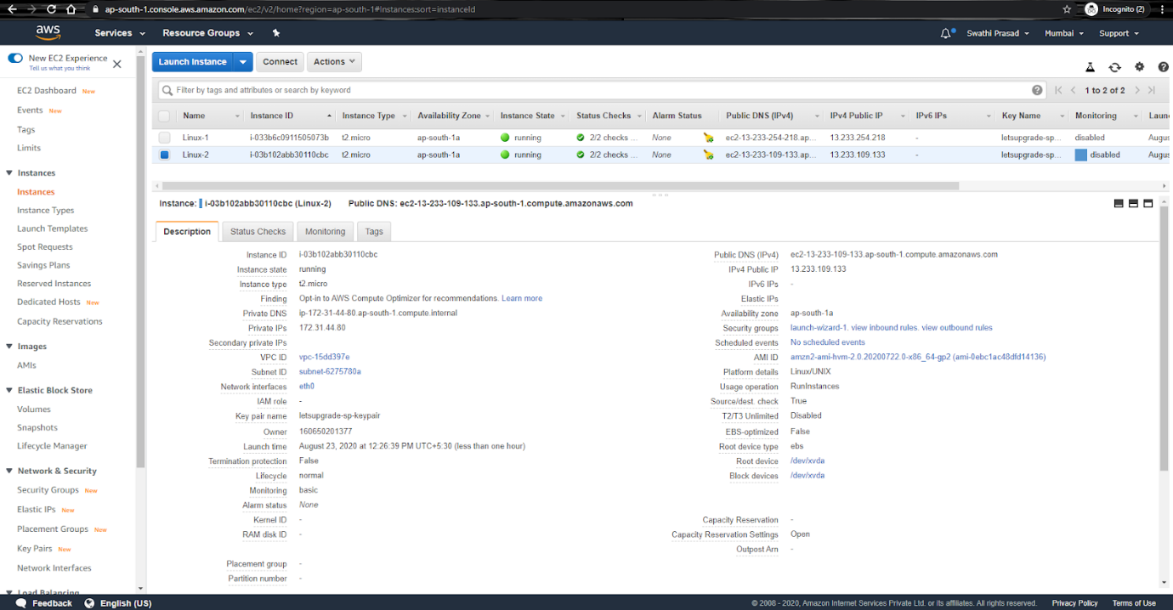

Web Pages deployed on Linux Instances :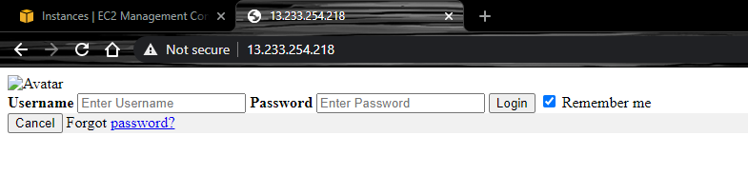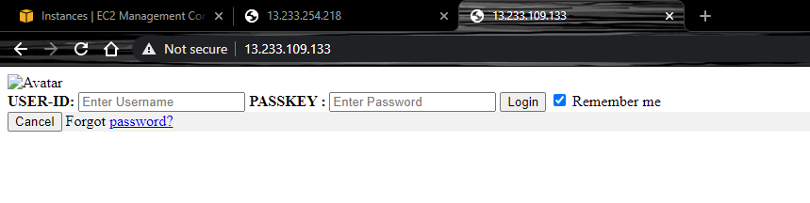

Load Balancer Created:

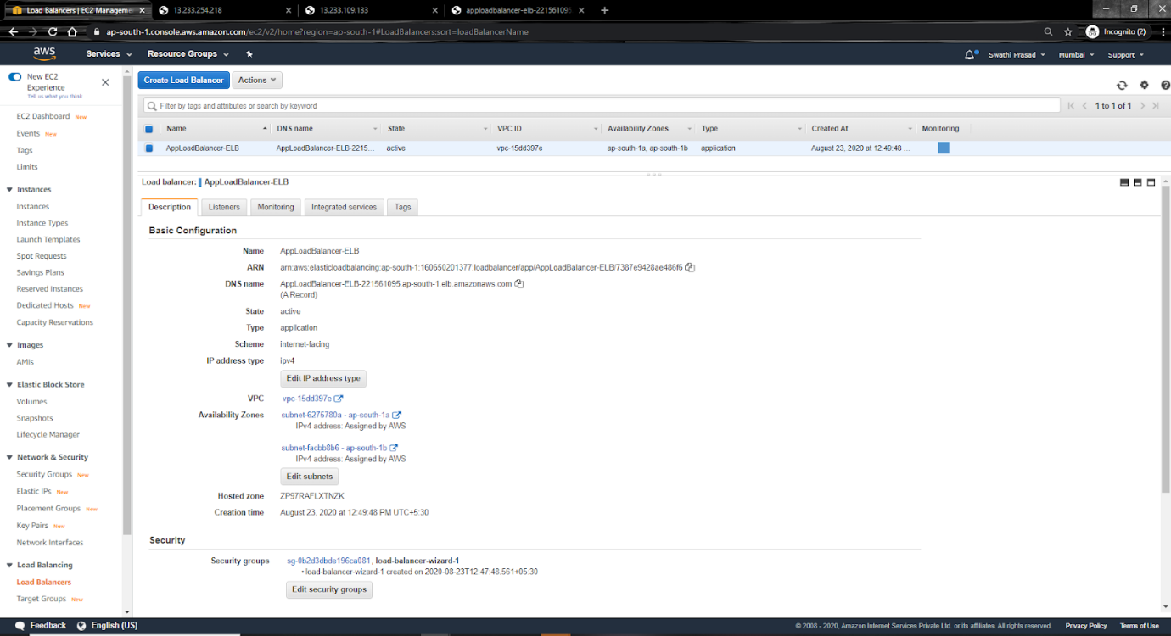

Load Balancer switching/functioning between servers:

